|  |  |  |  |  |  |  |
| --- | --- | --- | --- | --- | --- | --- |
| |  |  |  |  | | --- | --- | --- | --- | | logo_FU | | **MINISTRY OF EDUCATION AND TRAININGG** | | | **FPT UNIVERSITY** | | |
| Capstone Project Document |
| Building a Website For Badminton Sport Fans |
| |  |  |  |  |  |  |  |  |  |  |  | | --- | --- | --- | --- | --- | --- | --- | --- | --- | --- | --- | | |  |  | | --- | --- | | **Group 14** | | | **Group member** | Trần Tấn Phát – Leader – SE60842  Nguyễn Duy Thông – Member – 60399  Nguyễn Hồng Tuấn – Member – SE60635  Lê Minh Quân – Member – 60389 (***Droped out***)  Hồ Quang Hưng – Member – 60429 (**Droped out**) | | **Supervisor** | Nguyễn Trọng Tài | | **Ext. Supervisor** | N/A | | **Capstone Project code** | BSF-Website | | |
| * Ho Chi Minh City, May 2014 – |

*This page is intentionally left blank*

***ACKNOWLEDGEMENTS***

We would like to express our deep gratitude to Mr. Nguyễn Trọng Tài, our capstone project supervisors, for his patient guidance, enthusiastic encouragement and useful critiques of this project work.

We would also like to thank all FPT lecturers for their teaching us valuable knowledge in all our university study years.

Our grateful thanks are also extended to all FPT University Committee and all Department staff who support the best conditions for our study process in general and doing capstone project in particular.

We would also like to extend my thanks to our friends of the FPT University for their help in offering us the technical knowledge in project doing process.

Finally, we wish to thank our parents for their support and encouragement throughout our study.

# Table of Contents

[Table of Contents 5](#_Toc395790368)

[List of Tables 8](#_Toc395790369)

[List of Figures 9](#_Toc395790370)

[Definitions, Acronyms, and Abbreviations 13](#_Toc395790371)

[1 Introduction 14](#_Toc395790372)

[1.1 Project Information 14](#_Toc395790373)

[1.2 Introduction 14](#_Toc395790374)

[1.3 Current Existence Method 14](#_Toc395790375)

[1.4 System Overview 14](#_Toc395790376)

[1.5 Role and Responsibility 15](#_Toc395790377)

[2 Software Project Management Plan 16](#_Toc395790378)

[1. Problem Definition 16](#_Toc395790379)

[2.1.1 Name of this Capstone Project 16](#_Toc395790380)

[2.1.2 Problem Abstract 16](#_Toc395790381)

[2.1.3 Project Overview 16](#_Toc395790382)

[2.2 Project organization 18](#_Toc395790383)

[2.2.1 Software Process Model 18](#_Toc395790384)

[2.2.2 Roles and responsibilities 19](#_Toc395790385)

[2.2.3 Tools and Techniques 20](#_Toc395790386)

[2.3 Project Management Plan 21](#_Toc395790387)

[2.3.1 Task 21](#_Toc395790388)

[2.3.2 Task Sheet: Assignment and Timetable 25](#_Toc395790389)

[2.3.3 All Meeting Minutes 27](#_Toc395790390)

[2.4 Coding Convention 27](#_Toc395790391)

[3 Software Requirement Specification 28](#_Toc395790392)

[1. User Requirement Specification 28](#_Toc395790393)

[3.1.1 Guest Requirement 28](#_Toc395790394)

[3.1.2 Player Requirement 28](#_Toc395790395)

[3.1.3 Boss Requirement 29](#_Toc395790396)

[3.1.4 Coach Requirement 29](#_Toc395790397)

[3.1.5 Webmaster Requirement 30](#_Toc395790398)

[3.1.6 System Requirement 30](#_Toc395790399)

[3.2 System Requirement Specification 30](#_Toc395790400)

[3.2.1 External Interface Requirement 30](#_Toc395790401)

[3.2.2 Functional Requirement 32](#_Toc395790402)

[3.2.3 Non-functional Requirement 148](#_Toc395790403)

[3.3 Entity Relationship Diagram 150](#_Toc395790404)

[Data Dictionary 151](#_Toc395790405)

[4 Software Design Description 152](#_Toc395790406)

[1. Design Overview 152](#_Toc395790407)

[4.1 System Architectural Design 153](#_Toc395790408)

[4.2 Component Diagram 155](#_Toc395790409)

[4.3 Detailed Description of Components 156](#_Toc395790410)

[4.3.1 Class Diagram 156](#_Toc395790411)

[4.3.2 Class Diagram Explanation 158](#_Toc395790412)

[4.3.3 Sequence Diagram 171](#_Toc395790413)

[4.4 User Interface Design 201](#_Toc395790414)

[4.4.1 User Interface Design 201](#_Toc395790415)

[4.4.2 Boss Management Interface Design 213](#_Toc395790416)

[4.4.3 Webmaster Interface Design 214](#_Toc395790417)

[4.5 Database Design 216](#_Toc395790418)

[4.5.1 Physical Database Design 216](#_Toc395790419)

[4.5.2 Data Dictionary 219](#_Toc395790420)

[4.6 Algorithms 220](#_Toc395790421)

[4.6.1 Suggestion Algorithm 220](#_Toc395790422)

[4.6.2 Arrange Match Schedule Automatically Algorithm. 221](#_Toc395790423)

[5 System Implementation & Test 221](#_Toc395790424)

[1. Introduction 222](#_Toc395790425)

[5.1.1 System Overview 222](#_Toc395790426)

[5.1.2 Test Approach 222](#_Toc395790427)

[5.2 Test Plan 223](#_Toc395790428)

[5.2.1 Features to be tested 223](#_Toc395790429)

[5.2.2 Features not to be tested 223](#_Toc395790430)

[5.3 System Testing Test Case 224](#_Toc395790431)

[5.4 Module Test Case 224](#_Toc395790432)

[6 Software User’s Manual 225](#_Toc395790433)

[1. Installation Guide 225](#_Toc395790434)

[6.1.1 Setting up environment at server site 225](#_Toc395790435)

[6.2 User Guide 232](#_Toc395790436)

[6.2.1 Login 232](#_Toc395790437)

[6.2.2 Guest –Register Account. 232](#_Toc395790438)

[6.2.3 User –Edit Profile. 233](#_Toc395790439)

[6.2.4 Boss – Manage Contest Event 234](#_Toc395790440)

[6.2.5 Boss – Manage Contest 239](#_Toc395790441)

[6.2.6 Boss – Manage Contest Participation 241](#_Toc395790442)

[6.2.7 Boss – Manage Matches 244](#_Toc395790443)

[6.2.8 Boss – View Contest Statistics. 252](#_Toc395790444)

[6.2.9 User – Advanced Search Statistics. 252](#_Toc395790445)

[6.2.10 User – View Upcoming Contests. 253](#_Toc395790446)

[6.2.11 User –View Happening Contests. 254](#_Toc395790447)

[6.2.12 User – View Finished Contests. 254](#_Toc395790448)

[6.2.13 Player – View Player’s Joint Contest. 255](#_Toc395790449)

[6.2.14 User – View Contest Detail. 256](#_Toc395790450)

[6.2.15 Player –Join Contest. 258](#_Toc395790451)

[6.2.16 Player- Cancel Joining Contest: 259](#_Toc395790452)

[6.2.17 User –View Contest Schedule. 261](#_Toc395790453)

[6.2.18 User –View Contest Result. 262](#_Toc395790454)

# List of Tables

[Table 1: Roles and Responsibility 16](#_Toc396028357)

[Table 2: Hardware Requirement for Server 18](#_Toc396028358)

[Table 3: Roles and Responsibility Details 21](#_Toc396028359)

[Table 4: Task 25](#_Toc396028360)

[Table 5: Data Dictionary 180](#_Toc396028361)

[Table 6: Login 322](#_Toc396028362)

[Table 7: Register Account 323](#_Toc396028363)

[Table 8: Edit Profile 324](#_Toc396028364)

[Table 9:Advance Search 325](#_Toc396028365)

[Table 10: Upcoming Contests 326](#_Toc396028366)

[Table 11: View happening Contests 327](#_Toc396028367)

[Table 12: View Finished Contests 328](#_Toc396028368)

[Table 13: View Player’s Join Contest 329](#_Toc396028369)

[Table 14: List stadium 330](#_Toc396028370)

[Table 15: Stadium detail 331](#_Toc396028371)

[Table 16: Find court 332](#_Toc396028372)

[Table 17: Book court 333](#_Toc396028373)

[Table 18: Contest Detail 335](#_Toc396028374)

[Table 19: Join contest 337](#_Toc396028375)

[Table 20: Cancel contest 339](#_Toc396028376)

[Table 21: Contest Shedule 340](#_Toc396028377)

[Table 22: Con test Result 342](#_Toc396028378)

[Table 23: list Course 342](#_Toc396028379)

[Table 24: Join course 343](#_Toc396028380)

[Table 25: List register course 344](#_Toc396028381)

[Table 26: Create Court 348](#_Toc396028382)

[Table 27: Edit court 349](#_Toc396028383)

[Table 28:Add reservation 350](#_Toc396028384)

[Table 29: ReservationDetail 351](#_Toc396028385)

[Table 30:DeleteReview 352](#_Toc396028386)

[Table 31: View contest Event 352](#_Toc396028387)

[Table 32: Create Contest Event 354](#_Toc396028388)

[Table 33: Edit Contest 355](#_Toc396028389)

[Table 34: Delete Contest Event. 355](#_Toc396028390)

[Table 35: view contest list 356](#_Toc396028391)

[Table 36: Create Contest 358](#_Toc396028392)

[Table 37: Delete Contest. 358](#_Toc396028393)

[Table 38: Contest Participation 359](#_Toc396028394)

[Table 39: Edit contest participation 360](#_Toc396028395)

[Table 40: Report and Reset Viloate registration. 361](#_Toc396028396)

[Table 41: View matches list 362](#_Toc396028397)

[Table 42: Arrange match shedule 364](#_Toc396028398)

[Table 43: Arrange schedule automatically 365](#_Toc396028399)

[Table 44: Record Match Scores. 366](#_Toc396028400)

[Table 45: Export contest schedule 367](#_Toc396028401)

[Table 46: Export contest result. 368](#_Toc396028402)

[Table 47: View contest Statistics 369](#_Toc396028403)

[Table 48:Manage course 370](#_Toc396028404)

[Table 49:Manage register course 370](#_Toc396028405)

# List of Figures

[Figure 1 - Waterfall model 18](#_Toc385521273)

[Figure 2: Task Sheet and Assignment 24](#_Toc385521274)

[Figure 3: System Overview Use Case 28](#_Toc385521275)

[Figure 4: Show agency use-case 28](#_Toc385521276)

[Figure 5: View Product use-case 31](#_Toc385521277)

[Figure 6: View Agency use-case 32](#_Toc385521278)

[Figure 7: Show agency use-case 32](#_Toc385521279)

[Figure 8: Search Agency use-case 33](#_Toc385521280)

[Figure 9: Address of agency use-case 35](#_Toc385521281)

[Figure 10: View Promotion Campaign use-case 36](#_Toc385521282)

[Figure 11: Search product use-case 37](#_Toc385521283)

[Figure 12: Edit Account Information use-case 38](#_Toc385521284)

[Figure 13: Login use-case 40](#_Toc385521285)

[Figure 14: Log out use-case 42](#_Toc385521286)

[Figure 15: Comment Product use-case 43](#_Toc385521287)

[Figure 16: Register Agency use-case 45](#_Toc385521288)

[Figure 17: Feedback Agency use-case 47](#_Toc385521289)

[Figure 18: WishList use-case 49](#_Toc385521290)

[Figure 19: Add to WishList use-case 49](#_Toc385521291)

[Figure 20: View WishList use-case 50](#_Toc385521292)

[Figure 21: Order Product use-case 51](#_Toc385521293)

[Figure 22: Fast Order use-case 51](#_Toc385521294)

[Figure 23: Order with quantity use-case 53](#_Toc385521295)

[Figure 24: Update Order use-case 54](#_Toc385521296)

[Figure 25: Delete order use-case 56](#_Toc385521297)

[Figure 26: OrderHistory use-case 57](#_Toc385521298)

[Figure 27: Feedback Roundman use-case 58](#_Toc385521299)

[Figure 28: Find Bath use-case 59](#_Toc385521300)

[Figure 29: Manage Feedbacks use-case 61](#_Toc385521301)

[Figure 30: List Feedback use-case 61](#_Toc385521302)

[Figure 31: Answer Feedback use-case 62](#_Toc385521303)

[Figure 32: Manage Vehicles use-case 63](#_Toc385521304)

[Figure 33: List Vehicles use-case 64](#_Toc385521305)

[Figure 34: Add Vehicles use-case 65](#_Toc385521306)

[Figure 35: Update Vehicles use-case 66](#_Toc385521307)

[Figure 36: Disable Vehicles use-case 68](#_Toc385521308)

[Figure 37: Enable Vehicles use-case 69](#_Toc385521309)

[Figure 38: Manage Order use-case 70](#_Toc385521310)

[Figure 39: Search Order use-case 71](#_Toc385521311)

[Figure 40: Delete Order use-case 72](#_Toc385521312)

[Figure 41: Automatic Browse use-case 73](#_Toc385521313)

[Figure 42: Manually Browse use-case 75](#_Toc385521314)

[Figure 43: Manage Promotion Campaign use-case 76](#_Toc385521315)

[Figure 44: Add Campaign use-case 76](#_Toc385521316)

[Figure 45: Delete Campaign use-case 78](#_Toc385521317)

[Figure 46: Update Campaign use-case 80](#_Toc385521318)

[Figure 47: Manage Agencies use-case 82](#_Toc385521319)

[Figure 48: Approve Agency use-case 82](#_Toc385521320)

[Figure 49: Disable Agency use-case 84](#_Toc385521321)

[Figure 50: Enable Agency use-case 85](#_Toc385521322)

[Figure 51: Update Agency use-case 87](#_Toc385521323)

[Figure 52: Manage Products use-case 89](#_Toc385521324)

[Figure 53: List Product use-case 89](#_Toc385521325)

[Figure 54: Add Product use-case 90](#_Toc385521326)

[Figure 55: Update Product use-case 92](#_Toc385521327)

[Figure 56: Disable Products use-case 93](#_Toc385521328)

[Figure 57: Manage Categories use-case 95](#_Toc385521329)

[Figure 58: List Categories use-case 95](#_Toc385521330)

[Figure 59: Add Categories use-case 97](#_Toc385521331)

[Figure 60: Update Categories use-case 98](#_Toc385521332)

[Figure 61: Delete Categories use-case 100](#_Toc385521333)

[Figure 62: Manage Ages use-case 102](#_Toc385521334)

[Figure 63: List Age use-case 102](#_Toc385521335)

[Figure 64: Add Age use-case 103](#_Toc385521336)

[Figure 65: Update Age use-case 106](#_Toc385521337)

[Figure 66: Disable Ages use-case 107](#_Toc385521338)

[Figure 67: Enable Ages use-case 109](#_Toc385521339)

[Figure 68: Manage Packages use-case 111](#_Toc385521340)

[Figure 69: List Package use-case 111](#_Toc385521341)

[Figure 70: Add Package use-case 112](#_Toc385521342)

[Figure 71: Update Package use-case 114](#_Toc385521343)

[Figure 72: Disable Packages use-case 117](#_Toc385521344)

[Figure 73: Enable Packages use-case 118](#_Toc385521345)

[Figure 74: Statistic use-case 120](#_Toc385521346)

[Figure 75: Manage Administrator use-case 122](#_Toc385521347)

[Figure 76: Add Administrator use-case 124](#_Toc385521348)

[Figure 77: Update Administrator use-case 126](#_Toc385521349)

[Figure 78: Delete Administrator use-case 128](#_Toc385521350)

[Figure 79: Manage Sliders use-case 130](#_Toc385521351)

[Figure 80: List Slider use-case 130](#_Toc385521352)

[Figure 81: Add Slider use-case 132](#_Toc385521353)

[Figure 82: Update Slider use-case 133](#_Toc385521354)

[Figure 83: Delete Slider use-case 136](#_Toc385521355)

[Figure 84: Entity Relationship Diagram 139](#_Toc385521356)

[Figure 85: Component Diagram 143](#_Toc385521357)

[Figure 86: <Agency Manager> Order sequence diagram 179](#_Toc385521358)

[Figure 87: <Administrator> Add Product sequence diagram 180](#_Toc385521359)

[Figure 88: <Administrator> Edit Product sequence diagram 181](#_Toc385521360)

[Figure 89: <Administrator> Disable Product sequence diagram 182](#_Toc385521361)

[Figure 90: <Administrator> Enable Product sequence diagram 182](#_Toc385521362)

[Figure 91: <Administrator> Auto Browse Order sequence diagram 183](#_Toc385521363)

[Figure 92: <Administrator> Manual Browse Order sequence diagram 184](#_Toc385521364)

[Figure 93: <Administrator> Change Status Delivery sequence diagram 185](#_Toc385521365)

[Figure 94: <Roundman> Find Bath sequence diagram 186](#_Toc385521366)

[Figure 95: Manager Home Page 187](#_Toc385521367)

[Figure 96: Shopping Cart 189](#_Toc385521368)

[Figure 97: Delivery path 190](#_Toc385521369)

[Figure 98: Detail product 191](#_Toc385521370)

[Figure 99: Manager Home Page 192](#_Toc385521371)

[Figure 100: Statistic website 194](#_Toc385521372)

[Figure 101: Manager Agency 195](#_Toc385521373)

[Figure 102: Manager Promotion Campaign 196](#_Toc385521374)

[Figure 103: Manger Order 197](#_Toc385521375)

[Figure 104: Entity Relationship Diagram 199](#_Toc385521376)

[Figure 105: Database Relationship Diagram 208](#_Toc385521377)

[Figure 106: Core Workflow 210](#_Toc385521378)

[Figure 107: Prepare deployment package 235](#_Toc385521379)

[Figure 108: Deploy database – 1 236](#_Toc385521380)

[Figure 109: Deploy database - 2 237](#_Toc385521381)

[Figure 110: Deploy database - 3 237](#_Toc385521382)

[Figure 111: Configure Server before deploy – 1 238](#_Toc385521383)

[Figure 112: Configure Server before deploy – 2 238](#_Toc385521384)

[Figure 113: Configure Server before deploy - 3 239](#_Toc385521385)

[Figure 114: Deploy web application on server - 1 239](#_Toc385521386)

[Figure 115: Deploy web application on server – 2 240](#_Toc385521387)

[Figure 116: Deploy web application on server – 3 240](#_Toc385521388)

[Figure 117: Deploy web application on server – 4 241](#_Toc385521389)

[Figure 118: Deploy web application on server – 5 241](#_Toc385521390)

[Figure 119: Login Page 242](#_Toc385521391)

[Figure 120: Product List Page 242](#_Toc385521392)

[Figure 121: Insert Product Page 243](#_Toc385521393)

[Figure 122: Edit Product Page 243](#_Toc385521394)

[Figure 123: Order List Page 244](#_Toc385521395)

[Figure 124: Auto Browse Page 244](#_Toc385521396)

[Figure 125: View Delivery 245](#_Toc385521397)

[Figure 126: List Vehicle Page 245](#_Toc385521398)

[Figure 127: Insert Vehicle Popup 245](#_Toc385521399)

[Figure 128: Edit Vehicle Detail 246](#_Toc385521400)

[Figure 129: View List Roundman Page 246](#_Toc385521401)

[Figure 130: Insert Roundman Popup 247](#_Toc385521402)

[Figure 131: Edit Roundman Popup 247](#_Toc385521403)

[Figure 132: View Comment Page 248](#_Toc385521404)

[Figure 133: Answer Comment Popup 248](#_Toc385521405)

[Figure 134: List Package Page 249](#_Toc385521406)

[Figure 135: Insert Package Popup 249](#_Toc385521407)

[Figure 136: Edit Package Popup 250](#_Toc385521408)

[Figure 137: Statistic Page 250](#_Toc385521409)

[Figure 138: List User Page 251](#_Toc385521410)

[Figure 139: Edit User Information 251](#_Toc385521411)

[Figure 140: View List Agency 252](#_Toc385521412)

[Figure 141: Feedback Page 253](#_Toc385521413)

[Figure 115: Answer Feedback Popup 253](#_Toc385521414)

[Figure 143: Age List Page 254](#_Toc385521415)

[Figure 144: Add/Edit Age Popup 254](#_Toc385521416)

[Figure 145: Admin List Page 255](#_Toc385521417)

[Figure 146: Add Admin Popup 255](#_Toc385521418)

[Figure 147: Advance Search 256](#_Toc385521419)

[Figure 148: Search Product 256](#_Toc385521420)

[Figure 149: View List Product 256](#_Toc385521421)

[Figure 150: Product Detail Page 257](#_Toc385521422)

[Figure 151: View Cart Page 257](#_Toc385521423)

[Figure 152: Checkout popup 258](#_Toc385521424)

[Figure 153: Register Page 258](#_Toc385521425)

[Figure 154: Register Agency Page 259](#_Toc385521426)

[Figure 155: Find Path page 259](#_Toc385521427)

[Figure 156: Popup Result Find Path 260](#_Toc385521428)

# Definitions, Acronyms, and Abbreviations

|  |  |
| --- | --- |
| BSF Website | Badminton Sport Fan Website. |

# Introduction

## Project Information

* Project name: Website For Badminton Sport Fans
* Project Code: **BSF-Website**
* Product Type: **Web-based Application**
* Start Date: **May 13th, 2014**
* End Date: **August 30th, 2014**

## Introduction

Nowadays, the demand of playing sports for relaxing after work, studying...more and more decrease especially playing badminton sports. Moreover, there are not many websites supporting for badminton players, badminton court owners and badminton trainers to rent courts, manage courts, manage badminton classes

BSF-Website is website that provide many functions about badmiton sport such as reservation court and payment online, sponsor badmiton contests, open badmiton course,… for badminton players, badminton stadium bosses, badminton coaches, website admin and website guest. BSF-Website provides easy-use user interface for all roles of people and business operating process.

## Current Existence Method

There are some current websites about badminton online such as: <http://www.badminton.com/>, <http://sanchoi.vn/>, <http://vnbadminton.com/> … All of them have many limited features.

Limitations of the existing system:

* Not supporting for renting court online and online payment.
* Just providing addresses of badminton courts.
* Not supporting utilities for boss of badminton court such as: sponsoring badminton contest, opening badminton course, managing online business…
* Not supporting for trainer apply for teaching job.
* Not just focusing on badminton sport but many other sports.

## System Overview

Our website system is developed and focus on target users are badminton sport fans who want to rent badminton courts for playing; bosses of badminton courts who want to provide for sport fan renting court services; badminton trainers who want to apply teaching jobs; trainees who want to join to badminton course to improve their abilities.

Explored our website user can rent badminton courts online, take part in badminton courses, register badminton contest, open renting court service, manage badminton courts, sponsor badminton contests, open badminton courses, apply teaching badminton job, manage badminton classes.

The Website has four main users who interact with, includes:

* **Guests of website:** register account, login, find badminton court, find badminton course.
* **Fans of badminton sport:** login, log out, manage personal information, find badminton court, view court details, reserve court, view reservation history, do quick test for being suggested badminton course, view course detail, find course, join course, view badminton contests, join contests, do feedback for coach and course, find friend in near location.
* **Bosses of badminton courts**: login, log out, manage personal information, register for opening online badminton court renting, manage badminton courts, manage sub-badminton courts, manage court reservations, manage badminton course, manage badminton contests, manage badminton trainer, manage badminton trainee, manage renting prices, manage payment for using website, manage products, manage suppliers.
* **Trainers of badminton sport**: login, log out, manage personal information, find badminton teaching job, apply teaching job, and manage badminton classes, manage feedback.
* **Webmaster:** login, log out, manage accounts, manage request opening renting courts of the bosses and manage courts, manage ranking court criteria, manage payment from bosses, manage slides.

## Role and Responsibility

|  |  |  |
| --- | --- | --- |
| Role and Responsibilities | Full name | E-mail |
| Instructor | Nguyễn Trọng Tài | taint@fpt.edu.vn |
| Leader | Trần Tấn Phát | phatttse60842@fpt.edu.vn |
| Member | Nguyễn Duy Thông | thongnd60399@fpt.edu.vn |
| Member | Nguyễn Hồng Tuấn | tuannhse60635@fpt.edu.vn |
| Member | Lê Minh Quân (drop out) | quanlm60389@fpt.edu.vn |
| Member | Hồ Quang Hưng(drop out) | hunghq60429@fpt.edu.vn |

Table 1: Roles and Responsibility

# Software Project Management Plan

## Problem Definition

### Name of this Capstone Project

+ English: Building a website for badminton sport fans.

+Vietnamese: Xây dựng ứng dụng web dành cho người yêu thích môn thể thao cầu lông.

+Abbreviation: BSF-Website

### Problem Abstract

Nowadays, the demand of playing sports for relaxing after work, studying...more and more decrease especially playing badminton sports. Moreover, there are not many websites supporting for badminton players, badminton court owners and badminton trainers to rent courts, manage courts, manage badminton classes…

This website system is developed and focus on target users are badminton sport fans who want to rent badminton courts for playing; bosses of badminton courts who want to provide for sport fan renting court services; badminton trainers who want to apply teaching jobs; trainees who want to join to badminton course to improve their abilities

### Project Overview

#### The Current System

There are some current websites about badminton online such as: <http://www.badminton.com/>, <http://sanchoi.vn/>, <http://vnbadminton.com/> … All of them have many limited features.

Limitations of the existing system:

* Not supporting for renting court online and online payment.
* Just providing addresses of badminton courts.
* Not supporting utilities for boss of badminton court such as: sponsoring badminton contest, opening badminton course, managing online business…
* Not supporting for trainer apply for teaching job.
* Not just focusing on badminton sport but many other sports.

#### The Proposed System

Our website system is developed and focus on target users are badminton sport fans who want to rent badminton courts for playing; bosses of badminton courts who want to provide for sport fan renting court services; badminton trainers who want to apply teaching jobs; trainees who want to join to badminton course to improve their abilities.

Explored our website user can rent badminton courts online, take part in badminton courses, register badminton contest, open renting court service, manage badminton courts, sponsor badminton contests, open badminton courses, apply teaching badminton job, manage badminton classes.

The Website has 5main users who interact with, includes:

* **Guests of website:** register account, login, find badminton court, find badminton course.
* **Badminton players:** login, log out, manage personal information, find badminton court, view court details, reserve court, view reservation history, do quick test for being suggested badminton course, view course detail, find course, join course, view badminton contests, join contests, comment.
* **Bosses of badminton courts**: login, log out, manage personal information, register for opening online badminton court renting, manage badminton courts, manage court reservations, manage badminton course, manage badminton contest event, manage contest, mange contest register, manage match result and schedule, contest statistics, manage badminton trainer, manage renting prices.
* **Badminton coach**: login, log out, manage personal information, find badminton teaching job, apply teaching job, and manage badminton classes.
* **Webmaster:** login, log out, manage accounts, manage stadium register, mange service price, view and send message.

#### Boundaries of the System

* The system is intended for badminton sport fan, trainer, trainee, boss of badminton court.
* The system is intended for online functions, give information related to badminton sport activities.
* The language of the system is Vietnamese
* The complete product includes:

+ The website, for admin, user and guest to interactivate with the system.

+ All the process involved document.

#### Development Environment

##### Hardware requirements

**For Server**

|  |  |  |
| --- | --- | --- |
| Windows | Minimum Requirements | Recommended |
| Internet Connection | Cable, Wifi (4 Mbps) | Cable, Wifi (8 Mbps) |
| Operating System | XP, Vista, 7, | XP, Vista, 7 |
| Computer Processor | Intel® Core 2 Duo | Intel® Core(TM) i5 CPU , M 460 @ 2.53GHz |
| Computer Memory | 512MB RAM | 2GB or more |

Table 2: Hardware Requirement for Server

##### Software requirements

* Microsoft Windows 7: Operating System.
* SQL Server 2008 R2: used for managing the database for system.
* StarUML 5.0: designing models and diagrams tools.
* Skype: used for communication and meeting
* Visual Studio 2012: used to implement website and web service.
* Google Code & TortoiseSVN: used for source control.

## Project organization

### Software Process Model

With the schedule of weekly reports for every stage, the software will be developed by using waterfall model which is very simple and require minimal resource for implementation. With waterfall model, developing process will include six main phases:

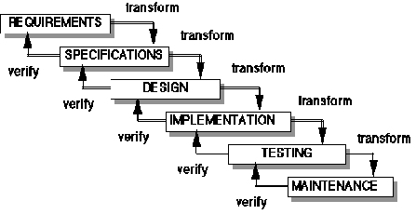

Figure 1 - Waterfall model

* **Requirement analysis and software definition**: The first phase is also the most important phase of the process which may cause great effect to other phases. This phase includes gathering as much as possible requirements from customer, or other information source like World Wide Web, and producing a most detail and accurate software definition.
* **System design**: This phase is fundamental for implementation phase. Based on customer’s requirements to create logical modules, and definite their inter relations. Using algorithm and diagram to describe implementation of those modules.
* **Implementation**: This phase consists of actually constructing the product as per the design specification(s) developed in the previous step. Typically, this step is performed by a development team consisting of programmers, interface designers and other specialists, using tools such as compilers, debuggers, interpreters and media editors.
* **Testing:**
  + **System implementation and Unit testing**: Developing software modules follow detail designs, and doing unit testing for each module.
  + **Integration and System testing**: Testing output, performance in modules integrating process, and retests all functions of whole system.
  + **User acceptance testing**: A proper execution of all the preceding stages ensures an application as per the provided requirements and most importantly, it ensures a satisfied client.
* **System deployment and maintenance**: After testing completely, the software is handle over client, developing team will respond for maintenance of the system.

### Roles and responsibilities

|  |  |  |  |
| --- | --- | --- | --- |
| **No** | **Full name** | **Role in Group** | **Responsibilities** |
| **1** | Nguyễn Trọng Tài | Project manager | * Specify user requirement * Control the development process * Give out technique and business analysis support |
| **2** | Trần Tấn Phát | Team Leader, BA, DEV, Tester | * Managing process * Assign task for team member * Designing database * Clarifying requirements * Prepare documents * GUI Design * Create test plan * Coding * Testing |
| **3** | Nguyễn Duy Thông | Team Member, BA, DEV, Tester | * Designing database * Clarifying requirements * Prepare documents * GUI Design * Create test plan * Coding * Testing |
| **4** | Nguyễn Hồng Tuấn | Team Member, BA, DEV, Tester | * Designing database * Clarifying requirements * Prepare documents * GUI Design * Create test plan * Coding * Testing |
| **5** | Hồ Quang Hưng | Team Member, BA, DEV, Tester | * Designing database * Clarifying requirements * Prepare documents * GUI Design * Create test plan * Coding * Testing |
| **6** | Lê Minh Quân  (droped out) | Team Member, BA, DEV, Tester | * Designing database * Clarifying requirements * Prepare documents * GUI Design * Create test plan * Coding * Testing |

Table 3: Roles and Responsibility Details

### Tools and Techniques

#### For Development

* Front-end technologies: HTML5, CSS3, JavaScript, jQuery, AJAX.
* Back-end: ASP .NET MVC4, Entity Framework.
* Real-time technology: SignalR
* Data Management System: SQL Server 2008 R2.
* IDE: Visual Studio 2012
* System design tool: StartUML
* IIS: web server

#### For Management

-Process and code tracking: Team Foundation Server.

-Tortoise SVN: Document version control and tracking.

#### For Communication

* Gmail: message exchange.
* Skype: chat tool.

## Project Management Plan

### Task

|  |  |  |  |  |  |  |  |
| --- | --- | --- | --- | --- | --- | --- | --- |
| **#** | **Task** | **Description** | **Output** | **Deliverables** | **Resource Needed** | **Dependencies and Constraints** | **Risk** |
| 1 | Creating Software Requirements Specification (SRS) | Creating SRS | SRS document | SRS document before 27/05/2014 | 4 people for 4 days |  | Lack of experience in getting requirement. |
| 2 | Designing Database | Creating conceptual, logical and physical database. | Database Design and Database script | Design Database before 08/06/2014 | 3 person for 3 days | Depends on the completion of SRS | May not cover all business rules, causing the database design to be inappropriate or must be changed by customers’ requirements. |
| 3 | Creating Software Design Description (SDD) | Design the system in an Object Oriendted Programming. | Architecture design, detailed design, diagrams and design specification | SDD before 21/06/2014 | 4 people for 4 days | Depends on the completion of SRS | Choosing inappropriate architecture and design patterns, causing the system hard to maintain, or wasting coding efforts. |
| 4 | Layout Designing | Create the main GUI for layout | HTML layout, Javascript and CSS files | Complete before 21/06/2013 | 2 person for 1 week |  | There is no professional designers in team. |
| 5 | Create Coding | Map the architecture design into source code, create the project solution files and common classes, and implement common functions. | .Net MVC4 project and solution file contain coding |  | 1 person for 3 days | Dependent on Architecture design and SRS |  |
| 6 | Coding | Implement the system based on the requirements. | Source code of the project, unit test reports | Executable programs and source code before 26/07/2014 | 4 people for 5 weeks | Depends on the completion of SRS, SDD, Database design, Coding framework | Unit test may not be performed thoroughly, it draws needing more efforts in system test phase. |
| 7 | Test Plan | Make a plan for testing | Test plan document | Test plan before 02/08/2014 |  |  |  |
| 8 | System Test | Perform system test for the system. | System test report | Software Test Documentation before 02/08/2014 | 3 people for 4 days | When Coding is finished | There is no professional testers in team. Developers are also do system testing, this may draws compromise. |
| 9 | User Guide | Create User manual document | Report 6 | Report 6 before 25/08/2014 | 3 people for 1 days |  | Unclear document may cause ambigious understanding. |
| 10 | Input Initial Data | Collect and input initial data for the system before release. | Initial data |  | 3 people for 3 days | When coding and system test are finished |  |
| 11 | Deployment | Deploy the system on server. | Running website with domain and hosting | Full Project | 2 people for 3 days | When Coding and system test are finished, initial data is inputted. | The owner host lacks of supporting in some components such as database engine. |

Table 4: Task

### Task Sheet: Assignment and Timetable

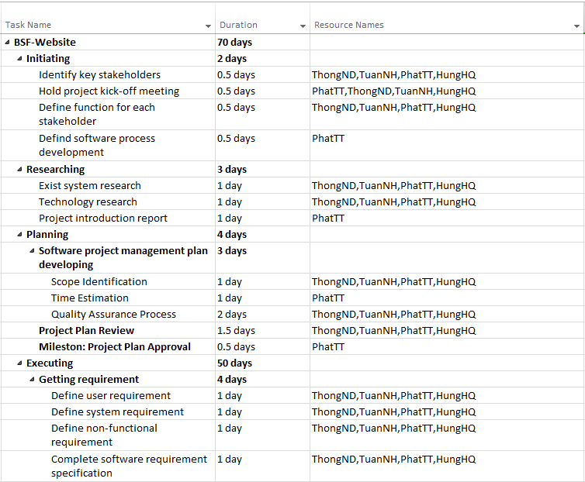

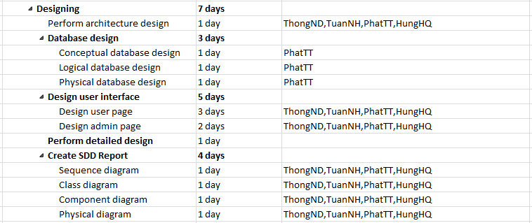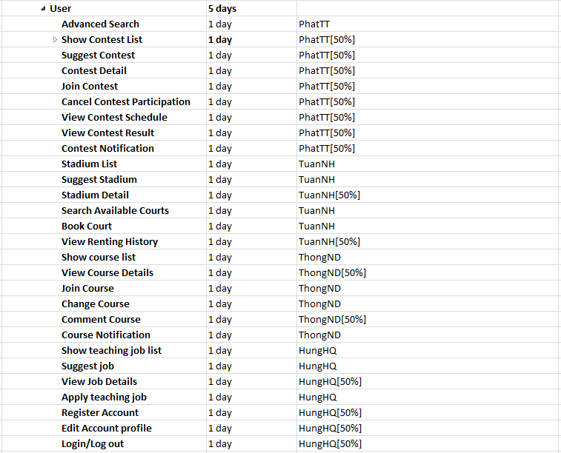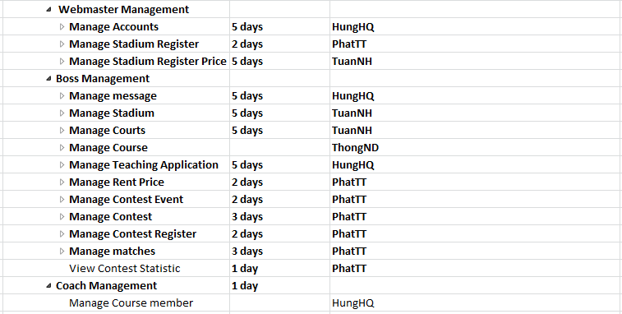

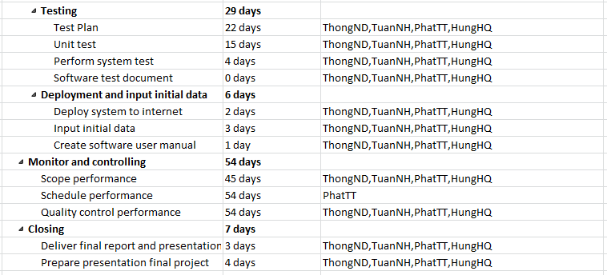

Figure 2: Task Sheet and Assignment

### All Meeting Minutes

Refer to Meeting Minutes folder.

## Coding Convention

C#: Using to develop BSF-website.

Summary:

* Naming Convention.
* Indentation.
* Declaration.
* Code Examples.

All “Code Conventions for the C# Programming Language, by Microsoft

<http://msdn.microsoft.com/en-us/library/ff926074.aspx>

# Software Requirement Specification

## User Requirement Specification

### Guest Requirement

Guest is person who have not loged in BSF-Website and website support these functions:

* **Registration**: guest need to register to become member. Username, password, fullname,home address, home ward, home district, and gender, role (Boss, Coach, Member), phone number and email are required for registration.
* **Search and view**: Guest can search and view detail of contest, court, course, job.

### Player Requirement

Player is a member of BSF-Website with member role when they register an account and they can do following functions:

* **Login**: User need to login to use BSF Website's functions with role member.
* **Edit Profile**: member can edit personal information such as home address, home ward, home district, fullname,...
* **Search and view**: Guest can search and view detail of contest, court, course, job.
* **View contest list**: view list of upcoming contests, happening contests, finished contests.
* **View contest detail**: view contest detail information.
* **Join contest**: register to join upcoming contests.
* **Cancel contest paticipation**: cancel contest participation if contest have yet happened.
* **View contest schedule**: view the time and place of matches of the contest.
* **View contest result**: view contest result statistic when contest have finished .
* **View stadium list**: view list of operating stadium.
* **View stadium detail**: view detail information of stadium.
* **Book court**: find available court to book and pay online.
* **View court reservation history**: view all court reservation history member have booked .
* **View course list**: view list of course to learn to play badminton with many level.
* **View course detail**: view course detail information.
* **Register to learn course**: register to join course and pay online.

### Boss Requirement

Boss is member who registered to the BSF-Website with boss role, they are people who own badminton stadium and want to use BSF-Website to operate their business online. To satisfy the demand of boss, the BSF-Website has these functions:

* **Login**: User need to login to use site's functions with role “Boss”.
* **Manage Stadium:** Boss can register open new stadium online with acceptance of Webmaster, can edit stadium and status of stadium .
* **Manage Court**: Add/edit/ delete court of stadium.
* **Manage Pricelist**: Add/Edit/Delete price list for player who rent their court to play badminton.
* **Mange Contest Event**: Add/Edit/Delete a contest event which includes contest for palyer take part in.
* **Mange Contest**: Add/Delete contest and view list of contest in contest event.
* **Mange Contest Register**: Boss view list player join in contest, create register, boss can report violated register and reset register.
* **Mange Matches of Contest**: Boss arrange match schedule, record the performance of joint player, export schedule and result in pdf file format.
* **View Contest Statistic**: Boss contest statistics of joint player’s result when contest has finished.
* **Manage Review**:Boss can view stadium review from players.
* **Manage Message**: Boss can view, reply, delete all messages from webmaster .

### Coach Requirement

Coach is person who teach badminton as a job. Theay have register an account on BSF-Website with role “Coach”. BSF-Website support following functions for coach.

* **Login**: Coach need to login to use site's functions with role “Coach”.
* **View Job List**: Coaches can view all jobs which boss have recruited on BSF-website.
* **View Job Detail**: Coaches can view job descriptions.
* **Apply teaching job**: Coaches can apply to teach badminton course which boss have recruited.
* **Mange Class Member**: Coach views member of course which coach is teaching.

### Webmaster Requirement

Webmaster is a person who manage the BSF-Website with can do following functions:

* **Login**: Admin need to login to use site's functions with role “Webmaster”.
* **Manage Account:** Webmaster can create, edit, ban account.
* **Manage Stadium Register**: manage all stadium registers of boss who register to operate their business online, webmaster can send message for boss.
* **Manage Stadium Register Price:** webmaster can view, create price list of using stadium online service which boss must pay to use BSF-Website for their business.
* **Manage Message:** Webmaster can view, delete, reply messages from bosses.

### System Requirement

System is an entity of BSF-Website. It will help BSF-Website following functions automatically:

* **Suggestion:** System suggest stadium, contest, job by their home address..
* **Notification:** System will send notification to admin when it has a new account register, and send notification to player when boss sponsor contest.
* **Handle unconfirmed request:** System will send notification to admin when it has a new account register, and send notification to player when boss sponsor contest.

## System Requirement Specification

### External Interface Requirement

#### User Interface

* The general interface of website is simple and simplifies user interfaces.
* The design is simple and monochrome is more prefer.
* The layout of information in page is showing simple but full of functions.
* The error, warning and notification messages must be simple, neat, and easy to understand. Error warning does not discomfort to the user.
* The working layout of user is spacious.
* Member can contact with manager and admin easily.

#### Hardware Interface

There is no extra hardware interfaces are needed. The system will use the standard hardware and data communications resources of a standard computer.

#### Software Interface

Browser: Chrome, Firefox

#### Communication Protocol

Thien Nam website uses HTTP/HTTPS protocol for communication with the web browser and the web server. In addition, TCP/IP network protocol for communication with HTTP protocol

### Functional Requirement

#### System Overview Use Case

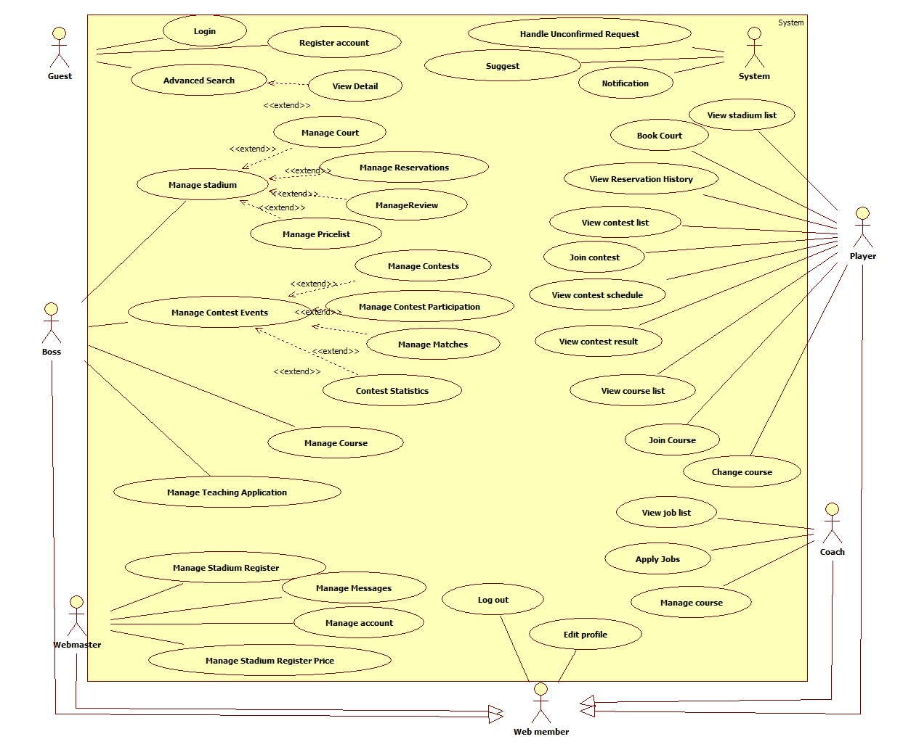

Figure 3: System Overview Use Case

#### List of Use Case

##### <Guest> Register

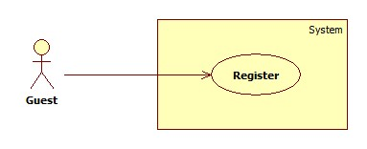

Figure 4: Register usecase

|  |  |  |  |  |
| --- | --- | --- | --- | --- |
| **USE CASE – REGISTER** | | | | |
| **Use-case No.** | UC001 | **Use-case Version** | | 2.0 |
| **Use-case Name** | Register | | | |
| **Author** | Trần Tấn Phát | | | |
| **Date** | 26/5/2014 | **Priority** | High | |
| **Actor:** Guest  **Summary:** This use case allows guest create an account in website system.  **Goal:**  It helps guest to create an account on website.  **Trigger:** Click on the “Đăng ký” button to register on home page  **Pre-conditions:**  Page is loaded successfully  Register page will be shown  **Post conditions:**   * Success: Register successfully, guest will have an account in system and will be logged into system. * Failure: Show message error.   **Main Success Scenario:**   |  |  |  | | --- | --- | --- | | Step | Actor Action | System Response | | 1 | Click on “Đăng ký” button home page | System redirect to register page for guest, contain a register form :   * Tên tài khoản [Username: textbox ] * Mật khẩu [Password : textbox] * Nhập lại mật khẩu [Repassword : textbox] * Địa chỉ email [Email: textbox]   In format: /^([a-zA-Z0-9\_\.\-])+\@(([a-zA-Z0-9\-])+\.)+([a-zA-Z0-9]{2,4})+$/ .   * Họ và tên [Fullname : textbox] * Địa chỉ [Address : textbox] * Thành Phố [City : textbox] * Số điện thoại[Phone : textbox] * Đóng[button] * Đăng ký[button] | | 2 | Input right information about username, email, password, full name, city, district, address, phone | Validate valid username and check with the green check | | 3 | Click on the “Đăng ký” button [Alternative 1] | Redirect to register success page [Exception 1,2 3,4] |   **Alternative Scenario:**   |  |  |  | | --- | --- | --- | |  | Actor Action | System Response | | 1 | [Alternative 1] Click on the “Đóng” button. | Back to home page |   **Exceptions:**   |  |  |  | | --- | --- | --- | | No. | Actor Action | System Response | | 1 | “Tên đăng nhập”,”Mật khẩu” ,”nhập lại mật khẩu” “Email” text-box is empty | Display message:” Vui lòng nhập chính xác thông tin yêu cầu.” | | 2 | When fills username is more than 32 characters or less than 6 characters | Display message “Tên đăng nhập phải từ 6 đến 32 ký tự” | | 3 | When user fills password is more than 32 characters or less than 6 characters | Display message “Mật khẩu trong khoảng từ 6-32 kí tự!” | | 4 | When user fills password and re-password different | Display message” Mật khẩu nhập lại chưa chính xác !” |   **Relationships:** Login usecase.  **Business Rules:** N/A | | | | |

##### <Guest> Login



Figure 5:Login usecase

|  |  |  |  |  |
| --- | --- | --- | --- | --- |
| **USE CASE – tên usecase** | | | | |
| **Use-case No.** | UC002 | **Use-case Version** | | 2.0 |
| **Use-case Name** | Login | | | |
| **Author** | Trần Tấn Phát | | | |
| **Date** | 28/05/2014 | **Priority** | High | |
| **Actor:**  Guest  **Summary:** If guest already has an account, wants to use the functions provided within this website they can log in using their username and password. After logging the functions corresponding to their role in the website.  **Goal:**  Allow a Member to use main functions of the website corresponding to their role.  **Triggers:** On the [Homepage] page, the Member inputs his/ her username and password and clicks [LOG IN] button to finish.  **Preconditions:**  The Member has already had an account of this website.  **Post Conditions:**   * **Success:** The Member successfully logs in the website. * **Failure:** An error message will appear, telling that the Member input wrong username or password.   **Main Success Scenario:**   |  |  | | --- | --- | | Actor Action | System Response | | 1. View [Homepage] page of the website. | 2. The website will show [Homepage] page with the header including the login form that includes:  - USERNAME: textbox (min length: 6, max length: 20)  -PASSWORD: password(min length: 6, max length: 20)  -LOG IN: button | | 3. Enter information in the fields | 4. [Exception1,3,5] | | 5. Click [LOG IN] button | 6. The website will redirect to [Homepage] page. |   In case of Log in in [Register] page, refer to the Main Success Scenario above.  **Alternative Scenario:N/A**  **Exceptions:**   |  |  | | --- | --- | | Actor Action | System Response | | 1. Click [LOG IN] button without inputting information in [USERNAME], or [PASSWORD] textboxes | 2. Display an error message “Please input this information” on the right side of the textbox that needs be input | | 3. [USERNAME] contains less than 6 or more than 20 letters | 4. Display an error message “Username requires 6-20 letters.” | | 5. [PASSWORD] not correct | 6. Display an error message “Incorrect password, please try again.” |   **Relationships:**  Register use case, Log out use case.  **Business Rules:**   * With the Registered Account, the Member can log in to the website and will be authorized based on the role of the account he/ she has.   After logging in successfully, the login region disappears and the text “Hello [username]”, profile image, notifications and [LOG OUT] button appear on the right | | | | |

##### <All Except Guest> Edit Profile

|  |  |  |  |  |
| --- | --- | --- | --- | --- |
| **USE CASE** | | | | |
| **Use-case No.** | UC001 | **Use-case Version** | | 2.0 |
| **Use-case Name** | Edit Profile | | | |
| **Author** | Quan | | | |
| **Date** | 17/1/2013 | **Priority** | High | |
| **Actor:** All actors  **Summary:** This use case allows player edit personal inofrmation in website system.  **Goal** This use case allows player edit personal inofrmation in website system.  **Trigger:** Click on the “Chỉnh sửa thông tin cá nhân” button to register on home page  **Pre-conditions:**  User must login  **Post conditions:**   * Failure: Show message error.   **Main Success Scenario:**   |  |  |  | | --- | --- | --- | | Step | Actor Action | System Response | | 1 | Click on “Chỉnh sửa thông tin” tab on menu | System redirect to register page for guest, contain a register form :   * Tên tài khoản [Username: textbox ] * Mật khẩu [Password : textbox] * Nhập lại mật khẩu [Repassword : textbox] * Địa chỉ email [Email: textbox]   In format: /^([a-zA-Z0-9\_\.\-])+\@(([a-zA-Z0-9\-])+\.)+([a-zA-Z0-9]{2,4})+$/ .   * Họ và tên [Fullname : textbox] * Địa chỉ [Address : textbox] * Thành Phố [City : textbox] * Số điện thoại[Phone : textbox] * Đóng[button] * Đăng ký[button] | | 2 | Input right information about username, email, password, full name, city, district, address, phone | Validate valid username and check with the green check | | 3 | Click on the “Lưu” button [Alternative 1] | Redirect to register success page [Exception 1,2 3,4] |   **Alternative Scenario:**   |  |  |  | | --- | --- | --- | |  | Actor Action | System Response | | 1 | [Alternative 1] Click on the “Đóng” button. | Back to home page |   **Exceptions:**   |  |  |  | | --- | --- | --- | | No. | Actor Action | System Response | | 1 | “Tên đăng nhập”,”Mật khẩu” ,”nhập lại mật khẩu” “Email” text-box is empty | Display message:” Vui lòng nhập chính xác thông tin yêu cầu.” | | 2 | When fills username is more than 32 characters or less than 6 characters | Display message “Tên đăng nhập phải từ 6 đến 32 ký tự” | | 3 | When user fills password is more than 32 characters or less than 6 characters | Display message “Mật khẩu trong khoảng từ 6-32 kí tự!” | | 4 | When user fills password and re-password different | Display message” Mật khẩu nhập lại chưa chính xác !” |   **Relationships:** Register Usecase, Login Usecase.  **Business Rules:** N/A | | | | |

##### < All Except Guest > Log out

|  |  |  |  |  |
| --- | --- | --- | --- | --- |
| **USE CASE – tên usecase** | | | | |
| **Use-case No.** | UC002 | **Use-case Version** | | 2.0 |
| **Use-case Name** | Login | | | |
| **Author** | Trần Tấn Phát | | | |
| **Date** | 28/05/2014 | **Priority** | High | |
| **Actor:**  All Actors except guest  **Summary:** Log out from website.  **Goal:**  Allow a Member to use main functions of the website corresponding to their role.  **Triggers:** On the [Homepage] page, clicks [LOG Out] button.  **Preconditions:**  The Member has already had log in this website.  **Post Conditions:**   * **Success:** Return Home Page. * **Failure:** N/A   **Main Success Scenario:**   |  |  | | --- | --- | | Actor Action | System Response | | 1. Click “Log out” button. | 2. Redirect ot Home Page |   **Alternative Scenario:N/A**  **Exceptions:N/A**  **Relationships:**  Log in use case.  **Business Rules:N/A** | | | | |

##### <All> Search by Keyword

| **USE CASE SPECIFICATION** | | | |
| --- | --- | --- | --- |
| **Use-case No.** | UC013 | **Use-case Version** | 2.0 |
| **Use-case Name** | Search by Keyword | | |
| **Author** | Trần Tấn Phát | | |
| **Date** | 28/05/2014 | **Priority** | High |
| **Actor:**  All actors.  **Summary:**  When users want to search items such as stadium, contest, course, teaching job from BSF-Website.  **Goal:**  Allow Guest, Player, Coach, Boss search information from BSF-Website such as available court to rent, contest, course, teaching job .  **Triggers:**  Guest, player, coach fill keyword parameters, then click “Tìm” button.  **Preconditions:**  Keyword must be filled.  **Post Conditions:**  **Success:**   * Result of search will be shoed for user.   **Failure:**   * An error message on screen.   **Main Success Scenario:**   |  |  | | --- | --- | | Actor Actions | System Response | | 1. Boss fills keyword in textbox and clicks on “Tìm” button. | [Exception 1] [Exception 2]  [Exception 3]   1. The search result will be displayed on screen. |   **Alternative Scenario: N/A**    **Exceptions:**   |  |  | | --- | --- | | Actor Actions | System Response | | [Exception 1]   1. “Từ khóa” is missing.   [Exception 2]   1. The length of input keyword longer than 250 chars.   [Exception 3]   1. Cannot connect database. | 1. Shows error “Vui lòng nhập từ khóa!. 2. Shows error “Từ khóa không được hơn 250 kí tự!. 3. Shows error “Có lỗi xảy ra vui lòng thử lại!. |   **Relationships:** Advanced Search Usecase  **Business Rules:**  In advanced search, user give input parameter value for system to search, if any emty parameter, the search will not use parameter to search. | | | |

##### <All> Advanced Search

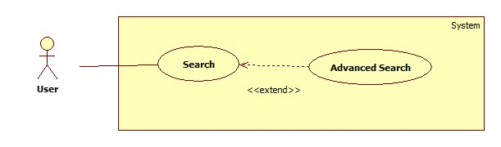

Figure 6: Advance Search usecase

| **USE CASE SPECIFICATION** | | | |
| --- | --- | --- | --- |
| **Use-case No.** | UC013 | **Use-case Version** | 2.0 |
| **Use-case Name** | Advanced Search | | |
| **Author** | Trần Tấn Phát | | |
| **Date** | 28/05/2014 | **Priority** | High |
| **Actor:**  All actors.  **Summary:**  When users want to search items such as stadium, contest, course, teaching job from BSF-Website.  **Goal:**  Allow Guest, Player, Coach, Boss search information from BSF-Website such as available court to rent, contest, course, teaching job .  **Triggers:**  Guest, player, coach clicks on “Tìm kiếm nâng cao”, after fill parameters user click “Tìm” button.  **Preconditions:**  Advanced Search form must be showed.  **Post Conditions:**  **Success:**   * Result of search will be shoed for user.   **Failure:**   * An error message on screen.   **Main Success Scenario:**   |  |  | | --- | --- | | Actor Actions | System Response | | 1. Boss clicks on the “Tìm kiếm nâng cao” button in search form. 2. Boss fills parammeters and clicks on “Tìm” button.   [Alternative 1] | 1. The “Tìm kiếm nâng cao” form is displayed on screen. Form includes:  * “Từ khóa” [Keyword of advanced search, textbox, optional] * “Đối tượng”[Item for searching, Listbox, value:”sân”,”giải đấu”,”khóa học”,”công việc”, required] * “Quận”[District of Hồ Chí Minh city, It can be place of stadium,multiple select, optional]   If user choose “sân” in “Đối tượng” listbox:   * “Giá thuê từ” [min rent court fee, textbox; number; optional]. * “Giá thuê đến” [max rent court fee, textbox; number; optional]. * “Ngày chơi” [Renting Court date, datepicker; required]. * “Giờ bắt đầu” [Start time to play, timepicker; required]. * “Thời lượng” [duration of reservation, listbox; required].   If user choose “Giải đấu” in “Đối tượng” listbox:   * “Từ ngày” [Start date of time frame which contest happen, datepicker; optional]. * “Đến ngày” [End date of time frame which contest happen, datepicker; optional]. * “Thể loại giải đấu” [Type of contest, checkbox; optional]. * “Trạng thái” [Status of contest, Listbox; value:”Sắp diễn ra”,”Đang diễn ra”,”Đã kết thúc”; optional].   If user choose “Khóa học” in “Đối tượng” listbox:   * “Học phí từ” [min course fee, textbox; number; optional]. * “Học phí đến” [max course fee, textbox; number; optional]. * “Từ giờ” [Start time of course, timepicker; optional]. * “Đến giờ” [End time of course, timepicker; optional]. * “Thứ” [days of course, checkbox; optional].   If user choose “Công việc” in “Đối tượng” listbox:   * “Lương từ” [min teaching job salary, textbox; number; optional]. * “Lương đến” [max teaching job salary, textbox; number; optional]. * “Từ giờ” [Start time of teaching course, timepicker; optional]. * “Đến giờ” [End time of teaching course, timepicker; optional]. * “Thứ” [days of teaching course, checkbox; optional]. * “Tìm” button. * “Tìm kím nâng cao” button.     [Exception 1] [Exception 2]  [Exception 3]   1. The search result will be displayed on screen. |   **Alternative Scenario:**   |  |  | | --- | --- | | Actor Actions | System Respons | | [Alternative 1]   1. Boss click “Tìm kiếm nâng cao” button again. | 1. The advanced search form is closed. |     **Exceptions:**   |  |  | | --- | --- | | Actor Actions | System Response | | [Exception 1]   1. “Ngày chơi” is missing.   [Exception 2]   1. “Giờ bắt đầu” is missing.   [Exception 3]   1. Cannot connect to database. | 1. Shows error “Vui lòng chọn ngày chơi!. 2. Shows error “Vui lòng chọn giờ bắt đầu!. 3. Shows error “Có lỗi xảy ra vui lòng thử lại!. |   **Relationships:**  Search by Keyword Usecase  **Business Rules:**  In advanced search, user give input parameter value for system to search, if any emty parameter, the search will not use parameter to search. | | | |

##### Stadium Use Case

###### <Player> Reservation

**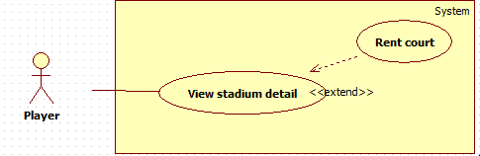**

Figure 7: Reservation usecase

|  |  |  |  |  |
| --- | --- | --- | --- | --- |
| **USE CASE – Reservation** | | | | |
| **Use-case No.** |  | **Use-case Version** | | 2.0 |
| **Use-case Name** | **Reservation** | | | |
| **Author** | TuanNH | | | |
| **Date** |  | **Priority** | High | |
| **Actor:**  Player  **Summary:**  alow player to rent court.  **Goal:**  **Triggers:**  \_Go to “StadiumDetail” page  \_ Using form in “StadiumDetail” page to find avaliable court to rent  \_ Click on [Đặt sân] button to rent court  \_ Click on [Đồng ý] button on pop up to finish rent court  **Preconditions:**   * Page is loaded successfully. * User has already created an account in system.   **Post Conditions:**   * Success: show “BookSuccess” page * Failure: show error message   **Main Success Scenario:**   |  |  | | --- | --- | | Actor Action | System Response | | 1. Click on [Chi tiết] button in “Home” page | 1. Page “StadiumDetail” will display and form include:   - Ngày chơi: calendar  - Giờ bắt đầu: calendar  - Thời lượng: dropdown-list:  +60 phút  +90 phút  +120 phút  +180 phút | | 1. Enter information in to fields | 1. Exception [1,3,5,7,9] | | 1. Click on [Tìm sân trống] button to find avaliable court   [Alternative 1] | 1. Show list court avaliable to user | | 1. Click on [Đặt sân] button to rent court   [Alternative 3] | 1. Show pop up to confirm user agree to continue | | 1. Click on [Đồng ý ] button in pop up | 1. Payment online process | | 1. Payment online finish   [Alternative 5] | 1. Page “BookSuccess” will display |   **Alternative Scenario:**   |  |  | | --- | --- | | Actor Action | System Response | | 1. Information search is not match | 1. Show message “Không có sân nào phù hợp với kết quả của bạn” | | 1. Click on [Hủy] button in pop up to cancel rent court | 1. Redirect to “StadiumDetail” page | | 1. Cancel payment online | 1. Redirect to “Home” page |   **Exceptions:**   |  |  | | --- | --- | | Actor Action | System Response | | 1. All fields are blank | 1. Show message “vui lòng chọn ngày” in field [Ngày chơi], “vui lòng chọn giờ” in field [Giờ bắt đầu] | | 1. Start time is smaller than now | 1. Show error message “đặt sân từ …giờ ” in field [Giờ bắt đầu] | | 1. End time is bigger than stadium’s close time | 1. Show error message “đặt sân trước…giờ ” in field [Giờ bắt đầu] | | 1. A court has been rent | 1. Show error message “Sân này hiện không còn trống” | | 1. Payment online fail | 1. Redirect to “Home” page |   **Relationships:**  Login usecase, Stadium Detail usecase  **Business Rules:**  User click on [Đặt sân] button but not payment online to finish renting court, system will save as court and show in “BookHistory” page and give user more 30 minutes to continue payment , after 30 minutes the court will be deleted , on this time user can not rent court any more, thay can rent court after 30 minutes. | | | | |

###### <Player> Renting history

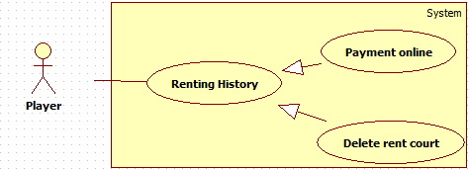

Figure 8: Renting history

###### <Player> View renting history

Hình usecase

|  |  |  |  |  |
| --- | --- | --- | --- | --- |
| **USE CASE – tên usecase** | | | | |
| **Use-case No.** |  | **Use-case Version** | | 2.0 |
| **Use-case Name** | View renting history | | | |
| **Author** |  | | | |
| **Date** |  | **Priority** | Normal | |
| **Actor:**  Player  **Summary:**  **Goal:**  player can view their rent court history.  **Triggers:**  \_ Click on “Đặt sân của bạn” link to go to “BookHistory” page.  **Preconditions:**   * Page is loaded successfully. * User has already created an account in system.   **Post Conditions:**   * Success: * Failure:   **Main Success Scenario:**   |  |  | | --- | --- | | Actor Action | System Response | | 1. Click on “Đặt sân của bạn” link | 1. Redirect to “BookHistory” page |   **Alternative Scenario: N/A**  **Exceptions:N/A**  **Relationships:** Login usecase  **Business Rules:** N/A | | | | |

###### <Player> Payment online

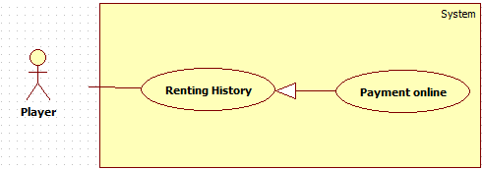

Hình usecase

|  |  |  |  |  |
| --- | --- | --- | --- | --- |
| **USE CASE – tên usecase** | | | | |
| **Use-case No.** |  | **Use-case Version** | | 2.0 |
| **Use-case Name** | Payment online | | | |
| **Author** | TuanNH | | | |
| **Date** |  | **Priority** | High | |
| **Actor:**  Player  **Summary:**  **Goal:**  **Triggers:**  \_ Click on [Tiếp tục thanh toán] button to finish rent court  **Preconditions:**   * Page is loaded successfully. * User has already created an account in system.   **Post Conditions:**   * Success: show “BookSuccess” page * Failure: show error message   **Main Success Scenario:**   |  |  | | --- | --- | | Actor Action | System Response | | 1. Click on [Tiếp tục thanh toán] button   [Alternative 1] | 1. Payment online process | | 1. Payment online finish   [Alternative 3] | 1. Page “BookSuccess” will display   Exception[1] |   **Alternative Scenario:**   |  |  | | --- | --- | | Actor Action | System Response | | 1. Click on [Hủy đặt sân] button to remove rent court | 1. Redirect to “BookHistory” page | | 1. User cancel payment online | 1. Redirect to “Home” page |   **Exceptions:**   |  |  | | --- | --- | | Actor Action | Sysem Response | | 1. Payment online fail | 1. Redirect to “Home” page |   **Relationships:**  Login usecase, Selected court usecase, View renting history usecase  **Business Rules:**  User click on [Đặt sân] button but not payment online to finish renting court, system will save as court and show in “BookHistory” page and give user more 30 minutes to continue payment , after 30 minutes the court will be deleted , on this time user can not rent court any more, thay can rent court after 30 minutes. | | | | |

###### C:\Users\TUANNH\Desktop\Boss\detail.PNG<Guest/user> Stadium Detail

Figure 9:Stadium Detail

|  |  |  |  |  |
| --- | --- | --- | --- | --- |
| **USE CASE – tên usecase** | | | | |
| **Use-case No.** |  | **Use-case Version** | | 2.0 |
| **Use-case Name** | Stadium Detail | | | |
| **Author** |  | | | |
| **Date** |  | **Priority** | Normal | |
| **Actor:**  user/guest  **Summary:**  **Goal:**  user can view stadium detail.  **Triggers:**  \_Click on [Chi tiết] button to view stadium detail  **Preconditions:**   * Page is loaded successfully. * User has already created an account in system.   **Post Conditions:**   * Success: * Failure:   **Main Success Scenario:**   |  |  | | --- | --- | | Actor Action | System Response | | 1. Click on [Chi tiết] button to view stadium detail | 1. Redirect to “StadiumDetail” page |   **Alternative Scenario: N/A**  **Exceptions:N/A**  **Relationships:** N/A  **Business Rules:** N/A | | | | |

###### <Player> Add Review

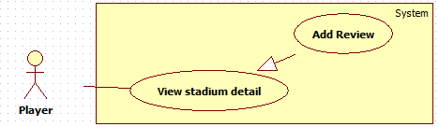

Figure 10:Add review

|  |  |  |  |  |
| --- | --- | --- | --- | --- |
| **USE CASE – tên usecase** | | | | |
| **Use-case No.** |  | **Use-case Version** | | 2.0 |
| **Use-case Name** | Add Review | | | |
| **Author** |  | | | |
| **Date** |  | **Priority** | High | |
| **Actor:**  player  **Summary:**  **Goal:**  player can review stadium if they rent court in this stadium  **Triggers:**  \_Click “Tiến hành đánh giá” link in “StadiumDetail” page  \_Selected point  \_Click [Đồng ý] button to finish  **Preconditions:**   * Page is loaded successfully. * User has already created an account in system.   **Post Conditions:**   * Success: * Failure:   **Main Success Scenario:**   |  |  | | --- | --- | | ctor Action | System Response | | 1. Click “Tiến hành đánh giá” link in “StadiumDetail” page | 1. Show pop up review to player   with form “Đánh giá sân” include:  \_Chất lượng: dropdown- list  +0  +1  …  +10  \_Dịch vụ: dropdown- list  +0  +1  …  +10  \_Phục vụ: dropdown- list  +0  +1  …  +10 | | 1. Selected point | 1. N/A | | 1. Click on [Đồng ý] button to finish   [Alternative 1] | 1. Redirect to “StadiumDetail” page |   **Alternative Scenario:**   |  |  | | --- | --- | | Actor Action | System Response | | 1. Click [Hủy]button to cancel review | 1. Redirect to “StadiumDetail” page |   **Exceptions:N/A**  **Relationships:** N/A  **Business Rules:** N/A | | | | |

###### <System> Suggest stadium

Hình usecase

|  |  |  |  |  |
| --- | --- | --- | --- | --- |
| **USE CASE – tên usecase** | | | | |
| **Use-case No.** |  | **Use-case Version** | | 2.0 |
| **Use-case Name** | Suggest stadium | | | |
| **Author** |  | | | |
| **Date** |  | **Priority** | High | |
| **Actor:**  system  **Summary:** system automatically suggest stadium for player when they login on BSF-Website  **Goal:**  This use case will help BSF-Website suggest stadium for player when they login on BSF-Website.  **Triggers:** they login on BSF-Website and view Home Page or ListStadium page.  **Preconditions:**   * Page is loaded successfully. * User has already created an account in system.   **Post Conditions:**   * Success: list stadium will appear by suggestion criterias. * Failure: list of upcoming will appear by create date order   **Main Success Scenario:**   |  |  | | --- | --- | | Actor Action | System Response | | 1. User login to BSF-Website and view “Home” page   [Alternative 1] | 1. Show list stadium by suggest criteria   [Exception 1] |   **Alternative Scenario:**   |  |  | | --- | --- | | Actor Action | System Response | | 1. User login to BSF-Website and view “ListStadium” page | 1. Show list stadium by suggest criteria |   **Exceptions:**   |  |  | | --- | --- | | Actor Action | System Response | | 1. System fail to load data | 1. Show list stadium |   **Relationships:** N/A  **Business Rules:**  Suggestion Algorithm:  +Distance Criteria: when user register an account in BSF-Website, system will get the latitude and longtitude of user’s home address and calculate distance between user’s home address and stadium’s address, then save to database.  +Gender Criteria: system compare gender of player and gender in type of contest to calculate gerder criteria index.  Then system calculate final suggestion index by formula: | | | | |

##### Contest Use Case

###### <All> List Upcoming Contest

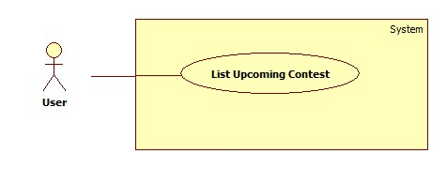

Figure 11: List upcoming contest

| **USE CASE SPECIFICATION** | | | |
| --- | --- | --- | --- |
| **Use-case No.** | UC001 | **Use-case Version** | 1.0 |
| **Use-case Name** | List Upcoming Contest | | |
| **Author** | Trần Tấn Phát | | |
| **Date** | 28/05/2014 | **Priority** | High |
| **Actor:**  All actors.  **Summary:**  View all contest will happen in future.  **Goal:**  Show list of upcoming contests.  **Triggers:**  User click on “Sắp diễn ra” submenu in “Giải đấu” menu.  **Preconditions:**  N/A.  **Post Conditions:**  **Success:**   * A list of upcoming contest will be showed up in table with paging.   **Failure:**   * The user is guided to Error page.   **Main Success Scenario:**   |  |  | | --- | --- | | Actor Actions | System Response | | 1. User click on “Giải đấu” menu then click on “Sắp diễn ra” sub-menu. | 1. System will show list of upcoming contests.   [Exception 1] |   **Alternative Scenario:** N/A  **Exceptions:**   |  |  | | --- | --- | | Actor Actions | System Response | | [Exception 1]   1. System fails to load data. | 1. Show Error page. |   **Relationships:** View Contest Deatail Usecase  **Business Rules:**  The list of upcoming will be showed in created date if user not login.  If user login, system will suggest list upcoming contest by distance from house to contest and gender of user. | | | |

###### <All> List Happening Contest

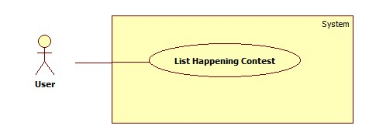

Figure 12:list happening contest

| **USE CASE SPECIFICATION** | | | |
| --- | --- | --- | --- |
| **Use-case No.** | UC001 | **Use-case Version** | 1.0 |
| **Use-case Name** | List Happening Contest | | |
| **Author** | Trần Tấn Phát | | |
| **Date** | 28/05/2014 | **Priority** | High |
| **Actor:**  All actors.  **Summary:**  View all contests are happening.  **Goal:**  Show list of happening contests.  **Triggers:**  User click on “Đang diễn ra” submenu in “Giải đấu” menu.  **Preconditions:**  N/A.  **Post Conditions:**  **Success:**   * A list of happening contest will be showed up in table with paging.   **Failure:**   * The user is guided to Error page.   **Main Success Scenario:**   |  |  | | --- | --- | | Actr Actions | System Response | | 1. User click on “Giải đấu” menu then click on “Đang diễn ra” sub-menu. | 1. System will show list of happening contests.   [Exception 1] |   **Alternative Scenario:** N/A  **Exceptions:**   |  |  | | --- | --- | | Actor Actions | System Response | | [Exception 1]   1. System fail to load data. | 1. Show Error page. |   **Relationships:** View Contest Schedule Usecase  **Business Rules:** N/A | | | |

###### <All> List Finished Contest

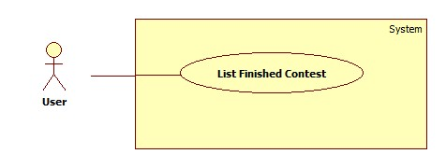

Figure 13: list finished contest

| **USE CASE SPECIFICATION** | | | |
| --- | --- | --- | --- |
| **Use-case No.** | UC001 | **Use-case Version** | 1.0 |
| **Use-case Name** | List Finished Contest | | |
| **Author** | Trần Tấn Phát | | |
| **Date** | 28/05/2014 | **Priority** | High |
| **Actor:**  All actors.  **Summary:**  View all contests are finished.  **Goal:**  Show list of finished contests.  **Triggers:**  User click on “Đã kết thúc” submenu in “Giải đấu” menu.  **Preconditions:**  N/A.  **Post Conditions:**  **Success:**   * A list of finished contest will be showed up in table with paging.   **Failure:**   * The user is guided to Error page.   **Main Success Scenario:**   |  |  | | --- | --- | | Actor Actions | System Response | | 1. User click on “Giải đấu” menu then click on “Đã kết thúc” sub-menu. | 1. System will show list of upcoming contests.   [Exception 1] |   **Alternative Scenario:** N/A  **Exceptions:**   |  |  | | --- | --- | | Actor Actions | System Response | | [Exception 1]   1. System fails to load data. | 1. Show Error page. |   **Relationships:** View Contest Result Usecase.  **Business Rules:** N/A | | | |

###### <All> View Contest Details

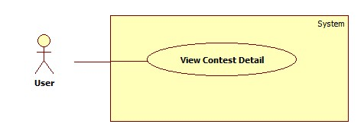

Figure 14: view contest details

| **USE CASE SPECIFICATION** | | | |
| --- | --- | --- | --- |
| **Use-case No.** | UC012 | **Use-case Version** | 2.0 |
| **Use-case Name** | View Contest Detail | | |
| **Author** | Trần Tấn Phát | | |
| **Date** | 28/05/2014 | **Priority** | High |
| **Actor:**  All actors.  **Summary:**  Guest, player can view contest detail.  **Goal:**  This use case help guest, player view detail information of contest.  **Triggers:**  Above actors click “Xem chi tiết” button in list upcoming contest or in result of search by keyword.  **Preconditions:**  Have at least one upcoming contest on system.  **Post Conditions:**  **Success:**   * Page detail of contest will be showed on screen.   **Failure:**   * System show error message:”Có lỗi, không lấy được dữ liệu từ database”   **Main Success Scenario:**   |  |  | | --- | --- | | Actor Actions | System Response | | 1. User clicks “Chi tiết” button on list of contests on homepage.   [Alternative 1] [Alternative 2] | 1. Show Contest Details Page   [Exception1] |   **Alternative Scenario:**   |  |  | | --- | --- | | Actor Actions | System Response | | [Alternative 1]   1. Actors click “Chi tiết” in list contest of search by keyword result.   [Alternative 2]   1. Actors click “Chi tiết” upcoming contest list. | 1. Same response with main scenario. 2. Same response with main scenario. |   **Exceptions:**   |  |  | | --- | --- | | Actor Actions | System Response | | [Exception 1]  1. System fails to load data. | 1. Show Error page. |   **Relationships:** List Upcoming Contest Usecase  **Business Rules:N/A** | | | |

###### <Player> View Contest Map

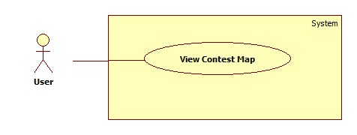

Figure 15: view contest map

| **USE CASE SPECIFICATION** | | | |
| --- | --- | --- | --- |
| **Use-case No.** | UC012 | **Use-case Version** | 2.0 |
| **Use-case Name** | View Contest Map | | |
| **Author** | Trần Tấn Phát | | |
| **Date** | 28/05/2014 | **Priority** | High |
| **Actor:**  Player  **Summary:**  When player want to see map from current location to contest location.  **Goal:**  This use case show player map from current location to contest location.  **Triggers:**  Player click “Xem đường đi” link on Contest Detail Page.  **Preconditions:**  Player already logined on system.  **Post Conditions:**  **Success:**   * Open new tab on browser and show map   **Failure:**   * System show error message   **Main Success Scenario:**   |  |  | | --- | --- | | Actor Actions | System Response | | 1. Player clicks “Xem đường đi” link on detail page. | [Exception 1]   1. Show map on screen. |   **Alternative Scenario:**  N/A  **Exceptions:**   |  |  | | --- | --- | | Actor Actions | System Response | | [Exception 1]  1. The can not connect Google API. | 1. Show message. |   **Relationships:** View Contest Detail  **Business Rules:**  N/A | | | |

###### <Player> List Contest Registered by Player

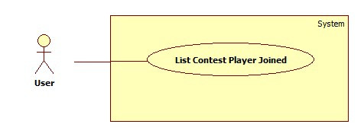

Figure 16: list contest registered

| **USE CASE SPECIFICATION** | | | |
| --- | --- | --- | --- |
| **Use-case No.** | UC001 | **Use-case Version** | 1.0 |
| **Use-case Name** | List Contest Registered by Player | | |
| **Author** | Trần Tấn Phát | | |
| **Date** | 28/05/2014 | **Priority** | High |
| **Actor:**  Player.  **Summary:**  View all contests which player joined.  **Goal:**  Show list of all contests which player joined.  **Triggers:**  User click on “Giải đấu đã tham gia” submenu in Personal menu.  **Preconditions:**  Player must login And player have joined at least one contest.  **Post Conditions:**  **Success:**   * A list of contests which player joined will be showed up in table with paging.   **Failure:**   * The user is guided to Error page.   **Main Success Scenario:**   |  |  | | --- | --- | | Actor Actions | System Response | | 1. User click on “Giải đấu đã tham gia” submenu in Personal menu. | 1. System will show list of contests which user joined in.   [Exception 1] |   **Alternative Scenario:** N/A  **Exceptions:**   |  |  | | --- | --- | | Actor Actions | System Response | | [Exception 1]   1. System fails to load data. | 1. Show Error page. |   **Relationships:** View Contest Result Usecase, Cancel Joining Contest, View Contest Schedule, View Contest Result.  **Business Rules:**  When palyer login in system, the submenu will appear. | | | |

###### <Player> Join Contest

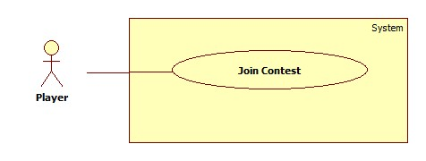

Figure 17: join contest

| **USE CASE SPECIFICATION** | | | |
| --- | --- | --- | --- |
| **Use-case No.** | UC012 | **Use-case Version** | 2.0 |
| **Use-case Name** | Join Contest | | |
| **Author** | Trần Tấn Phát | | |
| **Date** | 28/05/2014 | **Priority** | High |
| **Actor:**  Player  **Summary:**  When player want to join upcoming contest.  **Goal:**  This use case help player join upcoming contest.  **Triggers:**  Player click “Tham gia” button in list upcoming contest or in result of search by keyword or in contest detail page.  **Preconditions:**  Player already logined on system.  **Post Conditions:**  **Success:**   * Redirect to successful registration page.   **Failure:**   * System show error message:”Có lỗi, vui lòng thử lại”   **Main Success Scenario:**   |  |  | | --- | --- | | Actor Actions | System Response | | 1. Player clicks “Tham gia” button on detail page.   [Alternative 1] [Alternative 2]   1. Player click “Xác nhận” button on confirm popup. Incase of pair contest type, player must fill the player name of same team member.   [Alternative 3] | 1. Show confirm popup:   [Exception 1][Exception 2]   1. Redirect to successful registration page. |   **Alternative Scenario:**   |  |  | | --- | --- | | Actor Actions | System Response | | [Alternative 1]   1. Actors click “Tham gia” in contest list of advanced search result.   [Alternative 2]   1. Actors click “Tham gia” upcoming contest list.   [Alternative 3]   1. Actors click “Đóng” button. | 1. Same response with main scenario. 2. Same response with main scenario. 3. System will close confirm pop up window. |   **Exceptions:**   |  |  | | --- | --- | | Actor Actions | System Response | | [Exception 1]  1. The same team member’s name is missing.  [Exception 2]  1. Cannot save register information | 1. Show message “Vui lòng nhập tên” on popup window. 2. Redirect to error page |   **Relationships:** List Upcoming Contest Usecase  **Business Rules:**  Player can join a particular contest only one time.  In one contest event player can only join at most 2 contest.  At the same time, player can only join one contest event.  Player can join contest type with same gender as account trgistration. | | | |

###### <Player> Cancel Joining Contest

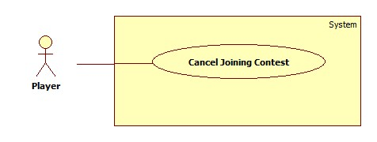

Figure 18: cancel joining contest

| **USE CASE SPECIFICATION** | | | |
| --- | --- | --- | --- |
| **Use-case No.** | UC012 | **Use-case Version** | 2.0 |
| **Use-case Name** | Cancel Joining Contest | | |
| **Author** | Trần Tấn Phát | | |
| **Date** | 28/05/2014 | **Priority** | High |
| **Actor:**  Player  **Summary:**  When player want to cancel joining contest which player has joined before.  **Goal:**  This use case help player cancel joining contest which player has joined before.  **Triggers:**  In list of player’s joint contest page, player click “Hủy tham gia” button.  **Preconditions:**  Player already logined on system and Player already join at least one contest and the contest is not happening.  **Post Conditions:**  **Success:**   * Show successful message of cancelation.   **Failure:**   * System show error message:”Có lỗi, vui lòng thử lại”   **Main Success Scenario:**   |  |  | | --- | --- | | Actor Actions | System Response | | 1. Player clicks “Hủy tham gia” button on join contest page. 2. Player click “Đồng ý” button on confirm popup.   [Alternative 1] | 1. Show confirm popup:   [Exception 1]   1. Redirect to cancel successful page. |   **Alternative Scenario:**   |  |  | | --- | --- | | Actor Actions | System Response | | [Alternative 1]   1. Actors click “Đóng” button. | 1. System will close confirm pop up window. |   **Exceptions:**   |  |  | | --- | --- | | Actor Actions | System Response | | [Exception 2]  1. Cannot cancel joining contest information | 1. Redirect to error page |   **Relationships:** List Player’s Contest Usecase  **Business Rules:**  Player just can cancel contest participation when the contest not happen. | | | |

###### <All> View Contest Schedule

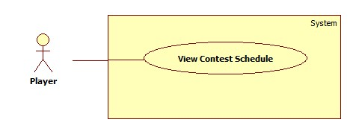

Figure 19: view contest schedule

| **USE CASE SPECIFICATION** | | | |
| --- | --- | --- | --- |
| **Use-case No.** | UC012 | **Use-case Version** | 2.0 |
| **Use-case Name** | View Contest Schedule | | |
| **Author** | Trần Tấn Phát | | |
| **Date** | 28/05/2014 | **Priority** | High |
| **Actor:**  All actors.  **Summary:**  Guest, player can view contest schedule when contest happening.  **Goal:**  This use case help guest, player view contest schedule information.  **Triggers:**  In list on happening contest, user click “Xem lịch” button.  **Preconditions:**  The contest have been arranged schedule.  **Post Conditions:**  **Success:**   * Page schedule of contest will be showed on screen.   **Failure:**   * System show error message:”Có lỗi, không lấy được dữ liệu từ database”   **Main Success Scenario:**   |  |  | | --- | --- | | Actor Actions | System Response | | 1. User clicks “Xem lịch” button on list of happening contests.   [Alternative 1] | 1. Show Contest Schedule Page   [Exception1] |   **Alternative Scenario:**   |  |  | | --- | --- | | Actor Actions | System Response | | [Alternative 1]   1. Actors click “Xem lịch” in list Player’s contest. | 1. Same response with main scenario. |   **Exceptions:**   |  |  | | --- | --- | | Actor Actions | System Response | | [Exception 1]  1. System fails to load data. | 1. Show Error page. |   **Relationships:** List Happening Contest Usecase. List Player’s Contest Usecase  **Business Rules:N/A** | | | |

###### <All> View Contest Result

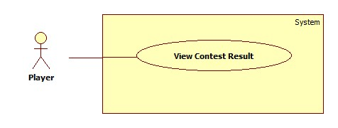

Figure 20: view contest result

| **USE CASE SPECIFICATION** | | | |
| --- | --- | --- | --- |
| **Use-case No.** | UC012 | **Use-case Version** | 2.0 |
| **Use-case Name** | View Contest Result | | |
| **Author** | Trần Tấn Phát | | |
| **Date** | 28/05/2014 | **Priority** | High |
| **Actor:**  All actors.  **Summary:**  Guest, player can view contest result when contest finished.  **Goal:**  This use case help guest, player view contest result information.  **Triggers:**  In list on finished contests or list Player’s contests, user click “Xem lịch” button.  **Preconditions:**  There is at least one contest have been finished.  **Post Conditions:**  **Success:**   * Page Result of contest will be showed on screen.   **Failure:**   * System show error message:”Có lỗi, không lấy được dữ liệu từ database”   **Main Success Scenario:**   |  |  | | --- | --- | | Actor Actions | System Response | | 1. User clicks “Xem kết quả” button on list of finished contests.   [Alternative 1] | 1. Show Contest Result Page   [Exception1] |   **Alternative Scenario:**   |  |  | | --- | --- | | Actor Actions | System Response | | [Alternative 1]   1. Actors click “Xem kết quả” in list Player’s contest. | 1. Same response with main scenario. |   **Exceptions:**   |  |  | | --- | --- | | Actor Actions | System Response | | [Exception 1]  1. System fails to load data. | 1. Show Error page. |   **Relationships:** List Finished Contest Usecase, List Player’s Contest Usecase  **Business Rules:N/A** | | | |

###### <System> Suggest Contests

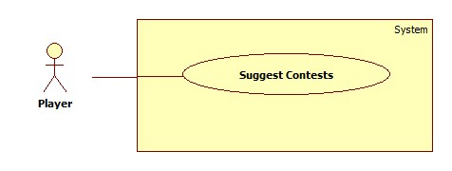

Figure 21: Suggest Contest

| **USE CASE SPECIFICATION** | | | |
| --- | --- | --- | --- |
| **Use-case No.** | UC012 | **Use-case Version** | 2.0 |
| **Use-case Name** | Suggest Contests. | | |
| **Author** | Trần Tấn Phát | | |
| **Date** | 28/05/2014 | **Priority** | High |
| **Actor:**  System  **Summary:**  System automatically suggest contest for player when they login on BSF-Website.  **Goal:**  This use case will help BSF-Website suggest contests for player when they login on BSF-Website.  **Triggers:**  Player login on BSF-Website and view Home Page or Upcoming Contest List page.  **Preconditions:**  There is at least one contest.  **Post Conditions:**  **Success:**   * List of upcoming contest will appear by suggestion criterias.   **Failure:**   * List of upcoming will appear by create date order.   **Main Success Scenario:**   |  |  | | --- | --- | | Actor Actions | System Response | | 1. User login on BSF-Website and view Home Page   [Alternative 1] | 1. Show list of upcoming contest by suggest criteria   [Exception1] |   **Alternative Scenario:**   |  |  | | --- | --- | | Actor Actions | System Response | | [Alternative 1]   1. User login on BSF-Website and view List Upcoming Contest Page. | 1. Same response with main scenario. |   **Exceptions:**   |  |  | | --- | --- | | Actor Actions | System Response | | [Exception 1]  1. System fails to load data. | 1. The upcpming contest will appear in Created Date order. |   **Relationships:** List Upcoming Contest Usecase, Login  **Business Rules:**  \*Suggestion Algorithm:  +Distance Criteria: when user register an account in BSF-Website, system will get the latitude and longtitude of user’s home address and calculate distance between user’s home address and stadium’s address, then save to database.  +Gender Criteria: system compare gender of player and gender in type of contest to calculate gerder criteria index.  Then system calculate final suggestion index by formula: | | | |

###### <Player> Contest Notification

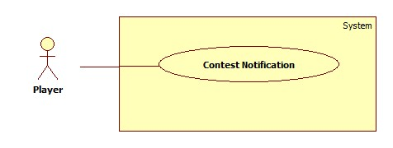

Figure 22: contest notification

| **USE CASE SPECIFICATION** | | | |
| --- | --- | --- | --- |
| **Use-case No.** | UC012 | **Use-case Version** | 2.0 |
| **Use-case Name** | Contest Notification | | |
| **Author** | Trần Tấn Phát | | |
| **Date** | 28/05/2014 | **Priority** | High |
| **Actor:**  Player  **Summary:**  Player want to see contest notification.  **Goal:**  This use case will notify for player when there are new contests or any contest information with real time way.  **Triggers:**  Player click on “Thông báo giải đấu” link on top of website.  **Preconditions:**  Player haved login on BSF-Website.  **Post Conditions:**  **Success:**   * List of contest notification will appear on.   **Failure:**   * Show message.   **Main Success Scenario:**   |  |  | | --- | --- | | Actor Actions | System Response | | 1. User login on BSF-Website and view Home Page and click on “Thông báo giải đấu” link on top op website.   [Alternative 1] | 1. Show list of contest notifiaction   [Exception1] |   **Alternative Scenario:**   |  |  | | --- | --- | | Actor Actions | System Response | | [Alternative 1]   1. There is no new contest notification. | 1. Show “Không có thông báo giải đấu nào”. |   **Exceptions:**   |  |  | | --- | --- | | Actor Actions | System Response | | [Exception 1]  1. System fails to load data. | 1. The error page will appear. |   **Relationships:**  **Business Rules:**  The notification just disappear when player click on notification or click delete icon. | | | |

##### Course Use Case

###### <Player> View List Courses

|  |  |  |  |
| --- | --- | --- | --- |
| **USE CASE – VIEW LIST COURSE INFORMATION SPECIFICATION** | | | |
| **Use Case NO.** | UC-E001 | **Use Case Version** | 1.0 |
| **Use Case Name** | View List Course | | |
| **Author** | ThongND | | |
| **Date** | 10/07/2013 | **Priority** | Normal |
| **Actor:**  Player  **Summary:**  Player view list course of stadium or boss.  **Goal:**  Player view all course easily.  **Triggers:**  On the [Home] page, the Player clicks on [Khóa Học] button. After that, the [List Course ] page is appears. In this page, there are list courses.  **Pre-Conditions:**  **Post-Conditions:**   * Success: The Player cam view all list course easily. * Failure: In this page, there aren’t list courses.   **Main Success Scenario:**   |  |  | | --- | --- | | Actor Action | System Response | | 1. Click on [Khóa Học] button on top menu in the [Home] page. | 2. The [List Course] page is shown with  - Information of course: Tên Lớp, Cấp Độ, Bắt Đầu, Kết thúc, Giáo Viên, Học Phí, Tham Gia.  - Button “Tham Gia”.  - Search(Datatable)  [Exception 1] |   **Alternative Scenario:**   |  |  | | --- | --- | | Actor Action | System Response | | 1. There is not any course | 2. Don’t have data . |   **Exceptions:**  N/A  **Relationships:**  N/A  **Business Rules:**  In this page, there are 10, 25, 50, 100 record on page follow select in top left page. In top right page, there is [Search] textbox. And player can sort in column on table. | | | |

###### <Player> View Detail Course

###### <Player> Comment Course

###### <Player> Delete Comment Course

###### <Player> Join Course

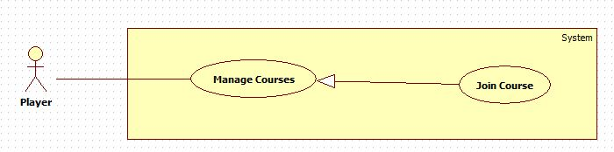

Figure 23: Join course

|  |  |  |  |
| --- | --- | --- | --- |
| **USE CASE – JOIN COURSE INFORMATION SPECIFICATION** | | | |
| **Use Case NO.** | UC-E001 | **Use Case Version** | 1.0 |
| **Use Case Name** | Join Course | | |
| **Author** | ThongND | | |
| **Date** | 10/07/2013 | **Priority** | Normal |
| **Actor:**  Player  **Summary:**  Player register course and then payment for request.  **Goal:**  Player can register course. Then there are name of player in class.  **Triggers:**  On the [List Course] page, the Player click on [Tham Gia] button. After that, the [Detail Course ] page is appears. The Player click on [Đăng Ký Lớp] button, the popup [Chọn ngày] is appeared. Player choose day and click on [Tiếp Tục] button. The popup[Xác Nhận] is appeared. Player click on [Tiếp Tục] button to finish.  **Pre-Conditions:**  The user has already logged in as Player role.  **Post-Conditions:**   * Success: The Player join course successful. A message “Học viên đăng ký lớp thành công.” is show on [List Register Courses] page. * Failure: An error message “Học viên đăng ký lớp thất bại.” is shown on [List Register Courses] Page.   **Main Success Scenario:**   |  |  | | --- | --- | | Actor Action | System Response | | 1. Click on [Tham Gia] button on the row of course that you want to join class in the [List Courses] page. | 2. The [Detail Course] page is shown with  - Information of course.  - Button “Đăng Ký Lớp”.  [Exception 1,3, 5] | | 3. Click on [Đăng Ký Lớp] button. | 4. The popup [Chọn Ngày] is shown with:  - Ngày bắt đầu : combobox  - Button:  + [Hủy] button.  + [Tiếp Tục] button.  [Alternative 1] | | 5. Player choose day and click on [Tiếp Tục] button. | 6. The popup [Xác Nhận] is shown with:  - Ngày bắt đầu : label  - Thông báo thanh toán trực tuyến: label  - Button:  + [Hủy] button.  + [Tiếp Tục] button.  [Alternative 3] | | 7. Player click on [Tiếp Tục] button. | 8. The website go to payment online.  [Exception 7, 9] |   **Alternative Scenario:**   |  |  | | --- | --- | | Actor Action | System Response | | 1. Click on [Hủy] link | 2. The popup [Chọn Ngày] is closed. | | 3. Click on [Hủy] link | 4. The popup [Xác Nhận] is closed. The system must delete request join course of the player. |   **Exceptions:**   |  |  | | --- | --- | | Actor Action | System Response | | 1. The Player registered this course. | 2. The system show label “Đã Đăng Ký” after information of course. | | 3. The course is full. | 4. The system show label “Đủ Học Viên” after information of course. | | 5. The Guest haven’t log in yet. | 6. The system don’t show anything after information of course. | | 7. The Player don’t want to continuous payment and back to website. | 8. The system change status of register is “Chưa Đóng HP” immediately. | | 9. The Player don’t want to payment and close the payment. | 10. The system change status of resister is “Chưa Đóng HP” after 15 minutes. |   **Relationships:**  Login usecase, View List Courses usecase, View Detail Course usecase, Notify Boss usecase, Payment usecase.  **Business Rules:**  When player click on [Đăng Ký Lớp], the system calculator three day that can start to study from start day, schedule of course and now.  When player chose [Ngày Bắt Đầu] and click on [Tiếp Tục] button, the system save the register to database with status “Đang Thanh Toán” and show popup [Xác Nhận].  When player click on [Tiếp Tục] on popup [Xác Nhận], the website go to the [PayPal]. If the player don’t payment or payment more than 15 minutes, the system will chang status of register is “Chưa Đóng HP” after 15 minute . If the player go back to [BSF] website, the system will change status of register is “Chưa Đóng HP” immediately. | | | |

###### <Player> View List Register Courses

###### <Player> Change Course

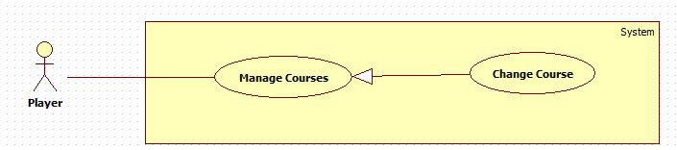

Figure 24: Change course

|  |  |  |  |
| --- | --- | --- | --- |
| **USE CASE – CHANGE COURSE INFORMATION SPECIFICATION** | | | |
| **Use Case NO.** | UC-E001 | **Use Case Version** | 1.0 |
| **Use Case Name** | Change Course | | |
| **Author** | ThongND | | |
| **Date** | 10/07/2013 | **Priority** | Normal |
| **Actor:**  Player  **Summary:**  Player change course after register course.  **Goal:**  Player can change course successful.  **Triggers:**  On the [List Register Course] page, the Player click on [Đổi Lớp] button. After that, the [Detail Course ] page is appears. The Player click on [Chuyển Lớp] button, the popup [ Chọn ngày] is appeared. Player choose day and click on [Tiếp Tục] button to finish.  **Pre-Conditions:**  The user has already logged in as Player role.  **Post-Conditions:**   * Success: The Player join course successful. A message “Học viên đăng ký thay đổi lớp thành công.” is show on [List Register Courses] page. * Failure: An error message “Học viên đăng ký thay đổi lớp thất bại.” is shown on [List Register Courses] Page.   **Main Success Scenario:**   |  |  | | --- | --- | | Actor Action | System Response | | 1. Click on [Đổi Lớp] button on the row of course that you want to join class in the [List Register Courses] page. | 2. The [Detail Course] page is shown with  - Information of course.  - Button “Chuyển Lớp”.  [Exception 1,3, 5] | | 3. Click on [Chuyển Lớp] button. | 4. The popup [Chọn Ngày] is shown with:  - Ngày bắt đầu : combobox  - Button:  + [Hủy] button.  + [Tiếp Tục] button.  [Alternative 1] | | 5. Player choose day and click on [Tiếp Tục] button. | 6. The system will save request change course to database and notify to Boss |   **Alternative Scenario:**   |  |  | | --- | --- | | Actor Action | System Response | | 1. Click on [Hủy] link | 2. The popup [Chọn Ngày] is closed. |   **Exceptions:**   |  |  | | --- | --- | | Actor Action | System Response | | 1. The Player registered this course. | 2. The system show label “Đã Đăng Ký” after information of course. | | 3. The course is full. | 4. The system show label “Đủ Học Viên” after information of course. | | 5. The player have registered change this course. | 6. The system don’t show anything after information of course. |   **Relationships:**  Login usecase, View List Register Courses usecase, View Detail Course usecase, Notify Boss usecase.  **Business Rules:**  When player click on [Chuyển Lớp], the system calculator three day that can start to study from start day, schedule of course and now.  When player chose [Ngày Bắt Đầu] and click on [Tiếp Tục] button, the system save the register to database with status “Chuyển Lớp” and show message “Bạn đã đăng ký chuyển lớp thành công.”. | | | |

##### <Coach> Manage Job

###### <Coach> View List Job

|  |  |  |  |
| --- | --- | --- | --- |
| **USE CASE – VIEW LIST COURSE INFORMATION SPECIFICATION** | | | |
| **Use Case NO.** | UC-E001 | **Use Case Version** | 1.0 |
| **Use Case Name** | View List Course | | |
| **Author** | ThongND | | |
| **Date** | 10/07/2013 | **Priority** | Normal |
| **Actor:**  Coach  **Summary:**  Coach view list course of stadium or boss.  **Goal:**  Coach view all course easily.  **Triggers:**  On the [Home] page, the Coach clicks on [Công Việc] button. After that, the [List Course ] page is appears. In this page, there are list courses.  **Pre-Conditions:**  **Post-Conditions:**   * Success: The Player cam view all list course easily. * Failure: In this page, there aren’t list courses.   **Main Success Scenario:**   |  |  | | --- | --- | | Actor Action | System Response | | 1. Click on [Công Việc] button on top menu in the [Home] page. | 2. The [List Course] page is shown with  - Information of course: Tên Lớp, Cấp Độ, Bắt Đầu, Kết thúc, Lương Giáo Viên, Xem.  - Button “Xem”.  - Search(Datatable)  [Exception 1] |   **Alternative Scenario:**   |  |  | | --- | --- | | Actor Action | System Response | | 1. There is not any course | 2. Don’t have data . |   **Exceptions:**  N/A  **Relationships:**  N/A  **Business Rules:**  In this page, there are 10, 25, 50, 100 record on page follow select in top left page. In top right page, there is [Search] textbox. And player can sort in column on table. | | | |

###### <Coach> View Detail Courses

###### <Coach> Join Job

|  |  |  |  |
| --- | --- | --- | --- |
| **USE CASE – JOIN JOB INFORMATION SPECIFICATION** | | | |
| **Use Case NO.** | UC-E001 | **Use Case Version** | 1.0 |
| **Use Case Name** | Join Job | | |
| **Author** | ThongND | | |
| **Date** | 10/07/2013 | **Priority** | Normal |
| **Actor:**  Coach  **Summary:**  Coach want to register teaching in the course.  **Goal:**  Coach can register teaching in this course.  **Triggers:**  On the [List Course] page, the Coach click on [Xem] button. After that, the [Detail Course ] page is appears. The Coach click on [Đăng Ký Dạy] button, the popup [Confirm] is appeared. Coach click on [Tiếp Tục] button to finish.  **Pre-Conditions:**  The user has already logged in as Player role.  **Post-Conditions:**   * Success: The Coach register teaching successful. A message “Bạn đã đăng ký dạy lớp này thành công.” is show on [Detail Courses] page. * Failure: An error message “Bạn đã đăng ký lớp này thất bại.” is shown on [Detail Courses] Page.   **Main Success Scenario:**   |  |  | | --- | --- | | Actor Action | System Response | | 1. Click on [Xem] button on the row of course that you want to join class in the [List Courses] page. | 2. The [Detail Course] page is shown with  - Information of course.  - Button “Đăng Ký Dạy”.  [Exception 1,3, 5] | | 3. Click on [Đăng Ký Dạy] button. | 4. The popup [Xác Nhận] is shown with:  - Button:  + [Hủy] button.  + [Tiếp Tục] button.  [Alternative 1] | | 5. Coach choose day and click on [Tiếp Tục] button. | 6. The message “Bạn đã đăng ký dạy lớp này thành công.”  [Alternative 3,5] |   **Alternative Scenario:**   |  |  | | --- | --- | | Actor Action | System Response | | 1. Click on [Hủy] link | 2. The popup [Xác nhận] is closed. | | 3. Click on [Tiếp tục] link | 4. The message “Bạn đã đăng ký dạy lớp này thất bại.” | | 5. Click on [Tiếp tục] link | 6. The message “Bạn đã dạy 2 lớp trùng giờ với lớp bạn đăng ký.” |   **Exceptions:**   |  |  | | --- | --- | | Actor Action | System Response | | 1. The Coach registered this course. | 2. The system show label “Đã Đăng Ký” after information of course. | | 3. The Guest haven’t log in yet. | 4. The system don’t show anything after information of course. |   **Relationships:**  Login usecase, View List Courses usecase, View Detail Course usecase, Notify Boss usecase, Payment usecase.  **Business Rules:**  When the coach click “Tiếp tục” button on [xác nhận] popup. The system will check the coach teached how many courses. If this coach teaching more than tow courses in the immediately, the coach can not teach this course. And show message”Bạn đã dạy 2 lớp trùng giờ với lớp bạn đăng ký.” | | | |

###### <Coach> Change Job

|  |  |  |  |
| --- | --- | --- | --- |
| **USE CASE – CHANGE JOB INFORMATION SPECIFICATION** | | | |
| **Use Case NO.** | UC-E001 | **Use Case Version** | 1.0 |
| **Use Case Name** | Change Job | | |
| **Author** | ThongND | | |
| **Date** | 10/07/2013 | **Priority** | Normal |
| **Actor:**  Coach  **Summary:**  Coach want to change teaching in another course.  **Goal:**  Coach can change teaching in another course.  **Triggers:**  On the [List Teaching Course] page, the Coach click on [Đổi Lớp] button. After that, the [Detail Course ] page is appears. The Coach click on [Đăng Ký Dạy] button, the popup [Confirm] is appeared. Coach click on [Tiếp Tục] button to finish.  **Pre-Conditions:**  The user has already logged in as Player role.  **Post-Conditions:**   * Success: The Coach change teaching in another successful. A message “Bạn đã đăng ký dạy lớp này thành công.” is show on [Detail Courses] page. * Failure: An error message “Bạn đã đăng ký chuyển sang dạy lớp này thất bại.” is shown on [Detail Courses] Page.   **Main Success Scenario:**   |  |  | | --- | --- | | Actor Action | System Response | | 1. Click on [Chuyển Lớp] button on the row of course that you want to join class in the [List Courses] page. | 2. The [Detail Course] page is shown with  - Information of course.  - Button “Đăng Ký Dạy”.  [Exception 1,3, 5] | | 3. Click on [Đăng Ký Dạy] button. | 4. The popup [Xác Nhận] is shown with:  - Button:  + [Hủy] button.  + [Tiếp Tục] button.  [Alternative 1] | | 5. Coach choose day and click on [Tiếp Tục] button. | 6. The message “Bạn đã đăng ký dạy lớp này thành công.”  [Alternative 3,5] |   **Alternative Scenario:**   |  |  | | --- | --- | | Actor Action | System Response | | 1. Click on [Hủy] link | 2. The popup [Xác nhận] is closed. | | 3. Click on [Tiếp tục] link | 4. The message “Bạn đã đăng ký dạy lớp này thất bại.” | | 5. Click on [Tiếp tục] link | 6. The message “Bạn đã dạy 2 lớp trùng giờ với lớp bạn đăng ký.” |   **Exceptions:**   |  |  | | --- | --- | | Actor Action | System Response | | 1. The Coach registered this course. | 2. The system show label “Đã Đăng Ký” after information of course. | | 3. The Guest haven’t log in yet. | 4. The system don’t show anything after information of course. |   **Relationships:**  Login usecase, View List Courses usecase, View Detail Course usecase, Notify Boss usecase, Payment usecase.  **Business Rules:**  When the coach click “Tiếp tục” button on [xác nhận] popup. The system will check the coach teached how many courses. If this coach teaching more than tow courses in the immediately, the coach can not teach this course. And show message”Bạn đã dạy 2 lớp trùng giờ với lớp bạn đăng ký.” | | | |

##### <Boss> Manage stadiums

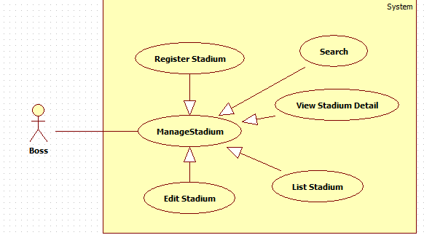Figure 25: Manage stadium

###### <Boss> List stadium

Hình usecase

|  |  |  |  |  |
| --- | --- | --- | --- | --- |
| **USE CASE –** Add stadium | | | | |
| **Use-case No.** |  | **Use-case Version** | | 2.0 |
| **Use-case Name** | List stadium | | | |
| **Author** | TuanNH | | | |
| **Date** |  | **Priority** | Normal | |
| **Actor:**  Boss  **Summary:**  **Goal:**  Boss view list stadium  **Triggers:**  **\_**Boss go to “ManageStadium” page to view list stadium  **Preconditions:**   * Page is loaded successfully. * User has already created an account in system.   **Post Conditions:**   * **Success**: * **Failure**:   **Main Success Scenario:**   |  |  | | --- | --- | | Actor Action | System Response | | 1. Click on [Quản lý sân] link in “Index” page | 2. redirect to “ManageStadium” page |   **Alternative Scenario:**  **N/A**  **Exceptions:**  **N/A**  **Relationships:**  Login usecase  **Business Rules:** N/A | | | | |

###### C:\Users\TUANNH\Desktop\Boss\stadium-register.PNG<Boss> Register stadium

Figure 26: Register stadium

|  |  |  |  |  |
| --- | --- | --- | --- | --- |
| **USE CASE –** Register stadium | | | | |
| **Use-case No.** |  | **Use-case Version** | | 2.0 |
| **Use-case Name** | Register stadium | | | |
| **Author** | TuanNH | | | |
| **Date** |  | **Priority** | Normal | |
| **Actor:**  Boss  **Summary:**  Boss can register stadium whith login and role “Boss”  **Goal:**  Allow boss to register new stadium by using payment online  **Triggers:**  \_Click on on [Thêm sân mới] button to add new stadium in “ManageStadium” page  \_Enter all fields  \_Click on [Đăng ký] button  \_ Click on [Thanh toán] button to finish register stadium in “StadiumPayment” page  **Preconditions:**   * Page is loaded successfully. * User has already created an account in system.   **Post Conditions:**   * **Success**: : System will return to “StadiumRegisSuccess” page. * **Failure**: : System will return to “ManageStadium” page.   **Main Success Scenario:**   |  |  | | --- | --- | | Actor Action | System Response | | 1.Click on [Thêm sân mới] button in “ManageStadium” page | 2. System will show  ” CreateNewStadium” page with from include:  -Tên sân: textbox.  -Số điện thoại: textbox.  -Email: textbox.  -Quận: drop-down list  -Phường: textbox.  -Đường: textbox.  -Giờ mở cửa: calendar.  -Giờ đóng cửa: calendar.  -Giá mặc định thuê 1 giờ: textbox  -Chọn thời gian thuê: drop- down list  +Thời hạn-giá thuê(12 tháng-100000 VND)  +Thời hạn-giá thuê(6 tháng-50000 VND)  -Hình ảnh | | 3. Enter information in to fields | 4. Exception[1,3,5,7,9,11,13] | | 5. Click on [Đăng ký ] button  [Alternative 1] | 6. Page “StadiumPayment” will be displayed | | 1. Click on [Thanh toán] button to finish register stadium in “StadiumPayment” page   [Alternative 3] | 1. Payment online process | | 1. Payment online finsih   [Alternative 5] | 1. Show “StadiumRegisSuccess” page |   **Alternative Scenario:**   |  |  | | --- | --- | | Actor Action | System Response | | 1. Click on [Hủy] button to cancel register stadium in “CreateNewStadium” page | 1. Redirect to “ManageStadium” page | | 1. Click on [Hủy] button to cancel register stadium in “StadiumPayment” page | 1. Redirect to “ManageStadium” page | | 1. Cancel Payment online | 1. Redirect to ManageStadium” page |   **Exceptions:**   |  |  | | --- | --- | | Actor Action | System Response | | 1. All filed are blank | 1. Show error message “ vui lòng không bỏ trống” on fields is blank | | 1. [Số điện thoại], [Giá mặc định thuê 1 giờ] is not a number | 1. Show error message “vui lòng nhập số” in fileds | | 1. Email is not correct format | 1. Show error message “vui lòng nhập đúng format” in fileds [Email] | | 1. Open time is smaller than close time | 1. Show error message “giờ đóng cửa không nhỏ hơn giờ mở cửa” in fileds [Giờ đóng cửa] | | 1. The image upload is more than 2mb | 1. Show error message “ảnh phải nhỏ hơn 2mb” in fileds [Hình ảnh] | | 1. The name of the stadium that has existed | 1. Show error message “tên này đã tồn tại” in fileds [Tên sân] | | 1. Payment online fail | 1. Redirect to “ManageStadium” page |   **Relationships:**  Login usecase, List stadium usecase  **Business Rules:**  Boss click on [Thanh toán] button but not payment online , system will save as stadium and show in “ManageStadium” page, Boss can continue payment this stadium to finish register. | | | | |

###### <Boss> Edit stadium

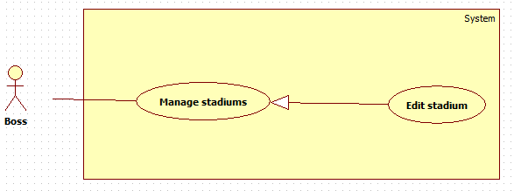

Figure 27: Edit stadium

|  |  |  |  |  |
| --- | --- | --- | --- | --- |
| **USE CASE –** Edit stadium | | | | |
| **Use-case No.** |  | **Use-case Version** | | 2.0 |
| **Use-case Name** | Edit stadium | | | |
| **Author** | TuanNH | | | |
| **Date** |  | **Priority** | Normal | |
| **Actor:**  Boss  **Summary:**  Boss can edit stadium whith login and role “Boss”  **Goal:**  Allow boss to edit stadium  **Triggers:**  \_Click on on [Chi tiết] button to edit stadium in “ManageStadium” page  \_enter field want to change  \_Click on [Cập nhật] button to finish  **Preconditions:**   * Page is loaded successfully. * User has already created an account in system.   **Post Conditions:**   * **Success**: System will return to page "ManageStadium". * **Failure**: System will show an error message.   **Main Success Scenario:**   |  |  | | --- | --- | | Actor Action | System Response | | 1.Click on link [Chi tiết] in “ManageStadium” page | 2. System will show  ” StadiumDetail” page with from include:  -Tên sân: textbox.  -Số điện thoại: textbox.  -Email: textbox.  -Quận: drop-down list  -Phường: textbox.  -Đường: textbox.  -Giờ mở cửa: calendar.  -Giờ đóng cửa: calendar.  -Giá mặc định thuê 1 giờ: textbox  -Chọn thời gian thuê: drop- down list  +Thời hạn-giá thuê(12 tháng-100000 VND)  +Thời hạn-giá thuê(6 tháng-50000 VND)  -Trạng thái: dropdow-list:  Alternative[1]  +Chưa thanh toán  Alternative[2]  +Đang hoạt động  +Ngừng hoạt động | | 3. Enter information in to fields | 4. Exception[1,3,5,7] | | 5. Click on [Cập nhật] button in “StadiumDetail” page to finish edit stadium  [Alternative 1] | 6. Page "ManageStadium" will be displayed with infor about a stadium |   **Alternative Scenario:**   |  |  | | --- | --- | | Actor Action | System Response | | 1. Click on [Hủy] to cancel edit stadium in “StadiumDetail” page | 1. System will return user back to "ManageStadium" page |   **Exceptions:**   |  |  | | --- | --- | | Actor Action | System Response | | 1. All filed are blank | 1. Show error message “ vui lòng không bỏ trống” on fields is blank | | 1. [Số điện thoại], [Giá mặc định thuê 1 giờ] is not a number | 1. Show error message “vui lòng nhập số” in fileds | | 1. [Email] is not correct format | 1. Show error message “vui lòng nhập đúng format” in fileds “Email” | | 1. Open time is smaller than close time | 1. Show error message “giờ đóng cửa không nhỏ hơn giờ mở cửa” in fileds [Giờ đóng cửa] |   **Relationships:**  Login usecase, List stadium usecase  **Business Rules:** N/A | | | | |

###### <Boss> Search stadium

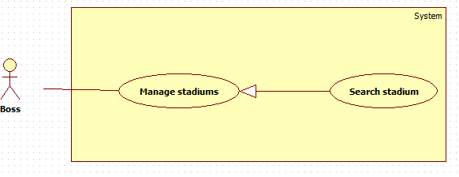

Figure 28: Search staidum

|  |  |  |  |  |
| --- | --- | --- | --- | --- |
| **USE CASE –** Search stadium | | | | |
| **Use-case No.** |  | **Use-case Version** | | 2.0 |
| **Use-case Name** | Search stadium | | | |
| **Author** | TuanNH | | | |
| **Date** |  | **Priority** | Normal | |
| **Actor:**  Boss  **Summary:**  **Goal:**  Boss can search to find stadium  **Triggers:**  \_Input data in [Tìm kiếm] textbox in “ManageStadium” page  **Preconditions:**   * Page is loaded successfully. * User has already created an account in system.   **Post Conditions:**   * Success: * Failure:   **Main Success Scenario:**   |  |  | | --- | --- | | Actor Action | System Response | | 1. Input data in [Tìm kiếm] textbox in “ManageStadium” page | 1. System will display result search in "ManageStadium" page |   **Alternative Scenario:**  **N/A**  **Exceptions:**   |  |  | | --- | --- | | Actor ction | System Response | | 1. Input data was not matched | 1. Show message “không có kết quả nào được tìm thấy” |   **Relationships:**  Login usecase, List stadium usecase  **Business Rules:** N/A | | | | |

##### C:\Users\TUANNH\Desktop\Boss\manage-court.PNG<Boss> Manage courts

Figure 29: Manage court

###### <Boss> List court

Hình usecase

|  |  |  |  |  |
| --- | --- | --- | --- | --- |
| **USE CASE –** Add court | | | | |
| **Use-case No.** |  | **Use-case Version** | | 2.0 |
| **Use-case Name** | View list court | | | |
| **Author** | TuanNH | | | |
| **Date** |  | **Priority** | Normal | |
| **Actor:**  Boss  **Summary:**  **Goal:**  Boss view list court.  **Triggers:**  \_Click on [Sân con] link on “ManageStadium” page  **Preconditions:**   * Page is loaded successfully. * User has already created an account in system.   **Post Conditions:**   * Success: * Failure:   **Main Success Scenario:**   |  |  | | --- | --- | | Actor Action | System Response | | 1. Click on link [Sân con] in “ManageStadium” page | 1. Page “ManageCourt” will be displayed |   **Alternative Scenario:**  **N/A**  **Exceptions:**  **N/A**  **Relationships:**  Login usecase, Manage stadium usecase  **Business Rules:** N/A | | | | |

###### <Boss> Add court

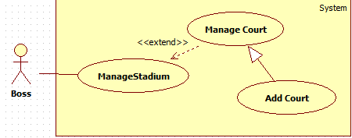

Figure 30: Add court

|  |  |  |  |  |
| --- | --- | --- | --- | --- |
| **USE CASE –** Add court | | | | |
| **Use-case No.** |  | **Use-case Version** | | 2.0 |
| **Use-case Name** | Add court | | | |
| **Author** | TuanNH | | | |
| **Date** |  | **Priority** | Normal | |
| **Actor:**  Boss  **Summary:**  **Goal:**  Check user’s role to use system’s functions.  **Triggers:**  \_Click on [Thêm sân con] link to add court in “ManageCourt” page  \_Click on [Đăng ký] button to finish  **Preconditions:**   * Page is loaded successfully. * User has already created an account in system.   **Post Conditions:**   * Success: * Failure:   **Main Success Scenario:**   |  |  | | --- | --- | | Actor Action | System Response | | 1. Click on link [Thêm sân mới] in “ManageCourt” page to add new court | 1. Page “CreateNewCourt” will be displayed with form include:   -Tên sân: textbox  -Trạng thái hoạt động: dropdown- list:  + Hoạt động  +Không hoạt động | | 1. Enter information in to fields | 1. Exception[1,3] | | 1. Click on [Đăng ký] button   [Alternative] | 1. System will show message “Đăng ký sân con thành công” |   **Alternative Scenario:**   |  |  | | --- | --- | | Actor Action | System Response | | 1. Click on [Hủy] button to cancel add new court | 1. Rediect to “ManageCourt” page |   **Exceptions:**   |  |  | | --- | --- | | Actor Action | System Response | | 1. All fields are blank | 1. Show error message “vui lòng không để trống” in field is blank | | 1. The name of the court that has existed | 1. Show error message “tên này đã tồn tại, vui lòng chọn tên khác” in field [Tên sân]. |   **Relationships:**  Login usecase, List court usecase  **Business Rules:** N/A | | | | |

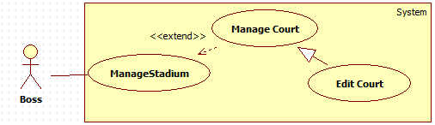

###### <Boss> Edit court

Figure 31: Edit court

|  |  |  |  |  |
| --- | --- | --- | --- | --- |
| **USE CASE –** Edit court | | | | |
| **Use-case No.** |  | **Use-case Version** | | 2.0 |
| **Use-case Name** | Edit court | | | |
| **Author** | TuanNH | | | |
| **Date** |  | **Priority** | Normal | |
| **Actor:**  Boss  **Summary:**  **Goal:**  Check user’s role to use system’s functions.  **Triggers:**  \_Click on [Chỉnh sửa] link to add court in “ManageCourt” page  \_Click on [Cập nhật] button to finish  **Preconditions:**   * Page is loaded successfully. * User has already created an account in system.   **Post Conditions:**   * Success: * Failure:   **Main Success Scenario:**   |  |  | | --- | --- | | Actor Action | System Response | | 1. Click on [Thêm sân mới] link in “ManageCourt” page to add new court | 1. Page “CreateNewCourt” will be displayed with form include:   -Tên sân: textbox  -Bảng giá: textbox  -Trạng thái hoạt động: dropdown- list:  + Hoạt động  +Không hoạt động | | 1. Enter information in to fields | 1. Exception[1,3,5] | | 1. Click on [Cập nhật] button to finish edit court   [Alternative 1] | 1. System will show message “Cập nhật sân con thành công” |   **Alternative Scenario:**   |  |  | | --- | --- | | Actor Action | System Response | | 1. Click on [Hủy] button to cancel edit court | 1. Rediect to “ManageCourt” page |   **Exceptions:**   |  |  | | --- | --- | | Actor Action | System Response | | 1. field [Tên sân con],[Chiết khấu] are blank | 1. Show error message “vui lòng không để trống” in field is blank | | 1. Filed [Chiết khấu] is not a number | 1. Show error message “vui lòng nhập số” |   **Relationships:**  Login usecase, List court usecase  **Business Rules:** N/A | | | | |

###### <Boss> Search court

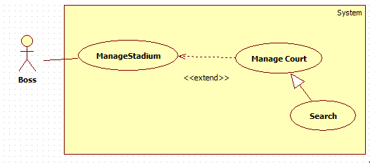

Figure 32: Search court

|  |  |  |  |  |
| --- | --- | --- | --- | --- |
| **USE CASE –** Search court | | | | |
| **Use-case No.** |  | **Use-case Version** | | 2.0 |
| **Use-case Name** | Search court | | | |
| **Author** |  | | | |
| **Date** |  | **Priority** | Normal | |
| **Actor:**  Boss  **Summary:**  **Goal:**  Boss can search to find court.  **Triggers:**  \_ Input data in [Tìm kiếm] textbox in “ManageCourt” page  **Preconditions:**   * Page is loaded successfully. * User has already created an account in system.   **Post Conditions:**   * Success: * Failure:   **Main Success Scenario:**   |  |  |  | | --- | --- | --- | | Actor Action | | System Response | | 1. Input data in [Tìm kiếm] textbox in “ManageCourt” page | 1. System will display result search in “ManageCourt” page | |   **Alternative Scenario:**  **N/A**  **Exceptions:**   |  |  | | --- | --- | | Actor Action | System Response | | 1. Input data was not matched | 1. Show message “không có kết quả nào được tìm thấy” |   **Relationships:**  Login usecase, List court usecase  **Business Rules:** N/A | | | | |

##### <Boss> Manage reservations

Figure 33: Manage reservation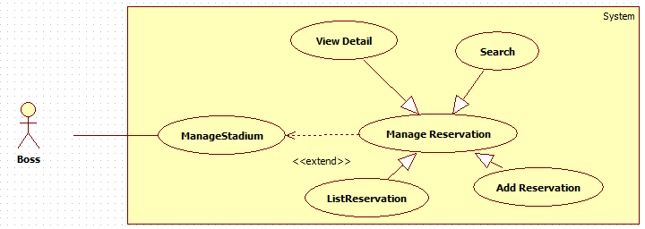

###### <Boss> List reservation

Hình usecase

|  |  |  |  |  |
| --- | --- | --- | --- | --- |
| **USE CASE –** Add court | | | | |
| **Use-case No.** |  | **Use-case Version** | | 2.0 |
| **Use-case Name** | List reservation | | | |
| **Author** | TuanNH | | | |
| **Date** |  | **Priority** | Normal | |
| **Actor:**  Boss  **Summary:**  **Goal:**  Boss view list price.  **Triggers:**  \_Click on [Đặt sân] link on “ManageStadium” page  **Preconditions:**   * Page is loaded successfully. * User has already created an account in system.   **Post Conditions:**   * Success: * Failure:   **Main Success Scenario:**   |  |  | | --- | --- | | Actor Action | System Response | | 1. Click on link [Đặt sân] in “ManageStadium” page | 1. Page “ManageReservation” will be displayed |   **Alternative Scenario:**  **N/A**  **Exceptions:**  **N/A**  **Relationships:**  Login usecase, Manage stadium usecase  **Business Rules:** N/A | | | | |

###### <Boss> Add reservation

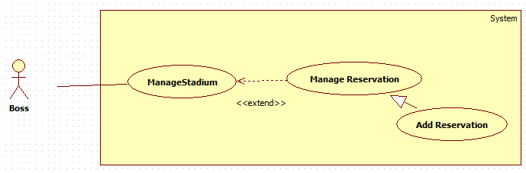

Figure 34: Add reservation

|  |  |  |  |  |
| --- | --- | --- | --- | --- |
| **Use-case No.** |  | **Use-case Version** | | 2.0 |
| **Use-case Name** | Add reservation | | | |
| **Author** |  | | | |
| **Date** |  | **Priority** | High | |
| **Actor:**  Boss  **Summary:**  **Goal:**  Check user’s role to use system’s functions.  **Triggers:**  *\_* Click on [Đặt sân mới] button to add new reservation  \_Enter all fields  \_ Click [Đăng ký] button to finish  **Preconditions:**   * Page is loaded successfully. * User has already created an account in system.   **Post Conditions:**   * Success: redirect to “ManageReservation” page * Failure: Show error message “Thêm đặt sân mới thất bại”   **Main Success Scenario:**   |  |  | | --- | --- | | Actor Action | System Response | | 1. Click on [Đặt sân mới] button to add new reservation | 1. Redirect to “CreateNewReservation” page with form “Thêm đặt sân mới” include:   \_Tên người chơi: textbox  \_Số điện thoại: textbox  \_Email: textbox  \_Ngày chơi: calendar  \_Giờ bắt đầu: calendar  \_Thời lượng: dropdown-list  +60 phút  +90 phút  +120 phút  +180 phút | | 1. Enter all fields | 1. Exception [1,3,5,7] | | 1. Click [Đăng ký ] button to finish   [Alternative] | 1. Redirect to “ManageReservation” page |   **Alternative Scenario:**   |  |  | | --- | --- | | Actor Action | System Response | | 1. Click [Hủy] button co cancle add reservation | 1. Redirect to “ManageReservation” page |   **Exceptions:**   |  |  | | --- | --- | | Actor Action | System Response | | 1. All fields are blank | 1. Show error message “Vui lòng không bỏ trống” | | 1. phone is not a number | 1. Show error message “Vui lòng nhập số” in field [Số điện thoại] | | 1. email is not corect format | 1. Show error message “Vui lòng nhập đúng định dạng mail” in flied [Email] | | 1. Start time is smaller than now | 1. Show error message “đặt sân từ …giờ ” in field [Giờ bắt đầu] | | 1. End time is bigger than stadium’s close time | 1. Show error message “đặt sân trước…giờ ” in field [Giờ bắt đầu] |   **Relationships:**  Login usecase, List reservation usecase  **Business Rules:**  Boss can use this function to add new reservation to user who do not had any payment online account. | | | | |

###### <Boss> Reservation detail

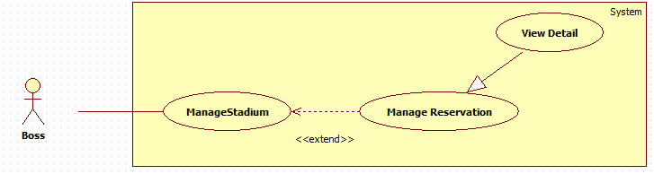

Figure 35: Reservation detail

|  |  |  |  |  |
| --- | --- | --- | --- | --- |
| **USE CASE –** Add court | | | | |
| **Use-case No.** |  | **Use-case Version** | | 2.0 |
| **Use-case Name** | Reservation detail | | | |
| **Author** | TuanNH | | | |
| **Date** |  | **Priority** | Normal | |
| **Actor:**  Boss  **Summary:**  **Goal:**  Boss view list price.  **Triggers:**  \_Click on [Chi tiết] link on “ManageReservation” page  **Preconditions:**   * Page is loaded successfully. * User has already created an account in system.   **Post Conditions:**   * Success: * Failure:   **Main Success Scenario:**   |  |  | | --- | --- | | Actor Action | System Response | | 1. Click on [Chi tiết] link in “ManageStadium” page | 1. Show pop up reservation detail |   **Alternative Scenario:**  **N/A**  **Exceptions:**  **N/A**  **Relationships:**  Login usecase, List reservation usecase  **Business Rules:** N/A | | | | |

###### <Boss> Search reservation

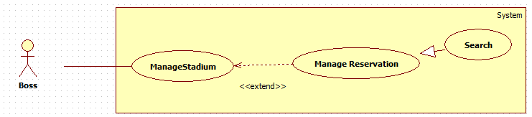

Figure 36: Search reservation

|  |  |  |  |  |
| --- | --- | --- | --- | --- |
| **USE CASE –** Search court | | | | |
| **Use-case No.** |  | **Use-case Version** | | 2.0 |
| **Use-case Name** | Search reservation | | | |
| **Author** |  | | | |
| **Date** |  | **Priority** | Normal | |
| **Actor:**  Boss  **Summary:**  **Goal:**  Boss can search to find reservation.  **Triggers:**  \_ Input data in [Tìm kiếm] textbox in “ManagePrice” page  **Preconditions:**   * Page is loaded successfully. * User has already created an account in system.   **Post Conditions:**   * Success: * Failure:   **Main Success Scenario:**   |  |  |  | | --- | --- | --- | | Actor Action | | System Response | | 1. Input data in [Tìm kiếm] textbox in “ManageReservation” page | 1. System will display result search in “ManageReservation” page | |   **Alternative Scenario:**  **N/A**  **Exceptions:**   |  |  | | --- | --- | | Actor Action | System Response | | 1. Input data was not matched | 1. Show message “không có kết quả nào được tìm thấy” |   **Relationships:**  Login usecase, List reservation usecase  **Business Rules:** N/A | | | | |

##### <Boss> Manage Pricelist

###### <Boss> List Pricelist

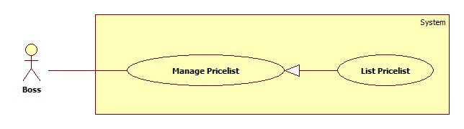

Figure 37: Price list

| **USE CASE SPECIFICATION** | | | |
| --- | --- | --- | --- |
| **Use-case No.** | UC001 | **Use-case Version** | 1.0 |
| **Use-case Name** | List Pricelist | | |
| **Author** | Trần Tấn Phát | | |
| **Date** | 28/05/2014 | **Priority** | High |
| **Actor:**  Boss.  **Summary:**  When boss want view all pricelists of one stadium.  **Goal:**  Show list of pricelists for boss.  **Triggers:**  Boss go to page “Trang quản lí của chủ sân”.  Boss browses navigation bar and click on tab “Quản lý sân”.  Boss click on “Xem bảng giá” button on “Bảng giá” column of table liststadium.  **Preconditions:**  Boss must log in BSF-Website with role “Boss”.  **Post Conditions:**  **Success:**   * A list of pricelists will be showed up in table with paging.   **Failure:**   * The Boss is guided to Error page.   **Main Success Scenario:**   |  |  | | --- | --- | | Actor Actions | System Response | | 1. Boss click “Xem bảng giá” button on “Bảng giá” column of table list stadium. | 1. System will redirect to PriceList page and show list of pricelist.   [Exception 1] |   **Alternative Scenario:** N/A  **Exceptions:**   |  |  | | --- | --- | | Actor Actions | System Response | | [Exception 1]   1. System fails to load data. | 1. Show Error page. |   **Relationships:** N/A  **Business Rules: N/A** | | | |

###### <Boss> Create Pricelist

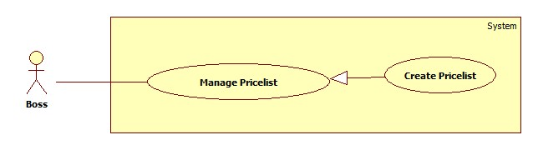

Figure 38: Create pricelist

| **USE CASE SPECIFICATION** | | | |
| --- | --- | --- | --- |
| **Use-case No.** | UC013 | **Use-case Version** | 2.0 |
| **Use-case Name** | Create Pricelist | | |
| **Author** | Trần Tấn Phát | | |
| **Date** | 28/05/2014 | **Priority** | medium |
| **Actor:**  Boss  **Summary:**  When boss want to create new pricelist.  **Goal:**  The purpose of this use case is allowed Boss create new pricelist which can be applied for particular stadium  **Triggers:**  Boss wants to create new pricelist  Boss clicks on “Thêm mới bảng giá” button top of list pricelist page.  **Preconditions:**  User must logged-in as Boss-role.  **Post Conditions:**  **Success:**   * A message will appear onscreen with successful creation content.   **Failure:**   * The Boss is presented with an error message on screen.   **Main Success Scenario:**   |  |  | | --- | --- | | Actor Actions | System Response | | 1. Boss clicks on the “Tạo mới bảng giá” button top of list pricelist page. 2. Boss fills price list information , boss can click “Thêm khun giờ” to add more time duration of pricelist or click “Xóa khung giờ” to remove time duration of pricelist.Finally clicks on “Lưu” button.   [Alternative 1] | 1. The page “Thêm bảng giá” is displayed on screen. Pricelist information form includes:  * “Tên bảng giá” [Name of pricelist, Textbox, max length: 250, required] * “Mô tả”[Description of pricelist, textbox, max length 250, require] * “Giá mặc định”[Default price of pricelist, textbox,require] * Time duration from time[From time of each price table by day of week, timepicker,required] * Time duration to time[To time of each price table by day of week, timepicker,required] * “Thêm khung giờ” link * “Xóa khung giờ” link * “Lưu” button. * “Hủy bỏ” button.     [Exception 1] [Exception 2]  [Exception 3] [Exception 4]  [Exception 5] [Exception 6]  [Exception 7] [Exception 8]   1. The message is displayed “Đã tạo mới bảng giá thành công”. |   **Alternative Scenario:**   |  |  | | --- | --- | | Actor Actions | System Response | | [Alternative 1]   1. Boss click “Hủy bỏ” button. | 1. System redirect to PriceList Page. |   **Exceptions:**   |  |  | | --- | --- | | Actor Actions | System Response | | [Exception 1]   1. Price List’s “Tên bảng giá” is missing.   [Exception 2]   1. The length of Price List’s “Tên bảng giá” is out of range.     [Exception 3]   1. Price List’s “Mô tả” is missing.   [Exception 4]   1. Price List’s “Mô tả” is out of range.   [Exception 5]   1. Time duration from time is missing.   [Exception 6]   1. Time duration to time is missing.   [Exception 7]   1. Time duration is override.   [Exception 8]   1. Cannot save pricelist. | 1. Shows error “Không được để trống!”. 2. Shows error “Tên quá dài (hơn 250 ký tự). 3. Shows error “Mô tả không được để trống!”. 4. Shows error “Mô tả không được quá 4000 kí tự!” . 5. Shows error”Hãy chọn giờ bắt đầu của khung giờ”. 6. Shows error “Hãy chọn giờ kết thúc khung giờ!”. 7. Shows error “Khung không được lồng nhau!”. 8. Shows error “Có lỗi xảy ra vui lòng thử lại!”. |   **Relationships:**  N/A  **Business Rules:**  The time duration in price list is not less than 3 hours. | | | |

###### <Boss> Edit Pricelist

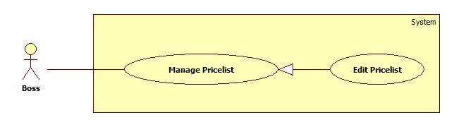

Figure 39: Edit pricelist

| **USE CASE SPECIFICATION** | | | |
| --- | --- | --- | --- |
| **Use-case No.** | UC013 | **Use-case Version** | 2.0 |
| **Use-case Name** | Edit Pricelist | | |
| **Author** | Trần Tấn Phát | | |
| **Date** | 28/05/2014 | **Priority** | medium |
| **Actor:**  Boss  **Summary:**  When boss want to edit exist pricelist.  **Goal:**  The purpose of this use case is allowed Boss edit pricelist which can be applied for particular stadium  **Triggers:**  Boss wants to edit pricelist  Boss clicks on “Chỉnh sửa bảng giá” button on “Thao tác” column of Price List table.  **Preconditions:**  User must logged-in as Boss-role.  PriceList already had been created.  **Post Conditions:**  **Success:**   * A message will appear onscreen with successful edit content.   **Failure:**   * The Boss is presented with an error message on screen.   **Main Success Scenario:**   |  |  | | --- | --- | | Actor Actions | System Response | | 1. Boss clicks on the “Chỉnh sửa bảng giá” button on “Thao tác” column of pricelist table. 2. Boss edit price list information , boss can click “Thêm khun giờ” to add more time duration of pricelist or click “Xóa khung giờ” to remove time duration of pricelist.Finally clicks on “Lưu” button.   [Alternative 1] | 1. The page “Chỉnh sửa bảng giá” is displayed on screen. Pricelist information form includes:  * “Tên bảng giá” [Name of pricelist, Textbox, max length: 250, required] * “Mô tả”[Description of pricelist, textbox, max length 250, require] * “Giá mặc định”[Default price of pricelist, textbox,require] * Time duration from time[From time of each price table by day of week, timepicker,required] * Time duration to time[To time of each price table by day of week, timepicker,required] * “Thêm khung giờ” link * “Xóa khung giờ” link * “Lưu” button. * “Hủy bỏ” button.     [Exception 1] [Exception 2]  [Exception 3] [Exception 4]  [Exception 5] [Exception 6]  [Exception 7] [Exception 8]   1. The message is displayed “chỉnh sửa bảng giá thành công”. |   **Alternative Scenario:**   |  |  | | --- | --- | | Actor Actions | System Response | | [Alternative 1]   1. Boss click “Hủy bỏ” button. | 1. System redirect to PriceList Page. |   **Exceptions:**   |  |  | | --- | --- | | Actor Actions | System Response | | [Exception 1]   1. Price List’s “Tên bảng giá” is missing.   [Exception 2]   1. The length of Price List’s “Tên bảng giá” is out of range.     [Exception 3]   1. Price List’s “Mô tả” is missing.   [Exception 4]   1. Price List’s “Mô tả” is out of range.   [Exception 5]   1. Time duration from time is missing.   [Exception 6]   1. Time duration to time is missing.   [Exception 7]   1. Time duration is override.   [Exception 8]   1. Cannot save pricelist. | 1. Shows error “Không được để trống!”. 2. Shows error “Tên quá dài (hơn 250 ký tự). 3. Shows error “Mô tả không được để trống!”. 4. Shows error “Mô tả không được quá 4000 kí tự!” . 5. Shows error”Hãy chọn giờ bắt đầu của khung giờ”. 6. Shows error “Hãy chọn giờ kết thúc khung giờ!”. 7. Shows error “Khung không được lồng nhau!”. 8. Shows error “Có lỗi xảy ra vui lòng thử lại!”. |   **Relationships:**  N/A  **Business Rules:**  The time duration in price list is not less than 3 hours. | | | |

###### <Boss> Deactivate Pricelist

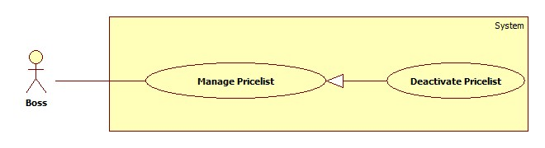

Figure 40: Deactive pricelist

| **USE CASE SPECIFICATION** | | | |
| --- | --- | --- | --- |
| **Use-case No.** | UC001 | **Use-case Version** | 2.0 |
| **Use-case Name** | Deactivate Pricelist | | |
| **Author** | Trần Tấn Phát | | |
| **Date** | 28/05/2014 | **Priority** | High |
| **Actor:**  Boss.  **Summary:**  When boss want to deactivate pricelist, the pricelist be deactivate will not appear in pricelist listbox when choose price list to apply for court.  **Goal:**  This use case will help boss deactivate one pricelist.  **Triggers:**  Boss wants to deactivate pricelist  Boss clicks on “Khóa bảng giá” button on “Thao tác” column of Price List table.  **Preconditions:**  Boss must log in BSF-Website with role “Boss”.  And there are more than one pricelist in table.  **Post Conditions:**  **Success:**   * A message of sucess will be showed up.   **Failure:**   * The Boss is guided to Error page.   **Main Success Scenario:**   |  |  | | --- | --- | | Actor Actions | System Response | | 1. Boss click “Khóa bảng giá” button on action column of Pricelist table. 2. Boss click “Đồng ý” button.   [Alternative 1] | 1. System will show confirm popup.   [Exception 1] [Exception 2]   1. System show success message of deactivate. |   **Alternative Scenario:**   |  |  | | --- | --- | | Actor Actions | System Response | | [Alternative 1]   1. Boss click “Không” button. | 1. The pop up window is closed. |     **Exceptions:**   |  |  | | --- | --- | | Actor Actions | System Response | | [Exception 1]   1. System cannot load.   [Exception 2]   1. System cannot deactivate pricelist. | 1. Show message “Hệ thống không thể kết nối với cơ sở dữ liệu.” 2. Show message “Xảy ra lỗi, xin hãy thử lại!” |   **Relationships:** N/A  **Business Rules:**  Boss just can deactivate particular pricelist when there is over one pricelist in table of pricelist is activate. | | | |

###### <Boss> Activate Pricelist

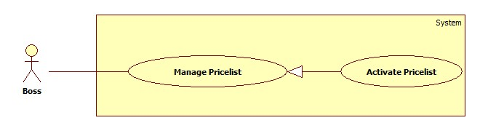

Figure 41: Activate pricelist

| **USE CASE SPECIFICATION** | | | |
| --- | --- | --- | --- |
| **Use-case No.** | UC001 | **Use-case Version** | 2.0 |
| **Use-case Name** | Activate Pricelist | | |
| **Author** | Trần Tấn Phát | | |
| **Date** | 28/05/2014 | **Priority** | High |
| **Actor:**  Boss.  **Summary:**  When boss want to activate pricelist.  **Goal:**  This use case will help boss activate one pricelist.  **Triggers:**  Boss wants to activate pricelist  Boss clicks on “Khóa bảng giá” button on “Thao tác” column of Price List table.  **Preconditions:**  Boss must log in BSF-Website with role “Boss”.  The pricelist had been deactivate before.  **Post Conditions:**  **Success:**   * A message of sucess will be showed up.   **Failure:**   * The Boss is guided to Error page.   **Main Success Scenario:**   |  |  | | --- | --- | | Actor Actions | System Response | | 1. Boss click “Mở bảng giá” button on action column of Pricelist table. 2. Boss click “Đồng ý” button.   [Alternative 1] | 1. System will show confirm popup.   [Exception 1] [Exception 2]   1. System show success message of deactivate. |   **Alternative Scenario:**   |  |  | | --- | --- | | Actor Actions | System Response | | [Alternative 1]   1. Boss click “Không” button. | 1. The pop up window is closed. |     **Exceptions:**   |  |  | | --- | --- | | Actor Actions | System Response | | [Exception 1]   1. System cannot load.   [Exception 2]   1. System cannot activate pricelist. | 1. Show message “Hệ thống không thể kết nối với cơ sở dữ liệu.” 2. Show message “Xảy ra lỗi, xin hãy thử lại!” |   **Relationships:** Usecase Deactivate Pricelist  **Business Rules:**  Boss just can activate particular pricelist when the price list have been deactivate before. | | | |

##### <Boss> Manage Contest Event

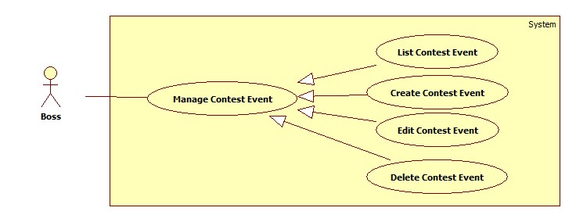

Figure 42: Manage contest event

###### <Boss> List Contest Event

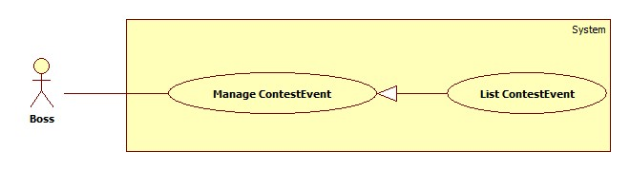

Figure 43: List contest event

| **USE CASE SPECIFICATION** | | | |
| --- | --- | --- | --- |
| **Use-case No.** | UC001 | **Use-case Version** | 1.0 |
| **Use-case Name** | List Contest Event | | |
| **Author** | Trần Tấn Phát | | |
| **Date** | 28/05/2014 | **Priority** | High |
| **Actor:**  Boss.  **Summary:**  When boss want view all contest events of their stadium.  **Goal:**  Show list of contest event for boss.  **Triggers:**  Boss go to page “Trang quản lí của chủ sân”.  Boss browses navigation bar and click on tab “Quản lý sự kiện giải đấu”.  **Preconditions:**  Boss must log in BSF-Website with role “Boss”.  **Post Conditions:**  **Success:**   * A list of contest events will be showed up in table with paging.   **Failure:**   * The Boss is guided to Error page.   **Main Success Scenario:**   |  |  | | --- | --- | | Actor Ations | System Response | | 1. Boss click “Quản lý sự kiện giải đấu” tab on management navigation bar. | 1. System will redirect to ListContestEvent page and show list of contest event.   [Exception 1] |   **Alternative Scenario:** N/A  **Exceptions:**   |  |  | | --- | --- | | Actor Actions | System Respnse | | [Exception 1]   1. System fails to load data. | 1. Show Error page. |   **Relationships:** N/A  **Business Rules:**  The list of contest event will be showed in created time order. | | | |

###### <Boss> Create Contest Event

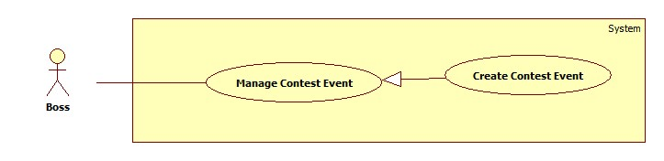

Figure 44: Create contest event

| **USE CASE SPECIFICATION** | | | |
| --- | --- | --- | --- |
| **Use-case No.** | UC013 | **Use-case Version** | 2.0 |
| **Use-case Name** | Create Contest Event | | |
| **Author** | Trần Tấn Phát | | |
| **Date** | 28/05/2014 | **Priority** | High |
| **Actor:**  Boss  **Summary:**  When boss want to create contest event which includes contests for player join.  **Goal:**  The purpose of this use case is allowed Boss create new Contest Event.  **Triggers:**  Boss wants to create new contest event  Boss clicks on “Tạo mới sự kiện thi đấu” button on corner of ListContestEvent page.  **Preconditions:**  User must logged-in as Boss-role.  **Post Conditions:**  **Success:**   * A message will appear onscreen with successful creation content.   **Failure:**   * The Boss is presented with an error message on screen.   **Main Success Scenario:**   |  |  | | --- | --- | | Actor Actions | System Response | | 1. Boss clicks on the “Tạo mới sự kiện giải đấu” button on above right corner of ListContestEvent page. 2. Boss fills contest event information and clicks on “Lưu” button.   [Alternative 1] | 1. The pop up “Thêm mới sự kiện” is displayed on screen. Contest event information form includes:  * “Tên” [Name of contest event, Textbox, max length: 250, required] * “Ngày bắt đầu”[Start date, Datepicker, require] * “Ngày kết thúc”[End date of contest event, Datetime picker,require] * “Hạn đăng ký”[Due date for player register, DatePicker * “Thêm” button. * “Đóng” button.     [Exception 1] [Exception 2]  [Exception 3] [Exception 4]  [Exception 5] [Exception 6]  [Exception 7] [Exception 8]   1. The pop up is closed and message is displayed “Đã tạo mới sự kiện thành công”. |   **Alternative Scenario:**   |  |  | | --- | --- | | Actor Actions | System Response | | [Alternative 1]   1. Boss click “Đóng” button. | 1. The pop up window is closed. |   **Exceptions:**   |  |  | | --- | --- | | Actor Actions | System Response | | [Exception 1]   1. Contest Event’s “Tên” is missing.   [Exception 2]   1. The length of Contest Event’s “Tên” is out of range.     [Exception 3]   1. Contest Event’s “Ngày bắt đầu” is missing.   [Exception 4]   1. Contest Event’s “Ngày kết thúc” is missing.   [Exception 5]   1. Contest Event’s “Hạn đăng kí” is missing.   [Exception 6]   1. Contest Event’s “Hạn đăng kí” is not before “Ngày bắt đầu” and “Ngày kết thúc” for 24 hours.   [Exception 7]   1. Contest Event’s “Ngày bắt đầu” is after “Ngày kết thúc”.   [Exception 8]   1. Contest event’s”Ngày bắt đầu” and “Ngày kết thúc” are override other exist contest events. | 1. Shows error “Không được để trống!”. 2. Shows error “Tên quá dài (hơn 250 ký tự). 3. Shows error “Hãy chọn ngày bắt đầu!”. 4. Shows error “Hãy chọn ngày kết thúc!” . 5. Shows error”Hãy chọn hạn đăng kí”. 6. Shows error “Hạn đăng kí phải trước thời gian bắt đầu ít nhất 24h!”. 7. Shows error “Ngày bắt đầu không được sau ngày kết thúc!”. 8. Shows error “ Sự kiện đã bị trùng thời gian xảy ra!”. |   **Relationships:**  N/A  **Business Rules:**  The happening time of contest event is not override other exist contest events’ time of the same stadium. | | | |

###### <Boss> Edit Contest Event

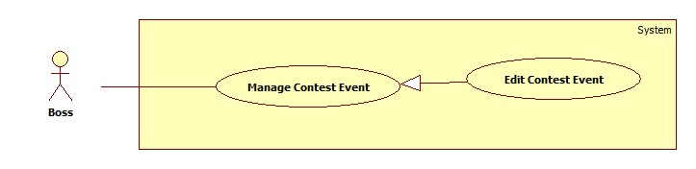

Figure 45: Edit contest event

| **USE CASE SPECIFICATION** | | | |
| --- | --- | --- | --- |
| **Use-case No.** | UC013 | **Use-case Version** | 2.0 |
| **Use-case Name** | Edit Contest Event | | |
| **Author** | Trần Tấn Phát | | |
| **Date** | 28/05/2014 | **Priority** | High |
| **Actor:**  Boss  **Summary:**  When boss want to edit contest event which includes contests for player join.  **Goal:**  The purpose of this use case is allowed Boss edit name, start date, end date, due register date of Contest Event which is create before.  **Triggers:**  Boss wants to edit created contest event  Boss clicks on “Chỉnh sửa sự kiện thi đấu” button on action column of ListContestEvent table.  **Preconditions:**  User must logged-in as Boss-role.  **Post Conditions:**  **Success:**   * A message will appear onscreen with successful edit content.   **Failure:**   * The Boss is presented with an error message on screen.   **Main Success Scenario:**   |  |  | | --- | --- | | Actor Actions | System Response | | 1. Boss clicks on the “Chỉnh sửa giải đấu” button on action column of ListContestEvent table. 2. Boss fills contest event information and clicks on “Lưu” button.   [Alternative 1] | 1. The pop up “Chỉnh sửa sự kiện” is displayed on screen. Contest event form includes:  * “Tên” [Name of contest event, Textbox, max length: 250, required] * “Ngày bắt đầu”[Start date, Datepicker, require] * “Ngày kết thúc”[End date of contest event, Datetime picker,require] * “Hạn đăng ký”[Due date for player register, DatePicker * “Thêm” button. * “Đóng” button.     [Exception 1] [Exception 2]  [Exception 3] [Exception 4]  [Exception 5] [Exception 6]  [Exception 7] [Exception 8]   1. The pop up is closed and message is displayed “Đã chỉnh sửa sự kiện thành công”. |   **Alternative Scenario:**   |  |  | | --- | --- | | Actor Actions | System Response | | [Alternative 1]   1. Boss click “Đóng” button. | 1. The pop up window is closed. |     **Exceptions:**   |  |  | | --- | --- | | Actor Actions | System Response | | [Exception 1]   1. Contest Event’s “Tên” is missing.   [Exception 2]   1. The length of Contest Event’s “Tên” is out of range.     [Exception 3]   1. Contest Event’s “Ngày bắt đầu” is missing.   [Exception 4]   1. Contest Event’s “Ngày kết thúc” is missing.   [Exception 5]   1. Contest Event’s “Hạn đăng kí” is missing.   [Exception 6]   1. Contest Event’s “Hạn đăng kí” is not before “Ngày bắt đầu” and “Ngày kết thúc” for 24 hours.   [Exception 7]   1. Contest Event’s “Ngày bắt đầu” is after “Ngày kết thúc”.   [Exception 8]   1. Contest event’s”Ngày bắt đầu” and “Ngày kết thúc” are override other exist contest events. | 1. Shows error “Không được để trống!”. 2. Shows error “Tên quá dài (hơn 250 ký tự). 3. Shows error “Hãy chọn ngày bắt đầu!”. 4. Shows error “Hãy chọn ngày kết thúc!” . 5. Shows error”Hãy chọn hạn đăng kí”. 6. Shows error “Hạn đăng kí phải trước thời gian bắt đầu ít nhất 24h!”. 7. Shows error “Ngày bắt đầu không được sau ngày kết thúc!”. 8. Shows error “ Sự kiện đã bị trùng thời gian xảy ra!”. |   **Relationships:**  N/A  **Business Rules:**  The edit contest event happen when boss want to edit wrong information when create contest event or they want to edit the time of contest event when there is a contest in contest event is overdued of registration but not enough player registration. | | | |

###### <Boss> Delete Contest Event

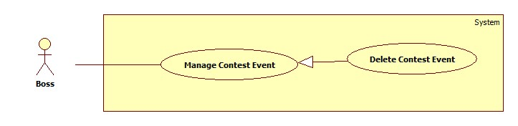

Figure 46: Delete contest event

| **USE CASE SPECIFICATION** | | | |
| --- | --- | --- | --- |
| **Use-case No.** | UC001 | **Use-case Version** | 2.0 |
| **Use-case Name** | Delete Contest Event | | |
| **Author** | Trần Tấn Phát | | |
| **Date** | 28/05/2014 | **Priority** | High |
| **Actor:**  Boss.  **Summary:**  When boss want delete contest events of their stadium.  **Goal:**  Delete contest event and all contest belong to this contest event.  **Triggers:**  Boss go to page “Trang quản lí của chủ sân”.  Boss browses navigation bar and click on tab “Quản lý sự kiện giải đấu”.  Boss click on “Xóa sự kiện” button.  **Preconditions:**  Boss must log in BSF-Website with role “Boss”.  **Post Conditions:**  **Success:**   * A message of sucess will be showed up.   **Failure:**   * The Boss is guided to Error page.   **Main Success Scenario:**   |  |  | | --- | --- | | Actor Actions | System Response | | 1. Boss click “Xóa sự kiện” button on action column of List Contest Event table. 2. Boss click “Đồng ý” button.   [Alternative 1] | 1. System will show confirm popup.   [Exception 1] [Exception 2]   1. System show success message of delete. |   **Alternative Scenario:**   |  |  | | --- | --- | | Actor Actions | System Response | | [Alternative 1]   1. Boss click “Không” button. | 1. The pop up window is closed. |     **Exceptions:**   |  |  | | --- | --- | | Actor Actions | System Response | | [Exception 1]   1. System cannot load.   [Exception 2]   1. System cannot delete contest event. | 1. Show message “Hệ thống không thể kết nối với cơ sở dữ liệu.” 2. Show message “Xảy ra lỗi, xin hãy thử lại!” |   **Relationships:** N/A  **Business Rules:**  When boss delete a contest event, all contest belong to this contest event will be deleted too. | | | |

##### <Boss> Manage Contest

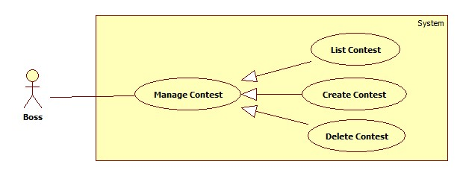

Figure 47:Manage contest

###### <Boss> List Contest

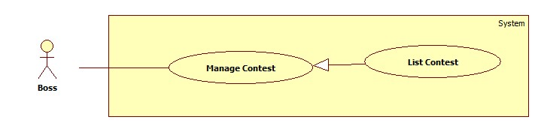

Figure 48: List contest

| **USE CASE SPECIFICATION** | | | |
| --- | --- | --- | --- |
| **Use-case No.** | UC001 | **Use-case Version** | 1.0 |
| **Use-case Name** | List Contest | | |
| **Author** | Trần Tấn Phát | | |
| **Date** | 28/05/2014 | **Priority** | High |
| **Actor:**  Boss.  **Summary:**  When boss want view all contests of one contest evnt.  **Goal:**  Show list of contest of particular contest event.  **Triggers:**  Boss go to page “Trang quản lí của chủ sân”.  Boss browses navigation bar and click on tab “Quản lý sự kiện giải đấu”.  On table of contest event boss click on button “Xem danh sách giải đấu” of particular contest event.  **Preconditions:**  Boss must log in BSF-Website with role “Boss”.  **Post Conditions:**  **Success:**   * A list of contest will be showed up in table with paging.   **Failure:**   * The Boss is guided to Error page.   **Main Success Scenario:**   |  |  | | --- | --- | | Actor Actions | System Response | | 1. Boss click “Xem danh sách giải đấu” button on action column of list of contest event table. | 1. System will redirect to ListContest page and show list of contest.   [Exception 1] |   **Alternative Scenario:** N/A  **Exceptions:**   |  |  | | --- | --- | | Actor Actions | System Response | | [Exception 1]   1. System fails to load data. | 1. Show Error page. |   **Relationships:** N/A  **Business Rules:**  The list of contest will be showed in created time order. | | | |

###### <Boss> Create Contest

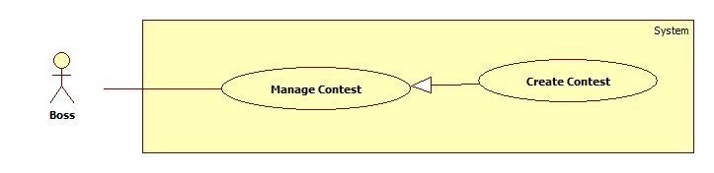

Figure 49: Create contest

| **USE CASE SPECIFICATION** | | | |
| --- | --- | --- | --- |
| **Use-case No.** | UC013 | **Use-case Version** | 2.0 |
| **Use-case Name** | Create Contest | | |
| **Author** | Trần Tấn Phát | | |
| **Date** | 28/05/2014 | **Priority** | High |
| **Actor:**  Boss  **Summary:**  When boss want to create new contest for player join.  **Goal:**  The purpose of this use case is allowed Boss create new contest.  **Triggers:**  Boss wants to create new contest  Boss clicks on “Tạo mới giải đấu” button on action column of ListContestEvent page.  **Preconditions:**  User must logged-in as Boss-role.  **Post Conditions:**  **Success:**   * A message will appear onscreen with successful creation content.   **Failure:**   * The Boss is presented with an error message on screen.   **Main Success Scenario:**   |  |  | | --- | --- | | Actor Actions | System Response | | 1. Boss clicks on the “Tạo mới giải đấu” button on action column of ListContestEvent table. 2. Boss fills and choose contest information and clicks on “Lưu” button.   [Alternative 1] | 1. The pop up “Thêm mới giải đấu” is displayed on screen. Contest form includes:  * “Thể loại” [Type of contest, Listbox, value: “Đôi nữ”,”Đơn nữ”,”Đôi nam”, “Đơn nam”,”Đôi nam”,”Đôi nam nữ”,required] * “Địa điểm”[Boss’s stadium, Listbox, required] * “Ngày kết thúc”[End date of contest event, Datetime picker,require] * “Số lượng người hoặc đội” [Quantity of player register team, value: 8, 16; requied]. * “Mô tả” [Description of contest, textarea, optional]. * “Lưu” button. * “Đóng” button.     [Exception 1]   1. The pop up is closed and message is displayed “Đã tạo mới giải đấu thành công”. |   **Alternative Scenario:**   |  |  | | --- | --- | | Actor Actions | System Response | | [Alternative 1]   1. Boss click “Đóng” button. | 1. The pop up window is closed. |     **Exceptions:**   |  |  | | --- | --- | | Actor Actions | System Response | | [Exception 1]   1. Cannot save new contest. | 1. Shows error “Co1 lỗi xảy ra vui lòng thử lại!. |   **Relationships:**  N/A  **Business Rules:**  In one contest event boss can just one contest of same type contest.  When contest is created all entities related to contest include group, round, team will be create too.  Start date, End date, due register date of contest will be automatically got from contest event’s ones. | | | |

###### <Boss> Delete Contest

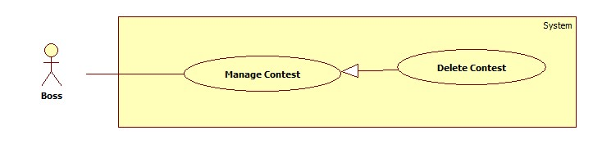

Figure 50: Delete contest

| **USE CASE SPECIFICATION** | | | |
| --- | --- | --- | --- |
| **Use-case No.** | UC001 | **Use-case Version** | 2.0 |
| **Use-case Name** | Delete Contest | | |
| **Author** | Trần Tấn Phát | | |
| **Date** | 28/05/2014 | **Priority** | High |
| **Actor:**  Boss.  **Summary:**  When boss want delete contest  **Goal:**  Delete contest and all item related to contest include group, team, round.  **Triggers:**  Boss go to page “Trang quản lí của chủ sân”.  Boss browses navigation bar and click on tab “Quản lý sự kiện giải đấu”.  In table list of contest, Boss click on “Xóa giải đấu” button.  **Preconditions:**  Boss must log in BSF-Website with role “Boss”.  **Post Conditions:**  **Success:**   * A message of sucess will be showed up.   **Failure:**   * The Boss is guided to Error page.   **Main Success Scenario:**   |  |  | | --- | --- | | Actor Actions | System Response | | 1. Boss click “Hủy giải đấu” button on action column of List Contest table. 2. Boss click “Đồng ý” button.   [Alternative 1] | 1. System will show confirm popup.   [Exception 1] [Exception 2]   1. System show success message of delete. |   **Alternative Scenario:**   |  |  | | --- | --- | | Actor Actions | System Response | | [Alternative 1]   1. Boss click “Không” button. | 1. The pop up window is closed. |     **Exceptions:**   |  |  | | --- | --- | | Actor Actions | System Response | | [Exception 1]   1. System cannot load.   [Exception 2]   1. System cannot delete contest. | 1. Show message “Hệ thống không thể kết nối với cơ sở dữ liệu.” 2. Show message “Xảy ra lỗi, xin hãy thử lại!” |   **Relationships:** N/A  **Business Rules:**  When boss delete a contest, all items related to this contest such as team, group, round will be deleted too. | | | |

##### <Boss> Manage Team

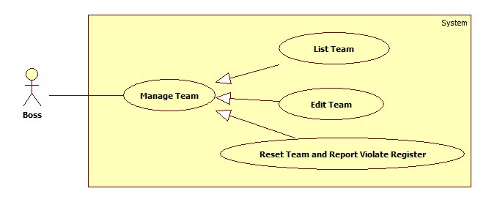

Figure 51: Manage team

###### <Boss> List Team

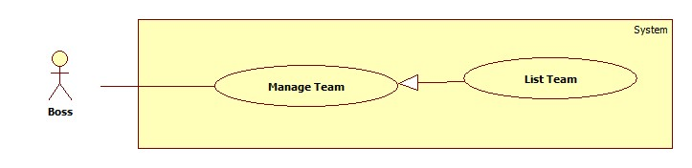

Figure 52: List team

| **USE CASE SPECIFICATION** | | | |
| --- | --- | --- | --- |
| **Use-case No.** | UC001 | **Use-case Version** | 1.0 |
| **Use-case Name** | List Contest Participation | | |
| **Author** | Trần Tấn Phát | | |
| **Date** | 28/05/2014 | **Priority** | High |
| **Actor:**  Boss.  **Summary:**  When boss want view player’s participation registration of contest.  **Goal:**  Show list of player’s contest participation register of contest.  **Triggers:**  Boss go to page “Trang quản lí của chủ sân”.  Boss browses navigation bar and click on tab “Quản lý tham gia giải đấu.  Boss choose contest event name in contest event listbox and contest name in contest listbox.  **Preconditions:**  Boss must log in BSF-Website with role “Boss”.  **Post Conditions:**  **Success:**   * A list of contest will be showed up in table with paging.   **Failure:**   * The Boss is guided to Error page.   **Main Success Scenario:**   |  |  | | --- | --- | | Actor Actions | System Response | | 1. Boss choose contest event name in contest event listbox then choose contest name in contest listbox. | 1. System will show list of player’s participation registration in table with paging.   [Exception 1] |   **Alternative Scenario:** N/A  **Exceptions:**   |  |  | | --- | --- | | Actor Actions | System Response | | [Exception 1]   1. System fails to load data. | 1. Show Error page. |   **Relationships:** N/A  **Business Rules:**  The list of player’s participation registration will be showed registration code order. | | | |

###### <Boss> Edit Team

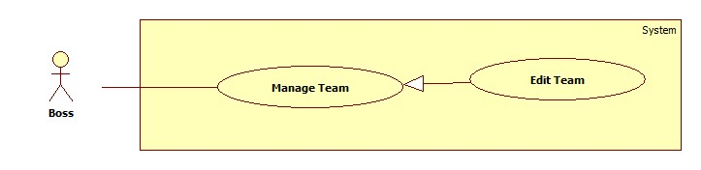

Figure 53: Edit team

| **USE CASE SPECIFICATION** | | | |
| --- | --- | --- | --- |
| **Use-case No.** | UC013 | **Use-case Version** | 2.0 |
| **Use-case Name** | Edit Contest Participation | | |
| **Author** | Trần Tấn Phát | | |
| **Date** | 28/05/2014 | **Priority** | High |
| **Actor:**  Boss  **Summary:**  When boss want to edit information of registration of registration player.  **Goal:**  The purpose of this use case is allowed Boss edit information of player registration or add new information in case of empty registration.  **Triggers:**  Boss clicks on “Chỉnh sửa đăng kí” button on action column of List Participation Registration table  **Preconditions:**  User must logged-in as Boss-role.  **Post Conditions:**  **Success:**   * A message will appear onscreen with successful creation content.   **Failure:**   * The Boss is presented with an error message on screen.   **Main Success Scenario:**   |  |  | | --- | --- | | Actor Actions | System Response | | 1. Boss clicks on the “Chỉnh sửa đăng kí” button on action column of List Registration table. 2. Boss fills and edit required information then choose registration information and clicks on “Lưu” button.   [Alternative 1] | 1. The pop up “Chỉnh sửa đăng kí” is displayed on screen. Registration form includes:  * “ Tên người tham gia” [Name of registration, Textbox, max length 250 ,required] * “Tên người cùng đội”[name of same team member in case registration for team with 2 member, Textbox, required] * “Số điện thoại”[Phone number of registration, textbox, required] * “Lưu” button. * “Đóng” button.     [Exception 1] [Exception 2]  [Exception 3] [Exception 4]  [Exception 5] [Exception 6]   1. The pop up is closed and message is displayed “Đã chỉnh sửa thành công”. |   **Alternative Scenario:**   |  |  | | --- | --- | | Actor Actions | System Response | | [Alternative 1]   1. Boss click “Đóng” button. | 1. The pop up window is closed. |     **Exceptions:**   |  |  | | --- | --- | | Actor Actions | System Response | | [Exception 1]   1. Participation Registration’s “Tên người tham gia” is missing.   [Exception 2]   1. The length of participation registration’s “Tên người tham gia” is out of range.   [Exception 3]   1. Participation Registration’s “Tên người cùng đội” is missing.   [Exception 4]   1. The length of participation registration’s “Tên người cùng đội” is out of range.   [Exception 5]   1. Participation Registration“Số điện thoại” is missing.   [Exception 6]   1. The length of participation registration’s “Số điện thoại” is out of range.   [Exception 7]   1. Cannot save edit registration information. | 1. Shows error “Không được để trống!”. 2. Shows error “Tên quá dài (hơn 250 ký tự). 3. Shows error “Hãy nhập tên!”. 4. Shows error “Tên không đượcd ài hơn 250 kí tự”. 5. Shows error”Hãy nhập số điện thoại”. 6. Shows error “Số điện thoại phải 10 hoặc 11 chữ số”. 7. Show message “Xảy ra lỗi, xin hãy thử lại!” |   **Relationships:**  N/A  **Business Rules:**  In one contest event boss can just one contest of same type contest. | | | |

###### <Boss> Reset Team and Report Violate Register.

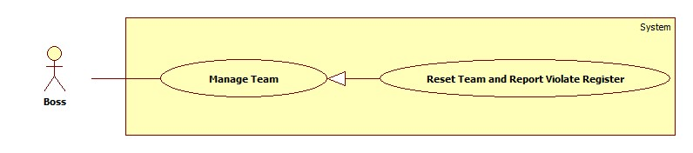

Figure 54: Reset team anf Report Violate register

| **USE CASE SPECIFICATION** | | | |
| --- | --- | --- | --- |
| **Use-case No.** | UC001 | **Use-case Version** | 2.0 |
| **Use-case Name** | Reset and Report Registration | | |
| **Author** | Trần Tấn Phát | | |
| **Date** | 28/05/2014 | **Priority** | High |
| **Actor:**  Boss.  **Summary:**  When boss want reset and report violate registration.  **Goal:**  Reset all player registration information and report violate registration account for webmaster.  **Triggers:**  Boss clicks on “Báo cáo vi phạm và reset đăng kí” button on action column of List Participation Registration table  **Preconditions:**  Boss must log in BSF-Website with role “Boss”.  **Post Conditions:**  **Success:**   * A message of sucess will be showed up.   **Failure:**   * The Boss is guided to Error page.   **Main Success Scenario:**   |  |  | | --- | --- | | Actor Actions | System Response | | 1. Boss click “Báo cáo vi phạm và reset đăng kí” button on action column of List Registration table. 2. Boss click “Đồng ý” button.   [Alternative 1] | 1. System will show confirm popup.   [Exception 1] [Exception 2]   1. System show success message. |   **Alternative Scenario:**   |  |  | | --- | --- | | Actor Actions | System Response | | [Alternative 1]   1. Boss click “Không” button. | 1. The pop up window is closed. |     **Exceptions:**   |  |  | | --- | --- | | Actor Actions | System Response | | [Exception 1]   1. System cannot load.   [Exception 2]   1. System cannot report and reset violate registration. | 1. Show message “Hệ thống không thể kết nối với cơ sở dữ liệu.” 2. Show message “Xảy ra lỗi, xin hãy thử lại!” |   **Relationships:** N/A  **Business Rules:**  When boss reset and report registration it means that this registration information will be empty and other account can register to this slot.  If an account has greater 3 violate reports, it will be ban. | | | |

##### <Boss> Manage Match

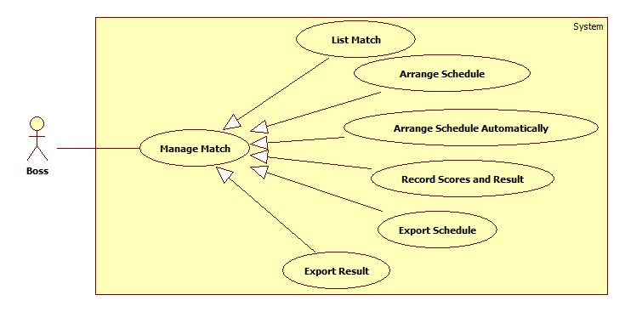

Figure 55: Manage match

###### <Boss> List Match

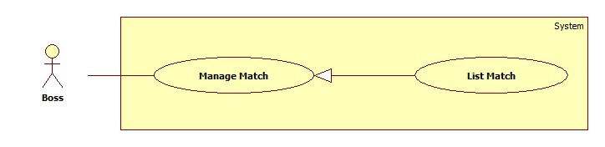

Figure 56: List match

| **USE CASE SPECIFICATION** | | | |
| --- | --- | --- | --- |
| **Use-case No.** | UC001 | **Use-case Version** | 1.0 |
| **Use-case Name** | List Macth | | |
| **Author** | Trần Tấn Phát | | |
| **Date** | 28/05/2014 | **Priority** | High |
| **Actor:**  Boss.  **Summary:**  When boss want view all matches of contest or round of contest.  **Goal:**  Show list matches by contest or round of contest.  **Triggers:**  Boss go to page “Trang quản lí của chủ sân”.  Boss browses navigation bar and click on tab “Quản lý trận đấu của giải đấu.  Boss choose contest event name in contest event listbox and contest name in contest listbox.  **Preconditions:**  Boss must log in BSF-Website with role “Boss”.  **Post Conditions:**  **Success:**   * A list of matches will be showed up in table with paging.   **Failure:**   * The Boss is guided to Error page.   **Main Success Scenario:**   |  |  | | --- | --- | | Actor Actions | System Response | | 1. Boss choose contest event name in contest event listbox then choose contest name in contest listbox.   [Alternative 1] | 1. System will show list of matches of whole contest.   [Exception 1] |   **Alternative Scenario:**   |  |  | | --- | --- | | Actor Actions | System Response | | [Alternative 1]   1. Boss choose contest event name in contest event listbox then choose contest name in contest listbox, then choose round name of contest. | 1. System will show list of matches by contest round. |   **Exceptions:**   |  |  | | --- | --- | | Actor Actions | System Response | | [Exception 1]   1. System fails to load data. | 1. Show Error page. |   **Relationships:** N/A  **Business Rules:**  The list of contest matches will be showed in match order. | | | |

###### <Boss> Arrange Schedule

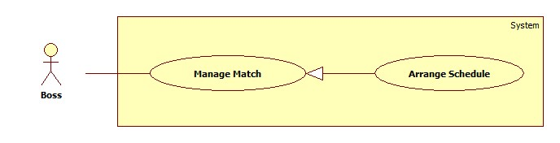

Figure 57: Arrange Schedule

| **USE CASE SPECIFICATION** | | | |
| --- | --- | --- | --- |
| **Use-case No.** | UC013 | **Use-case Version** | 2.0 |
| **Use-case Name** | Arrange Schedule | | |
| **Author** | Trần Tấn Phát | | |
| **Date** | 28/05/2014 | **Priority** | High |
| **Actor:**  Boss  **Summary:**  In order to happening of matches, boss need to arrange a schedule for match.  **Goal:**  The purpose of this use case is allowed Boss arrange a match schedule includeing time, place, duration one by one.  **Triggers:**  Boss browses navigation bar and click on tab “Quản lý trận đấu của giải đấu.  Boss choose contest event name in contest event listbox and contest name in contest listbox.  Boss clicks on “Lịch trận đấu” button on action column “Xếp lịch” of macth list table  **Preconditions:**  User must logged-in as Boss-role.  **Post Conditions:**  **Success:**   * A message will appear onscreen with successful creation content.   **Failure:**   * The Boss is presented with an error message on screen.   **Main Success Scenario:**   |  |  | | --- | --- | | Actor Actions | System Response | | 1. Boss clicks on the “Lịch thi đấu” button on “Xếp lịch” column of match list table. 2. Boss fills and edit required information then choose registration information and clicks on “Tìm sân” button.   [Exception 1]   1. Boss clicks on “Lưu” button.   [Alternative 1] | 1. The pop up “Xếp lịch trận đấu” is displayed on screen. Match Schedule form includes:  * “Ngày thi đấu” [Date of match,value: contest’s start date-contest’s end date, Listbox,required] * “Giờ bắt đầu”[start time of match, timepicker, required] * “Thời lượng dự tính”[duration of match,value: 45,60 minutes, listtbox, required] * “Sân”[Court where match happening, listbox, required] * “Tìm sân” button. * “Lưu” button. * “Đóng” button.  1. The “Sân’ listbox is valued all available courts in particular time.   [Exception 2] [Exception 3]  [Exception 4] [Exception 5]  [Exception 6] [Exception 7]   1. The pop up is closed and message is displayed “Đã xếp lịch thành công”. |   **Alternative Scenario:**   |  |  | | --- | --- | | Actor Actions | System Response | | [Alternative 1]   1. Boss click “Đóng” button. | 1. The pop up window is closed. |     **Exceptions:**   |  |  | | --- | --- | | Actor Actions | System Response | | [Exception 1]   1. There is no available court for match.   [Exception 2]   1. Match’s “Giờ bắt đầu” is missing.   [Exception 3]   1. Match’s “Sân” is missing.   [Exception 4]   1. Cannot save match schedule. | 1. Shows message “Không có sân phù hợp. vui long chọn khung giờ khác!”. 2. Shows error “Vui long chọn giờ bắt đầu”. 3. Shows error “Vui long click tìm sân!”. 4. Shows error “Có lỗi khi lưu lịch trân đấu! Vui lòng thử lại!”. |   **Relationships:**  N/A  **Business Rules:**  N/A. | | | |

###### Boss> Arrange Schedule Automatically

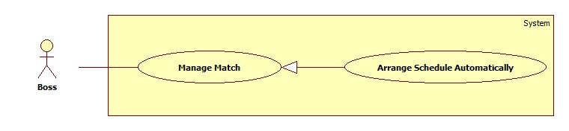

Figure 58: Arrange Shedule autumatically

| **USE CASE SPECIFICATION** | | | |
| --- | --- | --- | --- |
| **Use-case No.** | UC013 | **Use-case Version** | 2.0 |
| **Use-case Name** | Arrange Schedule Automatically | | |
| **Author** | Trần Tấn Phát | | |
| **Date** | 28/05/2014 | **Priority** | High |
| **Actor:**  Boss  **Summary:**  In order to happening of matches, boss need to arrange a schedule for match.  **Goal:**  The purpose of this use case is allowed Boss arrange schedule for all matches of one contest or all matches of contest round.  **Triggers:**  Boss browses navigation bar and click on tab “Quản lý trận đấu của giải đấu.  Boss choose contest event name in contest event listbox and contest name in contest listbox.  Boss clicks on “Xếp lịch tự động” button on above right corner of match list page.  **Preconditions:**  User must logged-in as Boss-role.  **Post Conditions:**  **Success:**   * A message will appear onscreen with successful creation content.   **Failure:**   * The Boss is presented with an error message on screen.   **Main Success Scenario:**   |  |  | | --- | --- | | Actor Actions | System Response | | 1. Boss choose contestevent in contest event listbox, then choose contest in contest listbox, Boss clicks on the “Xếp lịch tự động” button.   [Alternative1]   1. After filling all required parameters, Boss clicks on “Thực hiện” button.   [Alternative 2] | 1. The pop up “Xếp lịch tự động” is displayed on screen. Automatic Schedule Arrange input parameters include:  * “Sân” [Court of stadium where contest happen, multiple select,required] * “Ngày diễn ra”[date of when match happening,Value: date of contest, Listbox, required] * “Thời lượng dự tính”[Phone number of registration, textbox, required] * “Độ dài trận đấu”[duration of match, value:45, 60 minutes; listbox, required] * “Khung giờ 1”[from time and to time of date; timepicker, required] * “Khung giờ 2”[ from time and to time of date; timepicker,optional] * “Khung giờ 3”[ from time and to time of date; timepicker, optional] * “Thực hiện” button. * “Đóng” button.  1. The waiting pop up will show to reuire user waiting for a while.   [Exception 1] [Exception 2]  [Exception 3] [Exception 4]  [Exception 5]   1. The pop up is closed and message is displayed “Đã xếp lịch thành công”. |   **Alternative Scenario:**   |  |  | | --- | --- | | Actor Actions | System Response | | [Alternative 1]   1. Boss choose contestevent in contest event listbox, then choose contest in contest listbox, then choose round of contest in round listbox, Boss clicks on the “Xếp lịch tự động” button.   [Alternative 2]   1. Boss click “Đóng” button. | 1. (All system response same as main scenarios but for round of contest not for all contest). 2. The pop up window is closed. |     **Exceptions:**   |  |  | | --- | --- | | Actor Actions | System Response | | [Exception 1]   1. “Sân” is missing.   [Exception 2]   1. “Ngày diễn ra” is missing.   [Exception 3]   1. Duration 1 from time is missing.   [Exception 4]   1. Duration 2 to time is missing.   [Exception 5]   1. Cannot arrange schedule automatically | 1. Shows message “Vui lòng chọn sân!”. 2. Shows error “Vui lòng chọn ngày”. 3. Shows error “Vui long chọn giờ!”. 4. Shows error “Vui long chọn giờ!”. 5. Shows error “Có lỗi xảy ra, vui long thử lại!”. |   **Relationships:**  N/A  **Business Rules:**  \*Automatic Match Schedule Arrange Algorithm:  + Match schedule includes : date, start time, match duration, court  + Input parameters include: date list, time frame (from time-to time), match duration, court list.  + When having required parameters, algoritm devide parameters into list of match schedule, then check available of them with reservation and course timetable, then algorithm filter list of match schedule into available list match schedule.  + For each item of available match schedule list, algorithm will set for each match of contest or contest round with check same time frame of same registration.  \*When macth have schedule, button”Ghi kết quả” is available for recording result of match. | | | |

###### Boss> Record Scores and Result

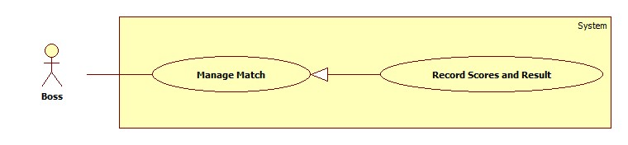

Figure 59: Record Scores and result

| **USE CASE SPECIFICATION** | | | |
| --- | --- | --- | --- |
| **Use-case No.** | UC013 | **Use-case Version** | 2.0 |
| **Use-case Name** | Record Scores and Result | | |
| **Author** | Trần Tấn Phát | | |
| **Date** | 28/05/2014 | **Priority** | High |
| **Actor:**  Boss  **Summary:**  After match happened, boss record the scores of match for contest statistic.  **Goal:**  The purpose of this use case is allowed Boss record the scores of match.  **Triggers:**  Boss browses navigation bar and click on tab “Quản lý trận đấu của giải đấu.  Boss choose contest event name in contest event listbox and contest name in contest listbox.  Boss clicks on “Kết quả trận đấu” button on action column “Kết quả” of macth list table  **Preconditions:**  User must logged-in as Boss-role.  The match already had schedule.  **Post Conditions:**  **Success:**   * A message will appear onscreen with successful creation content.   **Failure:**   * The Boss is presented with an error message on screen.   **Main Success Scenario:**   |  |  | | --- | --- | | Actor Actions | System Response | | 1. Boss clicks on the “Kết quả trận đấu” button on “Kết quả” column of match list table. 2. After filling all required information, Boss clicks on “Lưu” button.   [Alternative 1] | 1. The pop up “Ghi kết quả” is displayed on screen. Match result form includes:  * Member 1 of team 1“Hiệp 1” [Score of set 1,value: number, textbox,required] * Member 1 of team 1“Hiệp 2” [Score of set 1,value: number, textbox,required] * Member 1 of team 1“Hiệp 3” [Score of set 1,value: number, textbox,required]   If contest type is pair contest: (   * Member 2 of team 1“Hiệp 1” [Score of set 1,value: number, textbox,required] * Member 2 of team 1“Hiệp 2” [Score of set 1,value: number, textbox,required] * Member 2 of team 1“Hiệp 3” [Score of set 1,value: number, textbox,required]) * Member 1 of team 2“Hiệp 1” [Score of set 1,value: number, textbox,required] * Member 1 of team 2“Hiệp 2” [Score of set 1,value: number, textbox,required] * Member 1 of team 2“Hiệp 3” [Score of set 1,value: number, textbox,required]   If contest type is pair contest: (   * Member 2 of team 2“Hiệp 1” [Score of set 1,value: number, textbox,required] * Member 2 of team 2“Hiệp 2” [Score of set 1,value: number, textbox,required] * Member 2 of team 2“Hiệp 3” [Score of set 1,value: number, textbox,required]) * “Bên thắng trận đấu” [Name of win team, listbox, value: name 2 team of macth, required] * “Lưu” button. * “Đóng” button.   [Exception 1] [Exception 2]   1. The pop up is closed and message is displayed “Đã lưu kết quả thành công”. |   **Alternative Scenario:**   |  |  | | --- | --- | | Actor Actions | System Response | | [Alternative 1]   1. Boss click “Đóng” button. | 1. The pop up window is closed. |     **Exceptions:**   |  |  | | --- | --- | | Actor Actions | System Response | | [Exception 1]   1. Any Scores is missing.   [Exception 2]   1. Cannot save match result. | 1. Shows message “Vui lòng nhập kết quả!”. 2. Shows error “Có lỗi khi lưu kết quả trân đấu! Vui lòng thử lại!”. |   **Relationships:**  N/A  **Business Rules:**  If all matches of one contest round have results, system will automatically arrange team will be join next contest round. | | | |

###### Boss> Export Schedule

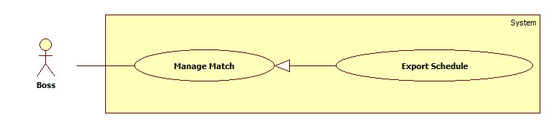

Figure 60: Export Schedule

| **USE CASE SPECIFICATION** | | | |
| --- | --- | --- | --- |
| **Use-case No.** | UC001 | **Use-case Version** | 1.0 |
| **Use-case Name** | Export Schedule | | |
| **Author** | Trần Tấn Phát | | |
| **Date** | 28/05/2014 | **Priority** | High |
| **Actor:**  Boss.  **Summary:**  When boss want to export match schedule in pdf file format.  **Goal:**  Export Schedule Usecase will help boss export the match schedule in pdf file format.  **Triggers:**  Boss go to page “Trang quản lí của chủ sân”.  Boss browses navigation bar and click on tab “Quản lý trận đấu của giải đấu.  Boss choose contest event name in contest event listbox and contest name in contest listbox.  Then click “Xuất pdf lịch và kết quả” button. In pop up click” Tải lịch” button.  **Preconditions:**  Boss must log in BSF-Website with role “Boss”.  The contest or contest round had schedule.  **Post Conditions:**  **Success:**   * A list of contest will be showed up in table with paging.   **Failure:**   * The Boss is guided to Error page.   **Main Success Scenario:**   |  |  | | --- | --- | | Actor Actions | System Response | | 1. Boss choose contest event name in contest event listbox then choose contest name in contest listbox. Then click “Xuất pdf lịch và kết quả” button. In pop up click” Tải lịch” button.   [Alternative 1] | 1. System will export schedule of contest in pdf file in your browser.   [Exception 1] |   **Alternative Scenario:**   |  |  | | --- | --- | | Actor Actions | System Response | | [Alternative 1]   1. Boss choose contest event name in contest event listbox then choose contest name in contest listbox, then choose round name of contest. Then click “Xuất pdf lịch và kết quả” button. In pop up click” Tải lịch” button. | 1. System will export all schedule of matches by contest round. |   **Exceptions:**   |  |  | | --- | --- | | Actor Actions | System Response | | [Exception 1]   1. System fails to load data. | 1. Show Error page. |   **Relationships:** N/A  **Business Rules:**  User just can export schedule in pdf file when all matches of contest or contest round have schedule. | | | |

###### Boss> Export Result

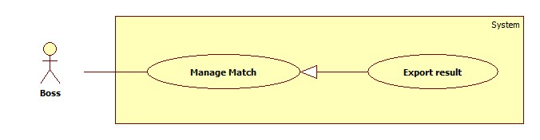

Figure 61: Export result

| **USE CASE SPECIFICATION** | | | |
| --- | --- | --- | --- |
| **Use-case No.** | UC001 | **Use-case Version** | 1.0 |
| **Use-case Name** | Export Result | | |
| **Author** | Trần Tấn Phát | | |
| **Date** | 28/05/2014 | **Priority** | High |
| **Actor:**  Boss.  **Summary:**  When boss want to export match result in pdf file format.  **Goal:**  Export Schedule Usecase will help boss export the match result in pdf file format.  **Triggers:**  Boss go to page “Trang quản lí của chủ sân”.  Boss browses navigation bar and click on tab “Quản lý trận đấu của giải đấu.  Boss choose contest event name in contest event listbox and contest name in contest listbox.  Then click “Xuất pdf lịch và kết quả” button. In pop up click” Tải kết quả” button.  **Preconditions:**  Boss must log in BSF-Website with role “Boss”.  The contest or contest round had result.  **Post Conditions:**  **Success:**   * A list of contest will be showed up in table with paging.   **Failure:**   * The Boss is guided to Error page.   **Main Success Scenario:**   |  |  | | --- | --- | | Actor Actions | System Response | | 1. Boss choose contest event name in contest event listbox then choose contest name in contest listbox. Then click “Xuất pdf lịch và kết quả” button. In pop up click” Tải kết quả” button.   [Alternative 1] | 1. System will export result of each contest in pdf file in your browser.   [Exception 1] |   **Alternative Scenario:**   |  |  | | --- | --- | | Actor Actions | System Response | | [Alternative 1]   1. Boss choose contest event name in contest event listbox then choose contest name in contest listbox, then choose round name of contest. Then click “Xuất pdf lịch và kết quả” button. In pop up click” Tải kết quả” button. | 1. System will export all result of matches by contest round. |   **Exceptions:**   |  |  | | --- | --- | | Actor Actions | System Response | | [Exception 1]   1. System fails to load data. | 1. Show Error page. |   **Relationships:** N/A  **Business Rules:**  User just can export result in pdf file when all matches of contest or contest round have results. | | | |

##### <Boss> View Contest Statistics

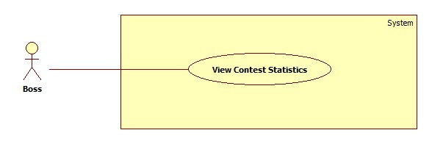

Figure 62: View contest statistics

| **USE CASE SPECIFICATION** | | | |
| --- | --- | --- | --- |
| **Use-case No.** | UC001 | **Use-case Version** | 1.0 |
| **Use-case Name** | View Contest Statistics | | |
| **Author** | Trần Tấn Phát | | |
| **Date** | 28/05/2014 | **Priority** | High |
| **Actor:**  Boss.  **Summary:**  After contest finished, boss can view contest statistic include range of team, the person who have most scores.  **Goal:**  This use case will help boss view contest statistics such as range of participation person’s performance, range of team, most scores person.  **Triggers:**  Boss go to page “Trang quản lí của chủ sân”.  Boss browses navigation bar and click on tab “Thống kê giải của giải đấu”.  Boss choose contest event name in contest event listbox and contest name in contest listbox.  **Preconditions:**  Boss must log in BSF-Website with role “Boss”.  **Post Conditions:**  **Success:**   * A list of contest will be showed up in table with paging.   **Failure:**   * The Boss is guided to Error page.   **Main Success Scenario:**   |  |  | | --- | --- | | Actor Actions | System Response | | 1. Boss choose contest event name in contest event listbox then choose contest name in contest listbox. | 1. System will table of contest statistics by participation registration.   [Exception 1] |   **Alternative Scenario: N/A**  **Exceptions:**   |  |  | | --- | --- | | Actor Actions | System Response | | [Exception 1]   1. System fails to load data. | 1. Show Error page. |   **Relationships:** N/A  **Business Rules:**  Contest statistic will be seen when contest finished and have result all matches of contest. | | | |

##### <Boss> Manage Message

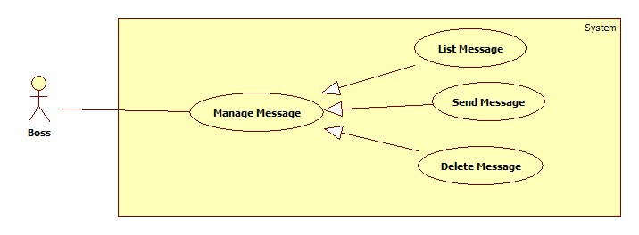

Figure 63: Manage Message.

###### <Boss> List Message

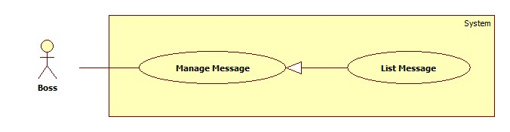

Figure 64: List Message

| **USE CASE SPECIFICATION** | | | |
| --- | --- | --- | --- |
| **Use-case No.** | UC001 | **Use-case Version** | 1.0 |
| **Use-case Name** | List Message | | |
| **Author** | Trần Tấn Phát | | |
| **Date** | 28/05/2014 | **Priority** | High |
| **Actor:**  Boss.  **Summary:**  When Boss want view all messages.  **Goal:**  Show list of messages for boss.  **Triggers:**  Boss go to page “Trang quản lí của chủ sân”.  Boss browses navigation bar and click on tab “Quản lý tin nhắn”.  **Preconditions:**  Boss must log in BSF-Website with role “Boss”.  **Post Conditions:**  **Success:**   * A list of message will be showed up in table with paging.   **Failure:**   * The Boss is guided to Error page.   **Main Success Scenario:**   |  |  | | --- | --- | | Actor Actions | System Response | | 1. Boss click on tab “Quản lý tin nhắn”. | 1. System will show list of messages in table with paging.   [Exception 1] |   **Alternative Scenario:** N/A  **Exceptions:**   |  |  | | --- | --- | | Actor Actions | System Response | | [Exception 1]   1. System fails to load data. | 1. Show Error page. |   **Relationships:** N/A  **Business Rules: N/A** | | | |

###### <Boss>Send Message

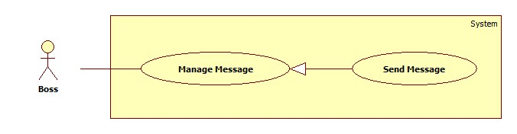

Figure 65: Send message

| **USE CASE SPECIFICATION** | | | |
| --- | --- | --- | --- |
| **Use-case No.** | UC013 | **Use-case Version** | 2.0 |
| **Use-case Name** | Send Message | | |
| **Author** | Trần Tấn Phát | | |
| **Date** | 28/05/2014 | **Priority** | High |
| **Actor:**  Boss  **Summary:**  When boss want to send message to webmaster.  **Goal:**  The purpose of this use case is allowed Boss send message to webmaster.  **Triggers:**  Boss clicks on “Gửi tin nhắn” button  **Preconditions:**  User must logged-in as Boss-role.  **Post Conditions:**  **Success:**   * A message will appear onscreen with successful creation content.   **Failure:**   * The Boss is presented with an error message on screen.   **Main Success Scenario:**   |  |  | | --- | --- | | Actor Actions | System Response | | 1. Boss clicks on the “Gửi tin nhắn”. 2. Boss fills and click “Gửi” button.   [Alternative 1] | 1. The pop up “Gửi tin nhắn” is displayed on screen. Message form includes:  * “Tiêu đề”[title of message, Textbox, required] * “Nội dung”[Content of message, textarea, required] * “Gửi” button. * “Đóng” button.     [Exception 1] [Exception 2]  [Exception 3] [Exception 4]  [Exception 5]   1. The pop up is closed and message is displayed “Đã gửi thành công”. |   **Alternative Scenario:**   |  |  | | --- | --- | | Actor Actions | System Response | | [Alternative 1]   1. Boss click “Đóng” button. | 1. The pop up window is closed. |     **Exceptions:**   |  |  | | --- | --- | | Actor Actions | System Response | | [Exception 1]   1. Message’s “Tiêu đề” is missing.   [Exception 2]   1. The length of message’s “Tiêu đề” is out of range.   [Exception 3]   1. Message’s “Nội dung” is missing.   [Exception 4]   1. The length of message’s “Nội dung” is out of range.   [Exception 5]   1. Cannot send message. | 1. Shows error “Không được để trống!”. 2. Shows error “Tiêu đề quá dài (hơn 250 ký tự). 3. Shows error “Không được để trống!”. 4. Shows error “Nội dung quá dài (hơn 1000 ký tự). 5. Show message “Xảy ra lỗi, xin hãy thử lại!” |   **Relationships:**  N/A  **Business Rules:**  N/A. | | | |

###### <Boss> Delete Message

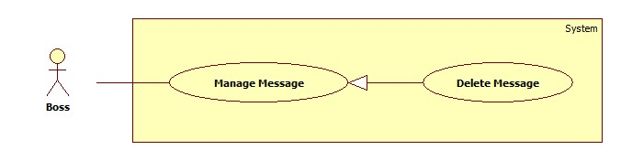

Figure 66:Delete message

| **USE CASE SPECIFICATION** | | | |
| --- | --- | --- | --- |
| **Use-case No.** | UC001 | **Use-case Version** | 2.0 |
| **Use-case Name** | Delete Message | | |
| **Author** | Trần Tấn Phát | | |
| **Date** | 28/05/2014 | **Priority** | High |
| **Actor:**  Boss.  **Summary:**  When boss want delete message  **Goal:**  Help Boss delete message.  **Triggers:**  Boss go to page “Trang quản lí của chủ sân”.  Boss browses navigation bar and click on tab “Quản lý tin nhắn”.  In table list of contest, Boss click on “Xóa tin nhắn” button.  **Preconditions:**  Boss must log in BSF-Website with role “Boss”.  **Post Conditions:**  **Success:**   * A message of sucess will be showed up.   **Failure:**   * The Boss is guided to Error page.   **Main Success Scenario:**   |  |  | | --- | --- | | Actor Actions | System Response | | 1. Boss click “Xóa tin nhắn” button on action column of List Message table. 2. Boss click “Đồng ý” button.   [Alternative 1] | 1. System will show confirm popup.   [Exception 1] [Exception 2]   1. System show success message of delete. |   **Alternative Scenario:**   |  |  | | --- | --- | | Actor Actions | System Response | | [Alternative 1]   1. Boss click “Không” button. | 1. The pop up window is closed. |     **Exceptions:**   |  |  | | --- | --- | | Actor Actions | System Response | | [Exception 1]   1. System cannot load.   [Exception 2]   1. System cannot delete contest. | 1. Show message “Hệ thống không thể kết nối với cơ sở dữ liệu.” 2. Show message “Xảy ra lỗi, xin hãy thử lại!” |   **Relationships:** N/A  **Business Rules:**  N/A | | | |

##### <Boss> Manage Course

###### <Boss> View ListCourse Course

###### <Boss> View Detail Course

###### <Boss> Create Course

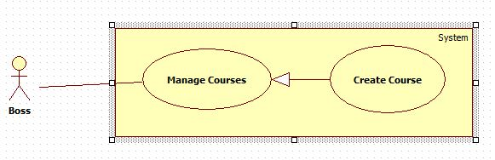

Figure 67: Create course

|  |  |  |  |
| --- | --- | --- | --- |
| **USE CASE – CREATE COURSE INFORMATION SPECIFICATION** | | | |
| **Use Case NO.** | UC-E001 | **Use Case Version** | 1.0 |
| **Use Case Name** | Create Course | | |
| **Author** | ThongND | | |
| **Date** | 10/07/2013 | **Priority** | Normal |
| **Actor:**  Boss  **Summary:**  Boss create new course.  **Goal:**  Boss can create course successfully.  **Triggers:**  On the [Course Manage] page, the Boss click on [+] button. After that, the [Tạo Lớp Mới] page is appears. The Boss input information, and click on [Tạo] button to finish.  **Pre-Conditions:**  The user has already logged in as Boss role.  **Post-Conditions:**   * Success: The Boss create new course successful. A message “Bạn đã tạo lớp mới thành công.” is show on [Course Manage] page. * Failure: An error message “Bạn đã tạo lớp thất bại.” is shown on [Tạo Lớp Mới] Page.   **Main Success Scenario:**   |  |  | | --- | --- | | Actor Action | System Response | | 1. Click on [+] button in the [List Courses] page. | 2. The website will redirect to [Create new course] with:  [Add Your Course Detail] form with:  - Tên Lớp : text box  - Cấp Độ : combobox  - Số Học Viên: text box  - Học Phí : text box  - Lương Giáo Viên : Text box  - Ngày học : Checkbox[thứ 2,3,4,5,6,7, chủ nhật]  - Giờ Bắt Đầu : calendar  - Giờ Kết Thúc : calendar  - Câu Lạc Bộ: combobox  - Sân : combobox  - Hình ảnh: textbox[file]  + [Add new Cấp Độ for course] link [Alternative 1]  + [Thayđổi] link [Alternative 2]  - Button:  + [Trở Lại] button  + [Tạo] button  [Tạo Cấp Độ] form popup:  - Tên Cấp Độ : Text box | | 3. Enter information into fields. | 4. [Exception 1, 3, 5, 7,9] | | 5. Click on [Tạo] button | 6. System show message: “Bạn đã Tạo lớp học mới thành công.” |   **Alternative Scenario:**   |  |  | | --- | --- | | Actor Action | System Response | | 1. Click on [Tạo Cấp Độ] link | 2. System show form [Tọa Cấp Độ] popup text box for boss add new Level. | | 3. Click on [Trở Lại] link | 4. System show [Organizer Name] text box for Attendees edit |   **Exceptions:**   |  |  | | --- | --- | | Actor Action | System Response | | 1. All fields are blank. | 2. Show error message: “Xin điền vào chỗ trống ” on the fields that is blank | | 3. The image which uploaded is more 2 MB | 4. Show error message: “Xin up 1 ảnh dưới 2MB” | | 5. [Ngày Học ] there are a least one day are chosen | 6. Show error message: “Vui long chọn ít nhất 1 ngày học.” | | 7. [Số học viên], [Số Tiết Học], [Học Phí], [Lương Giáo Viên] is not a number | 8. Display error message: “xin điền vào là dạng số [0-9].” | | 9. [Tên Lớp] field is exist. | 9. Display error message: “Tên lớp đã được sử dụng.” |   **Relationships:**  Login use case, View List Courses use case.  **Business Rules:**  When a Boss chose [Giờ Bắt Đầu], the system will generate [Giờ Kết Thúc] one hour later than [Giờ Bắt Đầu]. And [Giờ Kết Thúc] can chose early than it.  When a Boss chose [Giờ Bắt Đầu], [Giờ Kết Thúc], [Câu Lạc Bộ], the system will get all available courts(courts of stadium that was created by the Boss are free) show on combobox [Sân]. | | | |

###### <Boss> Edit Course

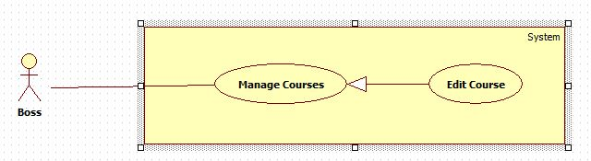

Figure 68: Edit course

|  |  |  |  |
| --- | --- | --- | --- |
| **USE CASE – EDIT COURSE INFORMATION SPECIFICATION** | | | |
| **Use Case NO.** | UC-E001 | **Use Case Version** | 1.0 |
| **Use Case Name** | Edit Course | | |
| **Author** | ThongND | | |
| **Date** | 10/07/2013 | **Priority** | Normal |
| **Actor:**  Boss  **Summary:**  Boss edit new course.  **Goal:**  Boss can edit course successfully.  **Triggers:**  On the [Course Manage] page, the Boss click on [Sửa] button. After that, the [Sửa Lớp ] page is appears. The Boss input information, and click on [Sửa] button to finish.  **Pre-Conditions:**  The user has already logged in as Boss role.  **Post-Conditions:**   * Success: The Boss edit new course successful. A message “Bạn đã sửa lớp thành công.” is show on [Course Manage] page. * Failure: An error message “Bạn đã sửa lớp thất bại.” is shown on [Tạo Lớp Mới] Page.   **Main Success Scenario:**   |  |  | | --- | --- | | Actor Action | System Response | | 1. Click on [Sửa] button in the [List Courses] page. | 2. The website will redirect to [Create new course] with:  [Edit Your Course Detail] form with:  - Tên Lớp : text box  - Cấp Độ : combobox  - Số Học Viên: text box  - Học Phí : text box  - Lương Giáo Viên : Text box  - Ngày học : Checkbox[thứ 2,3,4,5,6,7, chủ nhật]  - Giờ Bắt Đầu : calendar  - Giờ Kết Thúc : calendar  - Câu Lạc Bộ: combobox  - Sân : combobox  - Hình ảnh: textbox[file]  + [Add new Cấp Độ for course] link [Alternative 1]  + [Thayđổi] link [Alternative 2]  - Button:  + [Trở Lại] button  + [Tạo] button  [Create Cấp Độ] form popup:  - Tên Cấp Độ : Text box | | 3. Enter information into fields. | 4. [Exception 1, 3, 5, 7,9] | | 5. Click on [Sửa] button | 6. System show message: “Bạn đã Tạo lớp học mới thànhcông.” |   **Alternative Scenario:**   |  |  | | --- | --- | | Actor Action | System Response | | 1. Click on [Tạo Cấp Độ] link | 2. System show form [Tọa Cấp Độ] popup text box for boss add new Level. | | 3. Click on [Trở Lại] link | 4. System show [Organizer Name] text box for Attendees edit |   **Exceptions:**   |  |  | | --- | --- | | Actor Action | System Response | | 1. All fields are blank. | 2. Show error message: “Xin điền vào chỗ trống ” on the fields that is blank | | 3. The image which uploaded is more 2 MB | 4. Show error message: “Xin up 1 ảnh dưới 2MB” | | 5. [Ngày Học ] there are a least one day are chosen | 6. Show error message: “Vui long chọn ít nhất 1 ngày học.” | | 7. [Số học viên], [Số Tiết Học], [Học Phí], [Lương Giáo Viên] is not a number | 8. Display error message: “xin điền vào là dạng số [0-9].” | | 9. [Tên Lớp] field is exist. | 9. Display error message: “Tên lớp đã được sử dụng.” |   **Relationships:**  Login use case, View List Courses use case.  **Business Rules:**  When a Boss chose [Giờ Bắt Đầu], the system will generate [Giờ Kết Thúc] one hour later than [Giờ Bắt Đầu]. And [Giờ Kết Thúc] can chose early than it.  When a Boss chose [Giờ Bắt Đầu], [Giờ Kết Thúc], [Câu Lạc Bộ], the system will get all available courts(courts of stadium that was created by the Boss are free) show on combobox [Sân]. | | | |

###### <Boss> Delete Course

###### <Boss> Comment Course

###### <Boss> Delete Comment Course

###### <Boss> View List Register Course

###### <Boss> Confirm Join Course

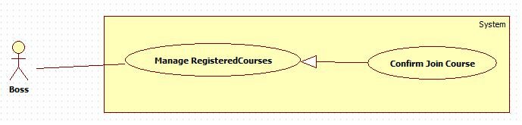

Figure 69: Confirm Join course

|  |  |  |  |
| --- | --- | --- | --- |
| **USE CASE – CONFIRM JOIN COURSE INFORMATION SPECIFICATION** | | | |
| **Use Case NO.** | UC-E001 | **Use Case Version** | 1.0 |
| **Use Case Name** | Confirm Join Course | | |
| **Author** | ThongND | | |
| **Date** | 10/07/2013 | **Priority** | Normal |
| **Actor:**  Boss  **Summary:**  Boss confirm request join course of Player.  **Goal:**  Boss confirm request join course of Player successfully.  **Triggers:**  On the [Course Manage] page, the Boss click on [Danh sách ĐK sân] button. After that, the [Register Course Manage ] page is appears. The Boss click on [Xác Nhận] button, the popup [Xác Nhận] and then click on [Tiếp Tục] button to finish.  **Pre-Conditions:**  The user has already logged in as Boss role.  **Post-Conditions:**   * Success: The Boss confirm join course successful. A message “Xác nhân học viên đã tham gia lớp học thành công.” is show on [Register Course Manage] page. * Failure: An error message “Xác nhân học viên tham gia lớp học thất bại.” is shown on [Register Course Manage] Page.   **Main Success Scenario:**   |  |  | | --- | --- | | Actor Action | System Response | | 1. Click on [Xác Nhận] button on the row of Player that you want to confirm in the [List Register Courses] page. | 2. The website will show popup [Xác Nhận Đăng Ký Lớp] with:  - Thông Báo : Label  - Button:  + [Hủy] button  + [Tiếp Tục] button | | 3. Click on [Tiếp Tục] button | 4. System show message: “Xác nhân học viên đã tham gia lớp học thành công.”  [Exception 1] |   **Alternative Scenario:**   |  |  | | --- | --- | | Actor Action | System Response | | 1. Click on [Hủy] link | 2. The popup [Xác Nhận Đăng Ký Lớp] is closed. |   **Exceptions:**   |  |  | | --- | --- | | Actor Action | System Response | | 1. Click on [Tiếp Tục] button | 2. There are exception in the system. Show error message: “Xác nhận học viên tham gia lớp học thất bại.” on the fields that is blank |   **Relationships:**  Login use case, View List Register Courses use case.  **Business Rules:**  When Boss click on [Tiếp Tục] button, the system will calculator the end day of course for the register course. The Course have the start day, the days of week that player study, the number of period course, so the system must be calculator the end day from them. | | | |

###### <Boss> Confirm Change Course

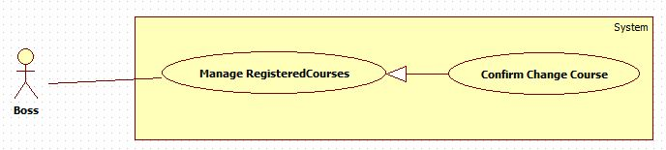

Figure 70: comfirm change course

|  |  |  |  |
| --- | --- | --- | --- |
| **USE CASE – CONFIRM CHANGE COURSE INFORMATION SPECIFICATION** | | | |
| **Use Case NO.** | UC-E001 | **Use Case Version** | 1.0 |
| **Use Case Name** | Confirm Change Course | | |
| **Author** | ThongND | | |
| **Date** | 10/07/2013 | **Priority** | Normal |
| **Actor:**  Boss  **Summary:**  Boss confirm request change course of Player.  **Goal:**  Boss confirm request change course of Player successfully.  **Triggers:**  On the [Course Manage] page, the Boss click on [Danh sách ĐK sân] button. After that, the [Register Course Manage ] page is appears. The Boss click on [Xác Nhận] button, and then click on [Tiếp Tục] button to finish.  **Pre-Conditions:**  The user has already logged in as Boss role.  **Post-Conditions:**   * Success: The Boss confirm join course successful. A message “Xác nhân học viên đã tham gia lớp học thành công.” is show on [Register Course Manage] page. * Failure: An error message “Xác nhân học viên tham gia lớp học thất bại.” is shown on [Register Course Manage] Page.   **Main Success Scenario:**   |  |  | | --- | --- | | Actor Action | System Response | | 1. Click on [Xác Nhận] button on the row of Player that you want to confirm in the [List Register Courses] page. | 2. The website will show popup [Xác Nhận Đăng Ký Lớp] with:  - Thông Báo : Label  - Button:  + [Hủy] button  + [Tiếp Tục] button | | 3. Click on [Tiếp Tục] button | 4. System show message: “Xác nhân học viên đã tham gia lớp học thành công.”  [Exception 1] |   **Alternative Scenario:**   |  |  | | --- | --- | | Actor Action | System Response | | 1. Click on [Hủy] link | 2. The popup [Xác Nhận Đăng Ký Lớp] is closed. |   **Exceptions:**   |  |  | | --- | --- | | Actor Action | System Response | | 1. Click on [Tiếp Tục] button | 2. There are exception in the system. Show error message: “Xác nhận học viên tham gia lớp học thất bại.” on the fields that is blank |   **Relationships:**  Login use case, View List Register Courses use case.  **Business Rules:**  When Boss click on [Tiếp Tục] button, the system will calculator the end day of course for the register change course. The Course have the start day, the days of week that player study, the number of period course and now so the system can calculator number period that player studied and the money that player left. Then system calculator end day of new course from start day, the days of week that player study, the number of period new course and money left. | | | |

##### < Webmaster > Manage Stadium Registers

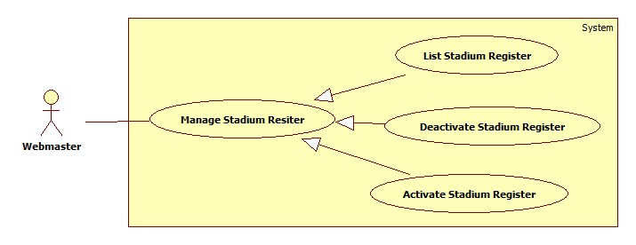

Figure 71: List Stadium Registers

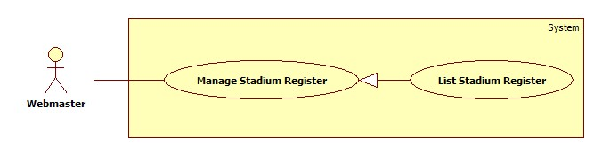

| **USE CASE SPECIFICATION** | | | |
| --- | --- | --- | --- |
| **Use-case No.** | UC001 | **Use-case Version** | 1.0 |
| **Use-case Name** | List Stadium Registers | | |
| **Author** | Trần Tấn Phát | | |
| **Date** | 28/05/2014 | **Priority** | High |
| **Actor:**  Webmaster.  **Summary:**  When Webmaster want view all stadium registrations of boss.  **Goal:**  Show list of stadium registrations of boss for Webmaster.  **Triggers:**  Webmaster go to page “Trang quản lí của quản trị viên”.  Webmaster browses navigation bar and click on tab “Quản lý đăng kí sân”.  **Preconditions:**  Webmaster must log in BSF-Website with role “Webmaster”.  **Post Conditions:**  **Success:**   * A list of stadium registers will be showed up in table with paging.   **Failure:**   * The Webmaster is guided to Error page.   **Main Success Scenario:**   |  |  | | --- | --- | | Actor Actions | System Response | | 1. Webmaster click on tab “Quản lý đăng kí sân”. | 1. System will show list of boss’s Stadium registers in table with paging.   [Exception 1] |   **Alternative Scenario:** N/A  **Exceptions:**   |  |  | | --- | --- | | Actor Actions | System Response | | [Exception 1]   1. System fails to load data. | 1. Show Error page. |   **Relationships:** N/A  **Business Rules: N/A** | | | |

###### < Webmaster > Deactivate Stadium Register

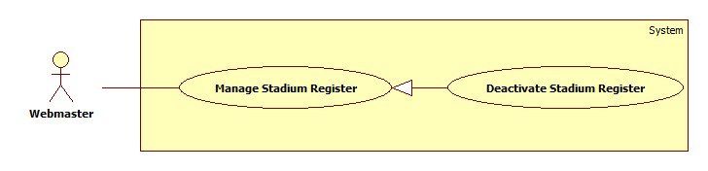

Figure 72: Deactive stadium register

| **USE CASE SPECIFICATION** | | | |
| --- | --- | --- | --- |
| **Use-case No.** | UC001 | **Use-case Version** | 2.0 |
| **Use-case Name** | Deactivate Stadium Register | | |
| **Author** | Trần Tấn Phát | | |
| **Date** | 28/05/2014 | **Priority** | High |
| **Actor:**  Webmaster.  **Summary:**  When webmaster want to deactivate stadium register of boss.  **Goal:**  This use case will help webmaster deactivate one stadium register.  **Triggers:**  Webmaster wants to deactivate stadium register.  Webmaster clicks on “Khóa” button on “Thao tác” column of Stadium register List table.  **Preconditions:**  Webmaster must log in BSF-Website with role “Webmaster”.  And there are more than one stadium register in table.  **Post Conditions:**  **Success:**   * A message of sucess will be showed up.   **Failure:**   * The Webmaster is guided to Error page.   **Main Success Scenario:**   |  |  | | --- | --- | | Actor Actions | System Response | | 1. Webmaster click “Khóa đăng kí sân” button on action column of Stadium Register table. 2. Webmaster click “Đồng ý” button.   [Alternative 1] | 1. System will show confirm popup.   [Exception 1] [Exception 2]   1. System show success message of deactivate. |   **Alternative Scenario:**   |  |  | | --- | --- | | Actor Actions | System Response | | [Alternative 1]   1. Webmaster click “Không” button. | 1. The pop up window is closed. |     **Exceptions:**   |  |  | | --- | --- | | Actor Actions | System Response | | [Exception 1]   1. System cannot load.   [Exception 2]   1. System cannot deactivate stadium register. | 1. Show message “Hệ thống không thể kết nối với cơ sở dữ liệu.” 2. Show message “Xảy ra lỗi, xin hãy thử lại!” |   **Relationships:** Activate Stadium Register Usecase  **Business Rules:**  Webmaster deactivate of stadium register it means all operating of stadium will not be public for players. | | | |

###### < Webmaster > Activate Stadium Register

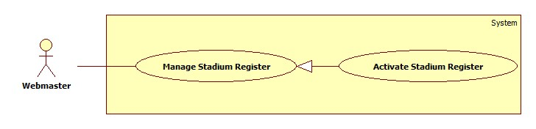

Figure 73: Activate stadium register

| **USE CASE SPECIFICATION** | | | |
| --- | --- | --- | --- |
| **Use-case No.** | UC001 | **Use-case Version** | 2.0 |
| **Use-case Name** | Activate Stadium Register | | |
| **Author** | Trần Tấn Phát | | |
| **Date** | 28/05/2014 | **Priority** | High |
| **Actor:**  Webmaster.  **Summary:**  When webmaster want to activate stadium register of boss.  **Goal:**  This use case will help webmaster activate one stadium register.  **Triggers:**  Webmaster wants to activate stadium register.  Webmaster clicks on “Mở Khóa” button on “Thao tác” column of Stadium register List table.  **Preconditions:**  Webmaster must log in BSF-Website with role “Webmaster”.  And there are more than one stadium register be deactivate in table.  **Post Conditions:**  **Success:**   * A message of sucess will be showed up.   **Failure:**   * The Webmaster is guided to Error page.   **Main Success Scenario:**   |  |  | | --- | --- | | Actor Actions | System Response | | 1. Webmaster click “Mở khóa” button on action column of Stadium Register table. 2. Webmaster click “Đồng ý” button.   [Alternative 1] | 1. System will show confirm popup.   [Exception 1] [Exception 2]   1. System show success message of activate. |   **Alternative Scenario:**   |  |  | | --- | --- | | Actor Actions | System Response | | [Alternative 1]   1. Webmaster click “Không” button. | 1. The pop up window is closed. |     **Exceptions:**   |  |  | | --- | --- | | Actor Actions | System Response | | [Exception 1]   1. System cannot load.   [Exception 2]   1. System cannot activate stadium register. | 1. Show message “Hệ thống không thể kết nối với cơ sở dữ liệu.” 2. Show message “Xảy ra lỗi, xin hãy thử lại!” |   **Relationships:**  Deactivate Stadium Register Usecase  **Business Rules:**  Webmaster activate of stadium register when it be deactivate before. | | | |

##### < Webmaster > Manage Stadium Register Price

###### <Admin> Add stadium rent price

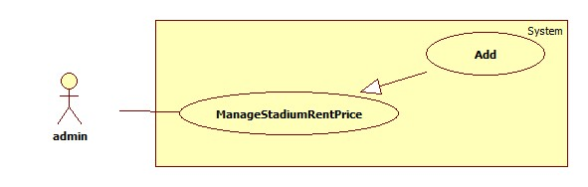

Figure 74:Add stadium rent price

|  |  |  |  |  |
| --- | --- | --- | --- | --- |
| **USE CASE – tên usecase** | | | | |
| **Use-case No.** |  | **Use-case Version** | | 2.0 |
| **Use-case Name** | Add stadium rent price | | | |
| **Author** |  | | | |
| **Date** |  | **Priority** | Normal | |
| **Actor:**  admin  **Summary:**  **Goal:**  admin can add new stadium rent price.  **Triggers:**  \_ Click on [Thêm bảng giá thuê sân mới] button on [StadiumRegisterPrice] page.  \_Fill data  \_Click on [Đồng ý] button  **Preconditions:**   * Page is loaded successfully. * User has already created an account in system.   **Post Conditions:**   * Success: redirect to “StadiumRegisterPrice” * Failure: show error message “Thêm bảng giá mới thất bại”   **Main Success Scenario:**   |  |  | | --- | --- | | Actor Action | System Response | | 1. Click on [Thêm bảng giá thuê sân mới] button on [StadiumRegisterPrice] page. | 1. Redirect to “AddNewPriceRegis” page with form include:  * Thời gian thuê: textbox * Giá thuê: textbox * Trạng thái: Dropdown-list   + Đang áp dụng  +Ngừng áp dụng | | 1. Fill all data | 1. Exception [1,3] | | 1. Click on [Đồng ý] button to finish   [Alternative 1] | 1. Redirect to [StadiumRegisterPrice] page |   **Alternative Scenario:**   |  |  | | --- | --- | | Actor Action | System Response | | 1. Click on [Hủy] button | 1. Redirect to “StadiumRegisterPrice” page |   **Exceptions:**   |  |  | | --- | --- | | Actor Action | System Response | | 1. All fields are blank | 1. Show error message “Vui lòng không bỏ trống” | | 1. Field [Giá thuê] is not a number | 1. Show error message “Vui lòng nhập số” |   **Relationships:** Login usecase  **Business Rules:** N/A | | | | |

###### <Admin> Update stadium rent price

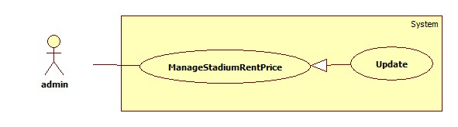

Figure 75:update stadium rent price

|  |  |  |  |  |
| --- | --- | --- | --- | --- |
| **USE CASE – tên usecase** | | | | |
| **Use-case No.** |  | **Use-case Version** | | 2.0 |
| **Use-case Name** | update stadium rent price | | | |
| **Author** |  | | | |
| **Date** |  | **Priority** | Normal | |
| **Actor:**  admin  **Summary:**  **Goal:**  admin can update stadium rent price.  **Triggers:**  \_ Click on [Chỉnh sửa] button on [StadiumRegisterPrice] page.  \_Fill data to change  \_Click on [Cập nhật] button  **Preconditions:**   * Page is loaded successfully. * User has already created an account in system.   **Post Conditions:**   * Success: show message “Cập nhật bảng giá thành công” * Failure: show error message “Thêm bảng giá mới thất bại”   **Main Success Scenario:**   |  |  | | --- | --- | | Actor Action | System Response | | 1. Click on [Chỉnh sửa] button on [StadiumRegisterPrice] page. | 1. Redirect to “UpdateRegisStadiumPrice” page with form include:  * Thời gian thuê: textbox * Giá thuê: textbox * Trạng thái: Dropdown-list   + Đang áp dụng  +Ngừng áp dụng | | 1. Fill data to change | 1. Exception [1,3] | | 1. Click on [Cập nhật] button to finish   [Alternative] | 1. show message “Cập nhật bảng giá thành công” |   **Alternative Scenario:**   |  |  | | --- | --- | | Actor Action | System Response | | 1. Click on [Hủy] button | 1. Redirect to “StadiumRegisterPrice” page |   **Exceptions:**   |  |  | | --- | --- | | Actor Action | System Response | | 1. All fields are blank | 1. Show error message “Vui lòng không bỏ trống” | | 1. Field [Giá thuê] is not a number | 1. Show error message “Vui lòng nhập số” |   **Relationships:** Login usecase  **Business Rules:** N/A | | | | |

##### < Webmaster > Manage Account

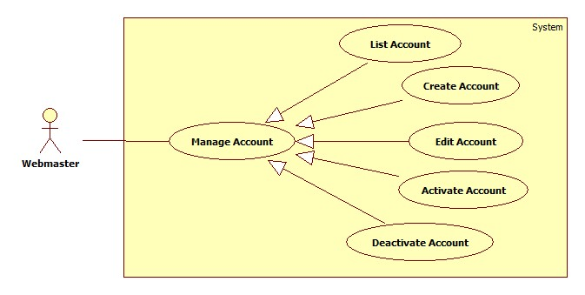

Figure 76: Manage account

###### <Webmaster> List Account

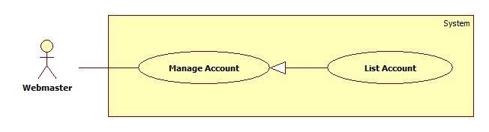

Figure 77: List account

| **USE CASE SPECIFICATION** | | | |
| --- | --- | --- | --- |
| **Use-case No.** | UC001 | **Use-case Version** | 1.0 |
| **Use-case Name** | List Account | | |
| **Author** | Trần Tấn Phát | | |
| **Date** | 28/05/2014 | **Priority** | High |
| **Actor:**  Webmaster.  **Summary:**  When Webmaster want view all accounts  **Goal:**  Show list of account of boss for Webmaster.  **Triggers:**  Webmaster go to page “Trang quản lí của quản trị viên”.  Webmaster browses navigation bar and click on tab “Quản lý tài khoản”  **Preconditions:**  Webmaster must log in BSF-Website with role “Webmaster”.  **Post Conditions:**  **Success:**   * A list of account will be showed up in table with paging.   **Failure:**   * The Webmaster is guided to Error page.   **Main Success Scenario:**   |  |  | | --- | --- | | Actor Actions | System Response | | 1. Webmaster click on tab “Quản lý tài khoản”. | 1. System will show list of user’s account in table with paging.   [Exception 1] |   **Alternative Scenario:** N/A  **Exceptions:**   |  |  | | --- | --- | | Actor Actions | System Response | | [Exception 1]   1. System fails to load data. | 1. Show Error page. |   **Relationships:** N/A  **Business Rules: N/A** | | | |

###### <Webmaster> Create Account

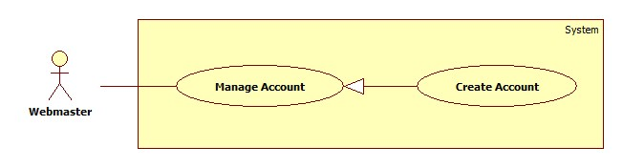

Figure 78: Create account

| **USE CASE SPECIFICATION** | | | |
| --- | --- | --- | --- |
| **Use-case No.** | UC013 | **Use-case Version** | 2.0 |
| **Use-case Name** | Create Account | | |
| **Author** | Trần Tấn Phát | | |
| **Date** | 28/05/2014 | **Priority** | High |
| **Actor:**  Webmaster  **Summary:**  When webmaster want to create new accountin BSF-Website.  **Goal:**  The purpose of this use case is allowed Webmaster create account.  **Triggers:**  Webmaster wants to create account  Webmaster clicks on “Tạo mới tài khoản” button.  **Preconditions:**  User must logged-in as Webmaster-role.  **Post Conditions:**  **Success:**   * A message will appear onscreen with successful creation content.   **Failure:**   * The Webmaster is presented with an error message on screen.   **Main Success Scenario:**   |  |  | | --- | --- | | Actor Actions | System Response | | 1. Webmaster clicks on the “Tạo mới tài khoản” button. 2. Webmaster fills required information and clicks on “Lưu” button.   [Alternative 1] | 1. The pop up “Thêm mới tài khoản” is displayed on screen. Account form includes:  * “Tên tài khoàn” [UserName of account, textbox,required] * “Tên” [Name of account, textbox,required] * “Vai trò” [Role of account, textbox,required] * “Địa chỉ” [UserName of account, textbox,required] * “Lưu” button. * “Đóng” button.     [Exception 1] [Exception 2]   1. The pop up is closed and message is displayed “Đã tạo mới tài khoản thành công”. |   **Alternative Scenario:**   |  |  | | --- | --- | | Actor Actions | System Response | | [Alternative 1]   1. Webmaster click “Đóng” button. | 1. The pop up window is closed. |     **Exceptions:**   |  |  | | --- | --- | | Actor Actions | System Response | | [Exception 1]   1. Not enough required information.   [Exception 1]   1. Cannot save new account. | 1. Shows error “Nhập đầy đủ!. 2. Shows error “Có lỗi xảy ra vui lòng thử lại!. |   **Relationships:**  N/A  **Business Rules:**  N/A | | | |

###### <Webmaster> Edit Account

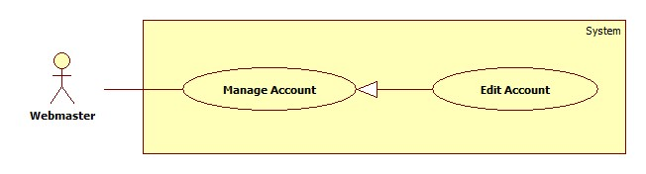

Figure 79: Edit account

| **USE CASE SPECIFICATION** | | | |
| --- | --- | --- | --- |
| **Use-case No.** | UC013 | **Use-case Version** | 2.0 |
| **Use-case Name** | Edit Account | | |
| **Author** | Trần Tấn Phát | | |
| **Date** | 28/05/2014 | **Priority** | High |
| **Actor:**  Webmaster  **Summary:**  When webmaster want to edit account in BSF-Website.  **Goal:**  The purpose of this use case is allowed Webmaster edit account.  **Triggers:**  Webmaster wants to edit account  Webmaster clicks on “Sửa tài khoản” button.  **Preconditions:**  User must logged-in as Webmaster-role.  **Post Conditions:**  **Success:**   * A message will appear onscreen with successful content.   **Failure:**   * The Webmaster is presented with an error message on screen.   **Main Success Scenario:**   |  |  | | --- | --- | | Actor Actions | System Response | | 1. Webmaster clicks on the “Chỉnh sửa tài khoản” button. 2. Webmaster fills required information and clicks on “Lưu” button.   [Alternative 1] | 1. The pop up “Chỉnh sửa tài khoản” is displayed on screen. Account form includes:  * “Tên” [Name of account, textbox,required] * “Vai trò” [Role of account, textbox,required] * “Địa chỉ” [UserName of account, textbox,required] * “Lưu” button. * “Đóng” button.     [Exception 1] [Exception 2]   1. The pop up is closed and message is displayed “Đã chỉnh sửa tài khoản thành công”. |   **Alternative Scenario:**   |  |  | | --- | --- | | Actor Actions | System Response | | [Alternative 1]   1. Webmaster click “Đóng” button. | 1. The pop up window is closed. |     **Exceptions:**   |  |  | | --- | --- | | Actor Actions | System Response | | [Exception 1]   1. Not enough required information.   [Exception 1]   1. Cannot save edit account. | 1. Shows error “Nhập đầy đủ!. 2. Shows error “Có lỗi xảy ra vui lòng thử lại!. |   **Relationships:**  N/A  **Business Rules:**  N/A | | | |

###### <Webmaster> Activate Account

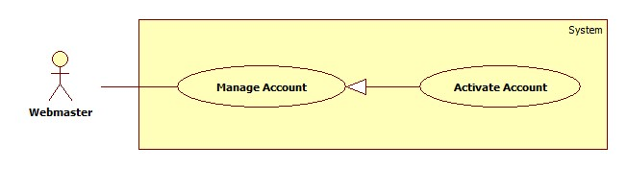

Figure 80: Activate account

| **USE CASE SPECIFICATION** | | | |
| --- | --- | --- | --- |
| **Use-case No.** | UC001 | **Use-case Version** | 2.0 |
| **Use-case Name** | Activate Account | | |
| **Author** | Trần Tấn Phát | | |
| **Date** | 28/05/2014 | **Priority** | High |
| **Actor:**  Webmaster.  **Summary:**  When webmaster want to activate account.  **Goal:**  This use case will help webmaster activate one account.  **Triggers:**  Webmaster wants to activate account.  Webmaster clicks on “Mở Khóa” button on “Thao tác” column of account List table.  **Preconditions:**  Webmaster must log in BSF-Website with role “Webmaster”.  And there are more than one account in table be deactivated.  **Post Conditions:**  **Success:**   * A message of sucess will be showed up.   **Failure:**   * The Webmaster is guided to Error page.   **Main Success Scenario:**   |  |  | | --- | --- | | Actor Actions | System Response | | 1. Webmaster click “Mở Khóa tài khoản” button on action column of account table. 2. Webmaster click “Đồng ý” button.   [Alternative 1] | 1. System will show confirm popup.   [Exception 1] [Exception 2]   1. System show success message of deactivate. |   **Alternative Scenario:**   |  |  | | --- | --- | | Actor Actions | System Response | | [Alternative 1]   1. Webmaster click “Không” button. | 1. The pop up window is closed. |     **Exceptions:**   |  |  | | --- | --- | | Actor Actions | System Response | | [Exception 1]   1. System cannot load.   [Exception 2]   1. System cannot activate account. | 1. Show message “Hệ thống không thể kết nối với cơ sở dữ liệu.” 2. Show message “Xảy ra lỗi, xin hãy thử lại!” |   **Relationships:** Deactivate Account Usecase  **Business Rules:**  N/A | | | |

###### <Webmaster> Deactivate Account

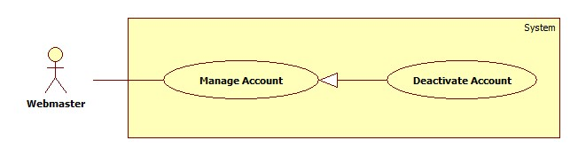

Figure 81: Deactivate account

| **USE CASE SPECIFICATION** | | | |
| --- | --- | --- | --- |
| **Use-case No.** | UC001 | **Use-case Version** | 2.0 |
| **Use-case Name** | Deactivate Account | | |
| **Author** | Trần Tấn Phát | | |
| **Date** | 28/05/2014 | **Priority** | High |
| **Actor:**  Webmaster.  **Summary:**  When webmaster want to deactivate account.  **Goal:**  This use case will help webmaster deactivate one account.  **Triggers:**  Webmaster wants to deactivate account.  Webmaster clicks on “Khóa” button on “Thao tác” column of account List table.  **Preconditions:**  Webmaster must log in BSF-Website with role “Webmaster”.  And there are more than one account in table.  **Post Conditions:**  **Success:**   * A message of sucess will be showed up.   **Failure:**   * The Webmaster is guided to Error page.   **Main Success Scenario:**   |  |  | | --- | --- | | Actor Actions | System Response | | 1. Webmaster click “Khóa tài khoản” button on action column of account table. 2. Webmaster click “Đồng ý” button.   [Alternative 1] | 1. System will show confirm popup.   [Exception 1] [Exception 2]   1. System show success message of deactivate. |   **Alternative Scenario:**   |  |  | | --- | --- | | Actor Actions | System Response | | [Alternative 1]   1. Webmaster click “Không” button. | 1. The pop up window is closed. |     **Exceptions:**   |  |  | | --- | --- | | Actor Actions | System Response | | [Exception 1]   1. System cannot load.   [Exception 2]   1. System cannot deactivate account. | 1. Show message “Hệ thống không thể kết nối với cơ sở dữ liệu.” 2. Show message “Xảy ra lỗi, xin hãy thử lại!” |   **Relationships:** Activate Account Usecase  **Business Rules:**  Webmaster deactivate of account it means all operating of account will not be public for players. | | | |

##### < Webmaster > Manage Message

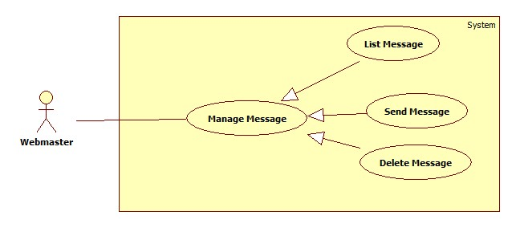

Figure 82:Manage Message

###### <Webmaster> List Message

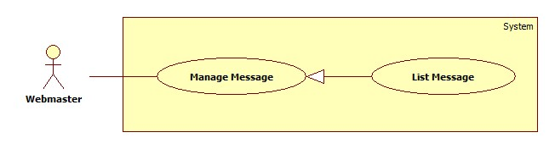

Figure 83: List Message

| **USE CASE SPECIFICATION** | | | |
| --- | --- | --- | --- |
| **Use-case No.** | UC001 | **Use-case Version** | 1.0 |
| **Use-case Name** | List Message | | |
| **Author** | Trần Tấn Phát | | |
| **Date** | 28/05/2014 | **Priority** | High |
| **Actor:**  Webmaster.  **Summary:**  When Webmaster want view all messages.  **Goal:**  Show list of messages for webmaster.  **Triggers:**  Webmaster go to page “Trang quản lí của quản trị viên”.  Webmaster browses navigation bar and click on tab “Quản lý tin nhắn”.  **Preconditions:**  Webmaster must log in BSF-Website with role “Webmaster”.  **Post Conditions:**  **Success:**   * A list of message will be showed up in table with paging.   **Failure:**   * The Webmaster is guided to Error page.   **Main Success Scenario:**   |  |  | | --- | --- | | Actor Actions | System Response | | 1. Webmaster click on tab “Quản lý tin nhắn”. | 1. System will show list of messages in table with paging.   [Exception 1] |   **Alternative Scenario:** N/A  **Exceptions:**   |  |  | | --- | --- | | Actor Actions | System Response | | [Exception 1]   1. System fails to load data. | 1. Show Error page. |   **Relationships:** N/A  **Business Rules: N/A** | | | |

###### <Webmaster> Send Message

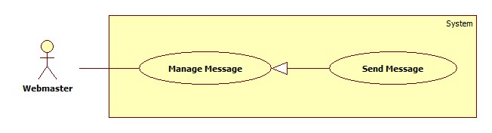

Figure 84: Send message

| **USE CASE SPECIFICATION** | | | |
| --- | --- | --- | --- |
| **Use-case No.** | UC013 | **Use-case Version** | 2.0 |
| **Use-case Name** | Send Message | | |
| **Author** | Trần Tấn Phát | | |
| **Date** | 28/05/2014 | **Priority** | High |
| **Actor:**  Webmaster  **Summary:**  When Webmaster want to send message.  **Goal:**  The purpose of this use case is allowed Webmaster send message.  **Triggers:**  Webmaster clicks on “Gửi tin nhắn” button  **Preconditions:**  User must logged-in as Webmaster -role.  **Post Conditions:**  **Success:**   * A message will appear onscreen with successful creation content.   **Failure:**   * The Webmaster is presented with an error message on screen.   **Main Success Scenario:**   |  |  | | --- | --- | | Actor Actions | System Response | | 1. Webmaster clicks on the “Gửi tin nhắn”. 2. Webmaster fills required information and click “Gửi” button.   [Alternative 1] | 1. The pop up “Gửi tin nhắn” is displayed on screen. Message form includes:  * “Tiêu đề”[title of message, Textbox, required] * “Nội dung”[Content of message, textarea, required] * “Gửi” button. * “Đóng” button.     [Exception 1] [Exception 2]  [Exception 3] [Exception 4]  [Exception 5]   1. The pop up is closed and message is displayed “Đã gửi thành công”. |   **Alternative Scenario:**   |  |  | | --- | --- | | Actor Actions | System Respnse | | [Alternative 1]   1. Webmaster click “Đóng” button. | 1. The pop up window is closed. |     **Exceptions:**   |  |  | | --- | --- | | Actor Actions | System Response | | [Exception 1]   1. Message’s “Tiêu đề” is missing.   [Exception 2]   1. The length of message’s “Tiêu đề” is out of range.   [Exception 3]   1. Message’s “Nội dung” is missing.   [Exception 4]   1. The length of message’s “Nội dung” is out of range.   [Exception 5]   1. Cannot send message. | 1. Shows error “Không được để trống!”. 2. Shows error “Tiêu đề quá dài (hơn 250 ký tự). 3. Shows error “Không được để trống!”. 4. Shows error “Nội dung quá dài (hơn 1000 ký tự). 5. Show message “Xảy ra lỗi, xin hãy thử lại!” |   **Relationships:**  N/A  **Business Rules:**  N/A. | | | |

###### <Webmaster>Delete Message

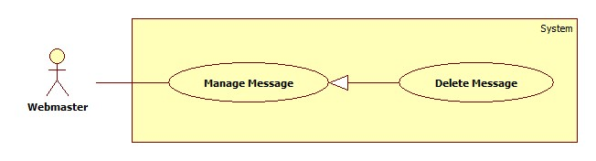

Figure 85: Delete Message

| **USE CASE SPECIFICATION** | | | |
| --- | --- | --- | --- |
| **Use-case No.** | UC001 | **Use-case Version** | 2.0 |
| **Use-case Name** | Delete Message | | |
| **Author** | Trần Tấn Phát | | |
| **Date** | 28/05/2014 | **Priority** | High |
| **Actor:**  Webmaster  **Summary:**  When webmaster want delete message  **Goal:**  Help webmaster delete message.  **Triggers:**  Webmaster go to page “Trang quản lí của quản trị viên”.  Webmaster browses navigation bar and click on tab “Quản lý tin nhắn”.  In table list of contest, Boss click on “Xóa tin nhắn” button.  **Preconditions:**  Webmaster must log in BSF-Website with role “Webmaster”.  **Post Conditions:**  **Success:**   * A message of sucess will be showed up.   **Failure:**   * The Webmaster is guided to Error page.   **Main Success Scenario:**   |  |  | | --- | --- | | Actor Actions | System Response | | 1. Webmaster click “Xóa tin nhắn” button on action column of List Message table. 2. Webmaster click “Đồng ý” button.   [Alternative 1] | 1. System will show confirm popup.   [Exception 1] [Exception 2]   1. System show success message of delete. |   **Alternative Scenario:**   |  |  | | --- | --- | | Actor Actions | System Response | | [Alternative 1]   1. Webmaster click “Không” button. | 1. The pop up window is closed. |     **Exceptions:**   |  |  | | --- | --- | | Actor Actions | System Response | | [Exception 1]   1. System cannot load.   [Exception 2]   1. System cannot delete contest. | 1. Show message “Hệ thống không thể kết nối với cơ sở dữ liệu.” 2. Show message “Xảy ra lỗi, xin hãy thử lại!” |   **Relationships:** N/A  **Business Rules:**  N/A | | | |

### Non-functional Requirement

#### Usability

##### Graphic User Interface

* All the text, label and image in user page should be in Vietnamese.
* All the text, label and image in admin page should be Vietnamese.

##### Usability

* Website admin, supervisor and roundman only need more than one hour to train.

##### Installation

* The system must be easy to deploy. Customer can deploy successfully and learn to configure, maintain the system within one day of training.
* The attached manual guide must be clear. User can read and do themselves without developer’s help.

#### Reliability

* There is no requirement for system maintenance task from the user.
* Mean Time Between Failures (MTBF): more than 6 months.
* Accuracy: 100%.
* Maximum Bugs and Defect Rate: 0.3 bugs per thousand lines of code (0.3bugs/KLOC).
* Critical bugs:
* Loss of data: not any

#### Availability

* The server shall be working 24 hours per day and 7 days per week.

#### Security

* *All sensitive* information (password, etc.) must be hashed when storing in database and during transmission over networks using MD5 hash.
* Validate input data in SQL query before execute to avoid SQL Injection, XSS
* The role of user and member is clearly.

#### Maintainability

* All code shall fully document. All program files shall include comments concerning authorship and date of last change.
* The code shall be modular to permit future modifications.

#### Portability

* N/A

#### Performance

* Large tables and indexes must be partitioned data into smaller, more manageable sections by using partition in SQL Server 2008 R2

## Entity Relationship Diagram

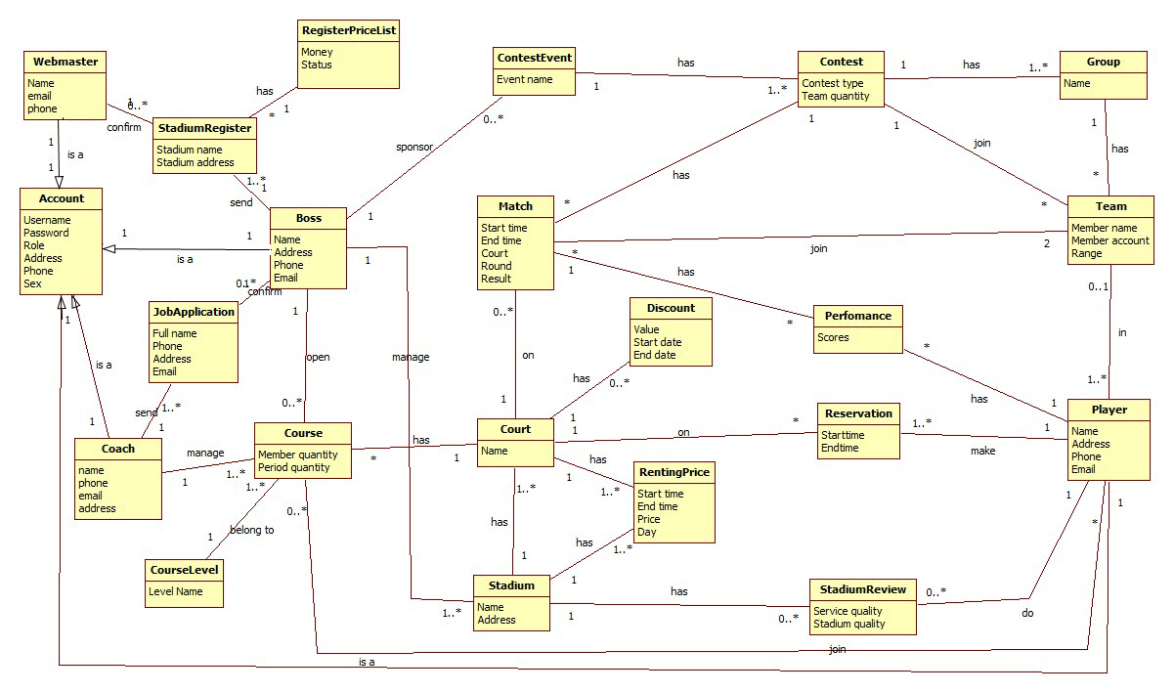

Figure 86: Entity Relationship Diagram

### Data Dictionary

|  |  |
| --- | --- |
| **Entity Data dictionary: describe content of all entities** | |
| Entity Name | Description |
| Account | Describe all account of BSF-Website system. |
| Webmaster | Describe all webmaster of website. |
| Boss | Describe all bosses who register their business on BSF-Website. |
| Coach | Describe all coaches who teaching badminton as job. |
| Player | Describe all badminton players who rent court, join contest, join course… |
| StadiumRegister | Describe all stadium register on system of boss who own their stadium. |
| RegisterPriceList | Describe all fee which boss must pay when register stadium to use BSF-Website for their business. |
| JobApplication | Describe all teaching application of coaches to boss. |
| Course | Describe all badminton courses which boss open for player learn. |
| CourseLevel | Describe all level of the course: elementary, intermediate, advanced… |
| Stadium | Describe all stadium of boss which includes courts. |
| Court | Describe all courts of stadium. |
| RentingPrice | Describe price which player must pay in one hour when they rent court to play. |
| Discount | Describe discount of price when player renting court. |
| Reservation | Describe all court reservation information of player. |
| StadiumReview | Describe all review of player about stadium. |
| ContestEvent | Describe all contest event which is sponsored by boss. |
| Contest | Describe all contests of event. |
| Group | Describe all group of team. |
| Match | Describe all matches of a contest. |
| Team | Describe all team of contest which is registered by player. |
| Performance | Describe scores of player after finish a macth. |

Table 5: Data Dictionary

# Software Design Description

## Design Overview

* This part describes the technical and user interface design of the BSF-Website system. This part includes the system architectural design, the detailed description of components, and detailed design of classes. This part also includes the sequence diagrams, database design, and design of user interface.
* The architectural design describes the overall architecture of the system, and the architecture of each main component which will describe the role of each component. The component design describes more detail about main components which will describe the way that sub-components communicate together and their responsibilities.
* The detailed design describes static and dynamic structure for each component which includes class diagrams, class explanations, algorithms of some important methods, and sequence diagrams of all use cases.
* The user interface design describes the layout of the system. It also includes description of links between webpages, by a page flow diagram.
* The database design will describe entities, relationship between entities, and entities details.

## System Architectural Design

In MVC pattern, the functions of model, view, and controller are defined as in following figure.

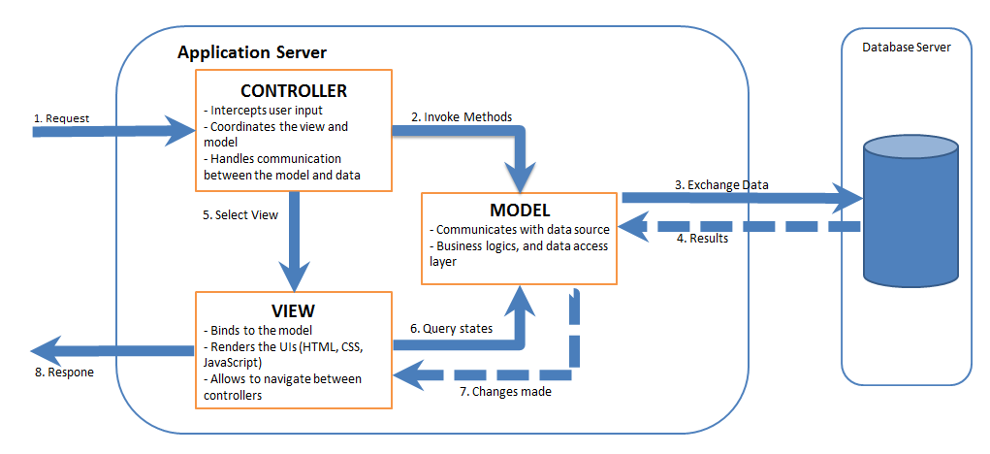

Figure 4-2 MVC Pattern

## Component Diagram

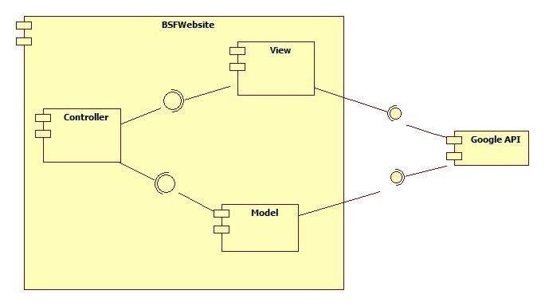

Figure 88: Component Diagram

## Detailed Description of Components

### Class Diagram

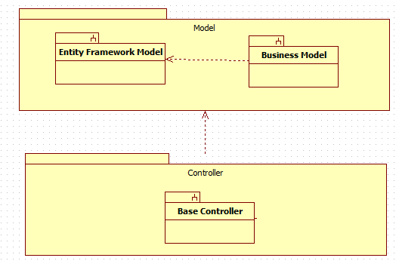

Figure 89: Class Diagram

#### Class Diagram –Entity Framework Model

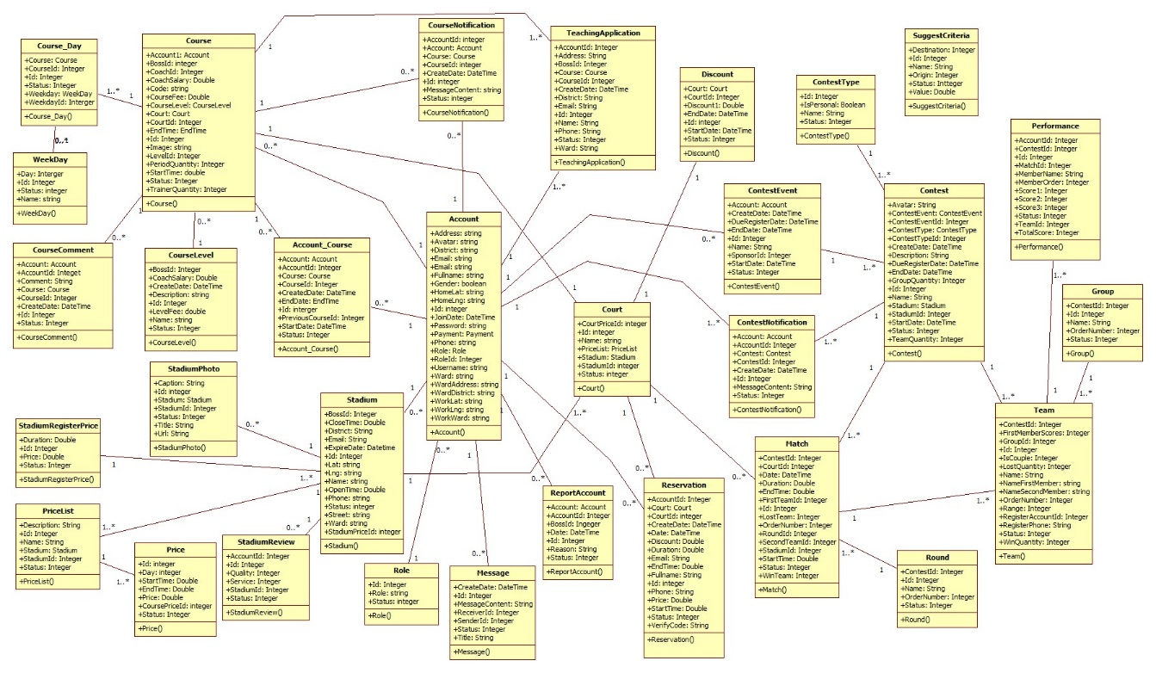

Figure 90:

#### Class Diagram – Business Model

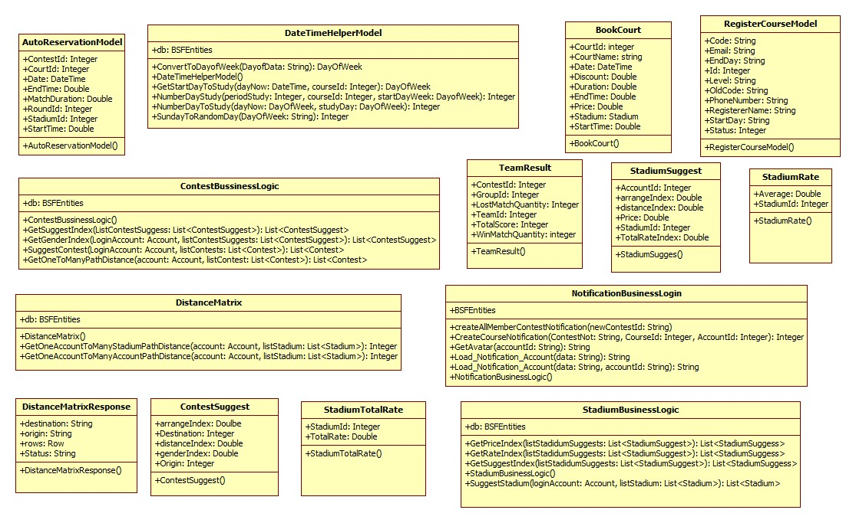

Figure 91

#### Class Diagram – Base Controller

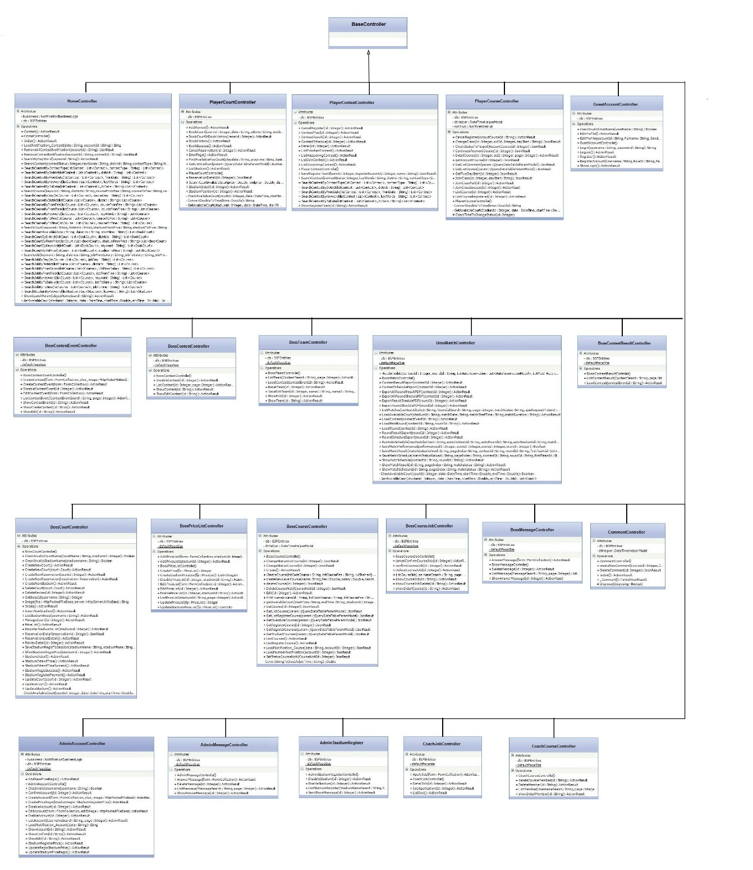

Figure 92

### Class Diagram Explanation

#### Class Diagram – Entity Framework Model

##### Account

Attribute

|  |  |  |  |
| --- | --- | --- | --- |
| **Attribute** | **Type** | **Visibility** | **Description** |
| Id | Interger | Public | Uniqe number of each account |
| Address | String | Public | Address of user’s home |
| Avatar | String | Public | Avata of user |
| District | String | Public | District of user’s home |
| Email | String | Public | Email user |
| Fullname | String | Public | User name |
| Gender | Boolean | Public | Gender user |
| HomeLat | String | Public | Home lattitude of user |
| HomeLng | String | Public | Home langtitude of user |
| IsActive | Boolean | Public |  |
| JoinDate | DateTime | Public | Day user join to website |
| Password | String | Public | User password |
| Phone | String | Public | User phone |
| Role | Role | Public | Mapping with Role table |
| RoleId | Integer | Public | Role id |
| Status | Integer | Public |  |
| Username | String | Public | User |
| Ward | String | Public | Ward of city |
| WorkAddress | String | Public | Address of user company |
| WorkDistrict | String | Public | District of user’s company |
| WorkLat | String | Public | Latitude of user’s company |
| WorkLng | String | Public | Langtitude of user’s campany |
| WorkWard | String | Public | Ward of user’s company |

Method: None

##### Account\_Course

Attribute

|  |  |  |  |
| --- | --- | --- | --- |
| **Attribute** | **Type** | **Visibility** | **Description** |
| Account | Account | Public | Mapping with Account table |
| AccountId | Integer | Public | Unique id of each account |
| Course | Course | Public | Mapping with course table |
| CourseId | Integer | Public | Unique id of each course |
| CreateDate | DateTime | Public | Create date |
| EndDate | DateTime | Public | End date |
| Id | Integer | Public | Uniqe id of each Account\_Course |
| PreviousCourseId | Integer | Public | Id of each course |
| StartDate | DateTime | Public | Chosen day start course |
| Status | Integer | Public | status |

Method: None

##### Course

Attribute

|  |  |  |  |
| --- | --- | --- | --- |
| **Attribute** | **Type** | **Visibility** | **Description** |
| Account1 | Account | Public | Mapping with Account table |
| BossId | Integer | Public | Id of each boss |
| CoachId | Integer | Public | Id of each coach |
| CoachSalary | Double | Public | Salary of each course |
| Code | String | Public | Code of each course |
| CourseFee | Double | Public | Fee for user to join course |
| CourseLevel | CourseLevel | Public | Level of course |
| Court | Court | Public | Mapping with Court table |
| CourtId | Integer | Public | Id for each court |
| EndTime | DateTime | Public | end time of each course |
| Id | Integer | Public | Id of each course |
| Image | String | Public | Course image |
| LevelId | Integer | Public | Level of course |
| PeriodQuantity | Integer | Public |  |
| StartTime | DateTime | Public | Start time |
| Status | Integer | Public | Status |
| TrainerQuantity | Integer | Public | Trainer quantity |

Method: None

##### Course\_Day

Attribute

|  |  |  |  |
| --- | --- | --- | --- |
| **Attribute** | **Type** | **Visibility** | **Description** |
| Course | Course | Public | Mapping with course table |
| CourseId | Integer | Public | Mapping with Course table |
| Id | Integer | Public | Id for each Course\_Day |
| Status | Integer | Public |  |
| WeekDay | WeekDay | Public | Mapping with WeekDay table |
| WeekDayId | Integer | Public | Mapping with WeekDay tabel |

Method: None

##### Contest

Attribute

|  |  |  |  |
| --- | --- | --- | --- |
| **Attribute** | **Type** | **Visibility** | **Description** |
| Avatar | String | Public | Avata of contest |
| ContestEvent | ContestEvent | Public | Mapping with ContestEvent table |
| ContestEvenetId | Integer | Public | Mapping with ContestEvent table |
| ContestType | ContestType | Public | Mapping with ContestType table |
| ContestTypeId | Integer | Public | Mapping with ContestType table |
| CreateDate | DateTime | Public | Day create contest |
| Description | String | Public | Description |
| DueRegisterDate | DateTime | Public | Due to register contest |
| EndDate | DateTime | Public | End day of contest |
| GroupQuantity | Integer | Public | Quantity of group |
| Id | Integer | Public | Id of each contest |
| Name | String | Public | Name of contest |
| Statium | Stadium | Public | Mapping with Stadium table |
| StadiumId | Integer | Public | Mapping with Stadium table |
| StartDate | DateTime | Public | Start day of contest |
| Status | Integer | Public | Status |
| TeamQuantity | Integer | Public | Team quantity |

Method: None

##### ContestEvent

Attribute

|  |  |  |  |
| --- | --- | --- | --- |
| **Attribute** | **Type** | **Visibility** | **Description** |
| Account | Account | Public | Mapping with Account table |
| CreateDate | DateTime | Public |  |
| DueRegisterDate | DateTime | Public | Mapping with Contest Table |
| EndDate | DateTime | Public | Mapping with Contest table |
| Id | Integer | Public | Id of each ContestEvent |
| Name | String | Public | Name of contest |
| SponsorId | String | Public | Mapping with Account table |
| StartDate | String | Public | Mapping with Conest table |

Method: None

##### Reservation

Attribute

|  |  |  |  |
| --- | --- | --- | --- |
| **Attribute** | **Type** | **Visibility** | **Description** |
| AccountId | Integer | Public | Mappting with Account table |
| Court | Court | Public | Mapping with Court table |
| CourtId | Integer | Public | Mapping with Court table |
| CreateDate | DateTime | Public | Day rent court |
| Date | DateTime | Public | Day to play |
| DisCount | Double | Public | Discount of each court |
| Duration | Double | Public | Time to play |
| Email | String | Public | Email player |
| EndTime | DateTime | Public | End time |
| Fullname | String | Public | User name |
| Id | Integer | Public | Id of each reservation |
| Phone | String | Public | User phone |
| Price | Double | Public | Price to rent court |
| StartTime | Double | Public | Start time |
| Status | Integer | Public | Status |
| VerifyCode | String | Public | Verify code |

Method: None

##### Message

Attribute

|  |  |  |  |
| --- | --- | --- | --- |
| **Attribute** | **Type** | **Visibility** | **Description** |
| CreateDate | DateTime | Public | Create date |
| Id | Integer | Public | Id of each message |
| MessageContent | String | Public | Content of message |
| ReceiverId | Integer | Public | Mapping with Account table |
| SenderId | Integer | Public | Mapping with Account table |
| Status | Integer | Public | Status |
| Title | String | Public | Title of message |

Method: None

##### Court

Attribute

|  |  |  |  |
| --- | --- | --- | --- |
| **Attribute** | **Type** | **Visibility** | **Description** |
| CourtPriceId | Integer | Public | Mapping with PriceList table |
| Id | Integer | Public | Id of each court |
| Name | String | Public | Nameof court |
| Stadium | Stadium | Public | Mapping with Stadium table |
| StadiumId | Stadium | Public | Mapping with Stadium table |
| Status | Integer | Public | status |

Method: None

##### Match

Attribute

|  |  |  |  |
| --- | --- | --- | --- |
| **Attribute** | **Type** | **Visibility** | **Description** |
| ContestId | Integer | Public | Mapping with Contest table |
| CourtId | Integer | Public | Mapping with Court table |
| Date | DateTime | Public | Day match occur |
| Duration | Double | Public | Duraton of match |
| EndTime | Double | Public | End time. |
| FirstTeamId | Integer | Public | Mapping with Team table |
| Id | Integer | Public | Id of each match |
| LostTeam | Integer | Public | Team closer |
| OrderNumber | Integer | Public | Number of match |
| RoundId | Integer | Public | Mapping with Round table |
| SecondTeamId | Integer | Public | Mapping with Team table |
| StadiumId | Integer | Public | Mapping with stadium table |
| StartTime | Double | Public | Start time of match |
| Status | Integer | Public | Status |
| WinTeam | Integer | Public | Team win match |

Method: None

##### Discount

Attribute

|  |  |  |  |
| --- | --- | --- | --- |
| **Attribute** | **Type** | **Visibility** | **Description** |
| Court | Court | Public | Mapping with Court table |
| CourtId | Integer | Public | Mapping with Court table |
| DisCount | Double | Public | Discount of each court |
| Id | Integer | Public | Id of each discount |
| status | Integer | Public | Status of order |

Method: None

##### StadiumRegisterPrice

Attribute

|  |  |  |  |
| --- | --- | --- | --- |
| **Attribute** | **Type** | **Visibility** | **Description** |
| Duration | Double | Public | Time to register stadium |
| Id | Integer | Public | Id of each price |
| Price | Double | Public | Price to register stadium |
| Status | Integer | Public | status |

Method: None

##### WeekDay

Attribute

|  |  |  |  |
| --- | --- | --- | --- |
| **Attribute** | **Type** | **Visibility** | **Description** |
| Day | Integer | Public | Day of week |
| Id | Integer | Public | Id of each WeekDay |
| Name | String | Public | Name of WeekDay |
| Status | Integer | Public | Status |

Method: None

##### CourseNotification

Attribute

|  |  |  |  |
| --- | --- | --- | --- |
| **Attribute** | **Type** | **Visibility** | **Description** |
| Account | Account | Public | Mapping with Account table |
| AccountId | Integer | Public | Mapping with Account table |
| Course | Course | Public | Mapping with Course tabe |
| CourseId | Integer | Public | Mapping with Course tabe |
| CreateDate | DateTime | Public | Create date |
| Id | Integer | Public | Id of each Notification |
| MessageContent | String | Public | Content of notification |
| Status | Integer | Public | Status |

Method: None

##### Round

Attribute

|  |  |  |  |
| --- | --- | --- | --- |
| **Attribute** | **Type** | **Visibility** | **Description** |
| Id | Integer | Public | Id of each Round |
| ContestId | Integer | Public | Mapping with Contest table |
| Name | String | Public | Name of Round |
| OrderNumber | Integer | Public | Number of round |
| Status | Integer | Public | status |

Method: None

##### StadiumReview

Attribute

|  |  |  |  |
| --- | --- | --- | --- |
| **Attribute** | **Type** | **Visibility** | **Description** |
| Id | Integer | Public | Id of each review |
| Description | String | Public | Description |
| Name | String | Public | Name of review |
| Stadium | Stadium | Public | Mapping with Stadium table |
| StadiumId | Integer | Public | Mapping with Stadium table |
| Status | Integer | Public | Status |

Method: None

##### SuggestCriteria

Attribute

|  |  |  |  |
| --- | --- | --- | --- |
| **Attribute** | **Type** | **Visibility** | **Description** |
| Destination | Integer | Public | End point |
| Id | Integer | Public | Id of each suggest criteria |
| Name | String | Public | Name of suggestCriteria |
| Origin | Integer | Public | Start point |
| Status | Integer | Public | Status |
| Value | Double | Double | Distance |

Method: None

##### ReportAccount

Attribute

|  |  |  |  |
| --- | --- | --- | --- |
| **Attribute** | **Type** | **Visibility** | **Description** |
| Account | Account | Public | Mapping with Account table |
| AccountId | Integer | Public | Mapping with Account table |
| BossId | Integer | Public | Mapping with Boss table |
| Date | DateTime | Public | Date report |
| Id | Integer | Public | Id of each report |
| Reason | String | Public | Reason for report |
| Status | Integer | Public | Status |

Method: None

##### Team

Attribute

|  |  |  |  |
| --- | --- | --- | --- |
| **Attribute** | **Type** | **Visibility** | **Description** |
| Id | Integer | Public | Ind of each team |
| ContestId | Integer | Public | Mapping with Contest table |
| FirstMemberScore | Integer | Public | Score of first member |
| GroupId | Integer | Public | Mapping with Group table |
| IsCouple | Boolean | Public | Team is a couple |
| LostQuantity | Integer | Public | Quantity for lose team |
| Name | String | Public | Name of team |
| NameFirstMember | String | Public | Name of first mem |
| NameSecondMember | String | Public | Name of second mem |
| OrderNumber | Integer | Public | Number of team |
| Range | Integer | Public | Range of team |
| RegisterAccountId | Integer | Public | Mapping with Account table |
| RegisterPhone | String | Public | Mapping Account table |
| SecondMemberScores | Integer | Public | Scores of second member |
| Status | Integer | Public | Status |
| WinQuantity | Integer | Public | Number of win mtach |

Method: None

##### PriceList

Attribute

|  |  |  |  |
| --- | --- | --- | --- |
| **Attribute** | **Type** | **Visibility** | **Description** |
| Description | String | Public | Description |
| Id | Integer | Public | If of each PriceList |
| Name | String | Public | Name of PriceList |
| Stadium | Stadium | Public | Mapping with Stadium table |
| StadiumId | Integer | Public | Mapping with Stadium table |
| Status | Integer | Public | Status |

Method: None

##### Stadium

Attribute

|  |  |  |  |
| --- | --- | --- | --- |
| **Attribute** | **Type** | **Visibility** | **Description** |
| Id | Integer | Public | Id of each Stadium |
| BossId | Integer | Public | Mapping with Account table |
| CloseTime | Double | Public | Close time of stadium |
| District | String | Public | District of stadium |
| Email | String | Public | Email of stadium |
| ExpireDate | DateTime | Public | ExpireDate of stadium |
| Id | Integer | Public | Id of each stadium |
| Lat | String | Public | Latitude of stadium |
| Lng | String | Public | Langtitude of stadium |
| Name | String | Puclic | Name of stadium |
| OpenTime | Double | Public | Open time of stadium |
| Phone | String | Public | Stadium’s phone |
| StadiumPriceId | Integer | Public | Mapping with Stadium table |
| Status | Integer | Public | Status |
| Street | String | Public | Streetof stadium |
| Ward | String | Public | Ward of stadium |

Method: None

##### Role

Attribute

|  |  |  |  |
| --- | --- | --- | --- |
| **Attribute** | **Type** | **Visibility** | **Description** |
| Id | Integer | Public | Unique id of role |
| Role | String | Public | Role of account |
| Status | Integer | Public | status |

Method: None

##### StadiumPhoto

Attribute

|  |  |  |  |
| --- | --- | --- | --- |
| **Attribute** | **Type** | **Visibility** | **Description** |
| Id | Integer | Public | Id of stadium photo |
| Caption | String | Public | Caption of photo |
| Stadium | Stadium | Public | Mapping with Stadium table |
| StadiumId | Integer | Public | Mapping with Stadium table |
| Title | String | Public | Title of photo |
| Url | String | Public | url of photo |
| Status | Integer | Public | status |

Method: None

##### TeachingApplication

Attribute

|  |  |  |  |
| --- | --- | --- | --- |
| **Attribute** | **Type** | **Visibility** | **Description** |
| Id | Integer | Public | In of each teaching application |
| AccountId | Integer | Public | Mapping with Account table |
| BossId | Integer | Public | Mapping with Account table |
| Course | Course | Public | Mapping with Course table |
| CourseId | Integer | Public | Mapping with Course table |
| CreateDate | DateTime | Public | Create teaching application |
| District | String | Public | District of class |
| Email | String | Public | Email of course |
| Name | String | Public | Name of course |
| Phone | String | Public | Phone of course |
| Ward | String | Public | Ward of course |
| Status | Integer | Public | status |

Method: None

##### Price

Attribute

|  |  |  |  |
| --- | --- | --- | --- |
| **Attribute** | **Type** | **Visibility** | **Description** |
| Id | Integer | Public | Id of each price |
| CourtPriceId | Integer | Public | Mapping with PriceList table |
| Day | Integer | Public | Day of price |
| Price | Double | Public | Price |
| StartTime | Double | Public | Start time |
| Status | Integer | Public | status |

Method: None

##### CourseLevel

Attribute

|  |  |  |  |
| --- | --- | --- | --- |
| **Attribute** | **Type** | **Visibility** | **Description** |
| Id | Integer | Public | Id of each Course level |
| BossId | Integer | Public | Mapping with Account table |
| CoachSalary | Double | Public | Salary for coach |
| CreateDate | DateTime | Public | Create of Course level |
| Description | String | Public | Description course level |
| LevelFee | Double | Public | Fee of each level |
| Name | String | Public | Name of course level |
| Status | Integer | Public | status |

Method: None

##### Performance

Attribute

|  |  |  |  |
| --- | --- | --- | --- |
| **Attribute** | **Type** | **Visibility** | **Description** |
| Id | Integer | Public | Id of each performance |
| AccountId | Integer | Public | Mapping with Account table |
| ContestId | Integer | Public | Mapping with Contest table |
| MatchId | Integer | Public | Mapping with Match table |
| MemberName | String | Public | Mapping with Team table |
| MemberOrder | Integer | Public | Number of member of each team |
| Score1 | Integer | Public | Score of set 1 |
| Score2 | integer | Public | Score of set 2 |
| Score3 | integer | Public | Score of set 3 |
| TeamId | Integer | Public | Mapping with Team table |
| TotalScore | Integer | Public | Total score of each member |

Method: None

##### CourseComment

Attribute

|  |  |  |  |
| --- | --- | --- | --- |
| **Attribute** | **Type** | **Visibility** | **Description** |
| Id | Integer | Public | CourseComment |
| AccountId | Integer | Public | Mapping with Account table |
| Account | Account | Public | Mapping with Account table |
| Comment | String | Public | Comment |
| Course | Course | Public | Mapping with Course table |
| CourseId | Integer | Public | Mapping with Course table |
| CreateDate | Integer | Public | Day create course comment |
| Status | integer | Public | Status |

##### ContestType

Attribute

|  |  |  |  |
| --- | --- | --- | --- |
| **Attribute** | **Type** | **Visibility** | **Description** |
| Id | Integer | Public | Id of each ContestType |
| IsPersonnal | Boolean | Public | One or many member |
| Name | String | Public | Name of Contest type |
| Status | Integer | Public | Status |

##### ContestNotification

Attribute

|  |  |  |  |
| --- | --- | --- | --- |
| **Attribute** | **Type** | **Visibility** | **Description** |
| Account | Account | Public | Mapping Account table |
| AccountId | Integer | Public | Mapping with Account table |
| Contest | Contest | Public | Mapping with Contest Table |
| ContestId | Integer | Public | Mapping with Contest Table |
| CreateDate | DateTime | Public | Day create notification |
| Id | Integer | Public | Id of each notification |
| MessageContent | String | Public | Content message |
| Status | Integer | Public | status |

Method: None

#### Class Diagram – Bussiness Model

##### ContestSuggest

Attribute

|  |  |  |  |
| --- | --- | --- | --- |
| **Attribute** | **Type** | **Visibility** | **Description** |
| arrangeIndex | Double | Public | Index of arrange. |
| Destination | Integer | Public | Stadium Id. |
| distanceIndex | Double | Public | Distance index. |
| genderIndex | Double | Public | Gender Index. |
| Orrigin | Integer | Public | Contest Id. |

Method: None

|  |  |  |  |
| --- | --- | --- | --- |
| **Method** | **Return Type** | **Visibility** | **Description** |
| ContestSuggest() |  | Public | Constructor |

##### TeamResult

Attribute

|  |  |  |  |
| --- | --- | --- | --- |
| **Attribute** | **Type** | **Visibility** | **Description** |
| ContestId | Integer | Public | Contest Id. |
| GroupId | Integer | Public | Contest Group Id. |
| LostMatchQuantity | Integer | Public | Number of lost matches. |
| TeamId | Integer | Public | Team Id. |
| TotalScores | Integer | Public | Total Scores of team. |
| WinMatchQuantity | Integer |  | Number of win matches. |

Method: None

|  |  |  |  |
| --- | --- | --- | --- |
| **Method** | **Return Type** | **Visibility** | **Description** |
| TeamResult() |  | Public | Constructor |

##### DistanceMatrixResponse

Attribute

|  |  |  |  |
| --- | --- | --- | --- |
| **Attribute** | **Type** | **Visibility** | **Description** |
| destination | String[] | Public | Stadium Id. |
| Origin | String[] | Public | Contest Id. |
| Rows | Row[] | Public | Number of lost matches. |
| Status | String | Public | Status of GoogleAPI response. |

Method: None

|  |  |  |  |
| --- | --- | --- | --- |
| **Method** | **Return Type** | **Visibility** | **Description** |
| DistanceMatrixResponse() |  | Public | Constructor |

##### DirectionResponse

Attribute

|  |  |  |  |
| --- | --- | --- | --- |
| **Attribute** | **Type** | **Visibility** | **Description** |
| Routes | Route[] | Public | Stadium Id. |
| Status | String | Public | Contest Id. |

Method: None

|  |  |  |  |
| --- | --- | --- | --- |
| **Method** | **Return Type** | **Visibility** | **Description** |
| DirectionResponse() |  | Public | Constructor |

##### AutoReservationModel

|  |  |  |  |
| --- | --- | --- | --- |
| **Attribute** | **Type** | **Visibility** | **Description** |
| ContestId | Integer | Public | Contest Id. |
| CourtId | Integer | Public | Court Id. |
| Date | DateTime | Public | Match date. |
| EndTime | Double | Public | End time of match. |
| MatchDuration | Double | Public | Duration of match. |
| RoundId | Integer | Public | Round Id. |
| StadiumId | Integer | Public | Stadium Id. |
| StartTime | Double | Public | Start time of macth. |

|  |  |  |  |
| --- | --- | --- | --- |
| **Method** | **Return Type** | **Visibility** | **Description** |
| AutoReservationModel() |  | Public | Constructor |

##### StadiumModel

Attribute

|  |  |  |  |
| --- | --- | --- | --- |
| **Attribute** | **Type** | **Visibility** | **Description** |
| Name | String | Public | Name of stadium |
| Address | String | Public | Address of stadium |
| Phone | String | Public | Stadium’s phone |
| Time | Double | Public |  |

Method: None

##### StadiumRate

Attribute

|  |  |  |  |
| --- | --- | --- | --- |
| **Attribute** | **Type** | **Visibility** | **Description** |
| StadiumId | Int | Public | Id of each stadium |
| Average | Double | Public | Average of review point |

Method: None

##### StadiumSuggest

Attribute

|  |  |  |  |
| --- | --- | --- | --- |
| **Attribute** | **Type** | **Visibility** | **Description** |
| AccountId | Int | Public | Mapping with Account table |
| StadiumId | Int | Public | Mapping with Stadium table |
| Price | Double | Public | Price for rent |
| TotalRateIndex | Double | Public | Total rate of stadium’s review |
| distanceIndex | Double | Public | Distance from player home to stadium |
| arrangeIndex | Double | Public | Use for suggest stadium |

Method: None

##### StadiumTotalRate

Attribute

|  |  |  |  |
| --- | --- | --- | --- |
| **Attribute** | **Type** | **Visibility** | **Description** |
| StadiumId | Int | Public | Mapping with stadium table |
| TotalRate | Double | Public | Rate of review |

Method: None

##### NotificationBusinessLogic

|  |  |  |  |
| --- | --- | --- | --- |
| **Attribute** | **Type** | **Visibility** | **Description** |
| db | BSFEntities | Private | DataContext |

|  |  |  |  |
| --- | --- | --- | --- |
| **Method** | **Return Type** | **Visibility** | **Description** |
| NotifiactionBussinessLogic() |  | Public | Contructor |
| CreateAllMemberContestNotification | void | Public | Create contest notification. |
| CreateCourseNotification(string contentNoti, int CourseId, int Integer) | Integer | Public | Create course notification. |
| GetAvarta(string accountId) | String | Public | Get avatar. |
| Load\_Notification\_Account(string data) | String | Public | Load all account notifications. |
| Load\_Notification\_Contest(string data, string accountId) | String | Public | Load all contest notifications. |

##### DistanceMatrix

|  |  |  |  |
| --- | --- | --- | --- |
| **Attribute** | **Type** | **Visibility** | **Description** |
| db | BSFEntities | Private | DataContext |

|  |  |  |  |
| --- | --- | --- | --- |
| **Method** | **Return Type** | **Visibility** | **Description** |
| DistanceMatrix() |  | Public | Contructor |
| GetOneAccountToManyStadiumPathDistance(Account account, List<Stadium> listStadium) | Integer | Public | Get distance from user’s location to stadium’s location. |
| GetOneStadiumToManyAccountPathDistance(Stadium stadium, List<Account> listAccount) | Integer | Public | Get distance from stadium’s position to user’s location. |

##### ContestBusinessLogic

|  |  |  |  |
| --- | --- | --- | --- |
| **Attribute** | **Type** | **Visibility** | **Description** |
| db | BSFEntities | Private | DataContext |

|  |  |  |  |
| --- | --- | --- | --- |
| **Method** | **Return Type** | **Visibility** | **Description** |
| ContestBussinessLogic() |  | Public | Contructor |
| GetGenderIndex(Account loginAccount, List<ContestSuggest> listContestSuggest) | List<ContestSuggest> | Public | Calculate gender index. |
| GetSuggestIndex(List<ContestSuggest> listContestSuggests) | List<ContestSuggest> | Public | Calculate suggest index. |
| SuggestContests(Account loginAccount, List<Contest> listContests) | List<ContestSuggest> |  | Suggest contests. |

##### StadiumBussinessLogic

Attribute

|  |  |  |  |
| --- | --- | --- | --- |
| **Attribute** | **Type** | **Visibility** | **Description** |
| Db | BSFEntities | Private | Entities |

Method:

|  |  |  |  |
| --- | --- | --- | --- |
| **Method** | **Return Type** | **Visibility** | **Description** |
| SuggestStadium(Account loginAccount, list<Stadium> stadium) | List<Stadium> | Public | Suggest stadium for player |
| GetRateIndex(list<StadiumSuggest> liststadiumSuggest) | List<StadiumSuggest> | Public | Get rate index |
| GetPriceIndex(list<StadiumSuggest> liststadiumSuggest) | List<StadiumSuggest> | Public | Get price index |
| GetSuggestIndex(List<StadiumSuggest>) | List<StadiumSuggest> | Public | Get last index for suggest stadium |

#### Class Diagram – Base Controller

##### BossCourseController

Attribute

|  |  |  |  |
| --- | --- | --- | --- |
| **Attribute** | **Type** | **Visibility** | **Description** |
| Db | BSFEntities | Private | Entites |
| dtHelper | DateTimeHelper | Private | DateTimeHelper |

Method:

|  |  |  |  |
| --- | --- | --- | --- |
| **Method** | **Return Type** | **Visibility** | **Description** |
| BossCourseController() |  | Public | Constructor |
| EditCourse(string courseId, string txtCodeSource,string txtCourseFee,string txtTrainerQuantity,string txtPeriodQuantity, string ddlevel, Ienumerable <string> cklDayofWeed, string txtStartTime, string txtEndTime, string ddlStadium, string ddlCourt, string txtCoachSalary, HttpPostedFileBass Image) | ActionResult | Public | Edit course |
| getAvailableCourt(string startTime, string endTime, int stadiumId, int courseId, string days) | JsonResult | Public | Get list Available court |
| CreateCourse(string courseId, string txtCodeSource,string txtCourseFee,string txtTrainerQuantity,string txtPeriodQuantity, string ddlevel, Ienumerable <string> cklDayofWeed, string txtStartTime, string txtEndTime, string ddlStadium, string ddlCourt, string txtCoachSalary, HttpPostedFileBass Image) | ActionResult | Public | Create new course |
| ConvertStringToDouble(string strTime) | Double | Public | Convert string do double |
| deleteCourse(ind id) | JsonResult | Public | Delete course |
| ChangeStatusCourse(int id) | JsonResult | Public | Boss confirm course for user |
| CreateNewLevelCourse(string name, string fee, string salary, string description) | JsonResult | Public | Boss create level of course |
| LoadNotification\_Course(string data, int accountId) | JsonResult | Public | Notification |
| LoadNumberNotification(int accountId) | JsonResult | Public | Load number of notification |
| SetStatusCourseNoti(int CourseNotiId) | JsonResult | Public | Set status for notification of join course is read |
| DeleteAccCourse(int id) | JsonResult | Public | Delete |
| DeleteCourseNoti(int CourseNotiId) | JsonResult | Public | Delete course notification |
| ChangeStatusAccCourse(int CourseNotiId) | JsonResult | Public | Confirm change course for trainee |
| RedirectRole(string rolename) | Void | Public | Redirect with role |

##### BossCourseJobController

Attribute

|  |  |  |  |
| --- | --- | --- | --- |
| **Attribute** | **Type** | **Visibility** | **Description** |
| Db | BSFEntities | Private | Entities |
| defaultPageSize | Integer | Private | Page size |
| Ilist<TeachingApplication> | List | Private | List TeachingApplicaiton |

Method:

|  |  |  |  |
| --- | --- | --- | --- |
| **Method** | **Return Type** | **Visibility** | **Description** |
| DeleteCourseJob(int id) | ActionResult | Public | Delete course job |
| confirmCourseJob(int id) | ActionResult | Public | Boss confirm job for trainer |
| cancelConfirmJob(int id) | ActionResult | Public | Cancel confirm job for trainer |
| CreateAge(FormCollection form) | ActionResult | Public | Create age |
| ShowEditAge(string id) | ActionResult | Public | View age to edit |
| EditAge(FormCollection form) | ActionResult | Public | Save edit age |

##### BossCourtController

Attribute

|  |  |  |  |
| --- | --- | --- | --- |
| **Attribute** | **Type** | **Visibility** | **Description** |
| Db | BSFEntities | Private | Entities |
| List<BookCourt> | List | Private | List BookCourt |
| allRoundman | IList<Roundman> | Private | List Roundman |

Method:

|  |  |  |  |
| --- | --- | --- | --- |
| **Method** | **Return Type** | **Visibility** | **Description** |
| CheckInvalidStadiumName(string stadiumname) | Bool | Public | Check stadium name |
| CheckInvalidCourtName(string CourtName, int stadiumid) | Bool | Public | Check court name |
| SaveStadiumRegisToSession(string stadiumName, string stadiumPhone, string stadiumMail, string txtStartTime, string txtEndTime, string txtPrice, string txtStadiumPrice, string district, string ward, string street, string lat, string lng) | JsonResult | Public | Save stadium register to session to show |
| InsertNewStadium() | ActionResult | Public | Add stadium to database with status = 3 “Chưa thanh toán” |
| StadiumRegisSuccess() | ActionResult | Public | Update stadium status = 1 “đã thanh toán” after payment |
| UpdateStadium() | ActionResult | Public | Update stadium |
| StadiumExtendTime() | ActionResult | Public | Extend time for stadium |
| StadiumExtendTimeSuccess() | ActionResult | Public | Update stadium status = 1 “đã thanh toán” |
| CreateNewCourt(Court court) | ActionResult | Public | Create new court of stadium |
| UpdateCourt(int courtid) | ActionResult | Public | Update court |
| DeleteReview(int id) | ActionResult | Public | Delete review |
| CreateNewReservation(Reservation reservation) | ActionResult | Public | Boss can add reservation for user who do not had payment online account |
| CheckAvailableCourt(int courtid, DateTime date, double startTime, double endTime) | ActinResult | Public | Check Available court for boss to add reservation |

##### BossMessageController

Attribute

|  |  |  |  |
| --- | --- | --- | --- |
| **Attribute** | **Type** | **Visibility** | **Description** |
| Db | BSFEntities | Private | Entities |
| defaultPageSize | Integer | Private | Page size |

Method:

|  |  |  |  |
| --- | --- | --- | --- |
| **Method** | **Return Type** | **Visibility** | **Description** |
| AnswerMessage(FormCollection form) | ActionResult | Public | Boss answer message |
| DeleteMessage(int id) | ActionResult | Public | Delete message |
| CheckValidEditNumber(string number, string id) | Boolean | Public | Check exist number but can same with current number |

##### CoachCourseController

Attribute

|  |  |  |  |
| --- | --- | --- | --- |
| **Attribute** | **Type** | **Visibility** | **Description** |
| Db | BSFEntities | Private | DataContext |
| defaultPageSize | Integer | Private | Page size |

Method:

|  |  |  |  |
| --- | --- | --- | --- |
| **Method** | **Return Type** | **Visibility** | **Description** |
| showDetailMember(string id) | ActionResult | Public | Show member detail |
| deleteCourseMember(string id) | ActionResult | Public | Delete course mem ber |
| DeleteMember(string id) | ActionResult | Public | Delete member |

##### CoachJobController

Attribute

|  |  |  |  |
| --- | --- | --- | --- |
| **Attribute** | **Type** | **Visibility** | **Description** |
| Db | BSFEntities | Private | DataContext |
| defaultPageSize | Integer | Private | Page size |

Method:

|  |  |  |  |
| --- | --- | --- | --- |
| **Method** | **Return Type** | **Visibility** | **Description** |
| ListJob() | ActionResult | Public | Show list job for trainer |
| DetailJob(int id) | ActionResult | Public | Detail job |
| JobApplication(int id) | ActionResult | Public | Trainer apply job |
| ApplyJob(FormCollection form) | ActionResult | Public | Submit cv for job |

##### CommentController

Attribute

|  |  |  |  |
| --- | --- | --- | --- |
| **Attribute** | **Type** | **Visibility** | **Description** |
| Db | BSFEntities | Private | Entities |
| dtHelper | DateTimehelperModel | Private |  |

Method:

|  |  |  |  |
| --- | --- | --- | --- |
| **Method** | **Return Type** | **Visibility** | **Description** |
| createNewComment(int courseId, string Comment) | JsonResult | Public | Create comment |
| DeleteComment(int id) | JsonResult | Public | Delete comment |

##### PlayerCourseController

Attribute

|  |  |  |  |
| --- | --- | --- | --- |
| **Attribute** | **Type** | **Visibility** | **Description** |
| db | BSFEntities | Private | Entites |
| dtHelper | DateTimeHelperModel | Private |  |
| notiHub | NotificationHub | Private |  |

Method:

|  |  |  |  |
| --- | --- | --- | --- |
| **Method** | **Return Type** | **Visibility** | **Description** |
| JoinClassSuccess(int id) | ActionResult | Public | Update status=1 |
| ConvertDoubleToTime(double time) | string | Price | Convert double to time |
| GetAvailableCourt(int StadiumId, DateTime date, double startTime, double endTime) | List<Court> | Price | Get list Available court |
| JoinClass(int id, string dayStart) | JsonResult | Public | Join class |
| ChangeClass(int id, int oldId, string datStart) | JsonResult | Public | Trainee can change class |
| CheckStatusToPaypal | JsonResult | Public | Check payment status |
| ContinuesPaymentCourse | JsonResult | Public |  |
| DeleteJoinClass | JsonResult | Public | Delete join class |
| CancelRegister(string AccountCourseId) | ActionResult | Public | Cancel register course |

##### PlayerCourtController

Attribute

|  |  |  |  |
| --- | --- | --- | --- |
| **Attribute** | **Type** | **Visibility** | **Description** |
| Db | BSFEntities | Private | Entites |
| List<BookCourt> | List | Private | List BookCourt |

Method:

|  |  |  |  |
| --- | --- | --- | --- |
| **Method** | **Return Type** | **Visibility** | **Description** |
| ListStadium() | ActionResult | Public | Show list stadium |
| StadiumDetail(int id) | ActionResult | Public | Show stadium detail |
| ConvertDoubleToTime(double time) | String | Private | Convert double to time |
| FindAvailablePlayCourt(string playdate, string playtime, string duration, string stadiumId) | ActionResult | Public | List available court for rent |
| BookCourt(int courtid, string date, string sttime, string endtime, string price, string duration, string discount) | JsonResult | Public | Save reservation with status =3 “Chưa thanh toán” |
| BookSuccess() | ActionResult | Public | Update reservation status = 1 “đã thanh toán” |
| BookHistory() | ActionResult | Public | Show reservation history |
| GetAvailableCourt(int stadiumid, DateTime date, double startTime, double endTime) | List<Court> | Private | Check and get list avalable court |
| CheckAvailableCourt(int courtid, DateTime date, double startTime, double endTime) | Boolean | Public | check reservation before user can rent |
| ReservationDetail(int id) | JsonResult | Public | Reservation detail |
| CancelReservation(int id) | ActionResult | Public | Player can cancel reservation |
| AddReview() | ActionResult | Public | User can review stadium after rent court |
| StadiumPosition(int id) | ActionResult | Public | Position of stadium |

##### PlayerContestController

Attribute

|  |  |  |  |
| --- | --- | --- | --- |
| **Attribute** | **Type** | **Visibility** | **Description** |
| db | BSFEntities | Private | DataContext |

Method:

|  |  |  |  |
| --- | --- | --- | --- |
| **Method** | **Return Type** | **Visibility** | **Description** |
| PlayerContestController() |  | Public | Constructor |
| CancelRegister(int id) | ActionResult | Public | Cancel joining Contest. |
| ContestMap(int id) | ActionResult | Public | Show map form user’s current position to contest’s location. |
| ContestResult(int id) | ActionResult | Public | Show contest result |
| ContestSchedule(int id) | ActionResult | Public | Show contest schedule |
| Detail(int id) | ActionResult | Public | Show contest detail. |
| ListFinishedContest() | ActionResult | Public | Show list of finished contests. |
| ListHappeningContest() |  |  | Show list of happening contests. |
| ListJoinContest() | ActionResult | Public | Show contest list which player have joined. |
| ListUpcomingContest() | ActionResult | Public | Show list of upcoming contests. |
| SaveRegisterTeam(int teamId, int registerAccountId, string name) | JsonResult | Public | Save palyer’s contest register information. |
| ShowRegisterTeam(string id) | ActionResult | Public | Show register team popup. |

##### BossContestEventController

Attribute

|  |  |  |  |
| --- | --- | --- | --- |
| **Attribute** | **Type** | **Visibility** | **Description** |
| db | BSFEntities | Private | DataContext |

Method:

|  |  |  |  |
| --- | --- | --- | --- |
| **Method** | **Return Type** | **Visibility** | **Description** |
| BossContestEventController() |  | Public | Constructor |
| CreateContest(FormCollection form, HttpPostedFileBase plus\_image) | ActionResult | Public | Create new contest of contest event. |
| CreateContestEvent(FormCollection form) | ActionResult | Public | Create new contest event. |
| DisableContestEvent(int id) | ActionResult | Public | Delete Contest event. |
| EditContestEvent(FormCollection form) | ActionResult | Public | Save edited contest event information. |
| ListContestEvent(string ContestSearchEvent,int page) | ActionResult | Public | List of contest events. |
| ShowContestEvent(string id) | ActionResult | Public | Show contest event details |
| ShowCreateContest(string id) |  |  | Show contest creation popup. |
| ShowEdit() | ActionResult | Public | Show contest event edit popup. |

##### BossContestController

Attribute

|  |  |  |  |
| --- | --- | --- | --- |
| **Attribute** | **Type** | **Visibility** | **Description** |
| db | BSFEntities | Private | DataContext |
| defaultPageSize | int | Private | Number of items per page in paging. |

Method:

|  |  |  |  |
| --- | --- | --- | --- |
| **Method** | **Return Type** | **Visibility** | **Description** |
| BossContestController() |  | Public | Constructor |
| DisableContest(int id) | ActionResult | Public | Delete Contest. |
| ListContest(int id , int page) | ActionResult | Public | List of contests. |
| ShowContest (string id) | ActionResult | Public | Show contest details. |

##### BossTeamController

Attribute

|  |  |  |  |
| --- | --- | --- | --- |
| **Attribute** | **Type** | **Visibility** | **Description** |
| db | BSFEntities | Private | DataContext |
| defaultPageSize | int | Private | Number of items per page in paging. |

Method:

|  |  |  |  |
| --- | --- | --- | --- |
| **Method** | **Return Type** | **Visibility** | **Description** |
| BossTeamController() |  | Public | Constructor |
| ListTeam(string ContestSearch,int page) | ActionResult | Public | List of Teams. |
| LoadContest(string contestEventId) | ActionResult | Public | Load list of contest to show in listbox. |
| ResetTeam(int id) | ActionResult | Public | Reset and report violate team registration. |
| DisableContestEvent(int id) | ActionResult | Public | Delete Contest event. |
| SaveEditTeam(int id, string name1, string name2, string phone) | ActionResult | Public | Save edited team information. |
| ShowEdit(int id) | ActionResult | Public | Show edit team popup. |
| ShowTeam(string id) |  |  | Show team detail. |

##### BossMatchController

Attribute

|  |  |  |  |
| --- | --- | --- | --- |
| **Attribute** | **Type** | **Visibility** | **Description** |
| db | BSFEntities | Private | DataContext |
| defaultPageSize | int | Private | Number of items per page in paging. |

Method:

|  |  |  |  |
| --- | --- | --- | --- |
| **Method** | **Return Type** | **Visibility** | **Description** |
| BossMatchController() |  | Public | Constructor |
| AutoSchedule(int contestId, string roundId, List<AutoReservationModel> ListAutoReservation, List<Match> ListMatchAuto, Account bossAccount) | ActionResult | int | Arrange Schedule. |
| ContestRoundResultExport(int roundId) | ActionResult | Public | Export match result by round. |
| ContestRoundScheduleExport(int roundId) | ActionResult | Public | Export match schedule by round. |
| ExportAllRoundSchedulePDF(int contestId) | ActionResult | Public | Export match schedule by contest. |
| ExportAllRoundResultPDF(int contestId) | ActionResult | Public | Export macth result by contest. |
| ExportSchedulePDF(int contestId) | ActionResult | Public | Show edit team popup. |
| ExportResultSchedulePDF(int contestId) | ActionResult | Public | Show team detail. |
| ListMatches(string contestIdSelect, string RoundIdSearch, int? page, string matchStatus, string ajaxRequestPretend) | ActionResult | Public | Show list of matches. |
| LoadAvailableCourt(string stadiumId, string matchDate, string matchStartTime,string matchDuration) | ActionResult | Public | Load available courts and show to available court listbox. |
| LoadContest(string contestEventId) | ActionResult | Public |  |
| LoadPrintRound(string contestId, string roundId) | ActionResult | Public | Show schedule and result export pop up. |
| LoadRound(string contestId) | ActionResult | Public | Load round to listbox. |
| RoundResultExport(int roundId) | ActionResult | Public | Export match results. |
| RoundScheduleExport(int roundId) | ActionResult | Public | Export schedule. |
| RunAutoSchedule(string rescheduleCheck, string autoContestId, string autoRoundId, string autoStadiumId,string matchDuration, string autoDates, string autoCourts,string matchStartTime1, string matchEndTime1) | ActionResult | Public | Execute arranging schedule automatically. |
| SaveMatchPerformance((int performanceId1, int score1, int score2, int score3) | Boolean | Public | Save match performance. |
| SaveMatchResult(string matchStatusReload, string pageIndex, string contestId, string roundId, string firstTeamId, string secondTeamId, string orderNumber,string matchId, string courtId, string stadiumId, string matchDate, string matchStartTime,string matchDuration, string winTeam,string score11, string score12, string score13, string score21, string score22, string score23, string score31, string score32, string score33, string score41, string score42, string score43, int performanceId1, int performanceId2, int performanceId3, int performanceId4) | ActionResult | Public | Save match result and scores. |
| SaveMatchSchedule(string matchStatusReload, string pageIndex, string contestId,  string roundId, string firstTeamId, string secondTeamId, string orderNumber, string matchId, string courtId,string stadiumId, string matchDate, string matchStartTime, string matchDuration) | ActionResult | Public | Save match schedule by each match. |
| CheckAvailableCourt(int courtId, DateTime date, double startTime, double endTime) | Boolean | private | Check available court. |
| GetAvailableCourt | List<Court> | private | Get available court. |

##### BossContestResultController

Attribute

|  |  |  |  |
| --- | --- | --- | --- |
| **Attribute** | **Type** | **Visibility** | **Description** |
| db | BSFEntities | Private | DataContext |
| defaultPageSize | int | Private | Number of items per page in paging. |

Method:

|  |  |  |  |
| --- | --- | --- | --- |
| **Method** | **Return Type** | **Visibility** | **Description** |
| BossTeamController() |  | Public | Constructor |
| ListContestResult(string ContestSearch,int page) | ActionResult | Public | List of Teams with result. |
| LoadContest(string contestEventId) | ActionResult | Public | Load list of contest to show in listbox. |

##### AdminAccountController

Attribute

|  |  |  |  |
| --- | --- | --- | --- |
| **Attribute** | **Type** | **Visibility** | **Description** |
| db | BSFEntities | Private | DataContext |
| defaultPageSize | int | Private | Number of items per page in paging. |
| bussiness | NotificationBussinessLogic | Private | Account notification |

Method:

|  |  |  |  |
| --- | --- | --- | --- |
| **Method** | **Return Type** | **Visibility** | **Description** |
| AdminAccountController() |  | Public | Constructor |
| CheckValidUsername(string username) | ActionResult | Public | Check validation of username. |
| ConfirmAccount(int id) | ActionResult | Public | Confirm account register. |
| CreateAccount(FormCollection form, HttpPostedFileBase plus\_image) | ActionResult | Public | Create new account. |
| DisableAccount(int id) | ActionResult | Public | Deactivate account. |
| EditAccount(FormCollection form, HttpPostedFileBase editImage) | ActionResult | Public | Edit account information. |
| EnableAccount(int id) | ActionResult | Public | Activate account. |
| ListAccount(string UsernameSearch, int page) | ActionResult | Public | List of accounts. |
| LoadNotification\_Account(string data) | String | Public | Load account notifications. |
| ShowAccount(string id) | ActionResult | Public | Show account details popup. |
| ShowConfirm(string id) | ActionResult | Public | Show account confirm popup. |
| ShowEdit(string id) | ActionResult | Public | Show edit popup. |

##### AdminStadiumRegister

Attribute

|  |  |  |  |
| --- | --- | --- | --- |
| **Attribute** | **Type** | **Visibility** | **Description** |
| db | BSFEntities | Private | DataContext |
| defaultPageSize | int | Private | Number of items per page in paging. |

Method:

|  |  |  |  |
| --- | --- | --- | --- |
| **Method** | **Return Type** | **Visibility** | **Description** |
| AdminStadiumRegisterController() |  | Public | Constructor |
| DisableStadium(int id) | ActionResult | Public | Deactivate stadium. |
| EnableStadium(int id) | ActionResult | Public | Activate stadium. |
| ListStadiumRegister(string StadiumNameSearch, string StadiumStatus, int page, string ajaxRequestPretend) | ActionResult | Public | Show list of stadium register. |
| SendBossMessage(int id) | ActionResult | Public | Send message for boss of stadium. |

##### AdminMessage

Attribute

|  |  |  |  |
| --- | --- | --- | --- |
| **Attribute** | **Type** | **Visibility** | **Description** |
| db | BSFEntities | Private | DataContext |
| defaultPageSize | int | Private | Number of items per page in paging. |

Method:

|  |  |  |  |
| --- | --- | --- | --- |
| **Method** | **Return Type** | **Visibility** | **Description** |
| AdminMessageController() |  | Public | Constructor |
| AnswerMessage(FormCollection form) | ActionResult | Public | Answer Message. |
| DeleteMessage(int id) | ActionResult | Public | Delete message. |
| ListSMessage(string MessageSearch, string StadiumStatus, int page) | ActionResult | Public | Show list of messages. |
| ShowAnswerMessage(int id) | ActionResult | Public | Show message pop up. |

##### HomeController

Attribute

|  |  |  |  |
| --- | --- | --- | --- |
| **Attribute** | **Type** | **Visibility** | **Description** |
| db | BSFEntities | Private | DataContext |
| bussiness | NotificationBussinessLogic | Private | Contest Notification. |

Method:

|  |  |  |  |
| --- | --- | --- | --- |
| **Method** | **Return Type** | **Visibility** | **Description** |
| HomeController() |  | Public | Constructor |
| Index() | ActionResult | Public | Home Index Action. |
| LoadNotification\_Contest(string data,string accountId) | string | Public | Load contest notifications. |
| RemoveAllContestNotification(string AccountId) | JsonResult | Public | Remove all contest notifications. |
| RemoveContestNotification (string accountId, string contestId) | JsonResult | Public | Remove one contest notification. |
| SearchByKeyWord(string keyword) | ActionResult | Public | Search by keyword |
| SearchContest(int contestStatus, string keyWords, string district, string contestType, string fromDate, string toDate) | ActionResult | Public | Search contest. |
| SearchContestByContestType(List<Contest> listContest, string contestType) | List<Contest> | Public | Search contest by contest type. |
| SearchContestByDistrict(List<Contest> listContest, string district) | List<Contest> | Public | Search contest by district. |
| SearchContestByFromDate(List<Contest> listContest, string fromDate) | List<Contest> | Public | Search contest happen after particular date. |
| SearchContestByKeyword(List<Contest> listContest, string keyWords) | List<Contest> | Public | Search contest by keyword. |
| SearchContestByToDate(List<Contest> listContest, string toDate) | List<Contest> | Public | Search contest happen beforeparticular date. |
| SearchCourse(string keyword, string districts, string courseFromFee, string courseToFee, string courseFromTime, string courseToTime, string courseDay) | ActionResult | Public | Search course. |
| SearchCourseByDay(List<Course> listCourse, string courseDay) | List<Course> | Public | Search course by course day. |
| SearchCourseByDistrict(List<Course> listCourse, string district) | List<Course> | Public | Search course by study location. |
| SearchCourseByFromFee(List<Course> listCourse, string courseFromFee) | List<Course> | Public | Search course by min fee. |
| SearchCourseByFromTime(List<Course> listCourse, string courseFromTime) | List<Course> | Public | Search course after particular time. |
| SearchCourseByKeyword(List<Course> listCourse, string keyWords) | List<Course> | Public | Search course by keyword. |
| SearchCourseByToFee(List<Course> listCourse, string courseToFee) | List<Course> | Public | Search course by less than particular fee. |
| SearchCourseByToTime(List<Course> listCourse, string courseToTime) | List<Course> | Public | Search course before particular time. |
| SearchCourt(string keyword, string districts, string stadiumFromPrice, string stadiumToPrice, string stadiumPlayDate, string stadiumStartTime, string stadiumDuration) | ActionResult | Public | Search court of stadium. |
| SearchCourtAvailable(string date, string duration, string startTime) | List<BookCourt> | Public | Search available court. |
| SearchCourtByDistrict(List<BookCourt> listCourt, string districts) | List<BookCourt> | Public | Search court by district. |
| SearchCourtByFromPrice(List<BookCourt> listCourt, string stadiumFromPrice) | List<BookCourt> | Public | Search court greater than particular price. |
| SearchCourtByKeyword(List<BookCourt> listCourt, string keyword) | List<BookCourt> | Public | Search court by keyword. |
| SearchCourtByToPrice(List<BookCourt> listCourt, string stadiumToPrice) | List<BookCourt> | Public | Search court less than particular price. |
| GetAvailableCourt(int stadiumid, DateTime date, double startTime, double endTime) | List<Court> | Private | Get available court. |
| SearchJob(string keyword, string districts, string jobFromSalary, string jobToSalary, string jobFromTime, string jobToTime, string jobDay) | ActionResult | Public | Search jobs. |
| SearchJobByDay(List<Course> listCourse, string jobDay) | List<Course> | Public | Search job by day. |
| SearchJobByDistrict(List<Course> listCourse, string districts) | List<Course> | Public | Search job by district. |
| SearchJobByFromSalary(List<Course> listCourse, string jobFromSalary) | List<Course> | Public | Search Job has salary greater than particular salary. |
| SearchJobByFromTime(List<Course> listCourse, string jobFromTime) | List<Course> | Public | Search Job has time after particular time |
| SearchJobByKeyword(List<Course> listCourse, string keyword) | List<Course> | Public | Search job by keyword. |
| SearchJobByToSalary(List<Course> listCourse, string jobToSalary) | List<Course> | Public | Search Job has salary less than particular salary. |
| SearchJobByToTime(List<Course> listCourse, string jobToTime) | List<Course> | Public | Search Job has time before particular time |
| ShowSearchParam(string objectNameSearch) | ActionResult | Public | Show search form for each search object. |

##### BossMessageController

|  |  |  |  |
| --- | --- | --- | --- |
| **Attribute** | **Type** | **Visibility** | **Description** |
| db | BSFEntities | Private | DataContext |
| defaultPageSize | int | Private | Number of items per page in paging. |

|  |  |  |  |
| --- | --- | --- | --- |
| **Method** | **Return Type** | **Visibility** | **Description** |
| BossMessageController() |  | Public | Constructor |
| AnswerMessage(FormCollection form) | ActionResult | Public | Answer Message. |
| DeleteMessage(int id) | ActionResult | Public | Delete message. |
| ListSMessage(string MessageSearch, string StadiumStatus, int page) | ActionResult | Public | Show list of messages. |
| ShowAnswerMessage(int id) | ActionResult | Public | Show message pop up. |

### Sequence Diagram

#### Player Sequence Diagram

##### <Player> Map

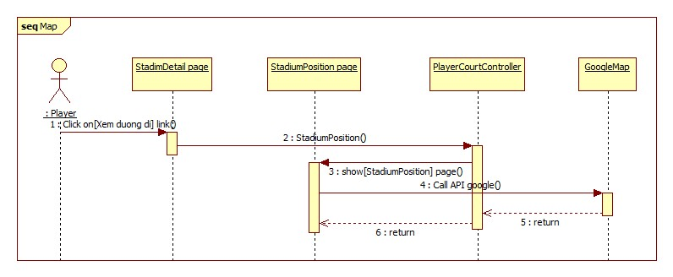

Figure 94: <Player> Map diagram

##### <Player> Rent Court

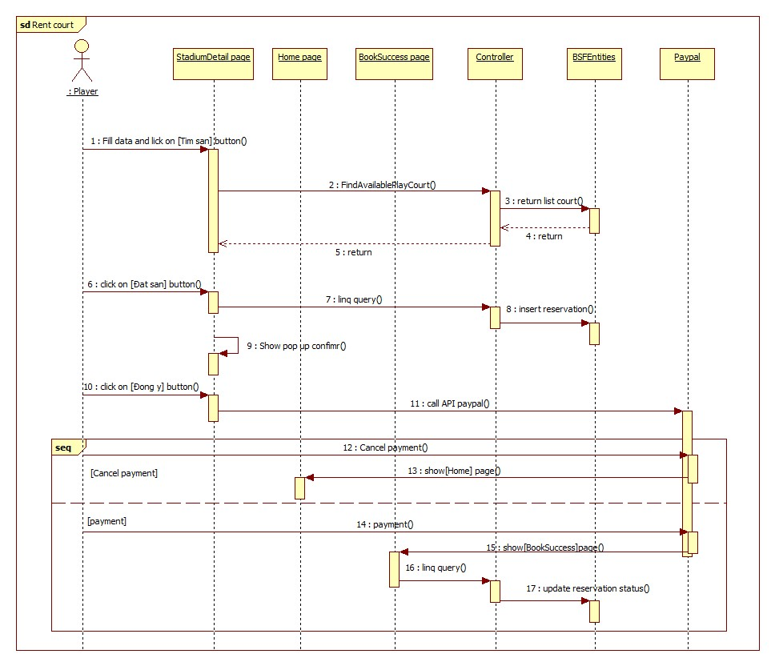

Figure 95: <Player> Rent court sequence diagram

##### <Player> Book history

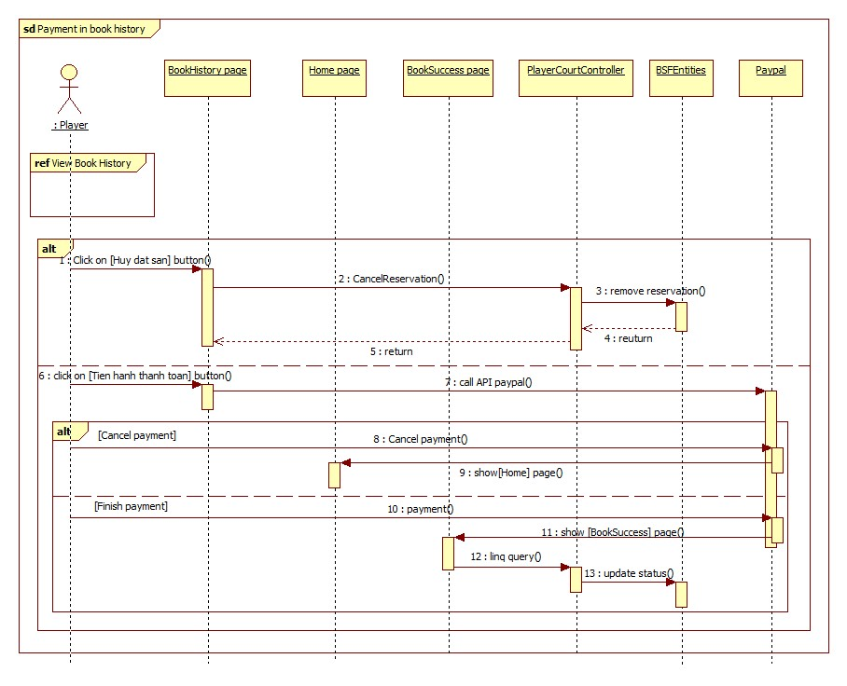

Figure 96: <Player> Book history diagram

##### <Player> Suggest stadium

Figure 97: <Player> Suggest stadium diagram

##### <All> Advanced Search

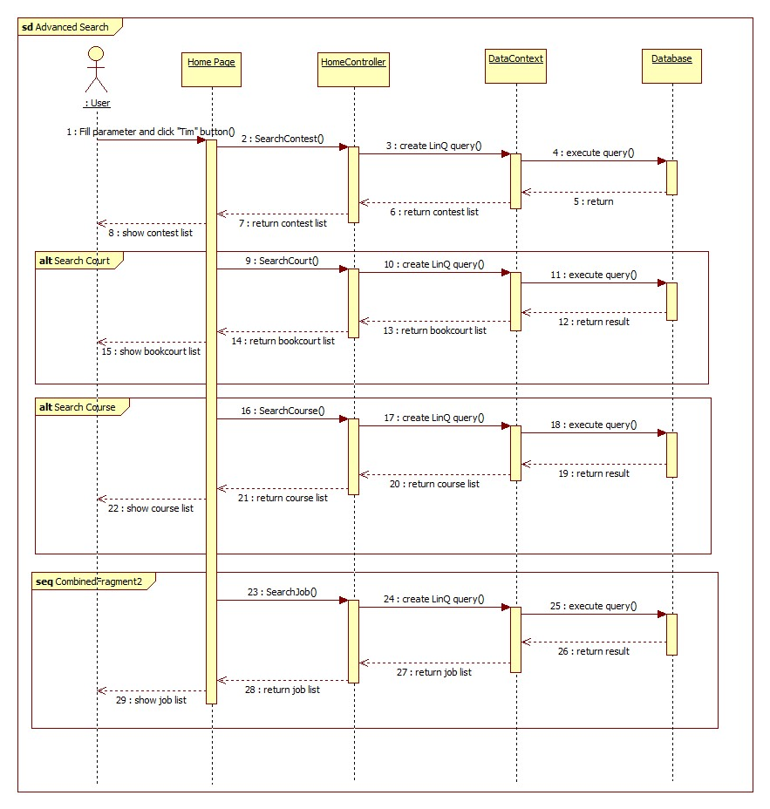

Figure 98: <Player>Advance search

##### <Player> List Upcoming Contest

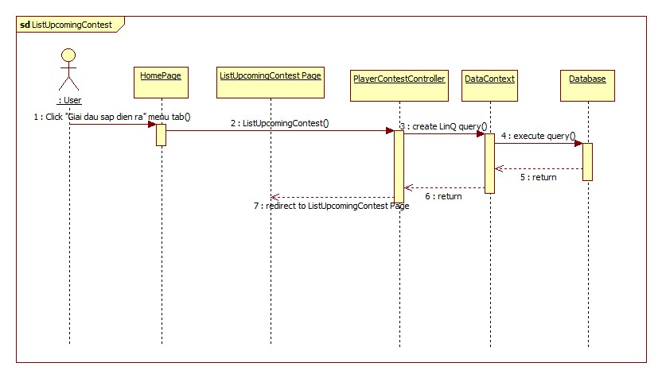

Figure 99: <Player>list upcoming contest sequence diagram

##### <Player> View Contest Detail

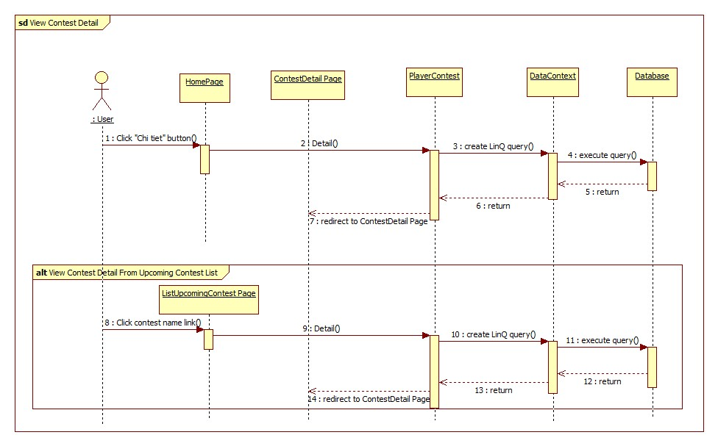

Figure 100: <Player>View contest detail sequence diagram

##### <Player> Join Contest

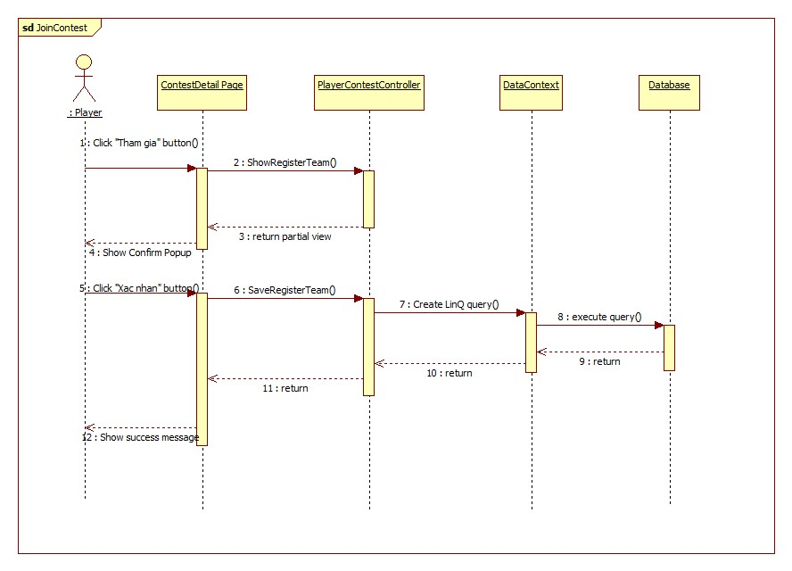

Figure 101: <Agency Manager> Order sequence diagram

##### <Player> Cancel Joining Contest

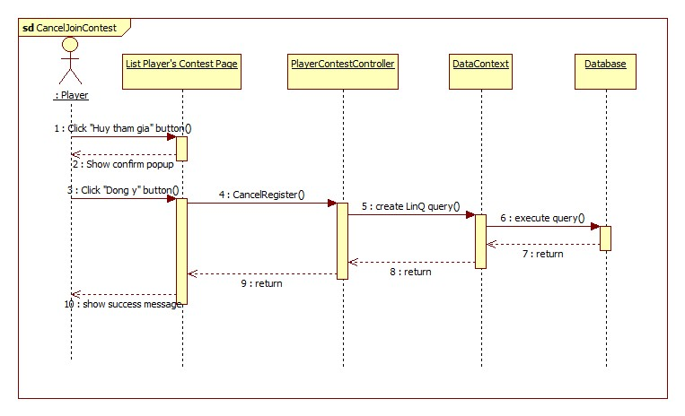

Figure 102:<Player> cancel joining contest sequence diagram

##### <Player> List Happening Contest

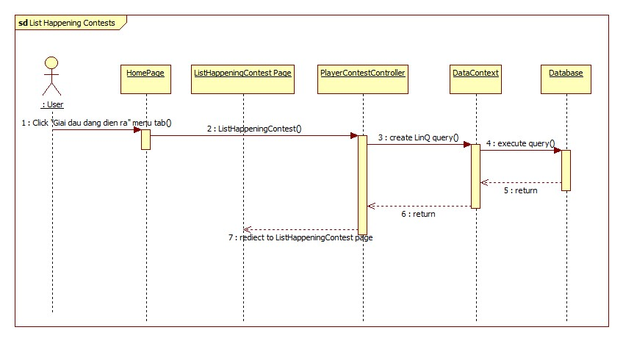Figure 103:<Player> list happening contest sequence diagram

##### <Player> View Contest Schedule

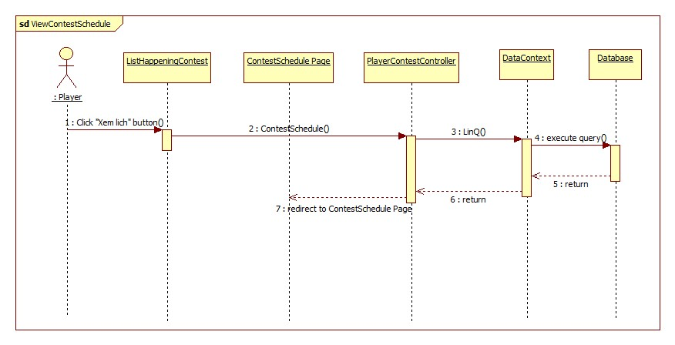

Figure 104:<Player> view contest schedule sequence diagram

##### <Player> List Finished Contest

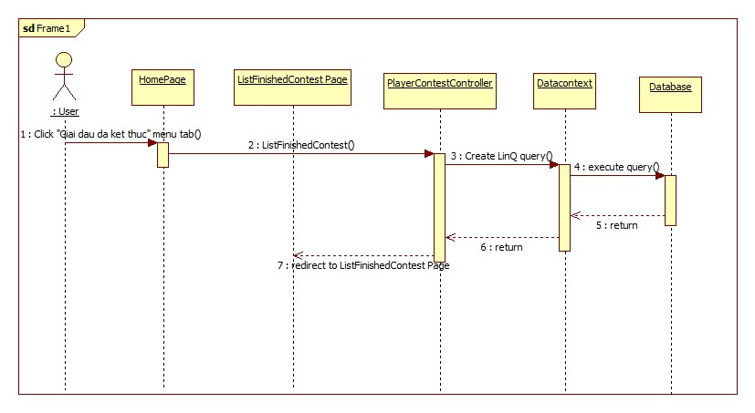

Figure 105:<Player> list finish contest sequence diagram

##### <Player> View Contest Result

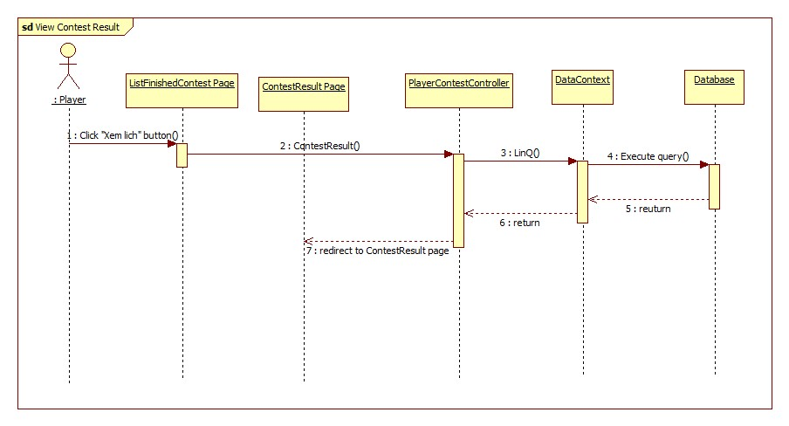

Figure 106:<Player> view contest result sequence diagram

##### <Player> List Contest Player Joined

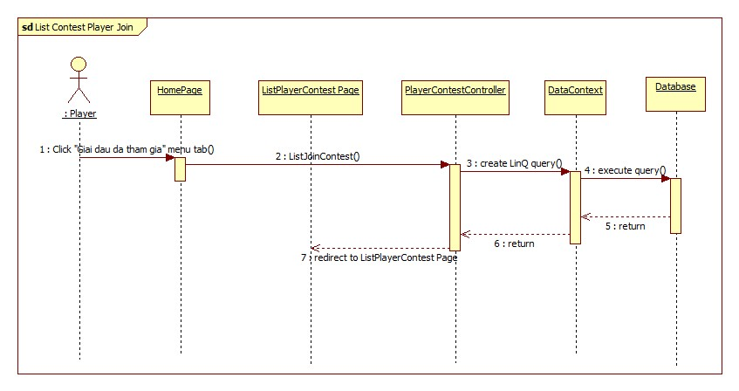

Figure 107:<Player> list contest player joined sequence diagram

##### <Player> View List Courses

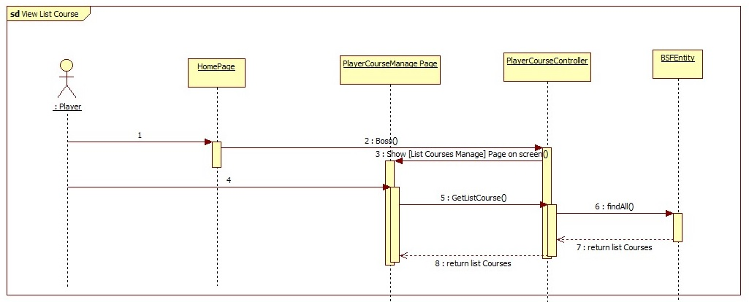

##### <Player> View Detail Course

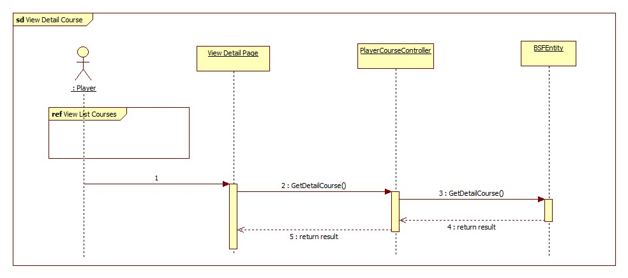

##### <Player> Comment Course

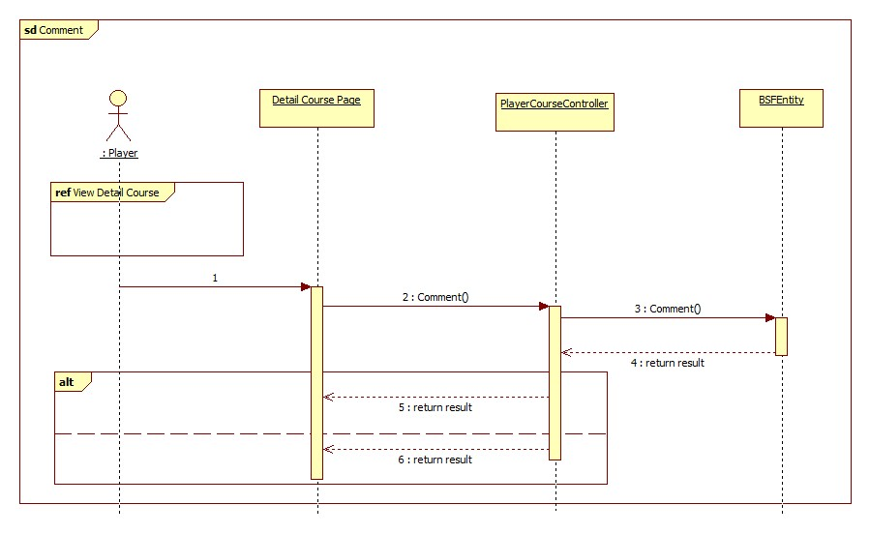

##### <Player> Delete Comment Course

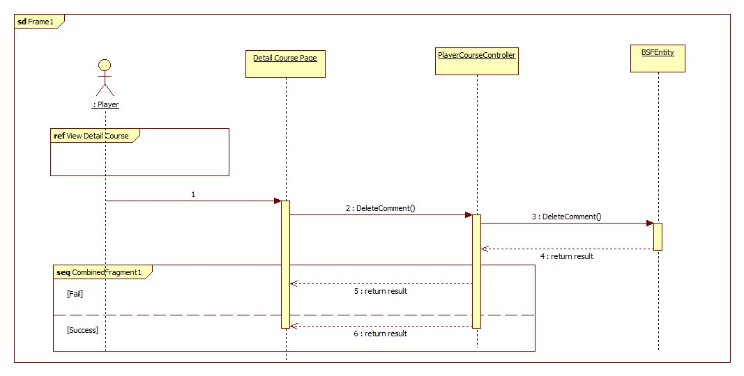

##### <Player> Join Course

**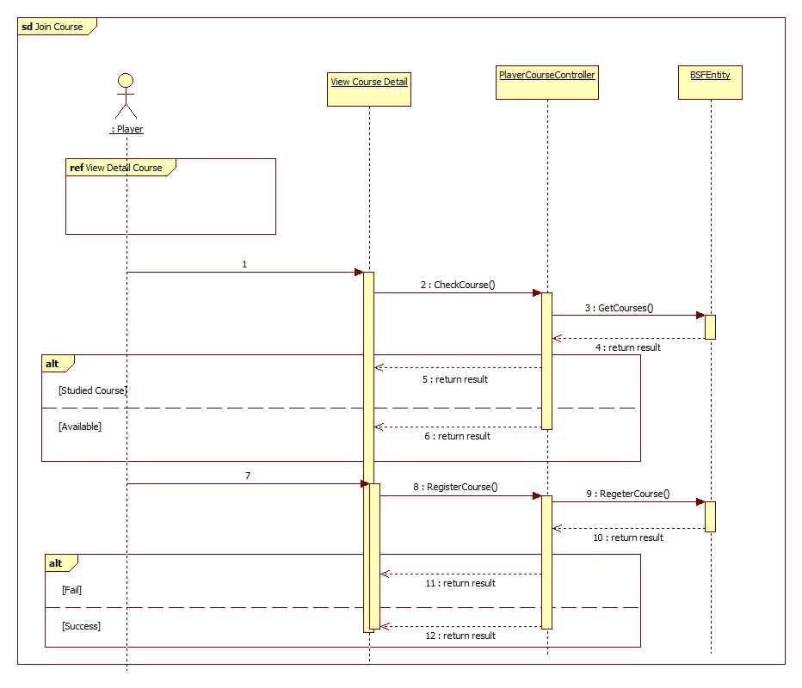**

##### <Player> View List Register Courses

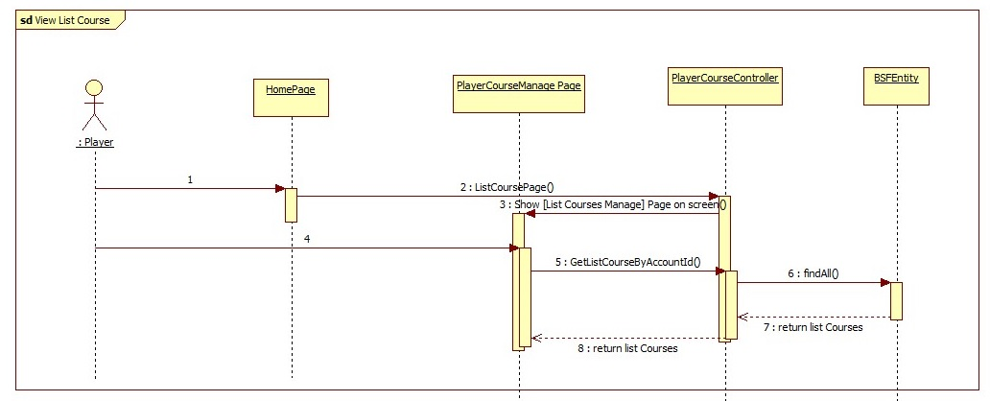

##### <Player> Change Course

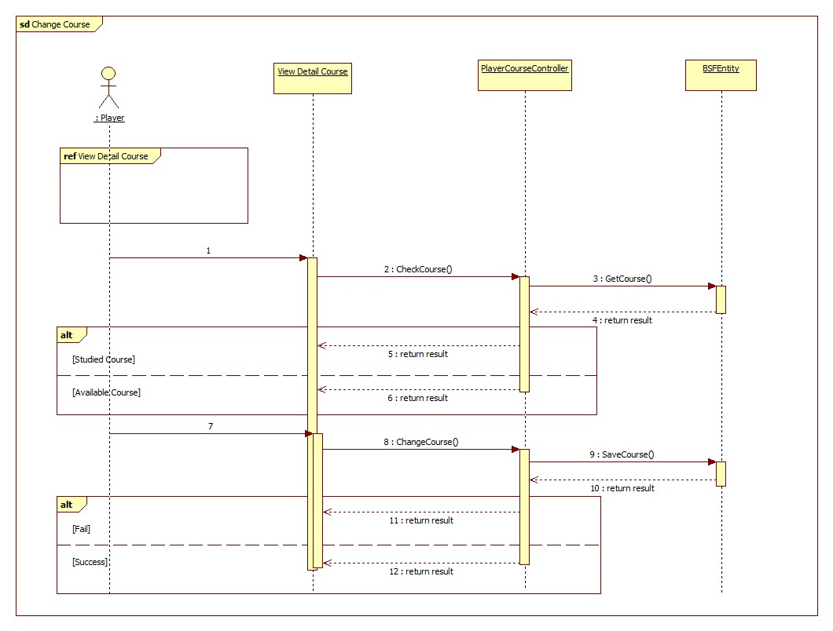

#### Boss Sequence Diagram

##### <Boss> Register stadium

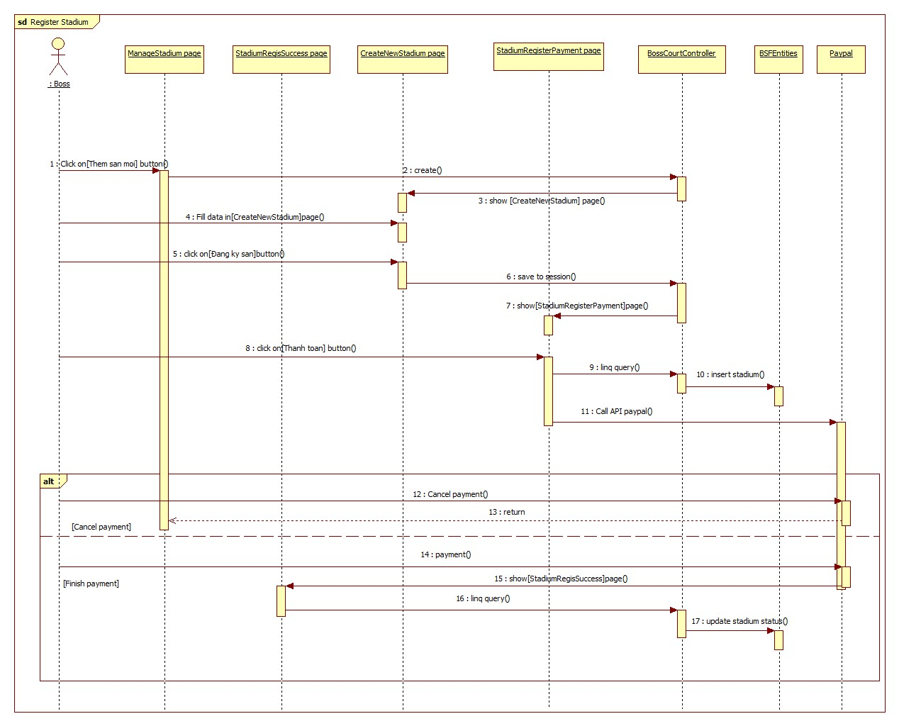

Figure 108: < Boss > Register sequence diagram

##### <Boss> Update Stadium

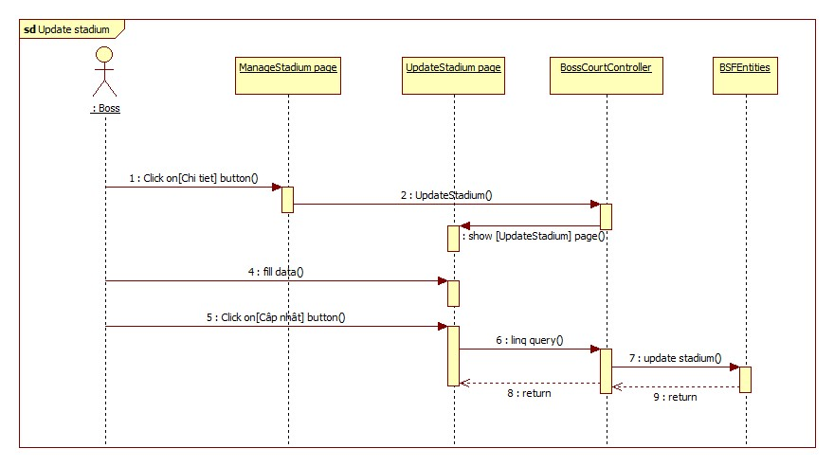

Figure 109: < Boss > Update Stadium sequence diagram

##### <Boss> Create new court

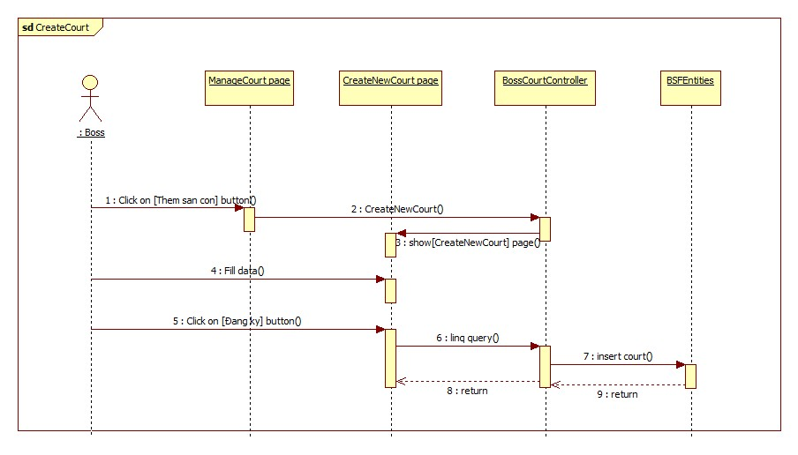

Figure 110: < Boss > Create new court sequence diagram

##### <Boss> Update court

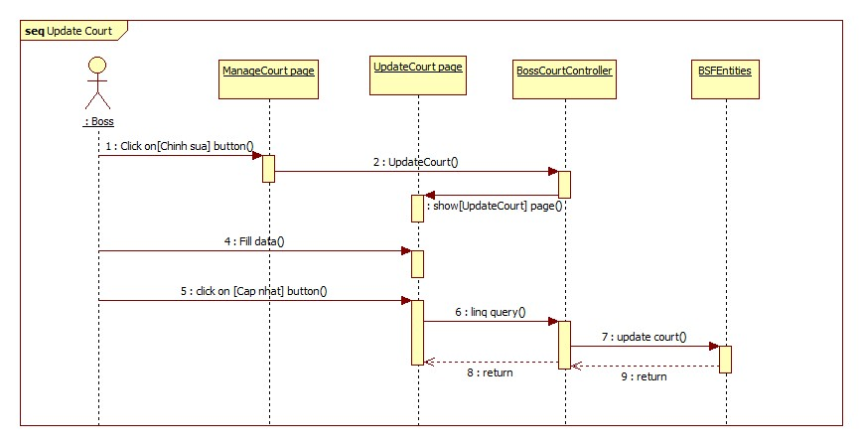

Figure 111: <Boss> Update court sequence diagram

##### <Boss> Add reservation

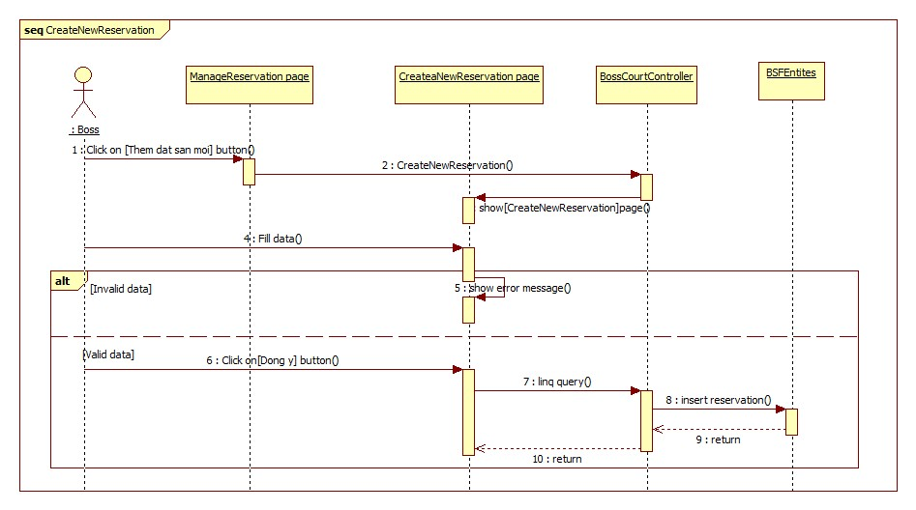

Figure 112: <Boss> Add reservation sequence diagram

##### <Boss> Reservation detail

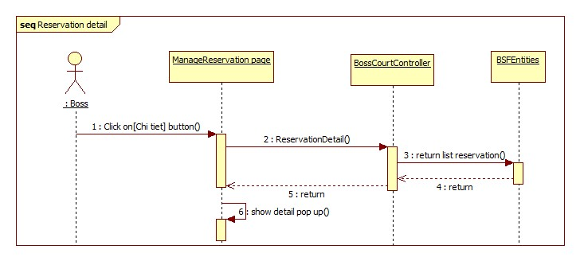

Figure 113: <Boss> Reservation detail sequence diagram

##### <Boss> Create Contest Event

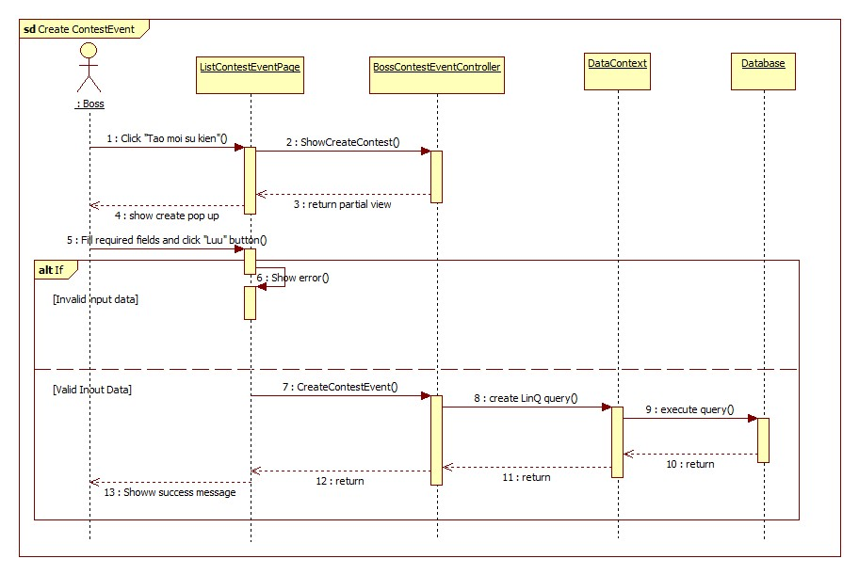

Figure 114:<Boss> Create contest event sequence diagram

##### <Boss> Edit Contest Event

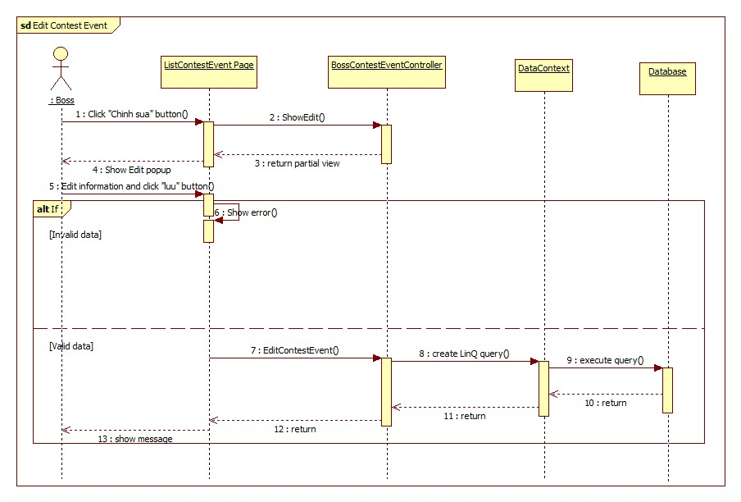

Figure 115:<Boss> Edit contest event sequence diagram

##### <Boss> Delete Contest Event

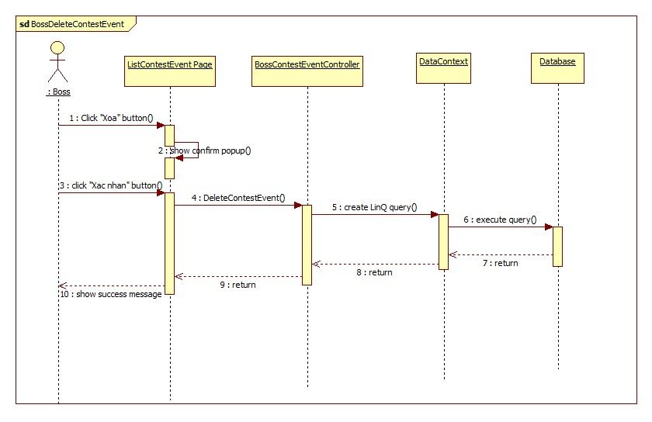

Figure 116:<Boss> delete contest event sequence diagram

##### <Boss> Create Contest

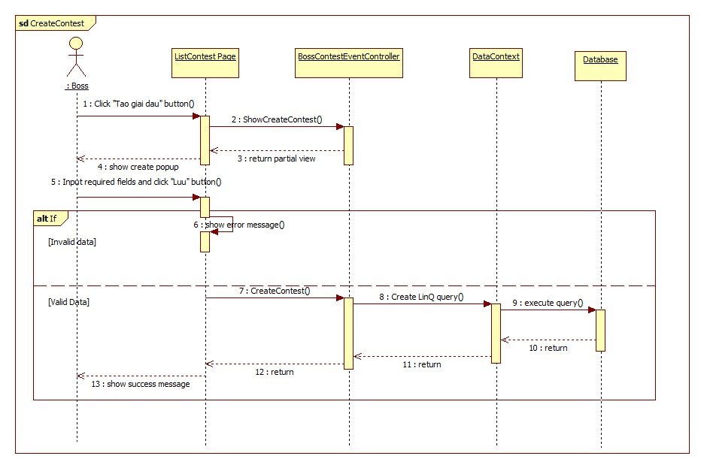

Figure 117:<Boss> Create contest sequence diagram

##### <Boss> Delete Contest

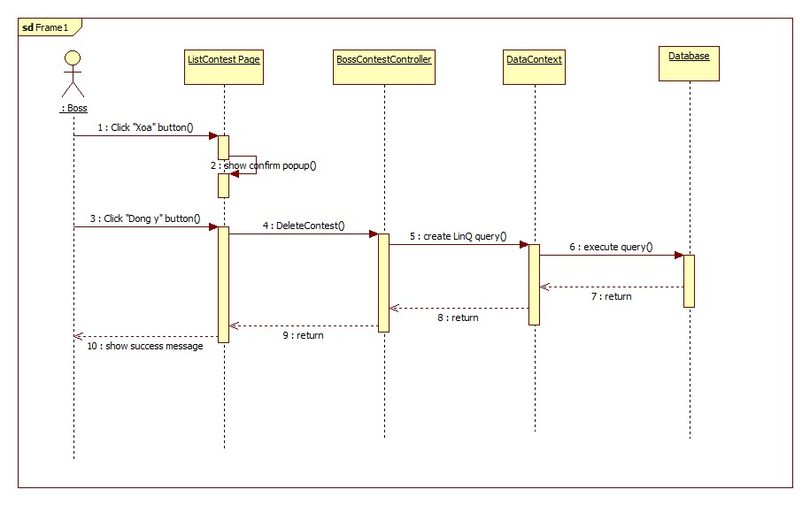

Figure 118:<Boss> Delete contest sequence diagram

##### <Boss> Edit Contest Participation

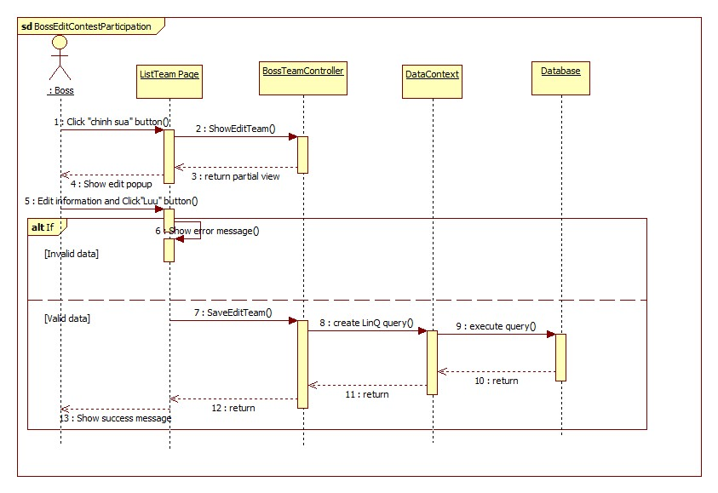

Figure 119:<Boss> edit contest participation sequence diagram

##### <Boss> Report and Reset Vilolate Registration

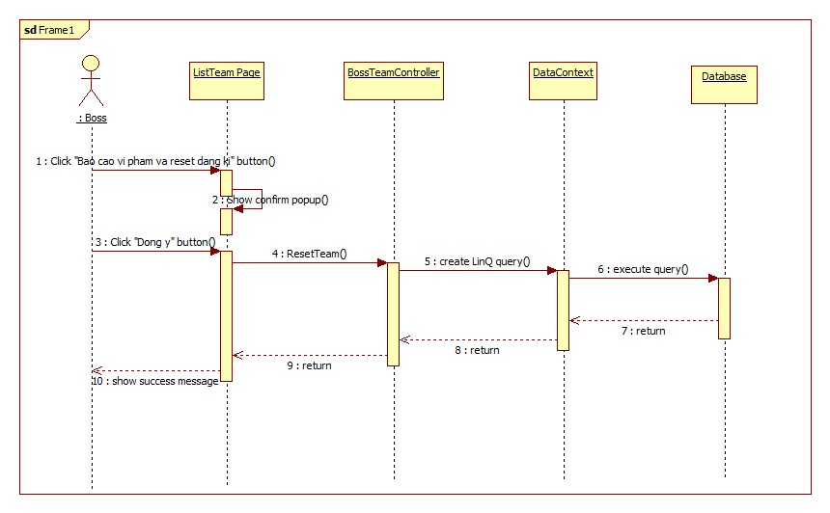

Figure 120:<Boss> report and reser vilolate registration sequence diagram

##### <Boss> Arrange Match Schedule

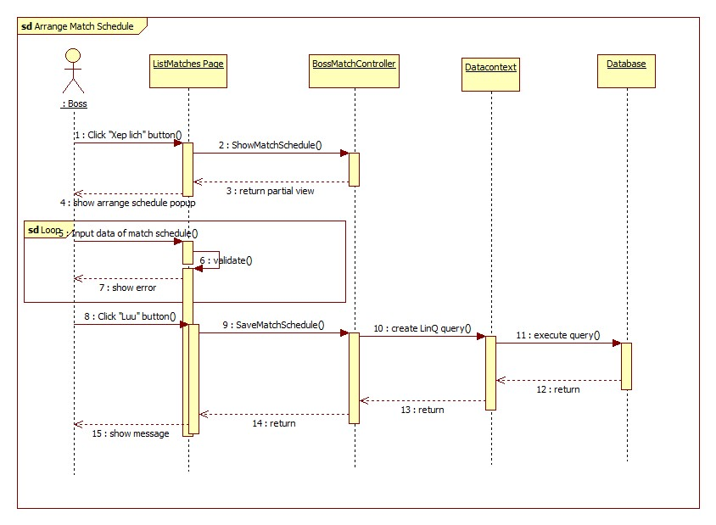

Figure 121:<Boss> arrang match schedule sequence diagram

##### <Boss> Arrange Matches Automatically

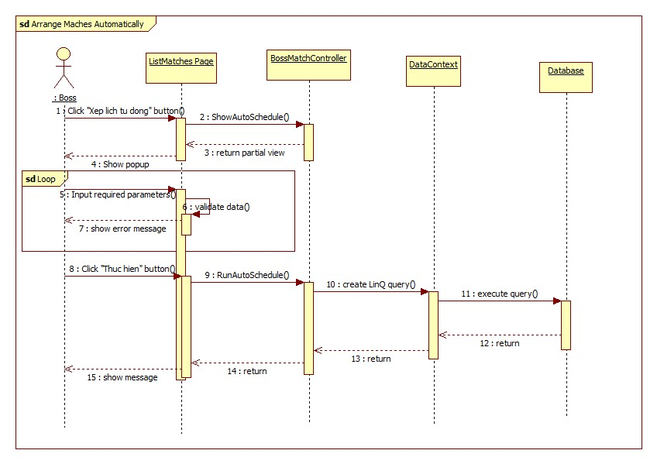

Figure 122:<Boss> arrange matched automatically sequence diagram

##### <Boss> Export Contest Schedule

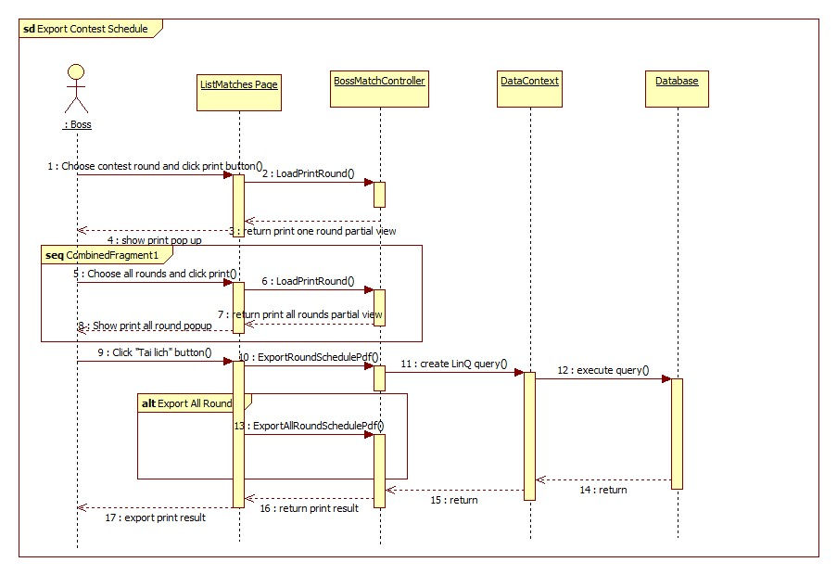

Figure 123:<Boss> export contest schedule sequence diagram

##### <Boss> Record Match Scores

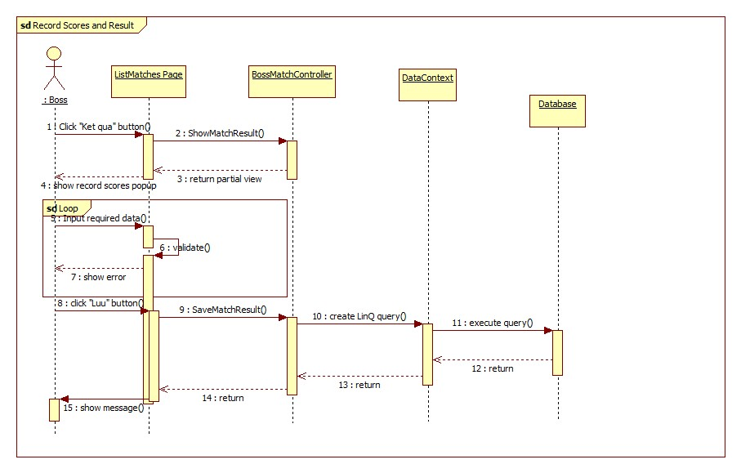

Figure 124:<Boss> reocrd match scores sequence diagram

##### <Boss> Export Contest Result

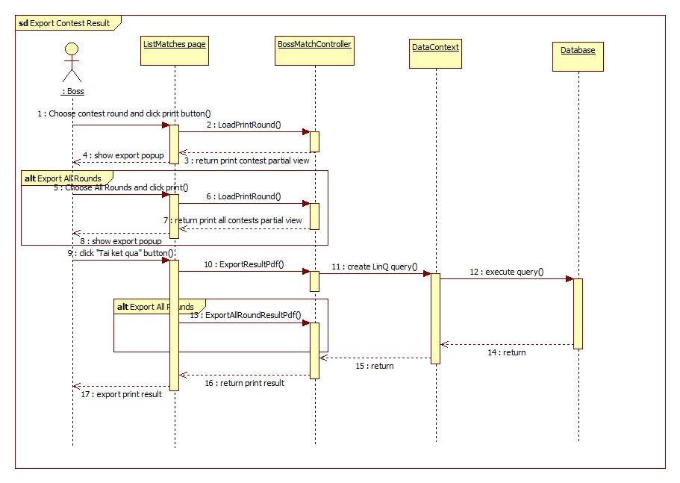

Figure 125: Export Contest Result sequence diagram

##### <Boss> View Contest Statistics

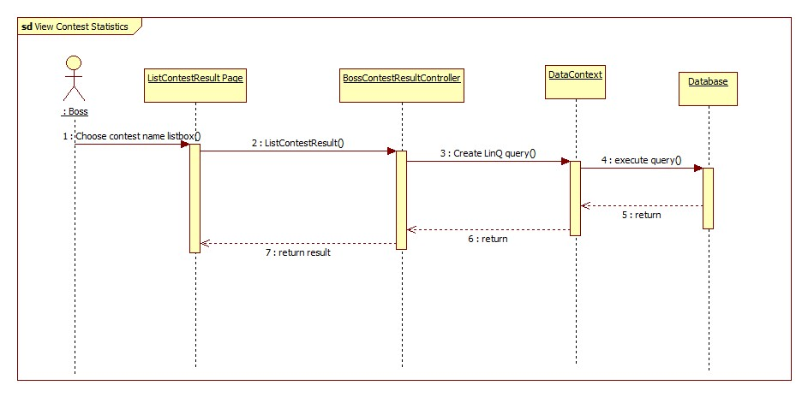

Figure 126: View Contest Statistics sequence diagram

##### <Boss> Answer Message

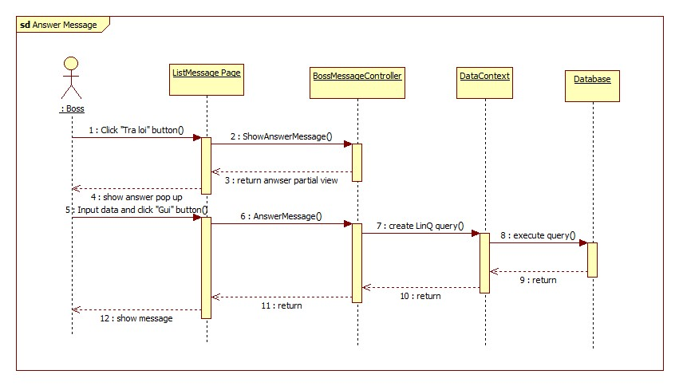

Figure 127:Answer Message sequence diagram

##### <Boss> Delete message

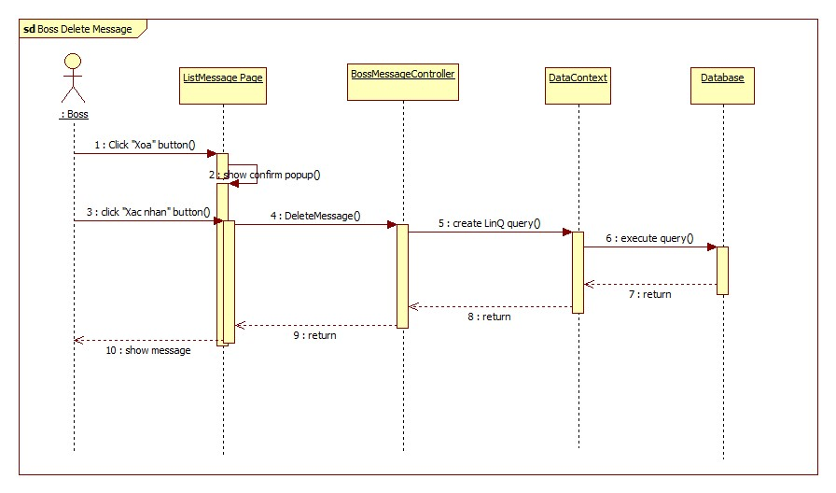

Figure 128:Delete Message sequence diagram

##### <Boss> Create Pricelist

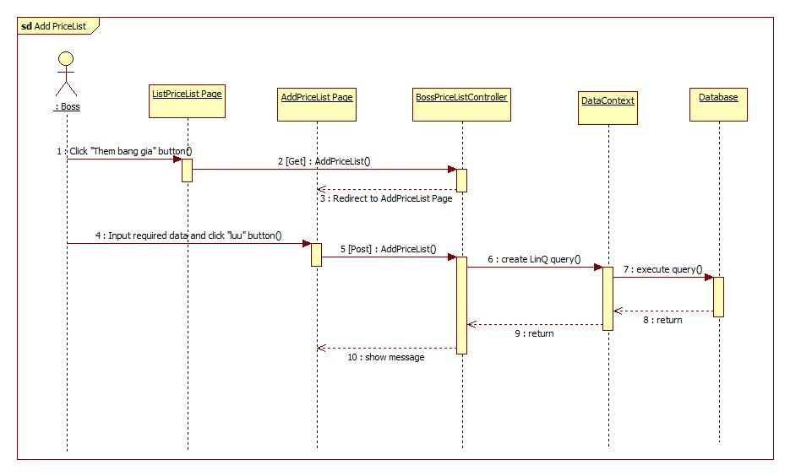

Figure 129:Create Pricelist sequence diagram

##### <Boss> Edit Pricelist

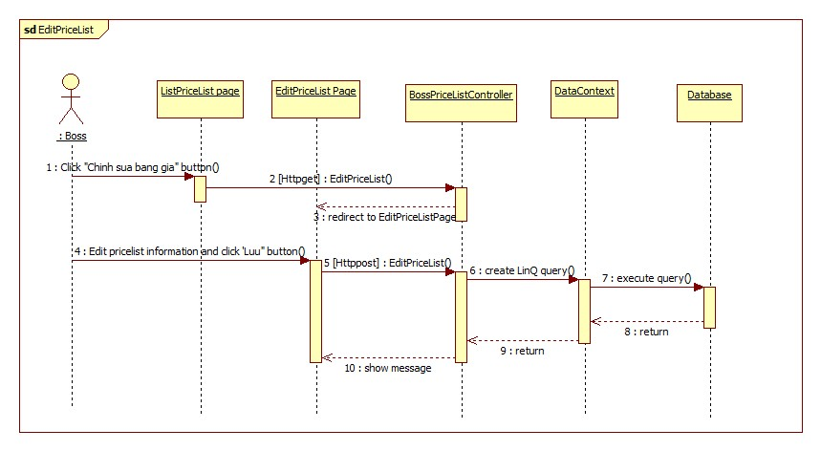

Figure 130: Edit Pricelist sequence diagram

##### <Boss> Enable Pricelist

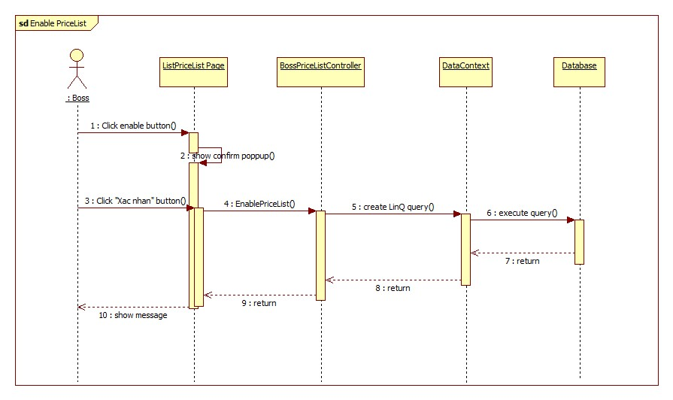

Figure 131:EnablePricelist sequence diagram

##### <Boss> Disable Pricelist

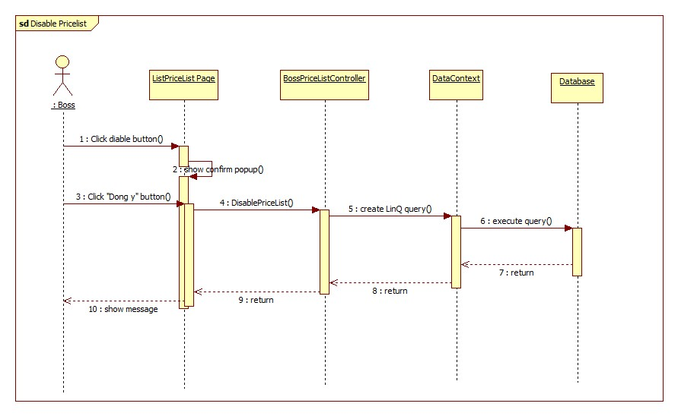

Figure 132: Disable Pricelist sequence diagram

##### <Boss> View List Course Course

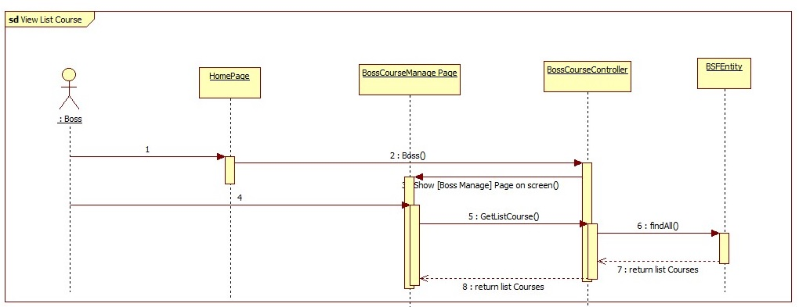

##### <Boss> View Detail Course

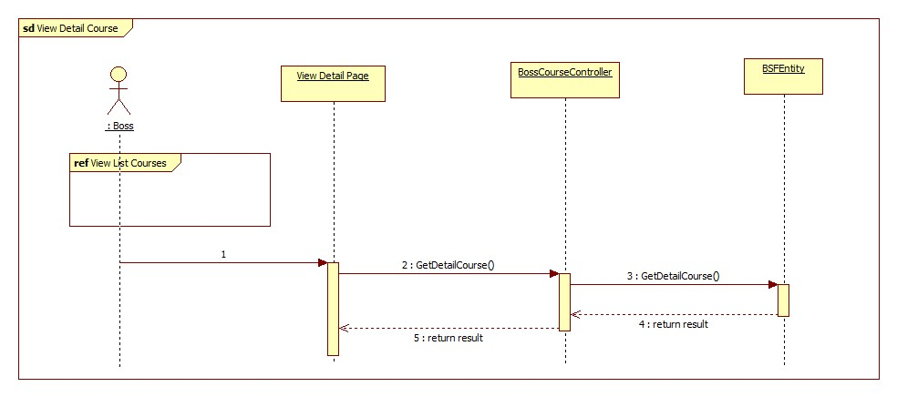

##### <Boss> Create Course

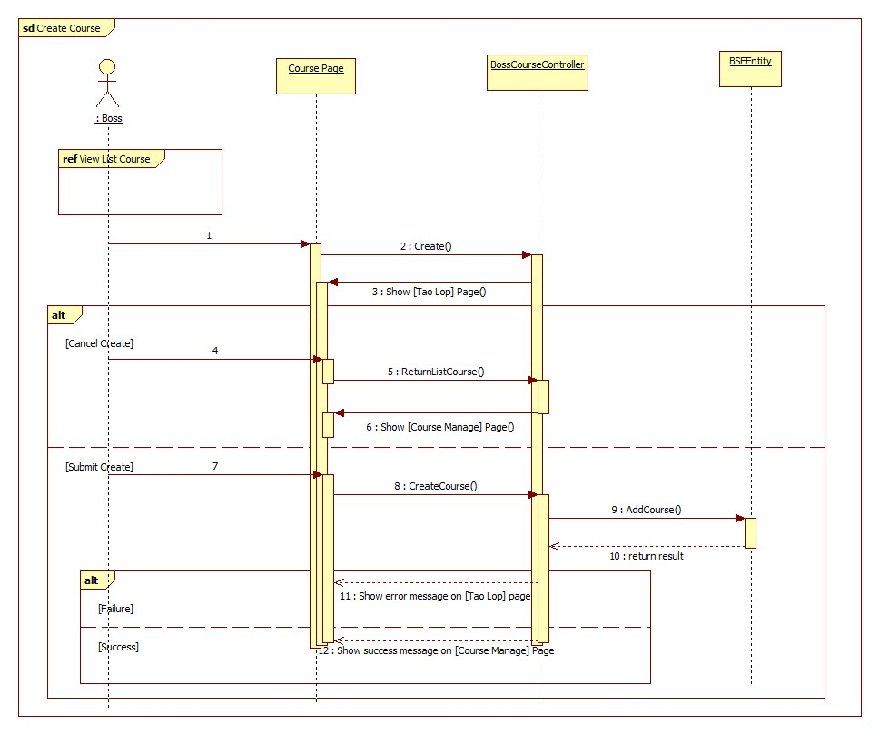

##### <Boss> Edit Course

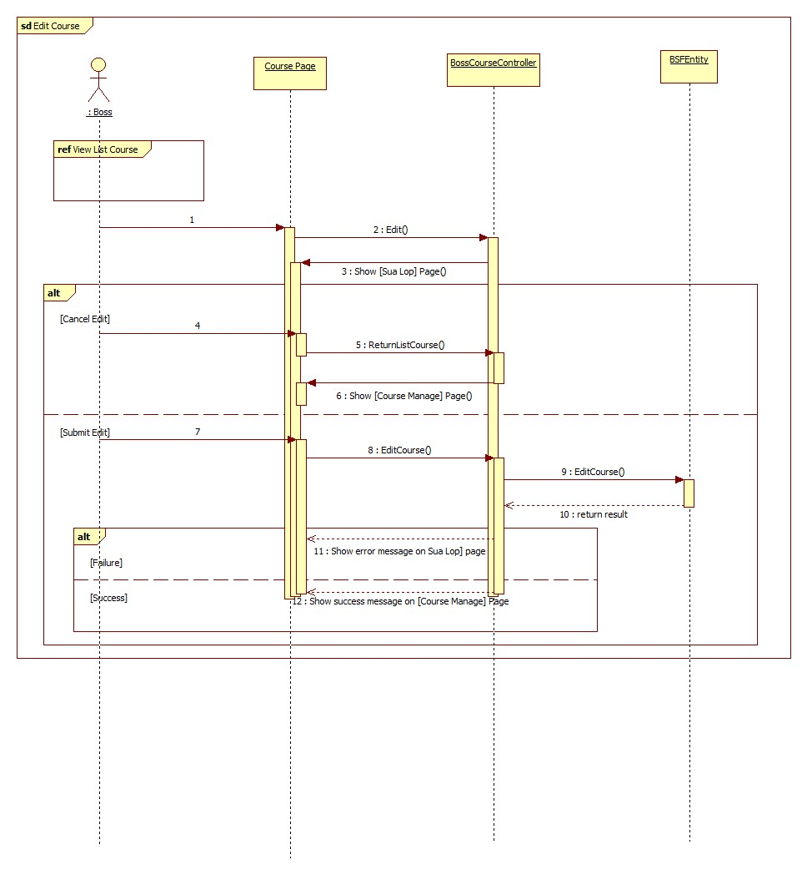

##### <Boss> Delete Course

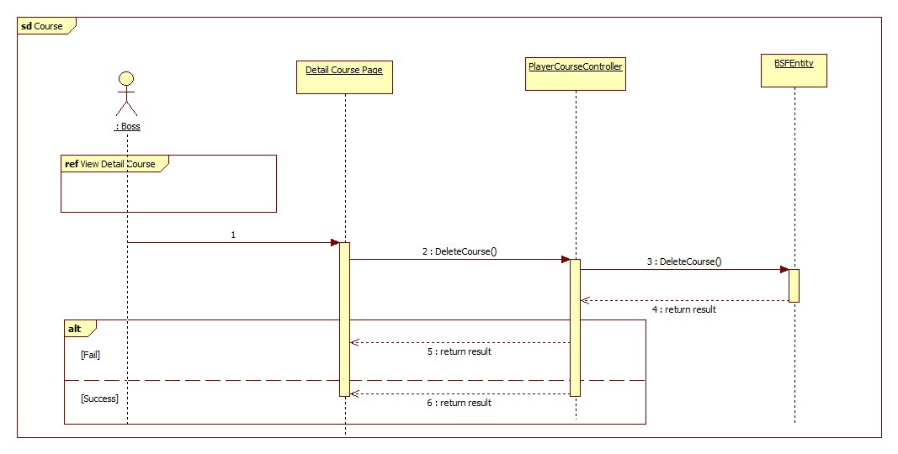

##### <Boss> Comment Course

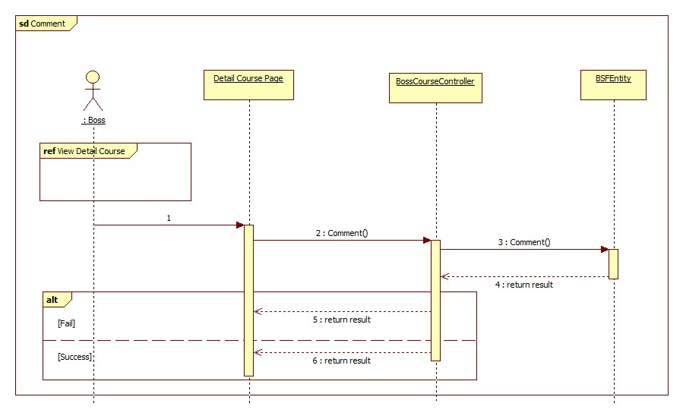

##### <Boss> Delete Comment Course

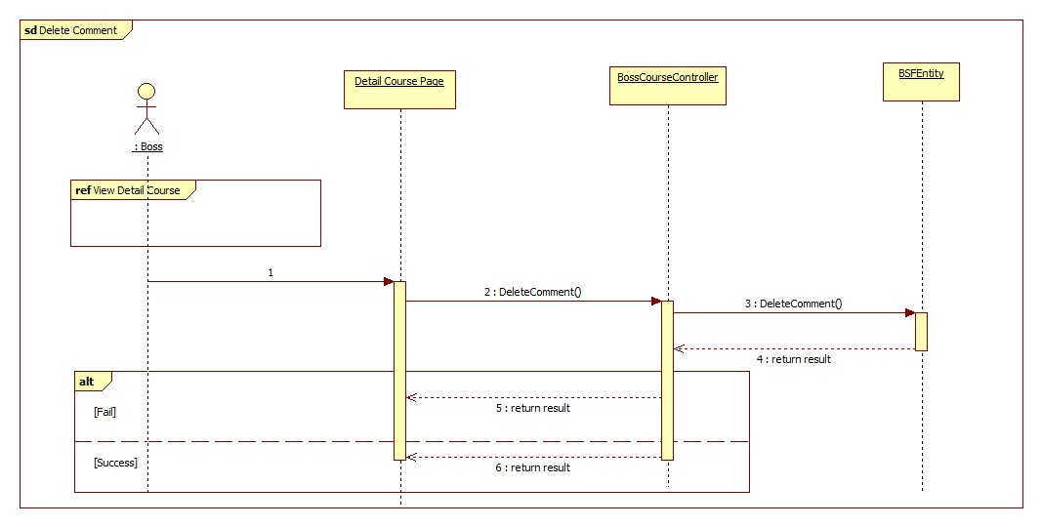

##### <Boss> View List Register Course

##### <Boss> Confirm Join Course

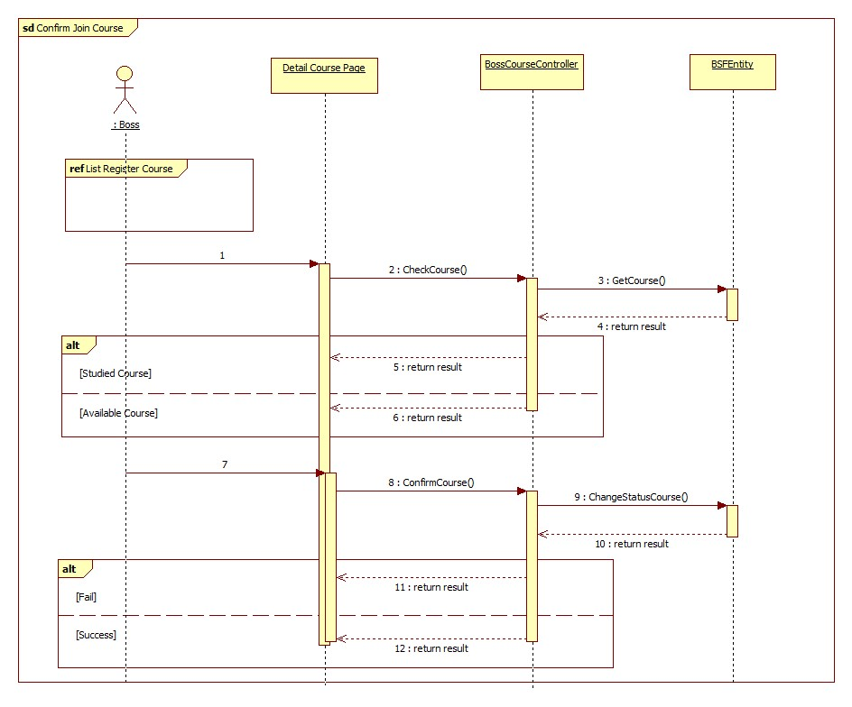

##### <Boss> Confirm Change Course

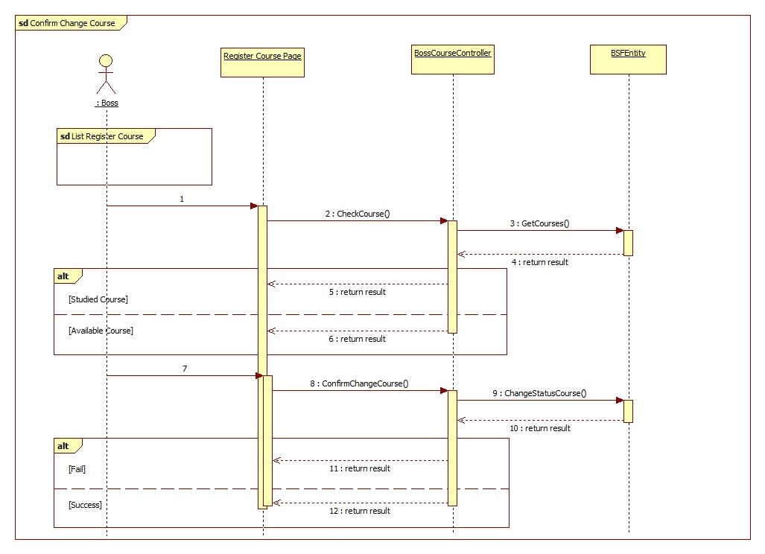

#### Coach Sequence Diagram

##### < Coach > View List Job

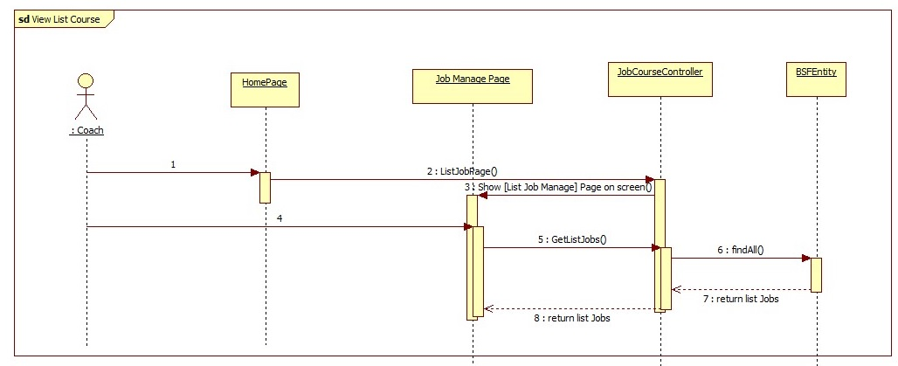

##### < Coach > View Detail Course

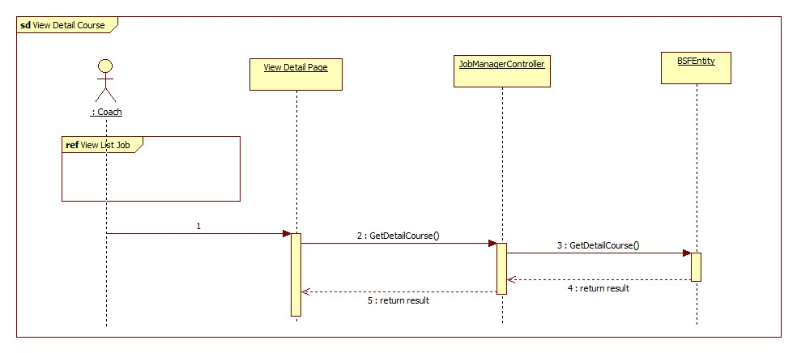

##### < Coach > Comment Course

##### < Coach > Delete Comment Course

##### < Coach > Join Job

**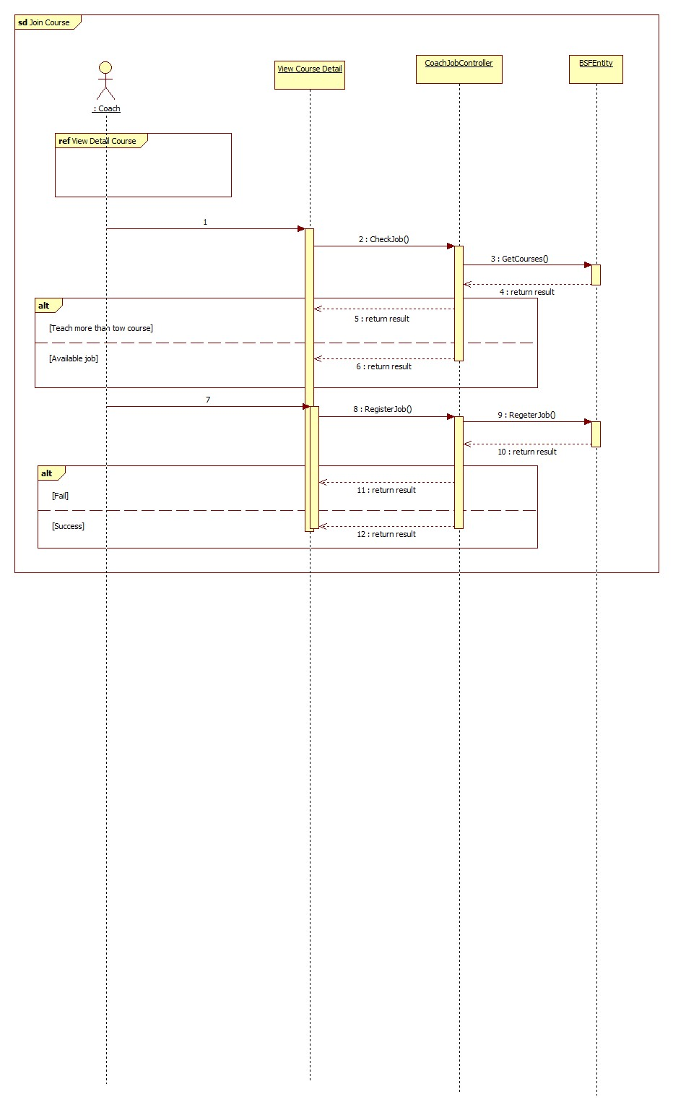**

##### < Coach > View List Teaching Job

##### < Coach > Change Job

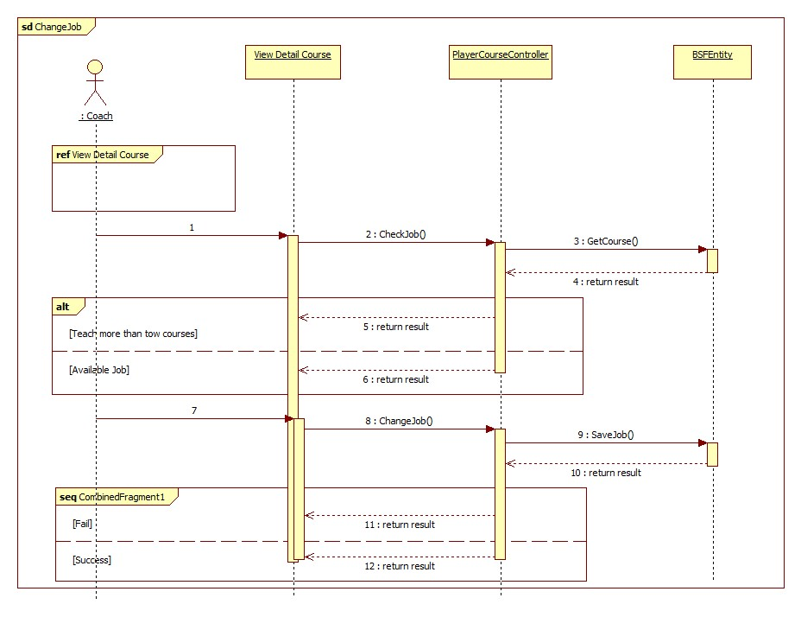

#### Webmaster Sequence Diagram

##### < Webmaster > Create Account

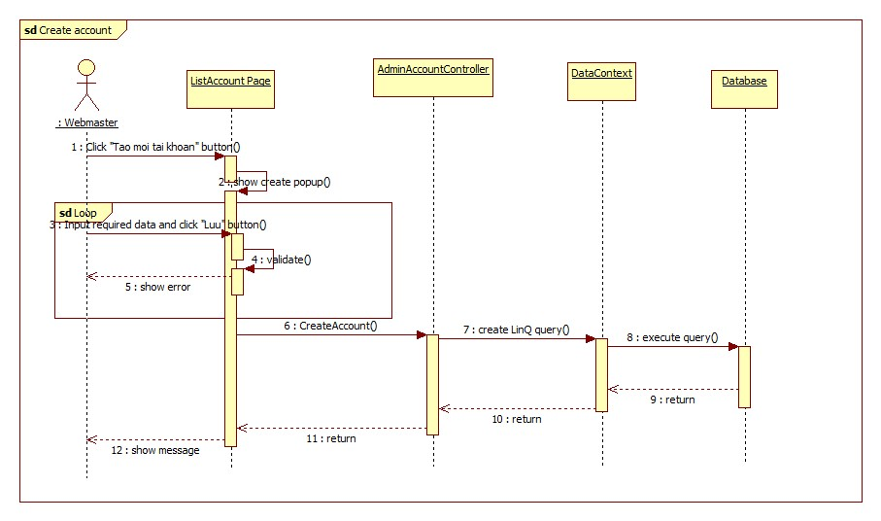

Figure 133: <Webmaster> Edit

##### < Webmaster > Edit Account

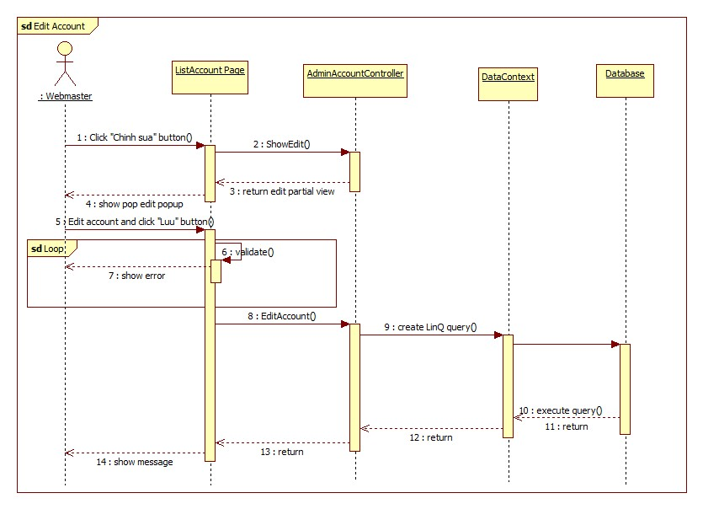

Figure 134: <Webmaster> Edit Product sequence diagram

##### < Webmaster > Delete Account

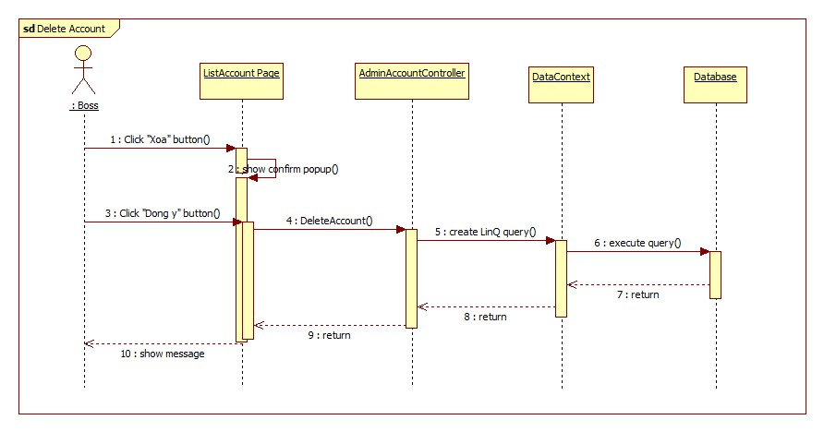

Figure 135: <Webmaster> Disable Product sequence diagram

##### <Webmaster> Disable Stadium Register

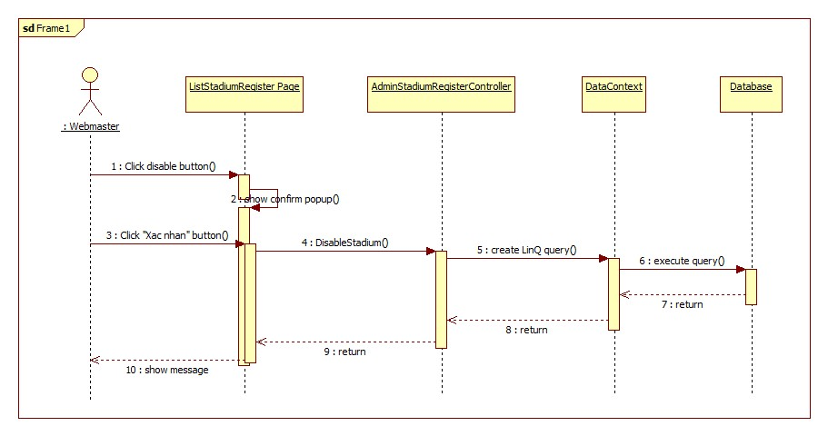

Figure 136: <Webmaster> Send Message

##### <Webmaster> Send Message

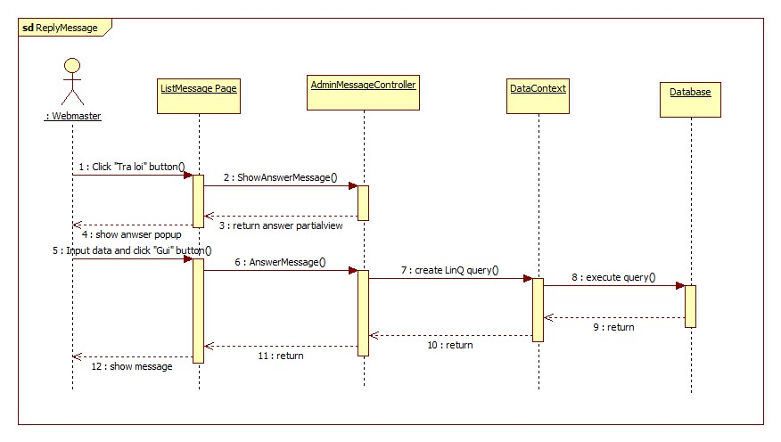

Figure 137: <Webmaster> Delete Message

##### <Webmaster> Delete Message

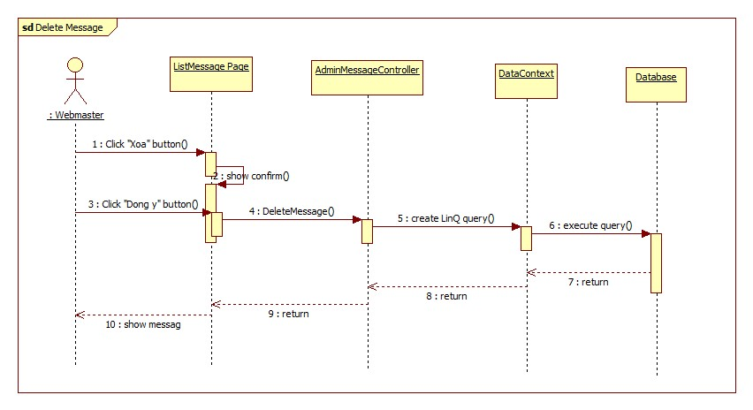

Figure 138: <Webmaster> Manual Browse Order sequence diagram

##### <Webmaster> Add stadium rent price

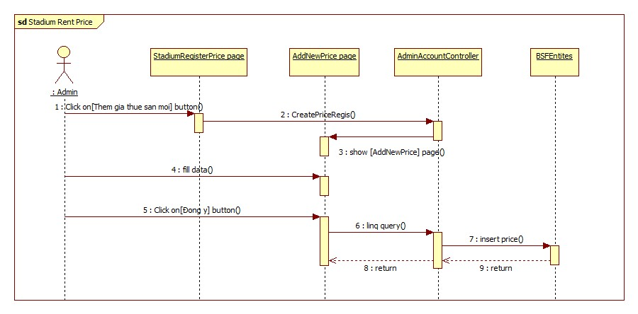

Figure 139: <Admin> Add stadium sequence diagram

##### <Webmaster> Edit Stadium Rent Price

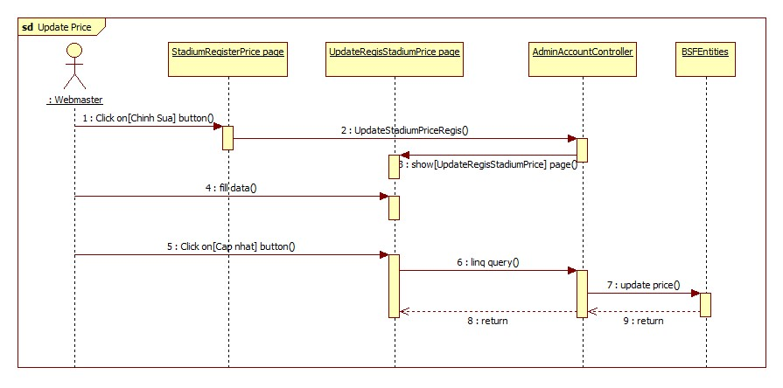

Figure 140: <Admin> edit stadium sequence diagram

#### System Sequence Diagram

##### <System>Suggest Contest

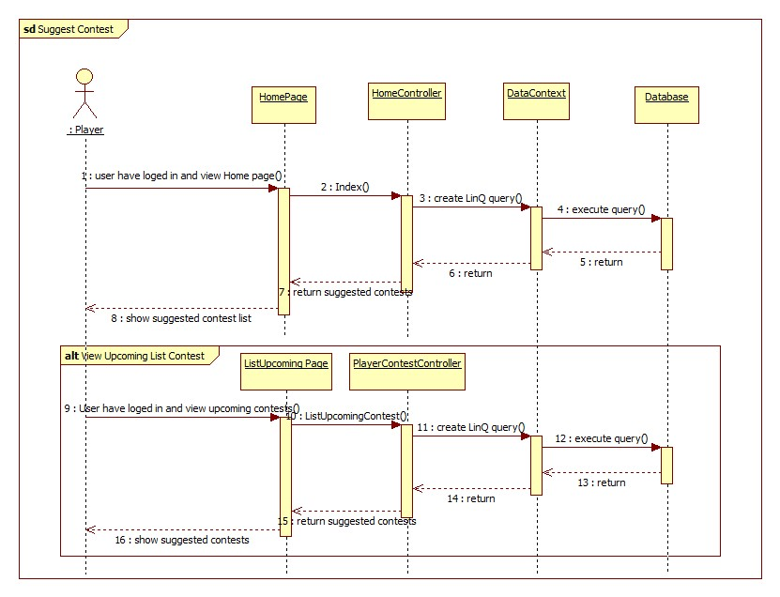

Figure 141: Suggest Contest sequence diagram

## User Interface Design

### User Interface Design

#### BSF-Website Home Page

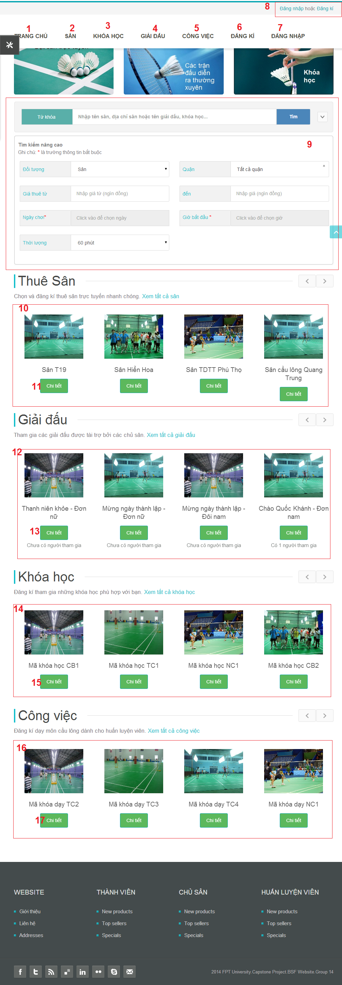

Figure 142: Manager Home Page

**Button/ Hyperlink**

|  |  |  |  |  |
| --- | --- | --- | --- | --- |
| **No** | **Function** | **Description** | **Validation** | **Outcome** |
| 1 | Home Page | Link to home page. | No | Home page |
| 2 | Stadium List | Link to list stadium page. | No | List Stadium page. |
| 3 | Course List | Link to Course List Page. | No | Course List Page |
| 4 | Contest List | Link to Upcoming Contest List Page | No | List upcoming contest page. |
| 5 | Teaching Job List | Link to Teaching Job page | No | List all page |
| 6 | Register Account | Register account | No | List agency page |
| 7 | Personal management | User activites management. | No | N/A |
| 8 | Login/Logout | Login/Logout. | No | Login Popup/Home Page |
| 9 | Search | Search and advanced search | No | N/A |
| 10 | Stadium Slides | Show stadium list. | No | Register page |
| 11 | Stadium detail | Stadium detail. | No | Stadium detail page. |
| 12 | Contest Slides | List of contests. | No | N/A |
| 13 | Contest Detail | Contest Detail | No | Contest Detail |
| 14 | Course Slides | List of course. | No | N/A |
| 15 | Course Detail | Course detail. | No | Course detail page. |
| 16 | Teaching Job Slide | List teaching job. | No | N/A |
| 17 | Job Detail | Job detail | No | Job detail. |

#### Stadium List

**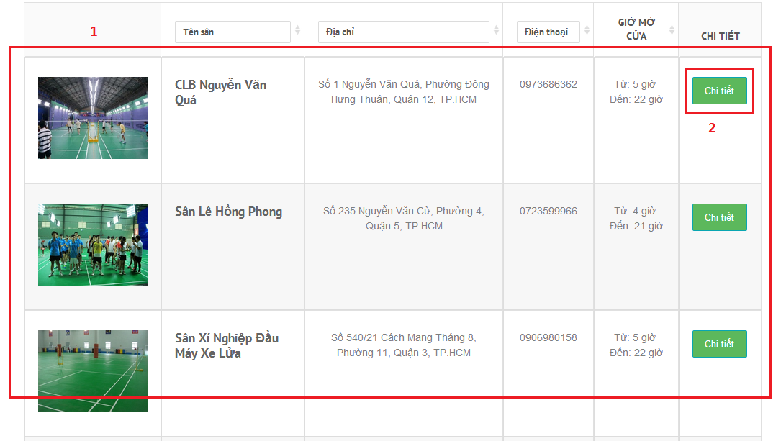**

Figure 143: stadium list

**Fields**

|  |  |  |  |  |  |  |  |
| --- | --- | --- | --- | --- | --- | --- | --- |
| **No** | **Field Name** | **Description** | **Read only** | **Mand-atory** | **Control Type** | **Data Type** | **Length** |
| 1 | Stadium list table | Show list stadium | N | Y | Table | N/A | N/A |

**Table Stadium list includes**

|  |  |  |  |  |  |
| --- | --- | --- | --- | --- | --- |
| **Field Name** | **Description** | **Read only** | **Control Type** | **Data Type** | **Length** |
| Image | Display image of stadium. | Y | Image | Image | N/A |
| Name stadium | Name of stadium | Y | Label | String | N/A |
| Stadium address | Stadium address | Y | Label | String | N/A |
| Sstadium phone | Stadium phone | Y | Label | String | N/A |
| Opentime | Stadium open time | Y | Label | String | N/A |
| Detail | Stadium detail | N | Button | N/A | N/A |

**Button/ Hyperlink**

|  |  |  |  |  |
| --- | --- | --- | --- | --- |
| **No** | **Function** | **Description** | **Validation** | **Outcome** |
| 2 | StadiumDetail | Show stadium detail | No | N/A |

#### Stadium Detail

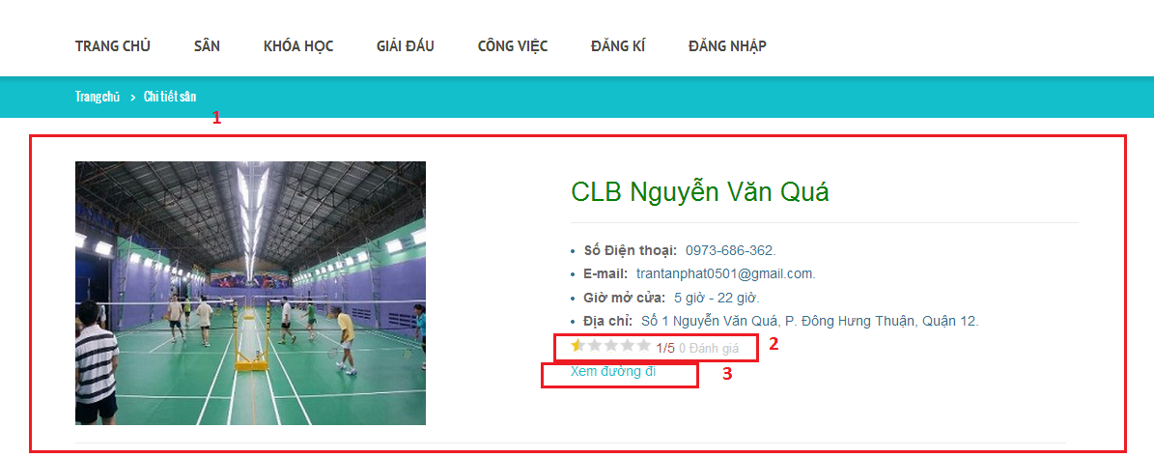

Figure 144: stadium detail

**Fields**

|  |  |  |  |  |  |  |  |
| --- | --- | --- | --- | --- | --- | --- | --- |
| **No** | **Field Name** | **Description** | **Read only** | **Mand-atory** | **Control Type** | **Data Type** | **Length** |
| 1 | Stadium detail form | Show stadium detail | N | Y | form | N/A | N/A |

**Button/ Hyperlink**

|  |  |  |  |  |
| --- | --- | --- | --- | --- |
| **No** | **Function** | **Description** | **Validation** | **Outcome** |
| 2 | Show review point | Show review point | No | N/A |
| 3 | View map | View map | No | N/A |

#### Find avaliable court

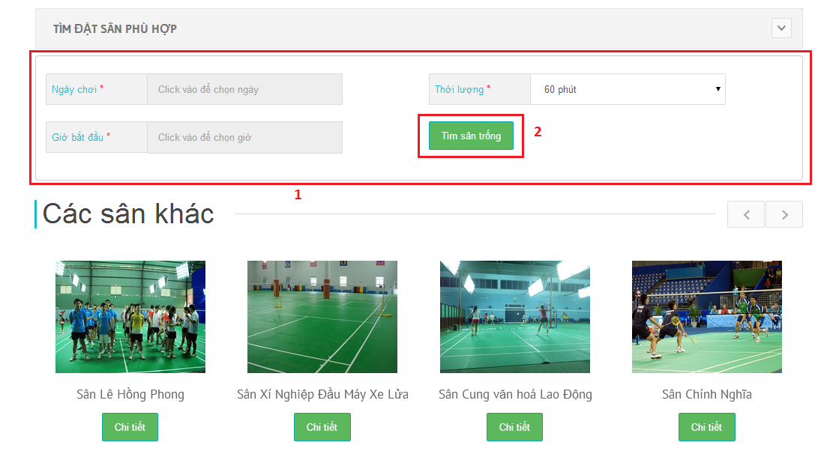

**Fields**

|  |  |  |  |  |  |  |  |
| --- | --- | --- | --- | --- | --- | --- | --- |
| **No** | **Field Name** | **Description** | **Read only** | **Mand-atory** | **Control Type** | **Data Type** | **Length** |
| 1 | Find avaliable form | Show form find court | N | Y | form | N/A | N/A |

**Button/ Hyperlink**

|  |  |  |  |  |
| --- | --- | --- | --- | --- |
| **No** | **Function** | **Description** | **Validation** | **Outcome** |
| 2 | Find court | Find court | YES | N/A |

#### BookCourt

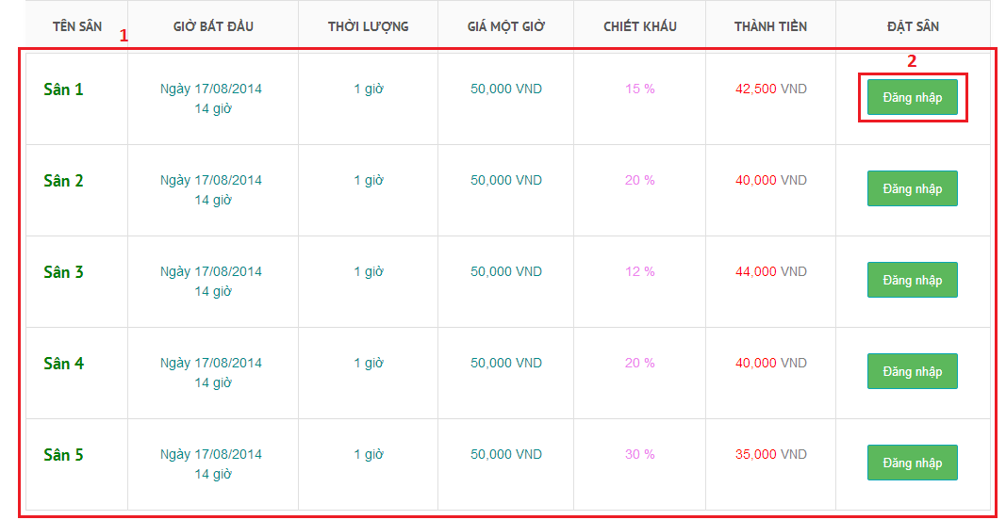

Figure 145: Book court

**Fields**

|  |  |  |  |  |  |  |  |
| --- | --- | --- | --- | --- | --- | --- | --- |
| **No** | **Field Name** | **Description** | **Read only** | **Mand-atory** | **Control Type** | **Data Type** | **Length** |
| 1 | List court | Show list court | N | Y | Table | N/A | N/A |

**Table Stadium list includes**

|  |  |  |  |  |  |
| --- | --- | --- | --- | --- | --- |
| **Field Name** | **Description** | **Read only** | **Control Type** | **Data Type** | **Length** |
| Name court | Start time | Y | Label | String | N/A |
| Duration | Duration | Y | Label | String | N/A |
| Price | Price | Y | Label | String | N/A |
| Discount | Discount of each court | Y | Label | String | N/A |
| Price | Price for pay | Y | Label | String | N/A |
| BookCourt | Book court | N | Button | N/A | N/A |

**Button/ Hyperlink**

|  |  |  |  |  |
| --- | --- | --- | --- | --- |
| **No** | **Function** | **Description** | **Validation** | **Outcome** |
| 2 | BookCourt | Show Book detail | No | N/A |

#### BookHistory

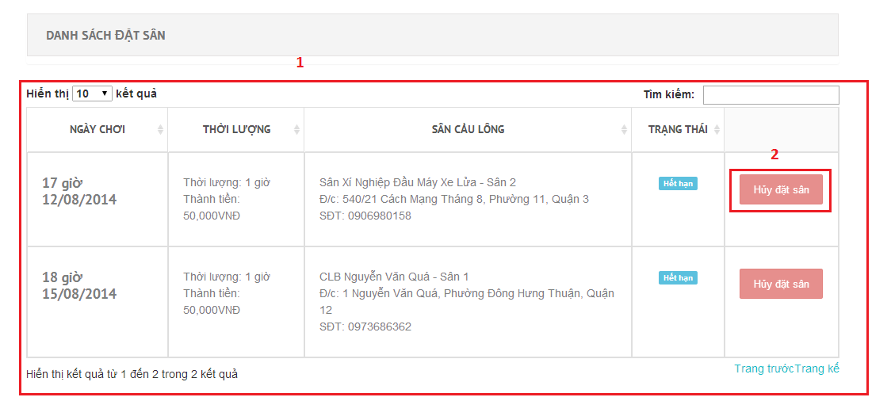

Figure 146: Book history

**Fields**

|  |  |  |  |  |  |  |  |
| --- | --- | --- | --- | --- | --- | --- | --- |
| **No** | **Field Name** | **Description** | **Read only** | **Mand-atory** | **Control Type** | **Data Type** | **Length** |
| 1 | Reservation table | Show list reservation | N | Y | Table | N/A | N/A |

**Table Stadium list includes**

|  |  |  |  |  |  |
| --- | --- | --- | --- | --- | --- |
| **Field Name** | **Description** | **Read only** | **Control Type** | **Data Type** | **Length** |
| Date | Date to play | Y | Label | String | N/A |
| Duration | Duration | Y | Label | String | N/A |
| Stadium information | Stadium information | Y | Label | String | N/A |
| Status | Status of reservation | Y | Label | String | N/A |
| Cancel reservation | Cancel reservation | N |  | Button | N/A |

**Button/ Hyperlink**

|  |  |  |  |  |
| --- | --- | --- | --- | --- |
| **No** | **Function** | **Description** | **Validation** | **Outcome** |
| 2 | Cancel reservation | User can cancel reservation |  | N/A |

#### Contest List

**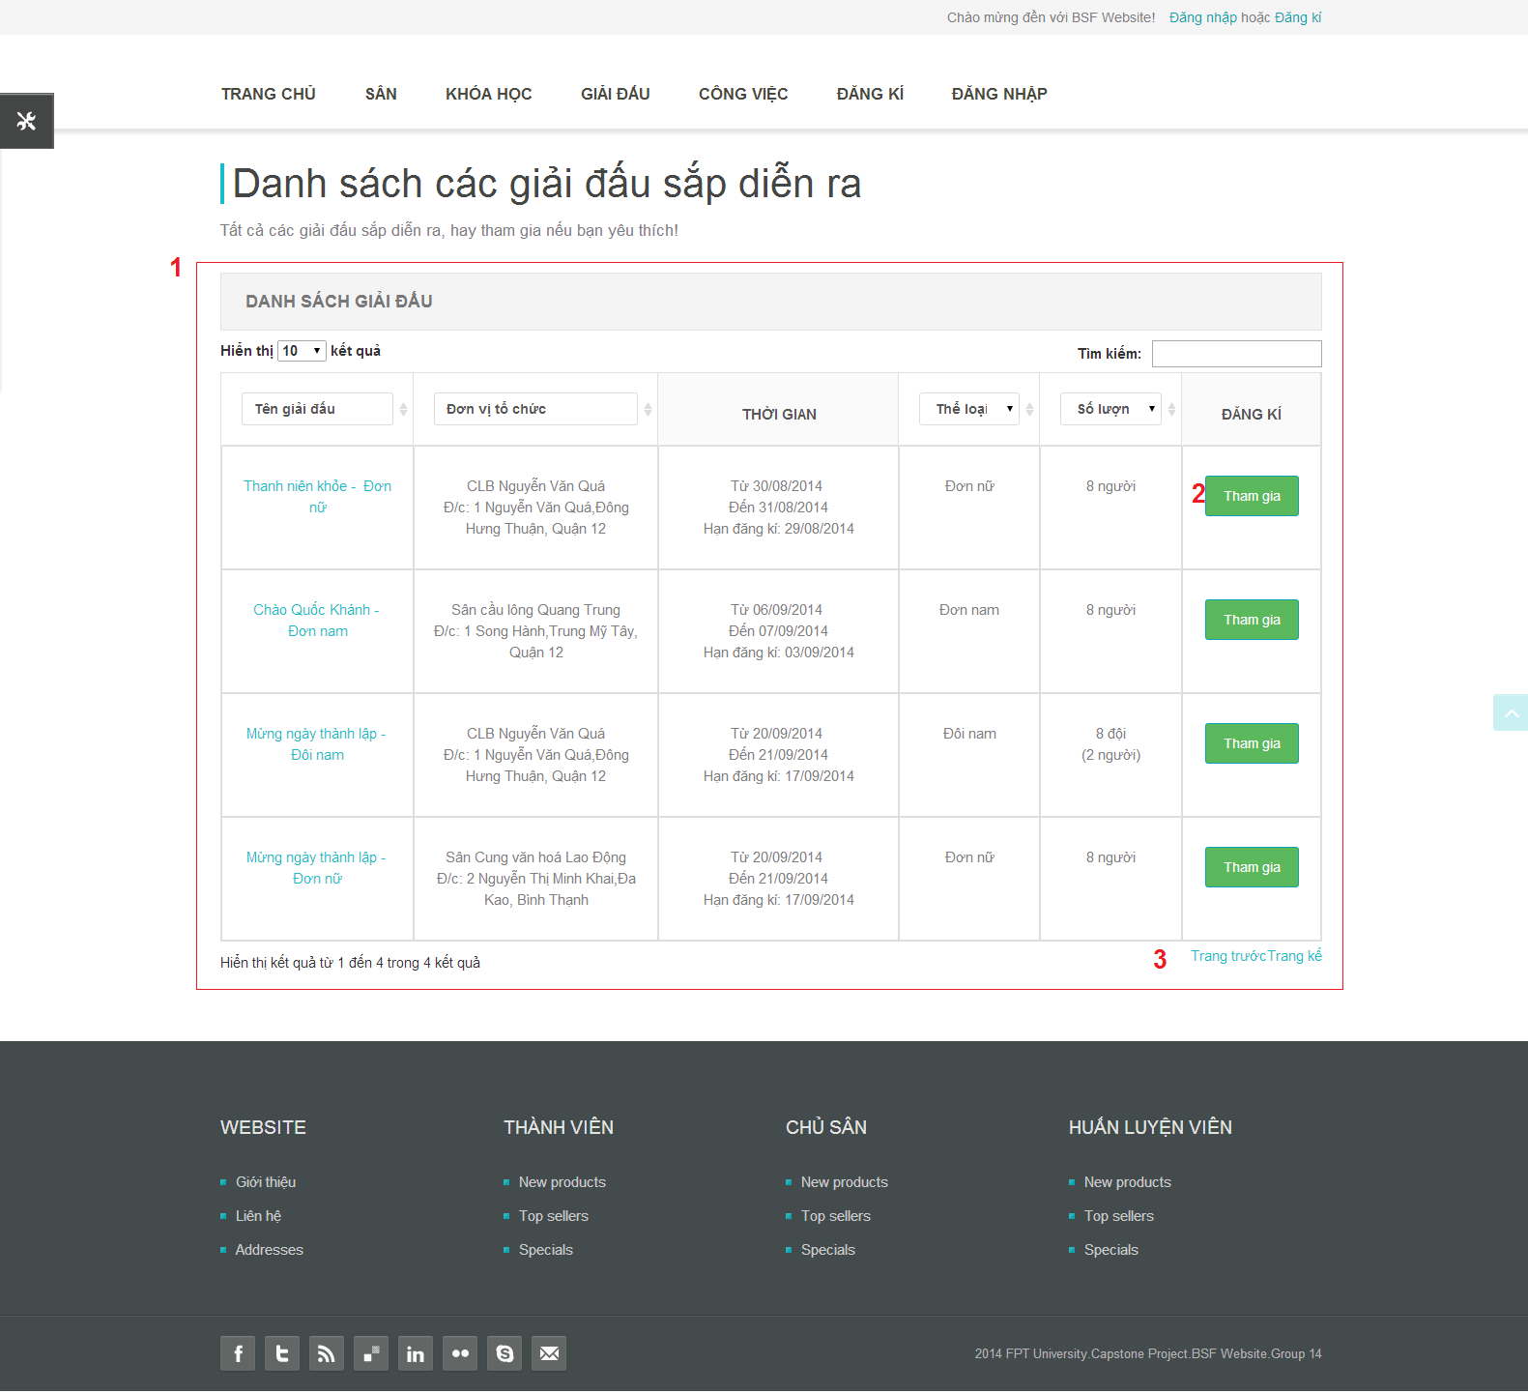**

**Fields**

|  |  |  |  |  |  |  |  |
| --- | --- | --- | --- | --- | --- | --- | --- |
| **No** | **Field Name** | **Description** | **Read only** | **Mand-atory** | **Control Type** | **Data Type** | **Length** |
| 1 | Table Contest | List Contest: Name, Stadium, Time, Contest Type, Qauntity, Join button. | N | Y | Table | N/A | N/A |

**Button/hyperlink**

|  |  |  |  |  |
| --- | --- | --- | --- | --- |
| **No** | **Function** | **Description** | **Validation** | **Outcome** |
| 2 | Join Contest | Click to join to contest. | No | Confirm Popup |
| 3 | Paging | Paging link | No | Page of table |

**Table Contest Event List includes**

|  |  |  |  |  |  |
| --- | --- | --- | --- | --- | --- |
| **Field Name** | **Description** | **Read only** | **Control Type** | **Data Type** | **Length** |
| Name | Name of contest. | Y | Label | String | N/A |
| Stadium | Stadium information |  |  |  |  |
| Time | Happen time of contest. | Y | Label | String | N/A |
| Contest type | Contest type. | Y | Label | String | N/A |
| Quantity | Quantity of team or person. |  | Lable | String | N/A |
| Join Button | Register to join contest | N | Button | N/A | N/A |

#### Contest Detail

**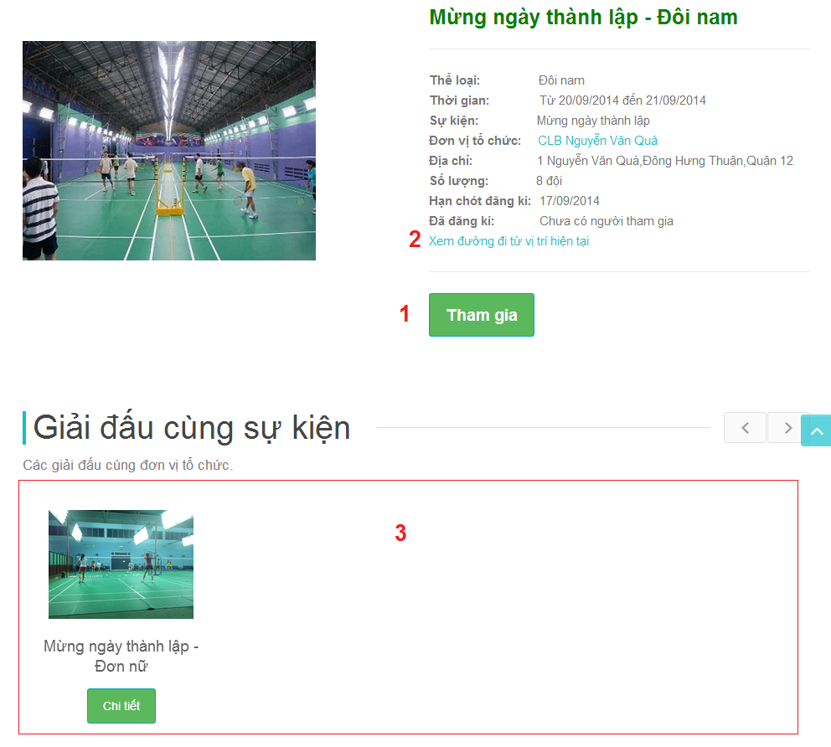**

**Fields**

|  |  |  |  |  |  |  |  |
| --- | --- | --- | --- | --- | --- | --- | --- |
| **No** | **Field Name** | **Description** | **Read only** | **Mand-atory** | **Control Type** | **Data Type** | **Length** |
| 3 | List of contest in same contest event | List of contest in same contest event | Y | Y | N/A | Tabble | N/A |

**Button/ Hyperlink**

|  |  |  |  |  |
| --- | --- | --- | --- | --- |
| **No** | **Function** | **Description** | **Validation** | **Outcome** |
| 1 | Join Button | Join to contest | No | N/A |
| 2 | Map | Link to map from current location to contest location. | No | N/A |

#### Course List

#### Course Detail

### Boss Management Interface Design

#### Boss Home Page

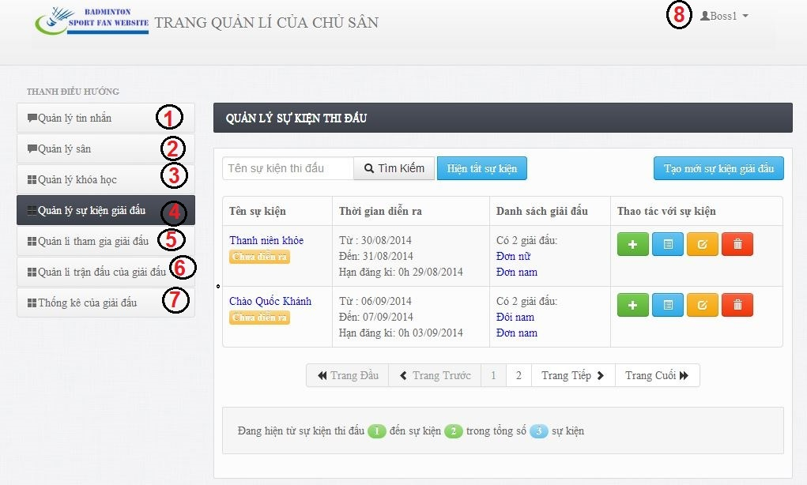

Figure 147: Boss Home Page

**Button/ Hyperlink**

|  |  |  |  |  |
| --- | --- | --- | --- | --- |
| **No** | **Function** | **Description** | **Validation** | **Outcome** |
| 1 | Message Management | Link to Message management page | No | List Message page. |
| 2 | Stadium Management | Link to Stadium Management page. | No | List Stadium Page. |
| 3 | Course Management | Link to Course Management page. | No | List Course Page. |
| 4 | Contest Event Management | Link to Contest Event page. | No | List Contest Event Page. |
| 5 | Contest Management | Link to Contest Management page. | No | List Contest Page. |
| 6 | Match Management | Link to Match Management page. | No | List Match page |
| 7 | Contest Statistics | Link to Contest Statistics page. | No | List Contest Statistics page |
| 8 | Log out | Click to go to Log out BSF-Website. | No | Home Page |

#### ManageStadium

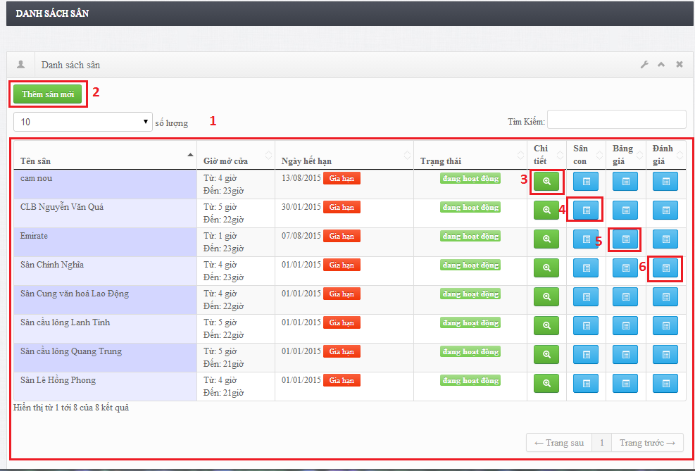

Figure 148: Manage Stadium

**Fields**

|  |  |  |  |  |  |  |  |
| --- | --- | --- | --- | --- | --- | --- | --- |
| **No** | **Field Name** | **Description** | **Read only** | **Mand-atory** | **Control Type** | **Data Type** | **Length** |
| 1 | Stadium table | Show list stadium | Y | Y | N/A |  | N/A |

**Table Stadium list includes**

|  |  |  |  |  |  |
| --- | --- | --- | --- | --- | --- |
| **Field Name** | **Description** | **Read only** | **Control Type** | **Data Type** | **Length** |
| Tên sân | Stadium name | Y | Label | String | N/A |
| Giờ mở cửa time | Stadium open time | Y | Label | String | N/A |
| Ngày hết hạn | Stadium expiredate | Y | Label | String | N/A |
| Trạng thái | Stadium status | Y | Label | String | N/A |
| Chi tiết | Stadium detail | N |  | Button | N/A |
| Sân con | Court | N |  | Button | N/A |
| Bảng giá | Price list | N |  | Button | N/A |
| Đánh giá | Stadium review | N |  | Button | N/A |

**Button/ Hyperlink**

|  |  |  |  |  |
| --- | --- | --- | --- | --- |
| **No** | **Function** | **Description** | **Validation** | **Outcome** |
| 2 | Detail | Stadium detail | No | N/A |
| 3 | Court | Court | No | N/A |
| 5 | Price | Price | No | N/A |
| 6 | Review | Stadium review | No | N/A |

#### CreateStadium

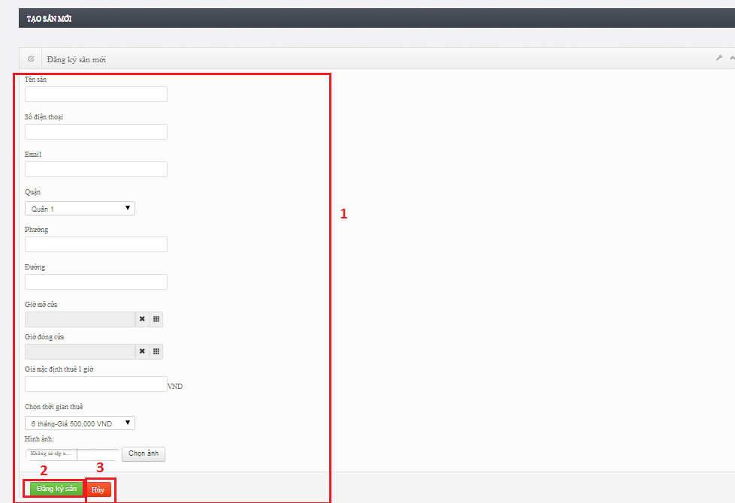

Figure 149: Create Stadium

**Fields**

|  |  |  |  |  |  |  |  |
| --- | --- | --- | --- | --- | --- | --- | --- |
| **No** | **Field Name** | **Description** | **Read only** | **Mand-atory** | **Control Type** | **Data Type** | **Length** |
| 1 | Stadium create form | Form create stadium | Y | Y | N/A |  | N/A |

#### Update Stadium

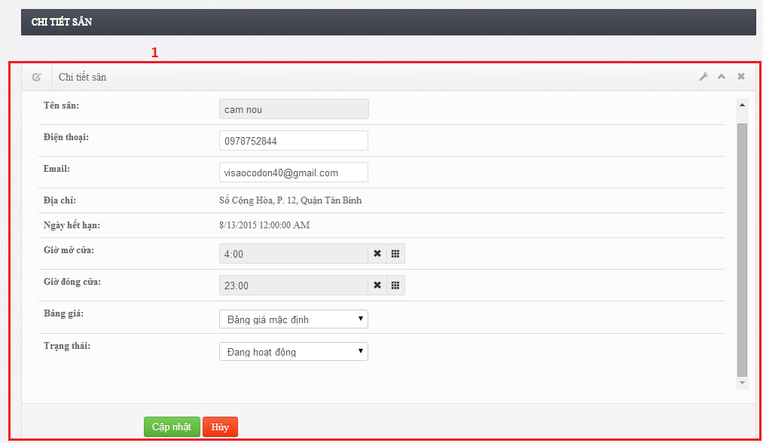

Figure 150: Create Stadium

**Fields**

|  |  |  |  |  |  |  |  |
| --- | --- | --- | --- | --- | --- | --- | --- |
| **No** | **Field Name** | **Description** | **Read only** | **Mand-atory** | **Control Type** | **Data Type** | **Length** |
| 1 | update create form | Form create stadium | Y | Y | N/A |  | N/A |

#### Manage Court

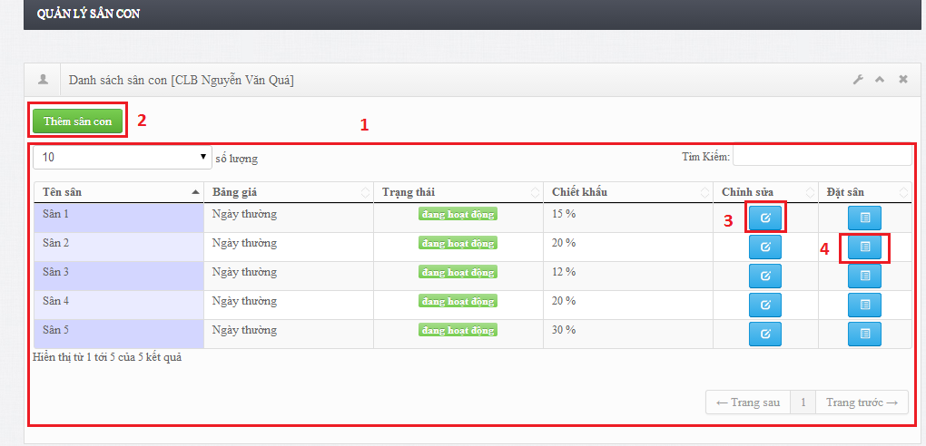

Figure 151: Manage Court

**Fields**

|  |  |  |  |  |  |  |  |
| --- | --- | --- | --- | --- | --- | --- | --- |
| **No** | **Field Name** | **Description** | **Read only** | **Mand-atory** | **Control Type** | **Data Type** | **Length** |
| 1 | court table | Show list court | Y | Y | N/A |  | N/A |

**Table Stadium list includes**

|  |  |  |  |  |  |
| --- | --- | --- | --- | --- | --- |
| **Field Name** | **Description** | **Read only** | **Control Type** | **Data Type** | **Length** |
| Tên sân | Court name | Y | Label | String | N/A |
| Bảng giá | Price list | Y | Label | String | N/A |
| Trạng thái | Stadium status | Y | Label | String | N/A |
| Chiết khấu | Discount of court | Y | Label | String | N/A |
| Chi tiết | Edit stadium | N |  | Button | N/A |
| Đặt sân | Reservation | N |  | Button | N/A |

**Button/ Hyperlink**

|  |  |  |  |  |
| --- | --- | --- | --- | --- |
| **No** | **Function** | **Description** | **Validation** | **Outcome** |
| 2 | Add court | Add new court | No | N/A |
| 3 | Edit | Edit court | No | N/A |
| 4 | Reservation | Reservation | No | N/A |

#### Manage reservation

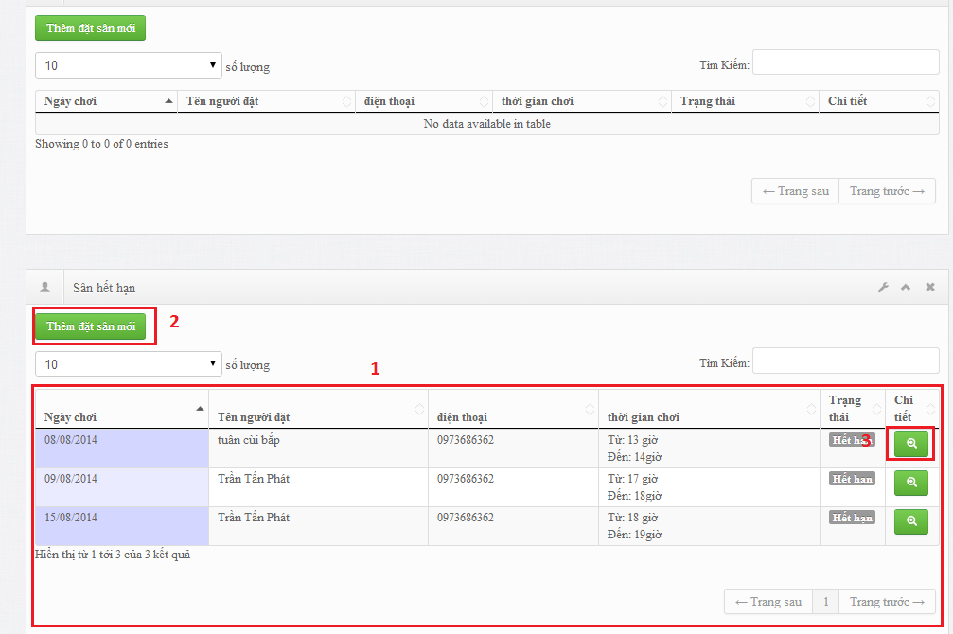

Figure 152: Manage reservation

**Fields**

|  |  |  |  |  |  |  |  |
| --- | --- | --- | --- | --- | --- | --- | --- |
| **No** | **Field Name** | **Description** | **Read only** | **Mand-atory** | **Control Type** | **Data Type** | **Length** |
| 1 | reservation table | Show list reservation | Y | Y | N/A |  | N/A |

**Table Stadium list includes**

|  |  |  |  |  |  |
| --- | --- | --- | --- | --- | --- |
| **Field Name** | **Description** | **Read only** | **Control Type** | **Data Type** | **Length** |
| Ngày chơi | Date to play | Y | Label | String | N/A |
| Tên người đặt | Name of player | Y | Label | String | N/A |
| Điện thoại | Player phone | Y | Label | String | N/A |
| Thời gian chơi | Time to play | Y | Label | String | N/A |
| Trạng thái | Status | Y | Label | String | N/A |
| Chi tiết | Reservation detail | N |  | Button | N/A |

**Button/ Hyperlink**

|  |  |  |  |  |
| --- | --- | --- | --- | --- |
| **No** | **Function** | **Description** | **Validation** | **Outcome** |
| 2 | AddNewReservation | Add reservation | No | N/A |
| 3 | ReservationDetail | Reservation detail | No | N/A |

#### Manage Pricelist

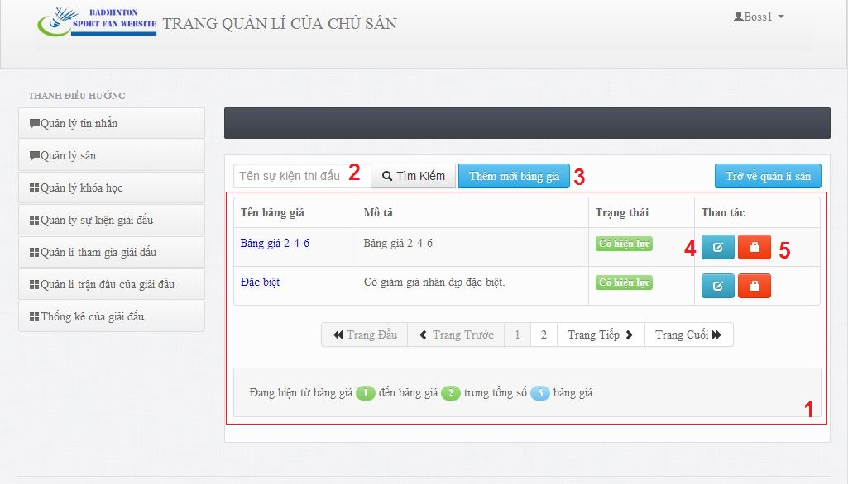

**Fields**

|  |  |  |  |  |  |  |  |
| --- | --- | --- | --- | --- | --- | --- | --- |
| **No** | **Field Name** | **Description** | **Read only** | **Mand-atory** | **Control Type** | **Data Type** | **Length** |
| 1 | Pricelist List Table | List of pricelists: Name, Description, status, edit button, Deactivate/Activate button. | N | Y | Table | N/A | N/A |

**Button/hyperlink**

|  |  |  |  |  |
| --- | --- | --- | --- | --- |
| **No** | **Function** | **Description** | **Validation** | **Outcome** |
| 2 | Search | Search pricelist by name | No | Display pricelist table result |
| 3 | Create New pricelist | Create new pricelist | No | Create page. |
| 4 | Edit Button | Edit pricelist. | No | Edit page. |
| 5 | Deactivate/Activate button | Deactivate/ activate pricelist. | No | Confirmed pop up. |

**Table Contest Event List includes**

|  |  |  |  |  |  |
| --- | --- | --- | --- | --- | --- |
| **Field Name** | **Description** | **Read only** | **Control Type** | **Data Type** | **Length** |
| Name | Name of pricelist | Y | Label | String | N/A |
| Description | Description of pricelist. | Y | Label | String | N/A |
| Status | Status of pricelist. | Y | Label | String | N/A |
| Edit button | Edit pricelist button. | N | Button | N/A | N/A |
| Deactivate/Activate button | Delete pricelist button. | N | Button | N/A | N/A |

#### Manage Contest Event

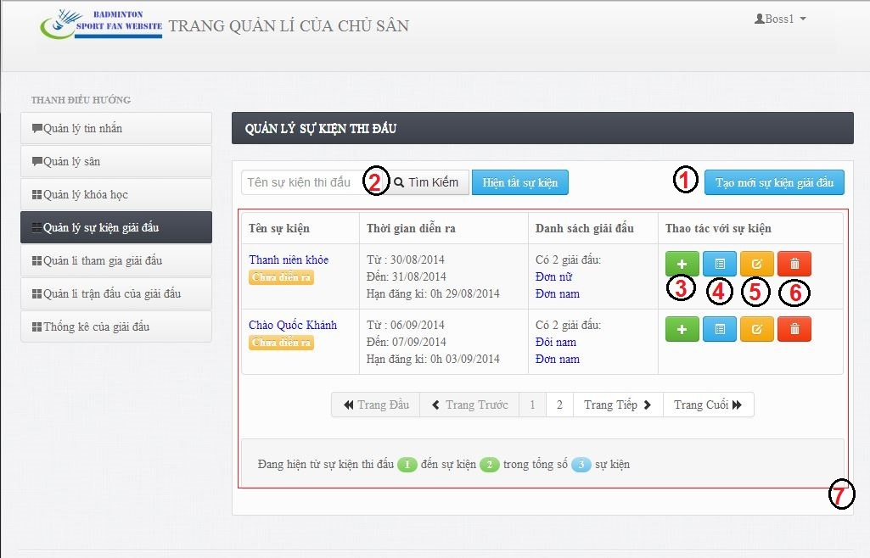

**Fields**

|  |  |  |  |  |  |  |  |
| --- | --- | --- | --- | --- | --- | --- | --- |
| **No** | **Field Name** | **Description** | **Read only** | **Mand-atory** | **Control Type** | **Data Type** | **Length** |
| 7 | Table Contest Event | List Contest Event: Name, Time, contest list, Add contest button, List contest button, edit contest event button, delete contest event button. | N | Y | Table | N/A | N/A |

**Button/hyperlink**

|  |  |  |  |  |
| --- | --- | --- | --- | --- |
| **No** | **Function** | **Description** | **Validation** | **Outcome** |
| 5 | Create New Contest Event | Click button show pop up for boss create new contest event | No | Create Contest Event pop up |
| 6 | Search | Search contest event by name. | No | Display result into table contest event |

**Table Contest Event List includes**

|  |  |  |  |  |  |
| --- | --- | --- | --- | --- | --- |
| **Field Name** | **Description** | **Read only** | **Control Type** | **Data Type** | **Length** |
| Contest Event Name | Name of contest event | Y | Label | String | N/A |
| Time | Time of contest event. | Y | Label | String | N/A |
| Contest list | List of contest in contest event. | Y | Label | String | N/A |
| Add Contest button | Show pop up for boss add new contest. | N | Button | N/A | N/A |
| LitsContest Button | Redirect to List Contest Page |  |  |  |  |
| Edit Contest Event button | Show pop up for boss edit contest event. | N | Button | N/A | N/A |
| Delete button | Delete contest event. | N | Button | N/A | N/A |

#### Manage Contest

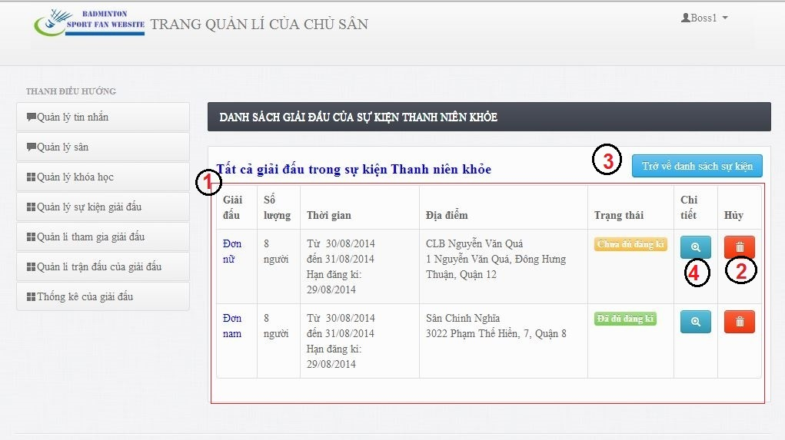

**Fields**

|  |  |  |  |  |  |  |  |
| --- | --- | --- | --- | --- | --- | --- | --- |
| **No** | **Field Name** | **Description** | **Read only** | **Mand-atory** | **Control Type** | **Data Type** | **Length** |
| 1 | Table Contest | List Contest: Type, Quantity, Time, Location, Status, Detail button, Delete button. | N | Y | Table | N/A | N/A |

**Button/hyperlink**

|  |  |  |  |  |
| --- | --- | --- | --- | --- |
| **No** | **Function** | **Description** | **Validation** | **Outcome** |
| 2 | Delete Button | Delete contest. | No | Delete Confirm Popup |
| 3 | Back to Contest Event | Click button to back List Contest Event Page | No | List Contest Event Page |
| 4 | Detail | Contest detail | No | Contest Detail popup. |

**Table Contest Event List includes**

|  |  |  |  |  |  |
| --- | --- | --- | --- | --- | --- |
| **Field Name** | **Description** | **Read only** | **Control Type** | **Data Type** | **Length** |
| Contest type | Type of contest. | Y | Label | String | N/A |
| Team Quantity |  |  |  |  |  |
| Time | Happen time of contest. | Y | Label | String | N/A |
| Location | Location of contest. | Y | Label | String | N/A |
| Status | Status of contest |  | Lable | String | N/A |
| Detail button | View detail of contest | N | Button | N/A | N/A |
| Delete button | Delete contest. | N | Button | N/A | N/A |

#### Manage Team

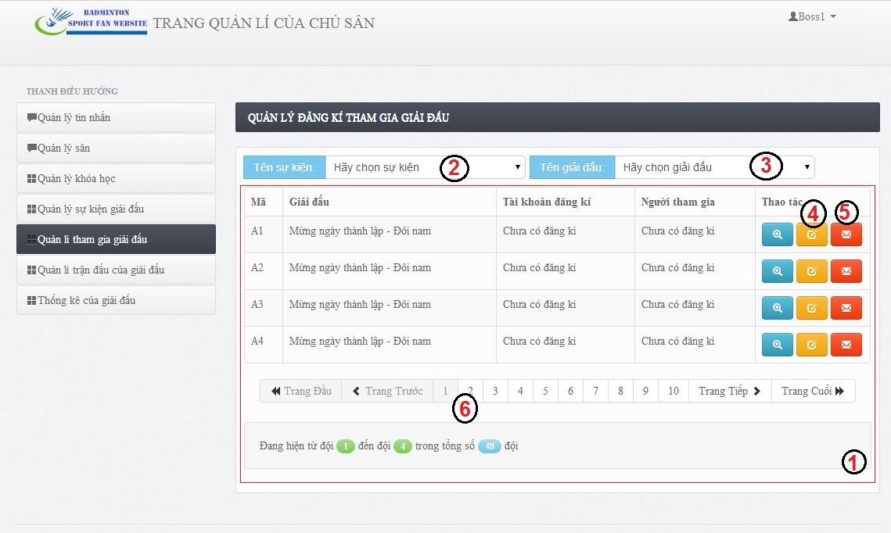

**Fields**

|  |  |  |  |  |  |  |  |
| --- | --- | --- | --- | --- | --- | --- | --- |
| **No** | **Field Name** | **Description** | **Read only** | **Mand-atory** | **Control Type** | **Data Type** | **Length** |
| 1 | Team List Table | List of teams: Name, Contest, Username, Team memeber, Detail button, Edit button, reset and report violate team. | N | Y | Table | N/A | N/A |
| 2 | Contest Event Dropdown List | Contest Event Dropdown List | N | Y | Drop down list | N/A | N/A |
| 3 | Contest Dropdown List | Contest dropdown list. | N | Y | Drop down list | N/A | N/A |

**Button/hyperlink**

|  |  |  |  |  |
| --- | --- | --- | --- | --- |
| **No** | **Function** | **Description** | **Validation** | **Outcome** |
| 4 | Edit Team Button | Edit Team Inofrmation. | No | Edit pop up. |
| 5 | Reset and Report Team Button | Reset team registration and report violate registration. | No | Confirm popup. |
| 6 | Paging button | Paging of table. | No | Next page of table. |

**Table Contest Event List includes**

|  |  |  |  |  |  |
| --- | --- | --- | --- | --- | --- |
| **Field Name** | **Description** | **Read only** | **Control Type** | **Data Type** | **Length** |
| Name | Code of team. | Y | Label | String | N/A |
| Contest | Name of contest. |  |  |  |  |
| RegisterAccount | Username of register account. | Y | Label | String | N/A |
| Team Member | Member name. | Y | Label | String | N/A |
| Status | Status of team. |  | Lable | String | N/A |
| Detail button | View detail of team. | N | Button | N/A | N/A |
| Delete button | Delete team. | N | Button | N/A | N/A |

#### Manage Match

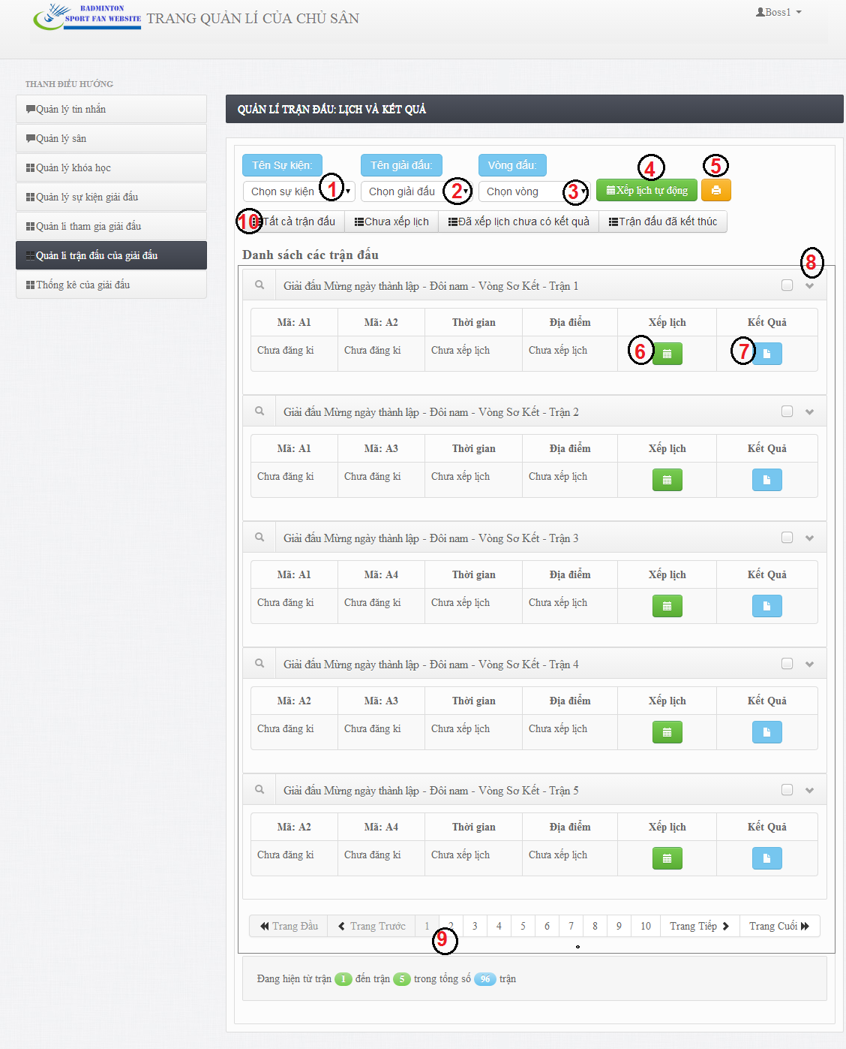

**Fields**

|  |  |  |  |  |  |  |  |
| --- | --- | --- | --- | --- | --- | --- | --- |
| **No** | **Field Name** | **Description** | **Read only** | **Mand-atory** | **Control Type** | **Data Type** | **Length** |
| 8 | Match List Table | List of matches: First Team Name, Second Team Name, Time, Location, Schedule button, Result button. | N | Y | Table | N/A | N/A |
| 1 | Contest Event Dropdown List | Contest Event Dropdown List | N | Y | Drop down list | N/A | N/A |
| 2 | Contest Dropdown List | Contest dropdown list. | N | Y | Drop down list | N/A | N/A |
| 3 | Contest Round Dropdown List | Contest round dropdown list. | N | Y | Drop down list | N/A | N/A |

**Button/hyperlink**

|  |  |  |  |  |
| --- | --- | --- | --- | --- |
| **No** | **Function** | **Description** | **Validation** | **Outcome** |
| 4 | Arrange Schedule Automatically Button | Arrange match schedule automatically. | No | Arrange automatically pop up. |
| 5 | Export schedule and result Button | Export schedule and result of round in pdf file format. | No | Export popup. |
| 6 | Arrange Schedule button | Arrange schedule for one match. | No | Schedule popup. |
| 7 | Record result button | Record scores and result of a match. | No | Result pop up. |
| 9 | Paging button | Paging button | No | Next page of table. |
| 10 | Match Status Link | Match status filter. | No | List match table. |

**Table Contest Event List includes**

|  |  |  |  |  |  |
| --- | --- | --- | --- | --- | --- |
| **Field Name** | **Description** | **Read only** | **Control Type** | **Data Type** | **Length** |
| First team name | Code of first team | Y | Label | String | N/A |
| Second team name | Code of second team. |  |  |  |  |
| Time | Happen time of match. | Y | Label | String | N/A |
| Location | Location of match | Y | Label | String | N/A |
| Detail button | View detail of team. | N | Button | N/A | N/A |
| Delete button | Delete team. | N | Button | N/A | N/A |

#### View Contest Statistics

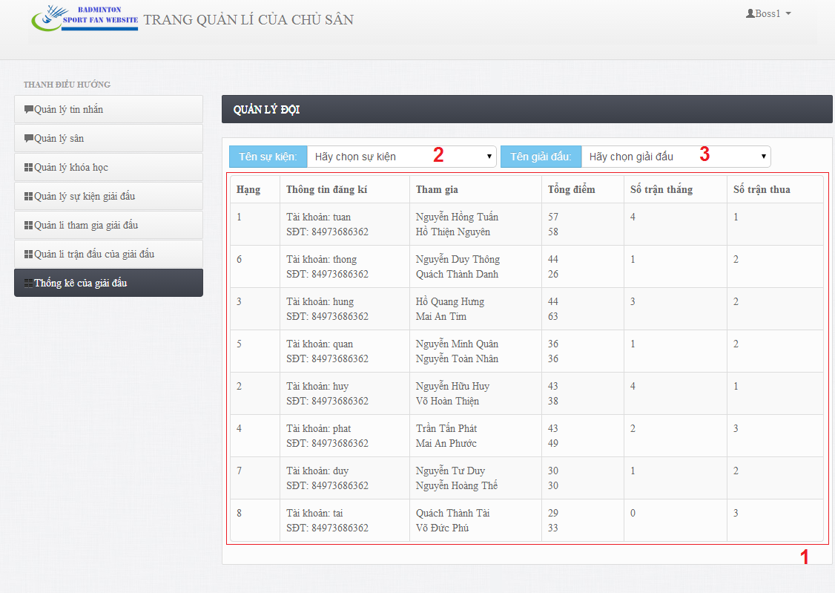

**Fields**

|  |  |  |  |  |  |  |  |
| --- | --- | --- | --- | --- | --- | --- | --- |
| **No** | **Field Name** | **Description** | **Read only** | **Mand-atory** | **Control Type** | **Data Type** | **Length** |
| 1 | Team Result Table | List of Team Result: Range, Register Information, Team member, total scores, win Quantity, Lost quantity. | N | Y | Table | N/A | N/A |
| 1 | Contest Event Dropdown List | Contest Event Dropdown List | N | Y | Drop down list | N/A | N/A |
| 2 | Contest Dropdown List | Contest dropdown list. | N | Y | Drop down list | N/A | N/A |

**Table Contest Event List includes**

|  |  |  |  |  |  |
| --- | --- | --- | --- | --- | --- |
| **Field Name** | **Description** | **Read only** | **Control Type** | **Data Type** | **Length** |
| Range | Range of team after contest finished. | Y | Label | String | N/A |
| Register Information | Register information. |  |  |  |  |
| Total scores | Total score of each member when contest finished. | Y | Label | String | N/A |
| Win Quantity | Number of win matches after contest finished. | Y | Lable | String | N/A |
| Lost quantity | Number of lost matches after contest finished. | Y | Lable | String | N/A |

#### Manage Course

#### Manage Message

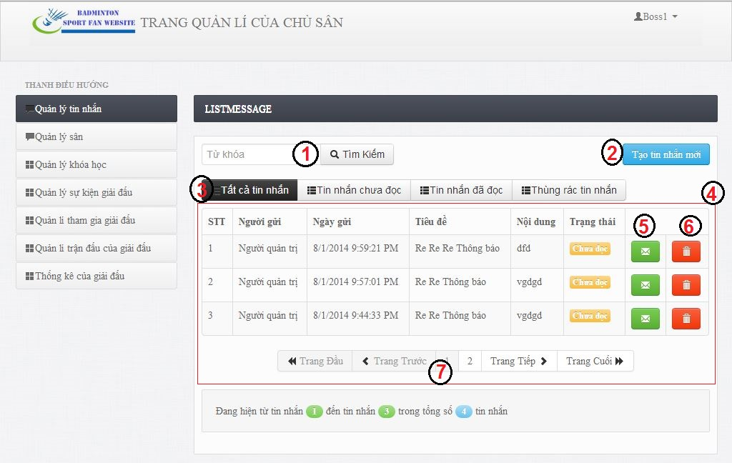

**Fields**

|  |  |  |  |  |  |  |  |
| --- | --- | --- | --- | --- | --- | --- | --- |
| **No** | **Field Name** | **Description** | **Read only** | **Mand-atory** | **Control Type** | **Data Type** | **Length** |
| 4 | Message List Table | List of messages: Order number, Sender, Send Date, Title, Content, Status, Reply button, delete button | N | Y | Table | N/A | N/A |
| 3 | Message Status tab. | Message status filter. | N | Y | button | N/A | N/A |
| 2 | Create message button | Create message. | N | Y | button | N/A | N/A |
| 5 | Reply button | Reply button | N | Y | button | N/A | N/A |
| 6 | Delete button | Delete button | N | Y | button | N/A | N/A |

**Table Contest Event List includes**

|  |  |  |  |  |  |
| --- | --- | --- | --- | --- | --- |
| **Field Name** | **Description** | **Read only** | **Control Type** | **Data Type** | **Length** |
| Order number | Order number of message | Y | Label | String | N/A |
| Sender | Sender account. |  |  |  |  |
| Send date | Send date of message. | Y | Label | String | N/A |
| Title | Title of message. | Y | Label | String | N/A |
| Content | Content of message. | Y | Label | String | N/A |
| Status | Message status | Y | lablel | String | N/A |
| Reply button | Reply button | Y | button | N/A | N/A |
| Delete button | Delete button. | Y | button | N/A | N/A |

### Webmaster Interface Design

#### Webmaster Home Page

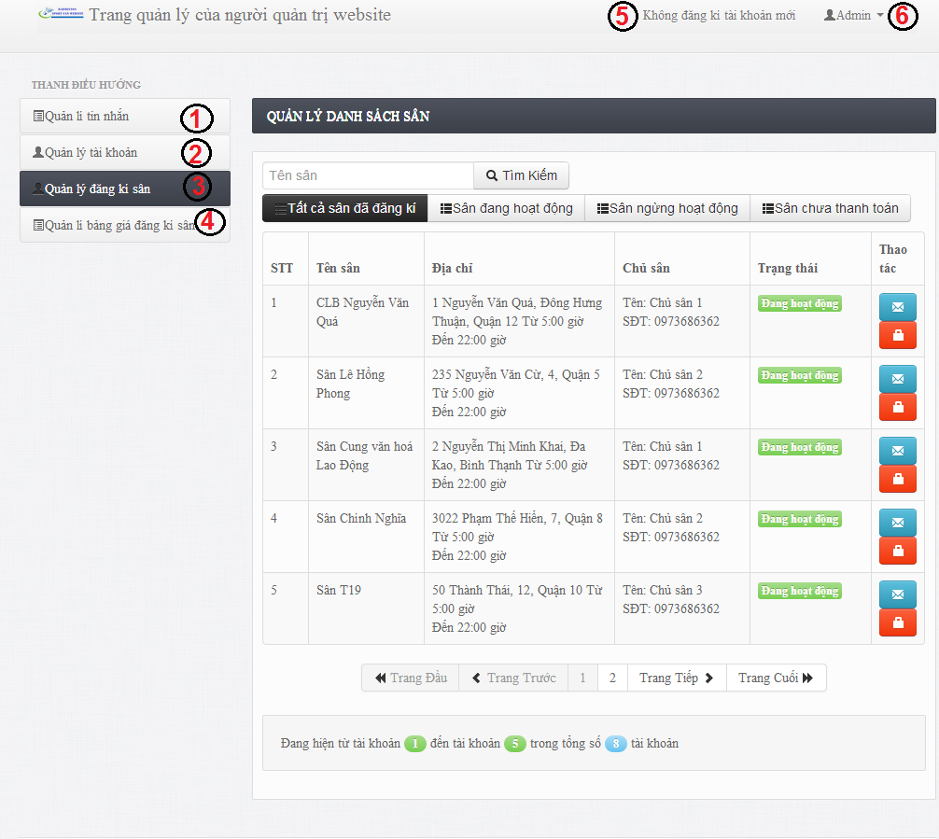

Figure 153: Webmaster Home Page

**Button/ Hyperlink**

|  |  |  |  |  |
| --- | --- | --- | --- | --- |
| **No** | **Function** | **Description** | **Validation** | **Outcome** |
| 1 | Message Management | Link to Message management page | No | List Message page. |
| 2 | Account Management | Link to Account Management page. | No | List Account Page. |
| 3 | Stadium Register Management | Link to Stadium register Management page. | No | List Stadium Register Page. |
| 4 | Stadium Register Pricelist Management | Link to Stadium Register Pricelist Management page. | No | List Stadium Register Pricelist Event Page. |
| 5 | Account Notification | Account Notification. | No | List of account notification. |
| 6 | Log out | Log out. | No | Home Page |

#### Manage Account

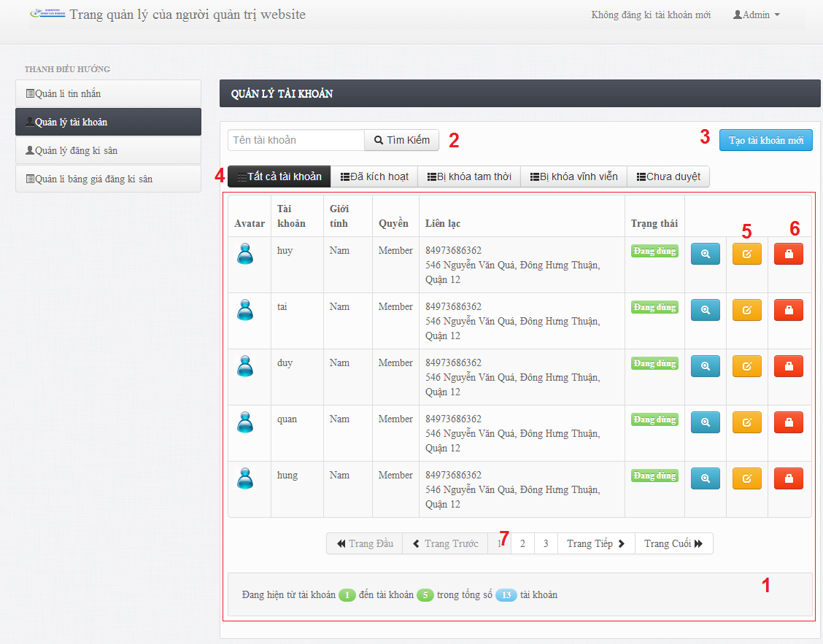

**Fields**

|  |  |  |  |  |  |  |  |
| --- | --- | --- | --- | --- | --- | --- | --- |
| **No** | **Field Name** | **Description** | **Read only** | **Mand-atory** | **Control Type** | **Data Type** | **Length** |
| 1 | Account List Table | List of Account: Avartar, username, gender, role, contact information, Status, Edit button, Deactivate/Activate button | N | Y | Table | N/A | N/A |
| 4 | Account Status tab. | Account status filter. | N | Y | button | N/A | N/A |
| 2 | Search | Search account by username. | N | Y | button | N/A | N/A |
| 3 | Create button | Create new account | N | Y | button | N/A | N/A |
| 6 | Deactivate/Activate button | Deactivate/Activate account. | N | Y | button | N/A | N/A |
| 7 | Paging | Paging of table. | N | Y | button | N/A | N/A |

**Table Contest Event List includes**

|  |  |  |  |  |  |
| --- | --- | --- | --- | --- | --- |
| **Field Name** | **Description** | **Read only** | **Control Type** | **Data Type** | **Length** |
| Avatar | Avatar of account. | Y | Image | Image | N/A |
| Username | Username of account. |  |  |  |  |
| Gender | Gender of account. | Y | Label | String | N/A |
| Contact information | Contact information of account. | Y | Label | String | N/A |
| Status | Account status. | Y | lablel | String | N/A |
| Detail button | View account detail | Y | button | N/A | N/A |
| Edit button | Edit account. | Y | button | N/A | N/A |
| Deactivate/Activate button | Deactivate/activate button. | Y | button | N/A | N/A |

#### Manage Message

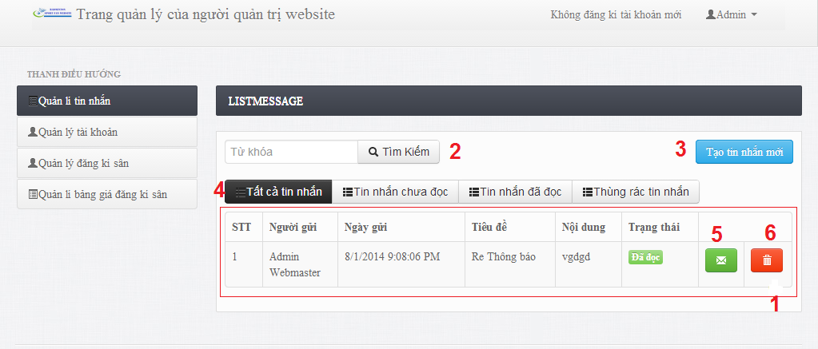

**Fields**

|  |  |  |  |  |  |  |  |
| --- | --- | --- | --- | --- | --- | --- | --- |
| **No** | **Field Name** | **Description** | **Read only** | **Mand-atory** | **Control Type** | **Data Type** | **Length** |
| 4 | Message List Table | List of messages: Order number, Sender, Send Date, Title, Content, Status, Reply button, delete button | N | Y | Table | N/A | N/A |
| 3 | Message Status tab. | Message status filter. | N | Y | button | N/A | N/A |
| 2 | Create message button | Create message. | N | Y | button | N/A | N/A |
| 5 | Reply button | Reply button | N | Y | button | N/A | N/A |
| 6 | Delete button | Delete button | N | Y | button | N/A | N/A |

**Table Contest Event List includes**

|  |  |  |  |  |  |
| --- | --- | --- | --- | --- | --- |
| **Field Name** | **Description** | **Read only** | **Control Type** | **Data Type** | **Length** |
| Order number | Order number of message | Y | Label | String | N/A |
| Sender | Sender account. |  |  |  |  |
| Send date | Send date of message. | Y | Label | String | N/A |
| Title | Title of message. | Y | Label | String | N/A |
| Content | Content of message. | Y | Label | String | N/A |
| Status | Message status | Y | lablel | String | N/A |
| Reply button | Reply button | Y | button | N/A | N/A |
| Delete button | Delete button. | Y | button | N/A | N/A |

#### Manage Stadium Register

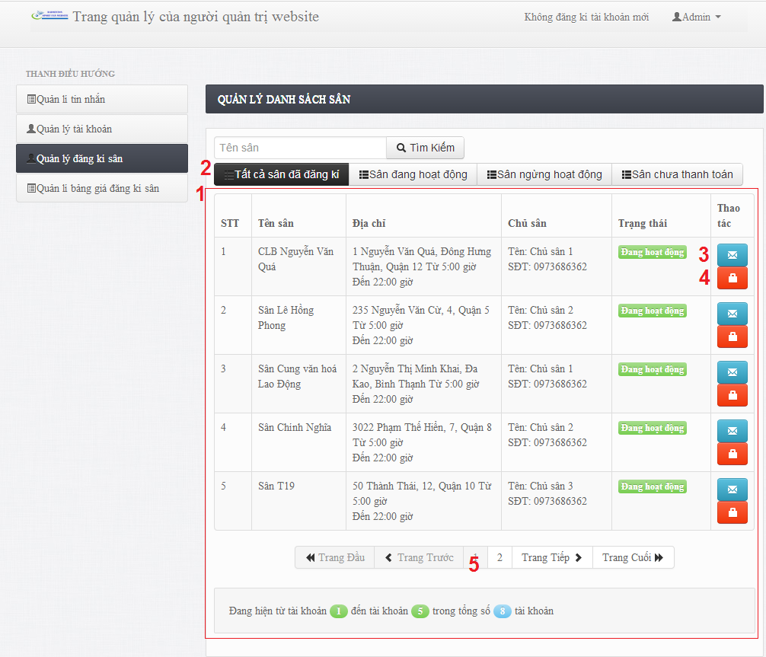

**Fields**

|  |  |  |  |  |  |  |  |
| --- | --- | --- | --- | --- | --- | --- | --- |
| **No** | **Field Name** | **Description** | **Read only** | **Mand-atory** | **Control Type** | **Data Type** | **Length** |
| 1 | Stadium Register List Table | List of Stadium register: Order number, Stadium name, Address, Boss Information, Content, Status, Send message button, Deactivate/Activate button | N | Y | Table | N/A | N/A |
| 2 | Stadium Register Status tab. | Stadium register status filter. | N | Y | button | N/A | N/A |
| 3 | Send message button | Send message to boss. | N | Y | button | N/A | N/A |
| 4 | Deactivate/Activate button | Deactivate/Activate stadium register. | N | Y | button | N/A | N/A |
| 5 | Paging | Paging of table. | N | Y | button | N/A | N/A |

**Table Contest Event List includes**

|  |  |  |  |  |  |
| --- | --- | --- | --- | --- | --- |
| **Field Name** | **Description** | **Read only** | **Control Type** | **Data Type** | **Length** |
| Order number | Order number of stadium register. | Y | Label | String | N/A |
| Stadium name | Name of stadium. |  |  |  |  |
| Address | Addtess of stadium. | Y | Label | String | N/A |
| Boss information | Information of boss. | Y | Label | String | N/A |
| Status | Stadium register status | Y | lablel | String | N/A |
| Send message button | Send message to boss button | Y | button | N/A | N/A |
| Deactivate/Activate button | Deactivate/activate button. | Y | button | N/A | N/A |

#### Manage Stadium Register Price

## Database Design

### Physical Database Design

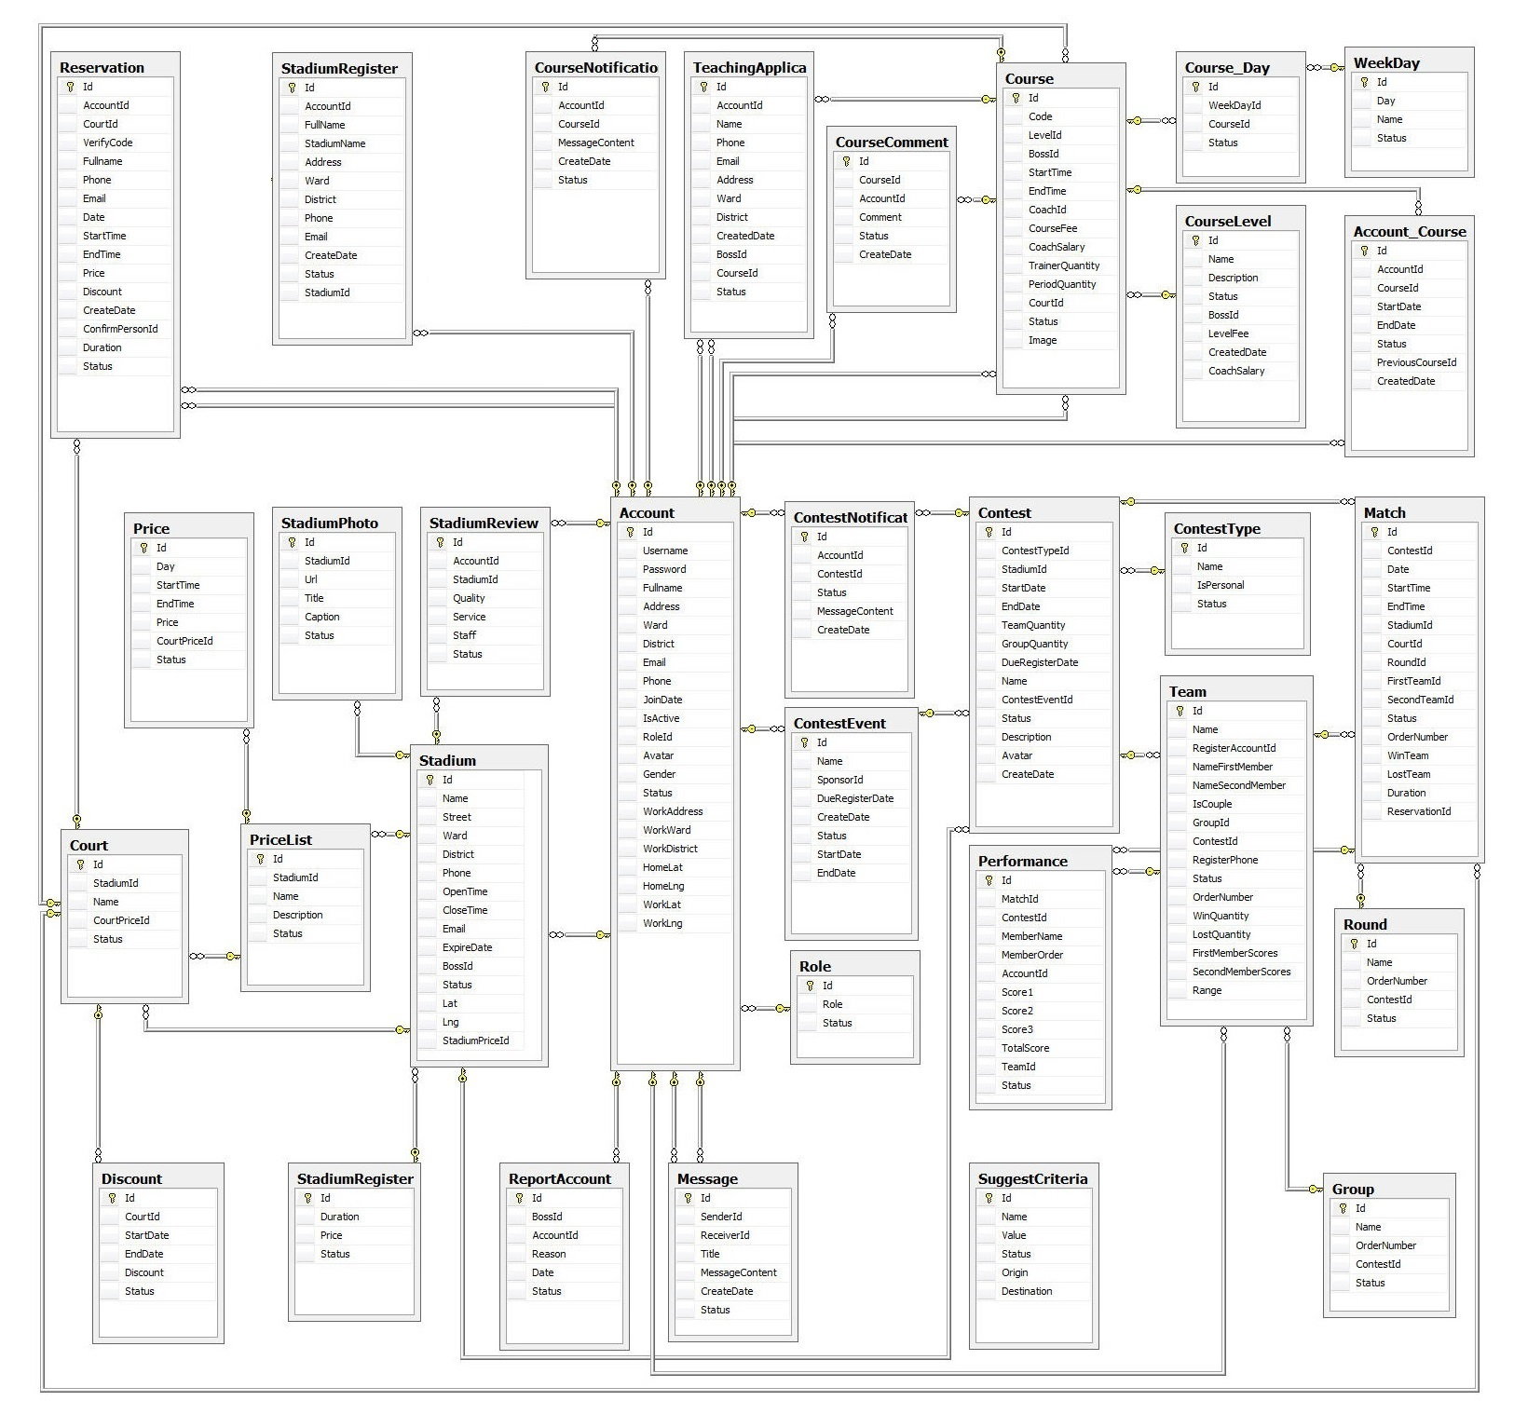

Figure 154: Physcial Database Diagram

### Data Dictionary

|  |  |
| --- | --- |
| **Table** | **Description** |
| Account | Describe all age of product in system. |
| Role | Describe all agency of system. |
| Reservation | Describe all reservation |
| StadiumRegister | Describe all register stadium |
| CourseNotification | Describe all Notification of course. |
| TeachingApplication | Describe all Teaching application |
| CourseComment | Describe all Course Comment |
| Course | Describe all course of system |
| CourseDay | Describe all Day of Course |
| CourseLevel | Describe all Level Course |
| WeekDay | Describe all Day of week |
| Account\_Course | Describe all account register course |
| Price | Describe all Price of court |
| StadiumPhoto | Describe all Photo of stadium |
| StadiumReview | Describe all review of stadium |
| Court | Describe all court of stadium |
| PriceList | Describe all price list of stadium |
| Stadium | Describe all stadium |
| Discount | Describe all discout of court |
| StadiumRegister | Describe all boss register stadium |
| ReportAccount | Describe all report account |
| Message | Describe message of player |
| ContestEvent | Describe contest event |
| ContestNotification | Describe all notification of contest |
| Performance | Describe performance. |
| ContestType | Describe all Contest Type |
| Team | Describe all Team of group |
| Match | Describe all match of contest |
| Round | Describe all round of group |
| Group | Describe all group of contest |
| SuggestCriteria | Describe all Suggest Criteria |

Table 5: Entity Data Dictionary

#### Account

|  |  |  |  |
| --- | --- | --- | --- |
| **Attribute** | **Type** | **Visibility** | **Description** |
| Id(FK) | Interger | Public | Uniqe number of each account |
| Address | Nvarchar | Public | Address of user’s home |
| Avatar | Nvarchar | Public | Avata of user |
| District | Nvarchar | Public | District of user’s home |
| Email | Nvarchar | Public | Email user |
| Fullname | String | Public | User name |
| Gender | Boolean | Public | Gender user |
| HomeLat | Nvarchar | Public | Home lattitude of user |
| HomeLng | Nvarchar | Public | Home langtitude of user |
| IsActive | Boolean | Public |  |
| JoinDate | DateTime | Public | Day user join to website |
| Password | String | Public | User password |
| Phone | String | Public | User phone |
| RoleId | Integer | Public | Role id |
| Status | Integer | Public |  |
| Username | Nvarchar | Public | User |
| Ward | Nvarchar | Public | Ward of city |
| WorkAddress | Nvarchar | Public | Address of user company |
| WorkDistrict | Nvarchar | Public | District of user’s company |
| WorkLat | Nvarchar | Public | Latitude of user’s company |
| WorkLng | Nvarchar | Public | Langtitude of user’s campany |
| WorkWard | Nvarchar | Public | Ward of user’s company |

#### Account\_Course

|  |  |  |  |
| --- | --- | --- | --- |
| **Attribute** | **Type** | **Visibility** | **Description** |
| AccountId | Integer | Public | Unique id of each account |
| CourseId | Integer | Public | Unique id of each course |
| CreateDate | DateTime | Public | Create date |
| EndDate | DateTime | Public | End date |
| Id(FK) | Integer | Public | Uniqe id of each Account\_Course |
| PreviousCourseId | Integer | Public | Id of each course |
| StartDate | DateTime | Public | Chosen day start course |
| Status | Integer | Public | status |

#### Course

|  |  |  |  |
| --- | --- | --- | --- |
| **Attribute** | **Type** | **Visibility** | **Description** |
| BossId | Integer | Public | Id of each boss |
| CoachId | Integer | Public | Id of each coach |
| CoachSalary | Double | Public | Salary of each course |
| Code | Nvarchar | Public | Code of each course |
| CourseFee | Double | Public | Fee for user to join course |
| CourtId | Integer | Public | Id for each court |
| EndTime | DateTime | Public | end time of each course |
| Id(FK) | Integer | Public | Id of each course |
| Image | Nvarchar | Public | Course image |
| LevelId | Integer | Public | Level of course |
| PeriodQuantity | Integer | Public |  |
| StartTime | DateTime | Public | Start time |
| Status | Integer | Public | Status |
| TrainerQuantity | Integer | Public | Trainer quantity |

#### Course\_Day

|  |  |  |  |
| --- | --- | --- | --- |
| **Attribute** | **Type** | **Visibility** | **Description** |
| CourseId | Integer | Public | Mapping with Course table |
| Id(FK) | Integer | Public | Id for each Course\_Day |
| Status | Integer | Public |  |
| WeekDayId | Integer | Public | Mapping with WeekDay tabel |

#### Contest

|  |  |  |  |
| --- | --- | --- | --- |
| **Attribute** | **Type** | **Visibility** | **Description** |
| Avatar | Nvarchar | Public | Avata of contest |
| ContestEvenetId | Integer | Public | Mapping with ContestEvent table |
| ContestTypeId | Integer | Public | Mapping with ContestType table |
| CreateDate | DateTime | Public | Day create contest |
| Description | Nvarchar | Public | Description |
| DueRegisterDate | DateTime | Public | Due to register contest |
| EndDate | DateTime | Public | End day of contest |
| GroupQuantity | Integer | Public | Quantity of group |
| Id(FK) | Integer | Public | Id of each contest |
| Name | Nvarchar | Public | Name of contest |
| StadiumId | Integer | Public | Mapping with Stadium table |
| StartDate | DateTime | Public | Start day of contest |
| Status | Integer | Public | Status |
| TeamQuantity | Integer | Public | Team quantity |

#### ContestEvent

|  |  |  |  |
| --- | --- | --- | --- |
| **Attribute** | **Type** | **Visibility** | **Description** |
| CreateDate | DateTime | Public |  |
| DueRegisterDate | DateTime | Public | Mapping with Contest Table |
| EndDate | DateTime | Public | Mapping with Contest table |
| Id(FK) | Integer | Public | Id of each ContestEvent |
| Name | Nvarchar | Public | Name of contest |
| SponsorId | Nvarchar | Public | Mapping with Account table |
| StartDate | Nvarchar | Public | Mapping with Conest table |

#### Reservation

|  |  |  |  |
| --- | --- | --- | --- |
| **Attribute** | **Type** | **Visibility** | **Description** |
| AccountId | Integer | Public | Mappting with Account table |
| CourtId | Integer | Public | Mapping with Court table |
| CreateDate | DateTime | Public | Day rent court |
| Date | DateTime | Public | Day to play |
| DisCount | Double | Public | Discount of each court |
| Duration | Double | Public | Time to play |
| Email | Nvarchar | Public | Email player |
| EndTime | DateTime | Public | End time |
| Fullname | Nvarchar | Public | User name |
| Id(FK) | Integer | Public | Id of each reservation |
| Phone | Nvarchar | Public | User phone |
| Price | Double | Public | Price to rent court |
| StartTime | Double | Public | Start time |
| Status | Integer | Public | Status |
| VerifyCode | Nvarchar | Public | Verify code |

#### Message

|  |  |  |  |
| --- | --- | --- | --- |
| **Attribute** | **Type** | **Visibility** | **Description** |
| CreateDate | DateTime | Public | Create date |
| Id(FK) | Integer | Public | Id of each message |
| MessageContent | Nvarchar | Public | Content of message |
| ReceiverId | Integer | Public | Mapping with Account table |
| SenderId | Integer | Public | Mapping with Account table |
| Status | Integer | Public | Status |
| Title | Nvarchar | Public | Title of message |

#### Court

|  |  |  |  |
| --- | --- | --- | --- |
| **Attribute** | **Type** | **Visibility** | **Description** |
| CourtPriceId | Integer | Public | Mapping with PriceList table |
| Id(FK) | Integer | Public | Id of each court |
| Name | Nvarchar | Public | Nameof court |
| StadiumId | Integer | Public | Mapping with Stadium table |
| Status | Integer | Public | status |

#### Match

|  |  |  |  |
| --- | --- | --- | --- |
| **Attribute** | **Type** | **Visibility** | **Description** |
| ContestId | Integer | Public | Mapping with Contest table |
| CourtId | Integer | Public | Mapping with Court table |
| Date | DateTime | Public | Day match occur |
| Duration | Double | Public | Duraton of match |
| EndTime | Double | Public | End time. |
| FirstTeamId | Integer | Public | Mapping with Team table |
| Id(FK) | Integer | Public | Id of each match |
| LostTeam | Integer | Public | Team closer |
| OrderNumber | Integer | Public | Number of match |
| RoundId | Integer | Public | Mapping with Round table |
| SecondTeamId | Integer | Public | Mapping with Team table |
| StadiumId | Integer | Public | Mapping with stadium table |
| StartTime | Double | Public | Start time of match |
| Status | Integer | Public | Status |
| WinTeam | Integer | Public | Team win match |

#### Discount

|  |  |  |  |
| --- | --- | --- | --- |
| **Attribute** | **Type** | **Visibility** | **Description** |
| CourtId | Integer | Public | Mapping with Court table |
| DisCount | Double | Public | Discount of each court |
| Id(FK) | Integer | Public | Id of each discount |
| status | Integer | Public | Status of order |

#### StadiumRegisterPrice

|  |  |  |  |
| --- | --- | --- | --- |
| **Attribute** | **Type** | **Visibility** | **Description** |
| Duration | Double | Public | Time to register stadium |
| Id(FK) | Integer | Public | Id of each price |
| Price | Double | Public | Price to register stadium |
| Status | Integer | Public | status |

#### WeekDay

|  |  |  |  |
| --- | --- | --- | --- |
| **Attribute** | **Type** | **Visibility** | **Description** |
| Day | Integer | Public | Day of week |
| Id(FK) | Integer | Public | Id of each WeekDay |
| Name | Nvarchar | Public | Name of WeekDay |
| Status | Integer | Public | Status |

#### CourseNotification

|  |  |  |  |
| --- | --- | --- | --- |
| **Attribute** | **Type** | **Visibility** | **Description** |
| AccountId | Integer | Public | Mapping with Account table |
| CourseId | Integer | Public | Mapping with Course tabe |
| CreateDate | DateTime | Public | Create date |
| Id(FK) | Integer | Public | Id of each Notification |
| MessageContent | Nvarchar | Public | Content of notification |
| Status | Integer | Public | Status |

#### Round

|  |  |  |  |
| --- | --- | --- | --- |
| **Attribute** | **Type** | **Visibility** | **Description** |
| Id(FK) | Integer | Public | Id of each Round |
| ContestId | Integer | Public | Mapping with Contest table |
| Name | Nvarchar | Public | Name of Round |
| OrderNumber | Integer | Public | Number of round |
| Status | Integer | Public | status |

#### StadiumReview

|  |  |  |  |
| --- | --- | --- | --- |
| **Attribute** | **Type** | **Visibility** | **Description** |
| Id(FK) | Integer | Public | Id of each review |
| Description | Nvarchar | Public | Description |
| Name | Nvarchar | Public | Name of review |
| StadiumId | Integer | Public | Mapping with Stadium table |
| Status | Integer | Public | Status |

#### SuggestCriteria

|  |  |  |  |
| --- | --- | --- | --- |
| **Attribute** | **Type** | **Visibility** | **Description** |
| Destination | Integer | Public | End point |
| Id(FK) | Integer | Public | Id of each suggest criteria |
| Name | Nvarchar | Public | Name of suggestCriteria |
| Origin | Integer | Public | Start point |
| Status | Integer | Public | Status |
| Value | Double | Double | Distance |

#### ReportAccount

|  |  |  |  |
| --- | --- | --- | --- |
| **Attribute** | **Type** | **Visibility** | **Description** |
| AccountId | Integer | Public | Mapping with Account table |
| BossId | Integer | Public | Mapping with Boss table |
| Date | DateTime | Public | Date report |
| Id(FK) | Integer | Public | Id of each report |
| Reason | Nvarchar | Public | Reason for report |
| Status | Integer | Public | Status |

#### Team

|  |  |  |  |
| --- | --- | --- | --- |
| **Attribute** | **Type** | **Visibility** | **Description** |
| Id(FK) | Integer | Public | Ind of each team |
| ContestId | Integer | Public | Mapping with Contest table |
| FirstMemberScore | Integer | Public | Score of first member |
| GroupId | Integer | Public | Mapping with Group table |
| IsCouple | Boolean | Public | Team is a couple |
| LostQuantity | Integer | Public | Quantity for lose team |
| Name | Nvarchar | Public | Name of team |
| NameFirstMember | Nvarchar | Public | Name of first mem |
| NameSecondMember | Nvarchar | Public | Name of second mem |
| OrderNumber | Integer | Public | Number of team |
| Range | Integer | Public | Range of team |
| RegisterAccountId | Integer | Public | Mapping with Account table |
| RegisterPhone | Nvarchar | Public | Mapping Account table |
| SecondMemberScores | Integer | Public | Scores of second member |
| Status | Integer | Public | Status |
| WinQuantity | Integer | Public | Number of win mtach |

#### PriceList

|  |  |  |  |
| --- | --- | --- | --- |
| **Attribute** | **Type** | **Visibility** | **Description** |
| Description | Nvarchar | Public | Description |
| Id(FK) | Integer | Public | If of each PriceList |
| Name | Nvarchar | Public | Name of PriceList |
| StadiumId | Integer | Public | Mapping with Stadium table |
| Status | Integer | Public | Status |

#### Stadium

|  |  |  |  |
| --- | --- | --- | --- |
| **Attribute** | **Type** | **Visibility** | **Description** |
| Id(FK) | Integer | Public | Id of each Stadium |
| BossId | Integer | Public | Mapping with Account table |
| CloseTime | Double | Public | Close time of stadium |
| District | Nvarchar | Public | District of stadium |
| Email | Nvarchar | Public | Email of stadium |
| ExpireDate | DateTime | Public | ExpireDate of stadium |
| Lat | Nvarchar | Public | Latitude of stadium |
| Lng | Nvarchar | Public | Langtitude of stadium |
| Name | Nvarchar | Puclic | Name of stadium |
| OpenTime | Double | Public | Open time of stadium |
| Phone | Nvarchar | Public | Stadium’s phone |
| StadiumPriceId | Integer | Public | Mapping with Stadium table |
| Status | Integer | Public | Status |
| Street | Nvarchar | Public | Streetof stadium |
| Ward | Nvarchar | Public | Ward of stadium |

#### Role

|  |  |  |  |
| --- | --- | --- | --- |
| **Attribute** | **Type** | **Visibility** | **Description** |
| Id(FK) | Integer | Public | Unique id of role |
| Role | Nvarchar | Public | Role of account |
| Status | Integer | Public | status |

#### StadiumPhoto

|  |  |  |  |
| --- | --- | --- | --- |
| **Attribute** | **Type** | **Visibility** | **Description** |
| Id(FK) | Integer | Public | Id of stadium photo |
| Caption | Nvarchar | Public | Caption of photo |
| StadiumId | Integer | Public | Mapping with Stadium table |
| Title | Nvarchar | Public | Title of photo |
| Url | Nvarchar | Public | url of photo |
| Status | Integer | Public | status |

#### TeachingApplication

|  |  |  |  |
| --- | --- | --- | --- |
| **Attribute** | **Type** | **Visibility** | **Description** |
| Id(FK) | Integer | Public | In of each teaching application |
| AccountId | Integer | Public | Mapping with Account table |
| BossId | Integer | Public | Mapping with Account table |
| CourseId | Integer | Public | Mapping with Course table |
| CreateDate | DateTime | Public | Create teaching application |
| District | Nvarchar | Public | District of class |
| Email | Nvarchar | Public | Email of course |
| Name | Nvarchar | Public | Name of course |
| Phone | Nvarchar | Public | Phone of course |
| Ward | Nvarchar | Public | Ward of course |
| Status | Integer | Public | status |

#### Price

|  |  |  |  |
| --- | --- | --- | --- |
| **Attribute** | **Type** | **Visibility** | **Description** |
| Id(FK) | Integer | Public | Id of each price |
| CourtPriceId | Integer | Public | Mapping with PriceList table |
| Day | Integer | Public | Day of price |
| Price | Double | Public | Price |
| StartTime | Double | Public | Start time |
| Status | Integer | Public | status |

#### CourseLevel

|  |  |  |  |
| --- | --- | --- | --- |
| **Attribute** | **Type** | **Visibility** | **Description** |
| Id(FK) | Integer | Public | Id of each Course level |
| BossId | Integer | Public | Mapping with Account table |
| CoachSalary | Double | Public | Salary for coach |
| CreateDate | DateTime | Public | Create of Course level |
| Description | Nvarchar | Public | Description course level |
| LevelFee | Double | Public | Fee of each level |
| Name | Nvarchar | Public | Name of course level |
| Status | Integer | Public | status |

#### Performance

|  |  |  |  |
| --- | --- | --- | --- |
| **Attribute** | **Type** | **Visibility** | **Description** |
| Id(FK) | Integer | Public | Id of each performance |
| AccountId | Integer | Public | Mapping with Account table |
| ContestId | Integer | Public | Mapping with Contest table |
| MatchId | Integer | Public | Mapping with Match table |
| MemberName | Nvarchar | Public | Mapping with Team table |
| MemberOrder | Integer | Public | Number of member of each team |
| Score1 | Integer | Public | Score of set 1 |
| Score2 | integer | Public | Score of set 2 |
| Score3 | integer | Public | Score of set 3 |
| TeamId | Integer | Public | Mapping with Team table |
| TotalScore | Integer | Public | Total score of each member |

#### CourseComment

|  |  |  |  |
| --- | --- | --- | --- |
| **Attribute** | **Type** | **Visibility** | **Description** |
| Id(FK) | Integer | Public | CourseComment |
| AccountId | Integer | Public | Mapping with Account table |
| Comment | Nvarchar | Public | Comment |
| Course | Course | Public | Mapping with Course table |
| CourseId | Integer | Public | Mapping with Course table |
| CreateDate | Integer | Public | Day create course comment |
| Status | integer | Public | Status |

#### ContestType

|  |  |  |  |
| --- | --- | --- | --- |
| **Attribute** | **Type** | **Visibility** | **Description** |
| Id(FK) | Integer | Public | Id of each ContestType |
| IsPersonnal | Boolean | Public | One or many member |
| Name | Nvarchar | Public | Name of Contest type |
| Status | Integer | Public | Status |

#### ContestNotification

|  |  |  |  |
| --- | --- | --- | --- |
| **Attribute** | **Type** | **Visibility** | **Description** |
| AccountId | Integer | Public | Mapping with Account table |
| ContestId | Integer | Public | Mapping with Contest Table |
| CreateDate | DateTime | Public | Day create notification |
| Id(FK) | Integer | Public | Id of each notification |
| MessageContent | Nvarchar | Public | Content message |
| Status | Integer | Public | status |

## Algorithms

### Suggestion Algorithm

1. Description:

Suggestion Algorithm is used for showing user the most appropriate result for user base on their distance from their house to stadium location and their gender compared with contest type, the renting price of stadium...

B. Execution:

\* System will calculate following indexs and base on them sytem will show for user most appropriate result:

+ Distance Index: The index is calculated based on distance from user’s house to stadium location.

+Gender Index: The index is calculated based on user’s gender compare with contest type.

+ Price Index: The index is calculated based on renting price of stadium.

+ Salary Index: The index is calculated based on salary which boss pay for coach when they teach course.

\* Suggestion Index is calculated by formula calculate mean with percent

Suggestion Index =

$$\frac{a1*Index1+a2*Index2+…+aN*IndexN}{(a1+a2+…+aN)}$$

With,

* a1: percent rate of Index1 which describe how important of Index1
* Index1: suggest index such as review rate, distance.
* a2: percent rate of Index2 which describe how important of Index2
* Index2: suggest index such as review rate, distance.
* aN: percent rate of IndexN which describe how important of IndexN
* IndexN: suggest index such as review rate, distance.
* a1+a2+…+aN=100

+After calculating Suggestion Index, system will show for user list of contest in oder ascending of Suggestion Index.

Suggestion includes: Stadium Suggestion, Contest Suggestion, Job List Suggestion.

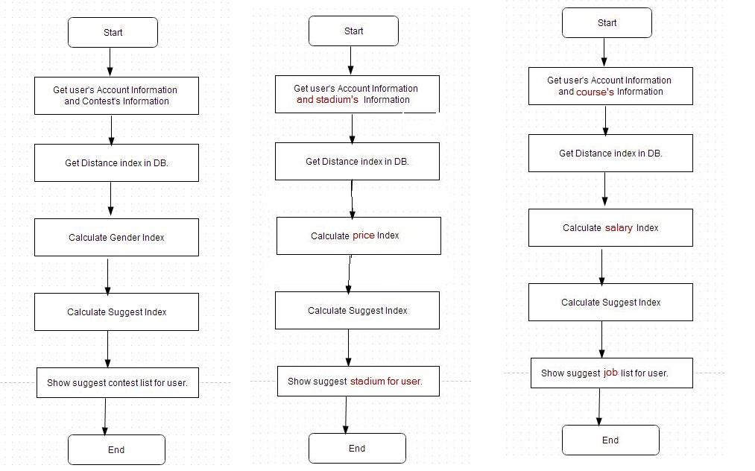

Figure 155: Suggesttion Flow Chart

### Arrange Match Schedule Automatically Algorithm.

1. Description

Arrange Match Schedule Automatically Algorithm is used to arrange all matches of contest round with contest location and time contraints.

1. Execution

* Get location parameters and time parameters.
* Get list of matches need to arrange schedule.
* Transfer parameters into match schedule list.
* Check valid and arrange schedule for each match base on information of match schedule list.
* Check all match schedule and run algorithm again if there is match which have no schedule.

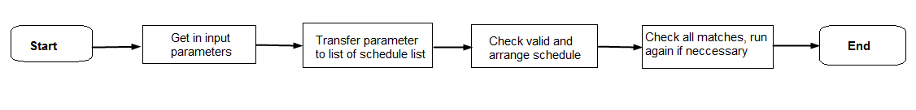

Figure 156: Arrange Macth Schedule Flow Chart

# System Implementation & Test

## Introduction

### System Overview

This section provides in detail all necessary information about test plans, test cases, test result, test environments, pass/fail criteria and risks estimations as well as a checklist to cover all possible cases of BSF\_Website.

### Test Approach

- Goal: To test the whole system based on the core workflow.

- Method: System Testing, Black-box Testing.

## Test Plan

The target of this section is to guarentee and ensure that BSF-website meets its design specification and other requirements from user. The following part will describe which features to be tested and which will not.

### Features to be tested

We will test the entire system based on the following core workflow

Based on the workflow, all following features will be tested, which can include one or more functions. These features will be focused and tested thoroughly during the test phase.

* Search: Normal Search , Advance Search, View deatail
* Stadium : List Stadium, Stadium Detail, Book court.
* Contest: View Contest List, Contest Detail, Join Contest, Cancel Contest, View Contest Result, View Contest Schedule.
* Course: Join Course, Change Course, View List Course, Course Detail.
* Job: List Job, Job Detail, Apply Job.

These remaining feature will be tested as individual module:

* Manage ContestEvent View, Add, Edit, Delete contest event.
* Manage Contest : View, Add, Delete contest
* Manage Contest Participation: View, Edit, Report and Reset Participation
* Manage Matches : Arrange schedule, Arrange schedule automatically, Record scores, Export contest result, Export contest schedule.
* Manage Stadium: Add, Edit, Delete stadium
* Manage Court: Add, Edit, Delete Court
* Manage Comment : View, Answer, Approve Comment
* Manage Pricelist: View, Add, Update,Disable, Enable pricelist.
* Manage Course: View, Add, Update, Delete.
* Manage Job Application: View, Approve.

### Features not to be tested

* Register account
* Logout
* Edit profile
* Boss – Manage Comment
* Boss – Manage Message
* Admin – Manage Message
* Player – Login, Change Edit profile

## C:\Users\TUANNH\Desktop\Untitled Diagram.jpgSystem Testing Test Case

Figure 157: Core Workflow

|  |  |  |  |  |  |  |
| --- | --- | --- | --- | --- | --- | --- |
| **ID** | **Test Case Description** | **Test Case Procedure** | **Expected output** | **Result** | **Test Date** | **Note** |
| STTC\_001 | View stadium detail | 1 – Login with player account.  2 – On the home page, click on [chi tiet] button | - After step 2, redirect to stadium detail page. | Pass | 16/07/2014 |  |
| STTC\_002 | Find court | 1 – Login with player account.  2 – On stadium detail page, use form  [tìm sân phù hợp] to find court  3 – Click ”Tìm sân” button. | - After step 3, show list court in stadiumdetail page. | Pass | 16/07/2014 |  |
| STTC\_003 | Book court | 1 – Login with player account.  2 – On stadium detail page find court and click on [Đặt sân] button | -After step 2, player payment online to finish. | Pass | 16/07/2014 |  |
| STTC\_004 | Course Detail | 1 – Login with player account.  2 – On the home page, click on [Khóa Học] button. | - After step 2, redirect to course detail page. | Pass | 16/07/2014 |  |
| STTC\_005 | Join Course | 1 – Login with player account.  2 – On the detail course page, click on [Đăng Ký Lớp] button.  3- On the detail course page, chose startdayand click [Tiếp Tục] button on the [Chọn Ngày] popup.  4- On the detail course page, click on [Tiếp Tục] button the [Xac Nhận] popup is show to confirm. | - After step 2, the [Chọn Ngày] popup is show with [Ngày Bắt Đầu] combobox..  - After step 3, the [Xac Nhận] popup is show to confirm.  - After step 4, the payment is continuous. | Pass | 16/07/2014 |  |
| STTC\_006 | View Contest | 1 – Login with player account.  2 – On home page, click “Giải Đấu” button.  3 – On list contest page, click “Chi Tiết” button. | - After step 2, redirect list course page.  - After step 3, redirect Detail contest page. | Pass | 16/07/2014 |  |
| STTC\_007 | Join Contest | 1 – Login with player account.  2 – On Detail Contest page, click “Tham Gia” button.  3 – Click “Xác Nhạn” button on popup | -After step 2, [Xác Nhận] popup is show.  - After step 3, “Bạn đã đăng ký giải đấu thành công.” Message. | Pass | 16/07/2014 |  |
| STTC\_008 | Mange stadium | 1 – Login with player account.  2- go to manage stadium page | -After step 2, show list stadium | Pass | 16/07/2014 |  |
| STTC\_009 | Register stadium | 1 – Login with player account.  2 – Click [Thêm sân mới] button.  3-Click on “Đặt sân” button | -After step2, redirect “CreateNewStadium” page.  - After step 3, payment online to finish. | Pass | 16/07/2014 |  |
| STTC\_010 | Create court | 1 – Login with player account.  2 – Click [Thêm sân con] button.  3-Click on “Đồng ý” button | -After step2, redirect “CreateNewCourt” page.  - After step 3, show success message. | Pass | 16/07/2014 |  |
| STTC\_011 | Manage course | 1 – Login with player account.  2- go to ListCourse page | --After step 2, show list course | Pass | 16/07/2014 |  |
| STTC\_011 | Confirm join course | 1 – Login with player account.  2- click [Tiếp tục] | --After step 2, change course status | Pass | 16/07/2014 |  |
| STTC\_012 | Manage contest | 1 – Login with player account.  2- go to ListContest page | --After step 2, show list contest | Pass | 16/07/2014 |  |
| STTC\_013 | Create contest | 1 – Login with player account.  2- click on [Tạo giải đấu mới]  3- click on [Lưu] button | --After step 2, show pop up  - After step 3, show success message. | Pass | 16/07/2014 |  |

## Module Test Case

### <Player>AdvanceSeach

#### AdvanceSearch-Court

|  |  |  |  |  |  |  |  |  |  |  |  |
| --- | --- | --- | --- | --- | --- | --- | --- | --- | --- | --- | --- |
| ID | Description | Test Case Procedure | | Expected Output | | Dependence | | Result | | Test date | Note |
|  | Steps   1. User and guest can use this function 2. Go to [Home] page, use form [Tìm kiếm] 3. Chose “Sân” in [Đối tượng] field 4. Fill data to search | | | | | | | | | | |
| Components | | | | | | | | | | | |
| TC\_ADCO  \_001 | Form [Addvance search] | | 5. [Quận]: 12  Click on[Tìm] button | | - Show error message “Vui lòng không bỏ trống” in field [Ngày chơi] and field [Giờ bắt đầu] | |  | | Pass | Jul-10-2014 |  |
| TC\_ ADC0 \_002 | Form [Addvance search] | | 6. [Quận]: 12  [Ngày chơi]: 30/7  [Giờ bắt đầu]: 14h  Click on[Tìm] button | | - Show list court | |  | | Pass | Jul-10-2014 |  |
| TC\_ ADC0 \_003 | Form [Addvance search] | | 7. [Quận]: 12  [Ngày chơi]: 31/7  [Giờ bắt đầu]: 10h  [Giá từ]:0 [đến]: 3000  Click on[Tìm] button | | - Show message “Không có sân phù hợp” | |  | | Pass | Jul-10-2014 |  |
| TC\_ ADC0  \_004 | Form [Addvance search] | | 8. [Quận]: 12  [Ngày chơi]: 30/7  [Giờ bắt đầu]: 10h [đến]: 300000  [Thời lượng]:60 phút  Click on[Tìm] button | | -Show list court | |  | | Fail | Jul-10-2014 | Fixed  Jul-13-2014 |
| TC\_ ADC0  \_005 | Form [Addvance search] | | 9.  Quận]: 12  [Ngày chơi]: 30/7  [Giá từ]:0 [đến]: 100000  [Thời lượng]:60 phút Click on[Tìm] button | | -show error message “Vui lòng không bỏ trống” in field[Giờ bắt đầu] | |  | | Pass | Jul-10-2014 |  |

#### AdvanceSearch-Contest

|  |  |  |  |  |  |  |  |  |  |
| --- | --- | --- | --- | --- | --- | --- | --- | --- | --- |
| ID | Description | Test Case Procedure | | Expected Output | | Dependence | Result | Test date | Note |
|  | Steps   * + - 1. User and guest can use this function       2. Go to [Home] page, use form [Tìm kiếm]       3. Chose “Giải đấu” in [Đối tượng] field       4. Fill data to search | | | | | | | | |
| Components | | | | | | | | | |
| TC\_ADCT\_001 | Form [Addvance search] | | 5. [Quận] : 12  Click on[Tìm] button | | - Show list contest |  | Pass | Jul-10-2014 |  |
| TC\_ ADCT \_002 | Form [Addvance search] | | 6. [Quận]: 12  [Thể loại giải đấu]: Đơn nam  [Trạng thái] :Đã diễn ra  Click on[Tìm] button | | - Show list contest |  | Pass | Jul-10-2014 |  |
| TC\_ ADCT  \_003 | Form [Addvance search] | | 7. [Quận]: 12  [Thể loại giải đấu]: Đơn nam  [Trạng thái] :Đã diễn ra  [Đến ngày]:5/9  Click on[Tìm] button | | - show message “không có giải đấu phù hợp” |  | Fail | Jul-10-2014 | Fixed  Jul-11-2014 |
| TC\_ ADCT  \_004 | Form [Addvance search] | | 8. [Quận]: 12  [Thể loại giải đấu]: Đơn nam  [Trạng thái] :Đã diễn ra  [Từ ngày]:10/7  Click on[Tìm] button | | -Show list contest |  | Fail | Jul-10-2014 | Fixed  Jul-11-2014 |
| TC\_ ADCT  \_005 | Form [Addvance search] | | 9. [Quận]: 12  [Thể loại giải đấu]: Đơn nam + Đơn nữ  [Trạng thái] :Sắp diễn ra  [Từ ngày]:10/7  [Đến ngày]:10/8  Click on[Tìm] button | | - Show list contest |  | Pass | Jul-10-2014 |  |
| TC\_ ADCT  \_006 | Form [Addvance search] | | 10. [Quận]: 12  [Trạng thái] :Sắp diễn ra  [Từ ngày]:10/7  [Đến ngày]:10/8  Click on[Tìm] button | | -Show list contest |  | Pass | Jul-10-2014 |  |

#### AdvanceSearch-Course

|  |  |  |  |  |  |  |  |  |  |
| --- | --- | --- | --- | --- | --- | --- | --- | --- | --- |
| ID | Description | Test Case Procedure | | Expected Output | | Dependence | Result | Test date | Note |
|  | Steps  1.User and guest can use this function  2.Go to [Home] page, use form [Tìm kiếm]  3.Chose “Khóa học” in [Đối tượng] field  4.Fill data to search | | | | | | | | |
| Components | | | | | | | | | |
| TC\_ADCS  \_001 | Form [Addvance search] | | 5. [Quận]: 12  Click on[Tìm] button | | - show list course |  | Pass | Jul-11-2014 |  |
| TC\_ ADCS  \_002 | Form [Addvance search] | | 6. [Quận]:12  [Học phí từ]:0  [Đến]:300  Click on[Tìm] button | | - Show list course |  | Pass | Jul-11-2014 |  |
| TC\_ ADCS  \_003 | Form [Addvance search] | | 7. [Quận]:12  [Học phí từ]:0  [Đến]:300  [Từ giờ]:11h  [Đến giờ]17h  Click on[Tìm] button | | - show message “Không có khóa học phù hợp” |  | Fail | Jul-11-2014 | Fixed  Jul-12-2014 |
| TC\_ ADCS \_004 | Form [Addvance search] | | 8. [Quận]:12  [Thứ]:2,4,6  Click on[Tìm] button | | -Show list court |  | Fail | Jul-11-2014 | Fixed  Jul-12-2014 |
| TC\_ ADCS  \_005 | Form [Addvance search] | | 9.  Click on[Tìm] button | | - Show list court |  | Pass | Jul-11-2014 |  |

### <Player>FindAvaliable Court

|  |  |  |  |  |  |  |  |  |  |  |
| --- | --- | --- | --- | --- | --- | --- | --- | --- | --- | --- |
| ID | Description | Test Case Procedure | | Expected Output | | Dependence | | Result | Test date | Note |
|  | Steps  1.Login with role Player  2.Go to [StadiumDetail] page  3.Using [Tìm sân phù hợp] form | | | | | | | | | |
| Components | | | | | | | | | | |
| TC\_FAC  \_001 | [Tìm sân phù hợp] form | | 4. All fields are blank  Click [Tìm sân trống] button | | - show error message “Vui lòng không để trống” | |  | Pass | Jul-13-2014 |  |
| TC\_ FAC \_002 | [Tìm sân phù hợp] form | | 5. [Ngày chơi]:30/7  Click [Tìm sân trống] button | | - show error message “Vui lòng không để trống” in field [Giờ bắt đầu] | |  | Pass | Jul-13-2014 |  |
| TC\_ FAC  \_003 | [Tìm sân phù hợp] form | | 6. [Ngày chơi]:30/7  [Giờ bắt đầu]:22h  [Thời lượng]:180 phút  Click [Tìm sân trống] button | | - show error message “Đặt sân trước 19h” on field [Giờ bắt đầu] | |  | Fail | Jul-13-2014 | Fixed jul-15-2014 |
| TC\_ FAC  \_004 | [Tìm sân phù hợp] form | | 7. [Ngày chơi]:13/7  [Giờ bắt đầu]:10h  [Thời lượng]:180 phút  Click [Tìm sân trống] button | | - show error message “đặt sân từ 12h” on field [Giờ bắt đầu] | |  | Fail | Jul-13-2014 | Fixed jul-15-2014 |
| TC\_ FAC  \_005 | [Tìm sân phù hợp] form | | 8. [Ngày chơi]:14/7  [Giờ bắt đầu]:10h  [Thời lượng]:180 phút  Click [Tìm sân trống] button | | - show list court | |  | Pass | Jul-13-2014 |  |

### <Player>Book Court

|  |  |  |  |  |  |  |  |  |  |  |
| --- | --- | --- | --- | --- | --- | --- | --- | --- | --- | --- |
| ID | Description | Test Case Procedure | | Expected Output | | Dependence | | Result | Test date | Note |
|  | Steps  1.Login with role Player  2.Go to [StadiumDetail] page  3.Using [Tìm sân phù hợp] form to find court | | | | | | | | | |
| Components | | | | | | | | | | |
| TC\_BOC  \_001 | Book Court | | 4.Click on[Đặt sân] button | | - show pop up to confirm | |  | Pass | Jul-13-2014 |  |
| TC\_ BOC \_002 | Book Court | | 5.View reservation in [BookHistory]page | | -show reservation just have been rent | |  | fail | Jul-13-2014 | Fixed jul-13-2014 |
| TC\_ BOC \_003 | Book Court | | 6. Click on [Đồng ý] button on pop up | | -Redirect to paypal page | |  | fail | Jul-13-2014 | Fixed jul-13-2014 |
| TC\_ BOC  \_004 | Book Court | | 7.Cancel payment online | | - Back to [Home] page | |  | Pass | Jul-13-2014 |  |
| TC\_ BOC  \_005 | Book Court | | 8. Finish payment online | | - Redirect to [BookSuccess] page | |  | Pass | Jul-13-2014 |  |

### <Boss>Register Stadium

|  |  |  |  |  |  |  |  |
| --- | --- | --- | --- | --- | --- | --- | --- |
| ID | Description | Test Case Procedure | Expected Output | Dependence | Result | Test date | Note |
|  | Steps  1.Login with role of Boss  2.Go to [ManageStadium] page  3.Click on [Thêm sân mới] button | | | | | | |
| Components | | | | | | | |
| TC\_RGST  \_001 | View [CreateNewStadium] | 4.Click [Thêm sân mới] on[ManageStadium] page | - Show [CreateNewStadium] form with components  - Display 2 buttons [Đăng ký sân] ,[Hủy] |  | Pass | Jul-13-2014 |  |
| TC\_ RGST \_002 | View [CreateNewStadium] | 5.Let all fields  Empty and click on [Đăng ký sân] button | - Show error message [Vui lòng không bỏ trống]  - Cannot add Stadium |  | Pass | Jul-13-2014 |  |
| TC\_ RGST  \_003 | View [CreateNewStadium] | 6.Fill all fields but [Phone],[Giá mặc định thuê 1 giờ] field is not number | - Show error label [Vui lòng nhập số]  - Cannot add Stadium |  | Pass | Jul-13-2014 |  |
| TC\_ RGST \_004 | View [CreateNewStadium] | 7.input [Giờ mở cửa]: 9 : 00 PM  [Giờ đóng cửa]: 8:00PM | - show error message “Giờ đóng cửa không nhỏ hơn giờ mở cửa”. |  | Fail | Jul-13-2014 | Fixed:Jul-13-2014 |
| TC\_ RGST \_005 | View [CreateNewStadium] | 8.[Email]: acbc | - Show error message [vui lòng nhập đúng format mail] |  | Pass | Jul-13-2014 |  |
| TC\_ RGST \_006 | Cancel Register | 9.Click on [Hủy] button | -Go back [ManageStadiujm] page |  | Pass | Jul-13-2014 |  |
| TC\_ RGST \_007 | Payment | 10Click on [Đăng ký sân] button | - Show [StadiumRegisterPayment] page |  | Fail | Jul-13-2014 | Fixed: Jul-13-2014 |
| TC\_ RGST \_008 | payment | 11. Click on [Thanh toán] button | -show paypal page |  | Pass | Jul-13-2014 |  |
| TC\_ RGST \_009 | Register success | 12.finish payment | -Redirect to [StadiumRegisSuccess] page |  | Fail | Jul-13-2014 | Fixed: Jul-13-2014 |

### <Boss>Create New Court

|  |  |  |  |  |  |  |  |
| --- | --- | --- | --- | --- | --- | --- | --- |
| ID | Description | Test Case Procedure | Expected Output | Dependence | Result | Test date | Note |
|  | Steps  1.Login with role of Boss  2.Go to [ManageCourt] page  3.Click [Thêm sân con] button ManageCourt page | | | | | | |
| Components | | | | | | | |
| TC\_CRCL  \_001 | View [CreateNewCourt] form | 4.Click [Thêm sân con] on ManageCourt page | - Show [CreateNewCourt] page |  | Pass | Jul-14-2014 |  |
| TC\_ CRCL \_002 | View [CreateNewCourt] form | 2.Let all fields  Empty and click on [Thêm sân con] button | - Show error message [Vui lòng không bỏ trống] |  | Pass | Jul-14-2014 |  |
| TC\_ CRCL \_003 | View [CreateNewCourt] form | 3.Enter name “Sân 1” in flied [Tên sân] and click on [Thêm sân con] button | - show error message “tên này đã tồn tại vui lòng chon tên khác” |  | Pass | Jul-14-2014 |  |
| TC\_ CRCL \_004 | View [CreateNewCourt] form | 4.Fill valid data and View [CreateNewCourt] form | - show message “tạo sân con thành công” |  | Pass | Jul-14-2014 |  |

### <Boss>Create New Course

|  |  |  |  |  |  |  |  |
| --- | --- | --- | --- | --- | --- | --- | --- |
| ID | Description | Test Case Procedure | Expected Output | Dependence | Result | Test date | Note |
|  | Steps  1.Login with role of managers/admin  2.Go to [List Courses page]  3.Click [+] on List Courses page | | | | | | |
| Components | | | | | | | |
| TC\_CTRU\_001 | View [Tạo Lớp] form | 5.Click [+] on List Courses page | - Show [Tạo Lớp] form with components  - Display 2 buttons [Tạo Lớp] ,[Trở Lại] |  | Pass | Jul-10-2014 |  |
| TC\_CTRU\_002 | View [Tạo Lớp] form | 6.Let all fields  Empty and click on [Tạo] button | - Show error label [This value is required]  - Cannot add Course |  | Pass | Jul-10-2014 |  |
| TC\_CTRU  \_003 | View [Tạo Lớp] form | 7.Fill all fields but [Học Phí],[Lương Giáo Viên], [Số học viên], [Tuần học] field is not number | - Show error label [This value should be a valid email.]  - Cannot add Course |  | Pass | Jul-10-2014 |  |
| TC\_CTRU\_004 | View [Tạo Lớp] form | 8.input [Giờ bắt đầu]: 9 : 00 AM | - The input [Giờ kết thúc] show 10:00AM. [Giờ kết thúc] can’t chose time early than 10:00 AM. |  | Pass | Jul-10-2014 |  |
| TC\_CTRU\_005 | View [Tạo Lớp] form | 9.Don’t check any day of week | - Show error label [This value is required]  - Cannot add Course |  | Fail | Jul-10-2014 | Fixed:Jul-11-2014 |
| TC\_CTRU  \_006 | View [Tạo Lớp] form | 10. Chose [Giờ bắt đầu][Giờ kết thúc][Câu Lạc Bộ][Ngày trong tuần] | -The combobox [Sân] is refresh with available course. |  | Pass | Jul-12-2014 |  |
| TC\_CTRU\_007 | Cancel Add | 11.Click on [Trở Về] | -Go back [List Courses] page |  | Pass | Jul-12-2014 |  |
| TC\_CTRU\_008 | Create New Course | 12.Click on [Tạo] button | - Show error label: “Bạn đã tạo mới cấp độ thành công” |  | Fail | Jul-12-2014 | Fixed: Jul-12-2014 |

### <Boss>Create New Course Level

|  |  |  |  |  |  |  |  |
| --- | --- | --- | --- | --- | --- | --- | --- |
| ID | Description | Test Case Procedure | Expected Output | Dependence | Result | Test date | Note |
|  | Steps  1.Login with role of managers/admin  2.Go to [List Courses page]  3.Click [+] on List Courses page  4.Click [+] after [Cấp Độ] combobox | | | | | | |
| Components | | | | | | | |
| TC\_CRCL  \_001 | View [Tạo Lớp] form | 1.Click [+] on List Courses page | - Show [Tạo Cấp Độ] popup with components  - Display 2 buttons [Tạo Cấp Độ] ,[Trở Lại] |  | Pass | Jul-10-2014 |  |
| TC\_ CRCL \_002 | View [Tạo Lớp] form | 2.Let all fields  Empty and click on [Tạo] button | - Show error label [This value is required] on [Tên]  - Cannot add Course level |  | Pass | Jul-10-2013 |  |
| TC\_ CRCL \_003 | Cancel Add | 3.Click on [Trở Về] | - [Tạo Cấp Độ] popup close on [Tạo Lớp] page |  | Pass | Jul-10-2013 |  |
| TC\_ CRCL \_004 | Create New Course Level | 4.Click on [Tạo] button | - Fail : Show error label: “Bạn đã tạo mới lớp thất bại” |  | Fail | Jul-10-2013 | Fixed:Jul-11-2014 |
| TC\_ CRCL \_005 | Create New Course Level | 5. Click on [Tạo] button | - Success: close [Tạo cấp độ] popup and show success label: “Bạn đã tạo mới cấp độ thành công.” On [Tạo Lớp] page. |  | Pass | Jul-12-2013 |  |

### <Boss>Create New Contest Event

|  |  |  |  |  |  |  |  |  |  |
| --- | --- | --- | --- | --- | --- | --- | --- | --- | --- |
| ID | Description | Test Case Procedure | Expected Output | | Dependence | | Result | Test date | Note |
|  | Steps  1.Login with role of Boss  2.Go to [ListContestEvent]page  3.Click on[Tạo mới sự kiện giải đấu] button | | | | | | | | |
| Components | | | | | | | | | |
| TC\_CNCE  \_001 | View [Thêm sự kiện thi đấu mới] | 4. Click [Tạo mới sự kiện giải đấu] button | | - show pop up [Thêm sự kiện thi đấu mới] | |  | Pass | Jul-13-2014 |  |
| TC\_ CNCE \_002 | View [Thêm sự kiện thi đấu mới] | 5. [Tên sự kiện]: khai trương  Click on [Lưu] button | | - Show message “Hãy chọn ngày” on fields [Hạn chót đăng ký] | |  | Pass | Jul-13-2014 |  |
| TC\_ CNCE \_003 | View [Thêm sự kiện thi đấu mới] | 6. [Tên sự kiện]: khai trương  [Hạn chót đăng ký]:30/8  Click on [Lưu] button | | - Show message “Hãy chọn ngày” on field [Ngày bắt đầu] | |  | Pass | Jul-13-2014 |  |
| TC\_ CNCE \_004 | View [Thêm sự kiện thi đấu mới] | 7. [Tên sự kiện]: khai trương  [Hạn chót đăng ký]:30/8  [Ngày bắt đầu]:5/9  Click on [Lưu] button | | - Show message “Hãy chọn ngày” on field [Ngày kết thúc] | |  | Pass | Jul-13-2014 |  |
| TC\_ CNCE \_005 | View [Thêm sự kiện thi đấu mới] | 8. [Tên sự kiện]: khai trương  [Hạn chót đăng ký]:30/8  [Ngày bắt đầu]:30/8  Click on [Lưu] button | | - show error message “Hạn chót đăng ký phải trước ngày bắt đầu ít nhất 24h”. | |  | Fail | Jul-13-2014 | Fixed jul-15-2014 |
| TC\_ CNCE  \_006 | View [Thêm sự kiện thi đấu mới] | 9. [Tên sự kiện]: khai trương  [Hạn chót đăng ký]:30/8  [Ngày bắt đầu]:2/9  [Ngày kết thúc]:1/9  Click on [Lưu] button | | - show error message “Ngày bắt đầu phải sau ngày đăng ký ít nhất 24h”. | |  | Fail | Jul-13-2014 | Fixed jul-15-2014 |
| TC\_ CNCE  \_007 | View [Thêm sự kiện thi đấu mới] | 10. [Tên sự kiện]: khai trương  [Hạn chót đăng ký]:30/8  [Ngày bắt đầu]:2/9  [Ngày kết thúc]:20/9  Click on [Lưu] button | | - show message “Tạo sự kiện giải đấu mới thành công” | |  | Pass | Jul-13-2014 |  |

### <Boss>Manage Match

|  |  |  |  |  |  |  |  |  |  |
| --- | --- | --- | --- | --- | --- | --- | --- | --- | --- |
| ID | Description | Test Case Procedure | Expected Output | | Dependence | | Result | Test date | Note |
|  | Steps  1.Login with role of Boss  2.Go to [ListMatches]page | | | | | | | | |
| Components | | | | | | | | | |
| TC\_MNM  \_001 | View[ListMatches] | 3. Click [Tất cả trận đấu] link | | - show list contest | |  | Pass | Jul-14-2014 |  |
| TC\_ MNM \_002 | View[ListMatches] | 4. Click [Chưa xếp lịch] link | | - show list contest | |  | Pass | Jul-14-2014 |  |
| TC\_ MNM \_003 | View[ListMatches] | 5. Click [Xếp lịch] button | | - show pop up shedule detail | |  | Pass | Jul-14-2014 |  |
| TC\_ MNM \_004 | View[ListMatches] | 6 .[Ngày thi đấu]:5/9  [Giờ bắt đầu]: 1h  click button [Lưu] | | - Show message “Bạn đã xếp lịch thành công” and  [Giờ kết thúc]:2h | |  | Fail | Jul-14-2014 | Fixed jul-16-2014 |
| TC\_ MNM \_005 | View [Thêm sự kiện thi đấu mới] | 7. click on [Xếp lịch tự động] button, Fill all valid data  And lick on[Thực hiện] button | | - show message “Bạn đã xếp lịch thành công”. | |  | Fail | Jul-14-2014 | Fixed jul-16-2014 |
| TC\_ MNM  \_006 | View [Thêm sự kiện thi đấu mới] | 8. click [Kết quả] button | | -show result of match | |  | Pass | Jul-14-2014 |  |
| TC\_ MNM  \_007 | View [Thêm sự kiện thi đấu mới] | 9. chose match and lick on [In lich] button | | -show pop up [Lịch của vòng đấu] | |  | Pass | Jul-14-2014 |  |
| TC\_ MNM  \_008 | View [Thêm sự kiện thi đấu mới] | 10. Click on [Tải về] button | | Download shedule of match | |  | Fail | Jul-14-2014 | Fixed jul-16-2014 |

### <Player>Join Contest

|  |  |  |  |  |  |  |  |  |  |
| --- | --- | --- | --- | --- | --- | --- | --- | --- | --- |
| ID | Description | Test Case Procedure | Expected Output | | Dependence | | Result | Test date | Note |
|  | Steps  1.Login with role of Player  2.Go to [ContestDetail]page | | | | | | | | |
| Components | | | | | | | | | |
| TC\_JMT  \_001 | View[ContestDetail] | 3. Click [Tham gia] button | | - show pop up information detail of user | |  | Pass | Jul-14-2014 |  |
| TC\_ JMT \_002 | View[ContestDetail] | 4. Fill name of second member  Click [Xac nhan] button | | - show message[Đăng ký thành công] | |  | Pass | Jul-14-2014 |  |
| TC\_ JMT \_003 | View[ContestDetail] | 5. Click [Tham gia] button] again | | - show error message  “Bạn đã đăng ký giải đấu này” | |  | Pass | Jul-14-2014 |  |
| TC\_CTRU\_004 | View [List RegisterCourse] form | 4. Click [Đăng ký] on Boss page Về] | - Show page with table have list [Đăng Ký] courses | |  | | Pass | Jul-14-2013 |  |

### <Boss>Confirm Join Course

|  |  |  |  |  |  |  |  |
| --- | --- | --- | --- | --- | --- | --- | --- |
| ID | Description | Test Case Procedure | Expected Output | Dependence | Result | Test date | Note |
|  | Steps  1.Login with role of Boss  2.Go to [List Courses page]  3. Click [Confirm] button on row in List Courses page | | | | | | |
| Components | | | | | | | |
| TC\_CTRU\_CFJC | View [List RegisterCourse] form | 1. Click [Confirm] button on row that have status is “Đăng ký lớp” in List register Courses page | - Show [Xác Nhận] popup with question “Bạn có muốn tiếp tục xác nhận.”  - Display 2 buttons [Tiếp Tục] ,[Trở Lại] |  | Pass | Jul-13-2014 |  |
| TC\_ CFJC \_002 | Cancel confirm | 2.Click [Trở Lại] on [Xác Nhận] popup. | - [Xác Nhận] popup is closed. |  | Pass | Jul-13-2014 |  |
| TC\_ CFJC \_003 | Continuous confirm | 3. Click [Tiếp Tục] on [Xác Nhận] popup. | - Close [Xác Nhận] popup  - Show success label “Bạn đã xác nhận đăng ký lớp thành công.” |  | Pass | Jul-13-2014 |  |
| TC\_ CFJC  \_004 | Check information after confirm | 4. Click [View] button on row that have status is “Đang Học” in List register Courses page | - Show information of course: check start day: Jul-13-2014 and end day: Nov-28-2014 |  | Fail | Jul-13-2014 | Fixed:Jul-16-2014 |
| TC\_ CFJC  \_005 | Check information after confirm | 5. Click [View] button on row that have status is “Đang Học” in List register Courses page | - Show information of course: check start day: Jul-01-2014 and end day: Nov-25-2014 |  | Fail | Jul-13-2014 | Fixed:Jul-16-2014 |
| TC\_ CFJC  \_006 | Check information after confirm | 6. Click [View] button on row that have status is “Đang Học” in List register Courses page | - Show information of course: check start day: Jul-05-2014 and end day: Nov-23-2014 |  | Pass | Jul-13-2014 |  |
| TC\_ CFJC  \_007 | Check information after confirm | 7. Click [View] button on row that have status is “Đang Học” in List register Courses page | - Show information of course: check start day: Jul-04-2014 and end day: Nov-23-2014 |  | Pass | Jul-13-2014 |  |

### <Boss>Confirm Change Course

|  |  |  |  |  |  |  |  |
| --- | --- | --- | --- | --- | --- | --- | --- |
| ID | Description | Test Case Procedure | Expected Output | Dependence | Result | Test date | Note |
|  | Steps  1.Login with role of Boss  2.Go to [List Courses page]  3. Click [Confirm] button on row in List Courses page | | | | | | |
| Components | | | | | | | |
| TC\_CFCC  \_001 | View [List RegisterCourse] form | 1. Click [Confirm] button on row that have status is “Chuyển Lớp” in List register Courses page | - Show [Xác Nhận] popup with question “Bạn có muốn tiếp tục xác nhận.”  - Display 2 buttons [Tiếp Tục] ,[Trở Lại] |  | Pass | Jul-13-2014 |  |
| TC\_ CFCC \_002 | Cancel confirm | 2.Click [Trở Lại] on [Xác Nhận] popup. | - [Xác Nhận] popup is closed. |  | Pass | Jul-13-2014 |  |
| TC\_ CFCC \_003 | Continuous confirm | 3. Click [Tiếp Tục] on [Xác Nhận] popup. | - Close [Xác Nhận] popup  - Show success label “Bạn đã xác nhận đăng ký lớp thành công.” |  | Pass | Jul-13-2014 |  |
| TC\_ CFCC  \_004 | Check information after confirm | 4. Click [View] button on row that have status is “Đang Học” in List register Courses page | - Show information of course: check start day: July-18-2014 and end day: Nov-28-2014 |  | Fail | Jul-13-2014 | Fixed:Jul-16-2014 |
| TC\_ CFCC  \_005 | Check information after confirm | 5. Click [View] button on row that have status is “Đang Học” in List register Courses page | - Show information of course: check start day: July-01-2014 and end day: Nov-25-2014 |  | Pass | Jul-13-2014 |  |
| TC\_ CFCC  \_006 | Check information after confirm | 6. Click [View] button on row that have status is “Đang Học” in List register Courses page | - Show information of course: check start day: July-13-2014 and end day: Nov-23-2014 |  | Fail | Jul-13-2014 | Fixed:Jul-16-2014 |
| TC\_ CFCC  \_007 | Check information after confirm | 7. Click [View] button on row that have status is “Đang Học” in List register Courses page | - Show information of course: check start day: July-12-2014 and end day: Nov-23-2014 |  | Pass | Jul-13-2014 |  |

### <Player>View Detail Course

|  |  |  |  |  |  |  |  |
| --- | --- | --- | --- | --- | --- | --- | --- |
| ID | Description | Test Case Procedure | Expected Output | Dependence | Result | Test date | Note |
|  | Steps  1.Login with role of player  2.Go to [List RegisterCourses page]  3. Select on course on list register course | | | | | | |
| Components | | | | | | | |
| TC\_VDC  \_001 | View [Detail Course] form | 1. Select on course(id = 5) on list register course | - Show Detail course width: Tên, Cấp độ, Giáo viên, Ngày học, Giờ bắt đầu, Giờ kết thúc, Học phí, Số tiết học  +button  + Comment |  | Pass | Jul-14-2014 |  |
| TC\_ VDC \_002 | View [Detail Course] form | 2. The Player registered | - button show “Đã Đăng Ký” |  | Pass | Jul-14-2014 |  |
| TC\_ VDC \_003 | View [Detail Course] form | 3. Course is full. | - button show “Hết chỗ” |  | Pass | Jul-14-2014 |  |
| TC\_ VDC \_004 | View [Detail Course] form | 4. The player have not register or studied | - button show “Đăng ký Lớp” |  | Pass | Jul-10-2014 |  |
| TC\_ VDC \_005 | View [Detail Course] form | 4. The player is studying. | - button show “Chuyển Lớp” |  | Pass | Jul-10-2014 |  |

### <Player>Join Class

|  |  |  |  |  |  |  |  |
| --- | --- | --- | --- | --- | --- | --- | --- |
| ID | Description | Test Case Procedure | Expected Output | Dependence | Result | Test date | Note |
|  | Steps  1.Login with role of player  2.Go to [List Courses page]  3. Select on course on list register course.  4. Click “Đăng ký lớp”. | | | | | | |
| Components | | | | | | | |
| TC\_JCL  \_001 | Join Course | 1. Click “Đăng ký lớp” in [Detail Course] page | - Show [Chọn Ngày] popup with [Ngày bắt đầu] combobox  +2 button: [Hủy], [Tiếp Tục] |  | Pass | Jul-20-2014 |  |
| TC\_ JCL \_002 | Check Day Start on popup | 2. Click [Ngày bắt đầu] combobox | - Combobox show three day that player can study:  Jul-21-2014, Jul-23-2014, Jul-25-2014 |  | Fail | Jul-20-2014 | Fixed: Jul-23-2014 |
| TC\_ JCL \_003 | Check Day Start on popup | 3. Click [Ngày bắt đầu] combobox | - Combobox show three day that player can study:  Jul-22-2014, Jul-23-2014, Jul-24-2014 |  | Fail | Jul-20-2014 | Fixed: Jul-23-2014 |
| TC\_ JCL \_004 | Check Day Start on popup | 4. Click [Ngày bắt đầu] combobox | - Combobox show three day that player can study:  Jul-22-2014, Jul-23-2014, Jul-27-2014 |  | Fail | Jul-20-2014 | Fixed: Jul-23-2014 |
| TC\_ JCL \_005 | Cancel Register | 5. Click [Hủy] button | - [Chọn Ngày] popup is closed |  | Pass | Jul-20-2014 |  |
| TC\_ JCL  \_006 | Continuous  Register | 6. Choose one day (Jul-22-2014) Click [Tiếp Tục] button | - [Xác Nhận] popup is show with start day (Jul-22-2014). Information about payment online. The system will save register on database  + 2 button: [Hủy], [Tiếp Tục] |  | Pass | Jul-20-2014 |  |
| TC\_ JCL \_007 | Continuous Payment | 7. Click [Tiếp Tục] button | - Go to [Paypal] page. |  | Pass | Jul-20-2014 |  |
| TC\_ JCL \_008 | Cancel Payment | 8. Click [Go back home page] button in [Paypal] page | - Go to [List Register Course] page. The system change status of register course: Chưa Đóng HP. |  | Pass | Jul-20-2014 |  |
| TC\_ JCL \_009 | Cancel Payment | 9. Close [Paypal] page | - After 15 minute, the system change status of register course is “Chưa Đóng HP”. |  | Pass | Jul-20-2014 |  |
| TC\_ JCL \_010 | Cancel Payment | 10. Continuous payment | - After payment success, the system change status of register course is “Đang Học” and go back [List Register Course] page. |  | Pass | Jul-20-2014 |  |

### <Player>Change Class

|  |  |  |  |  |  |  |  |
| --- | --- | --- | --- | --- | --- | --- | --- |
| ID | Description | Test Case Procedure | Expected Output | Dependence | Result | Test date | Note |
|  | Steps  1.Login with role of player  2.Go to [List Courses page]  3. Select on course on list register course.  4. Click “Chuyển Lớp”. | | | | | | |
| Components | | | | | | | |
| TC\_CHCL  \_001 | Join Course | 1. Click “Chuyển Lớp” in [Detail Course] page | - Show [Chọn Ngày] popup with [Ngày bắt đầu] combobox  +2 button: [Hủy], [Tiếp Tục] |  | Pass | Jul-20-2014 |  |
| TC\_ CHCL \_002 | Check Day Start on popup | 2. Click [Ngày bắt đầu] combobox | - Combobox show three day that player can study:  Jul-21-2014, Jul-23-2014, Jul-25-2014 |  | Fail | Jul-20-2014 | Fixed: Jul-23-2014 |
| TC\_ CHCL \_003 | Check Day Start on popup | 3. Click [Ngày bắt đầu] combobox | - Combobox show three day that player can study:  Jul-22-2014, Jul-23-2014, Jul-24-2014 |  | Fail | Jul-20-2014 | Fixed: Jul-23-2014 |
| TC\_ CHCL \_004 | Check Day Start on popup | 4. Click [Ngày bắt đầu] combobox | - Combobox show three day that player can study:  Jul-22-2014, Jul-23-2014, Jul-27-2014 |  | Fail | Jul-20-2014 | Fixed: Jul-23-2014 |
| TC\_ CHCL \_005 | Cancel Register | 5. Click [Hủy] button | - [Chọn Ngày] popup is closed |  | Pass | Jul-20-2014 |  |
| TC\_ CHCL \_006 | Continuous  Register | 6. Choose one day (Jul-22-2014) Click [Tiếp Tục] button | - The system show message “Bạn đã đăng ký chuyển lớp thành công.” |  | Pass | Jul-20-2014 |  |

# Software User’s Manual

## Installation Guide

### Setting up environment at server site

The following software must be installed into the server machine:

#### Hardware requirements

Personal computers for developing with the minimum configuration:

* CPU Core 2 Duo 2.0GHz.
* 4GB of RAM.
* 300GB of hard disk.
* Wifi Internet (> 2Mbps).

#### Software requirements

* Web Server: Internet Information System – IIS 7.5
* Microsoft Windows 7: operating system and platform for development
* SQL Server 2008 R2: used to create and manage the database for web application

#### Prepare deployment package

* Extract the deployment package to a folder on the server.
* For example: C:\User\PHATTTSE60842\Desktop\BSFWebsite

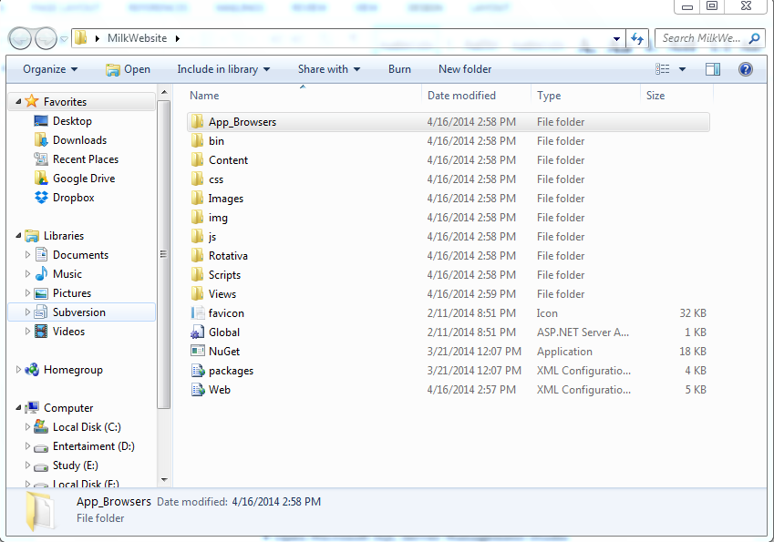

Figure 158: Prepare deployment package

#### Deploy database

* Open Microsoft SQL Server Management Studio

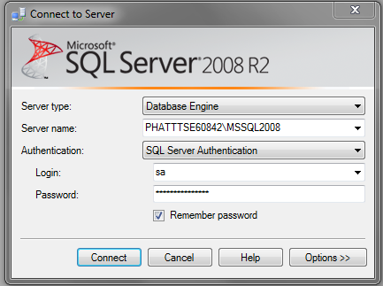

Figure 159: Deploy database – 1

* Open the script.sql file

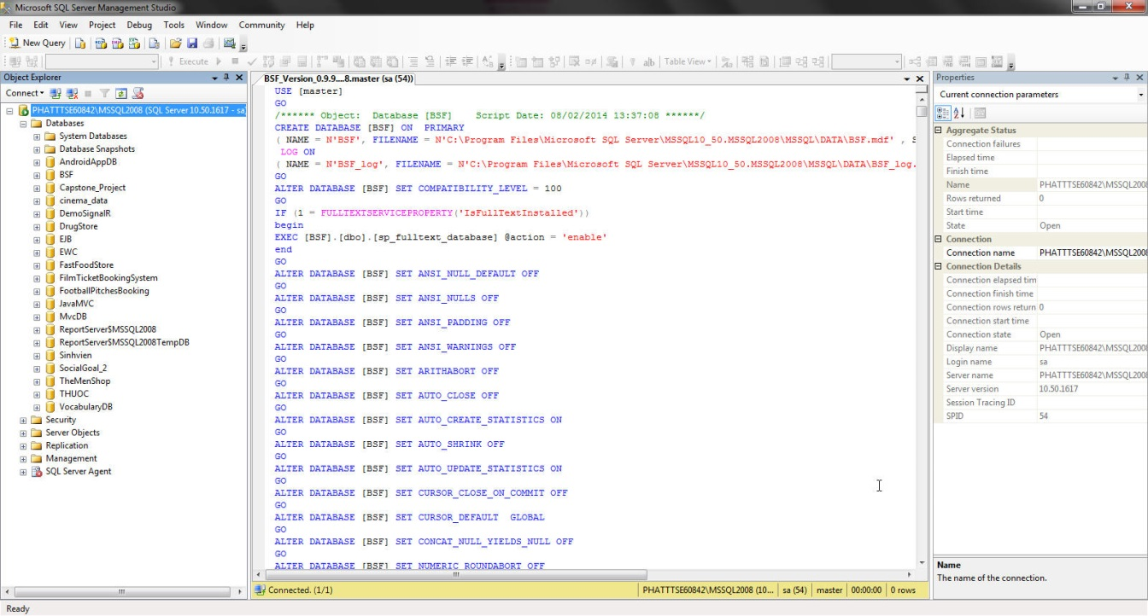

Figure 160: Deploy database - 2

* Execute the script to finish the process

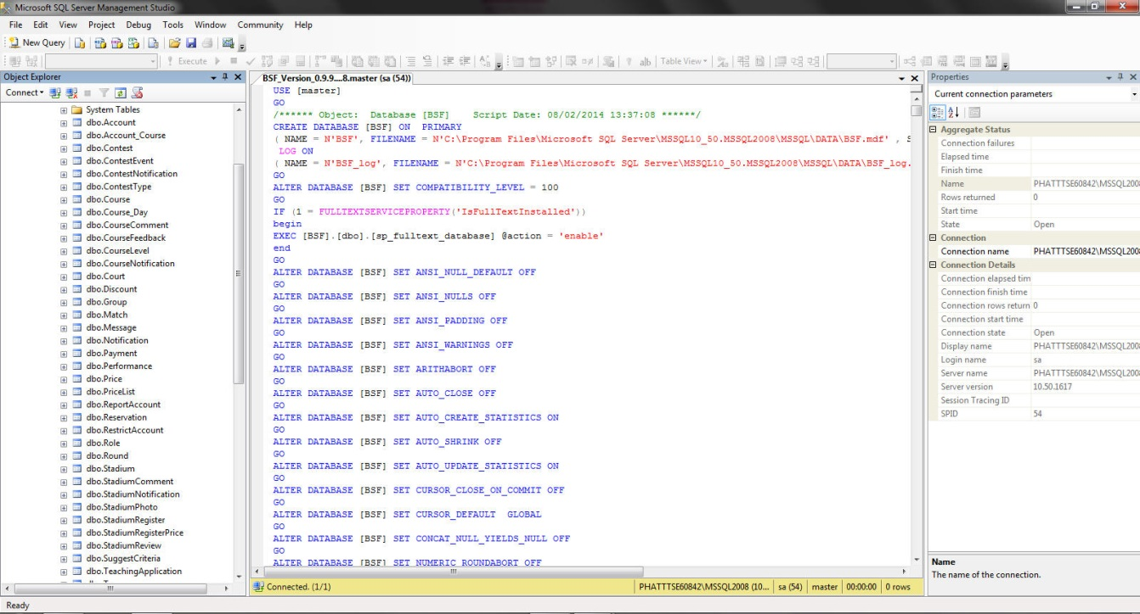

Figure 161: Deploy database - 3

#### Configure Server before deploy

* Open the Internet Information System Manager
* Change the .NET Framework version to 4.0

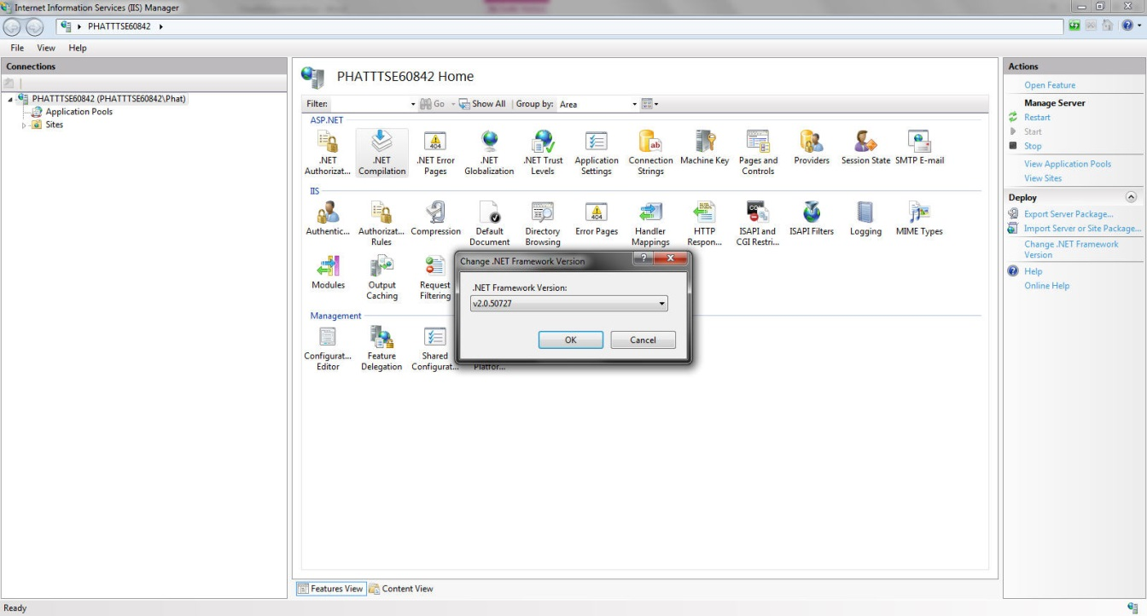

Figure 162: Configure Server before deploy – 1

* Click the Application Pool

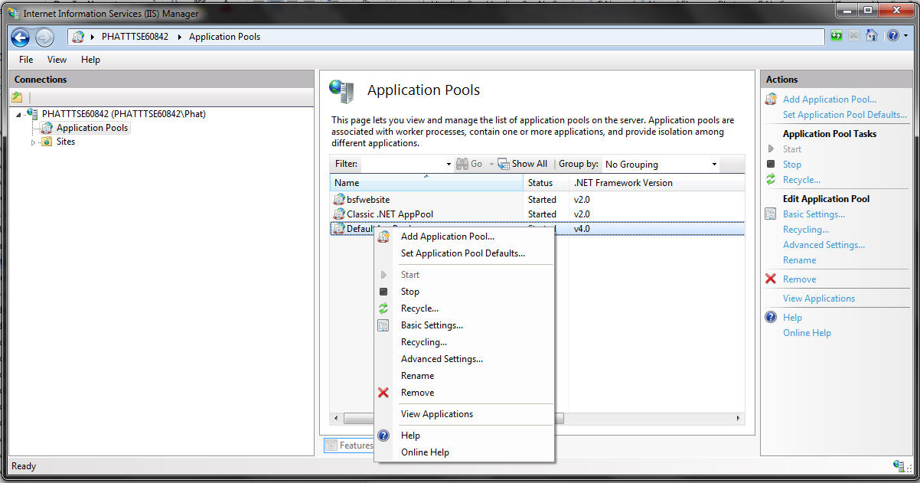

Figure 163: Configure Server before deploy – 2

* Right click the ASP.NET 4.0 Pool, select “Advance Settings”.
* Set “Enable 32-bit Applications” to True.



Figure 164: Configure Server before deploy - 3

#### Deploy web application on server

* Change the connection string in Web.config
* Replace the “integrated security” with your own username and password

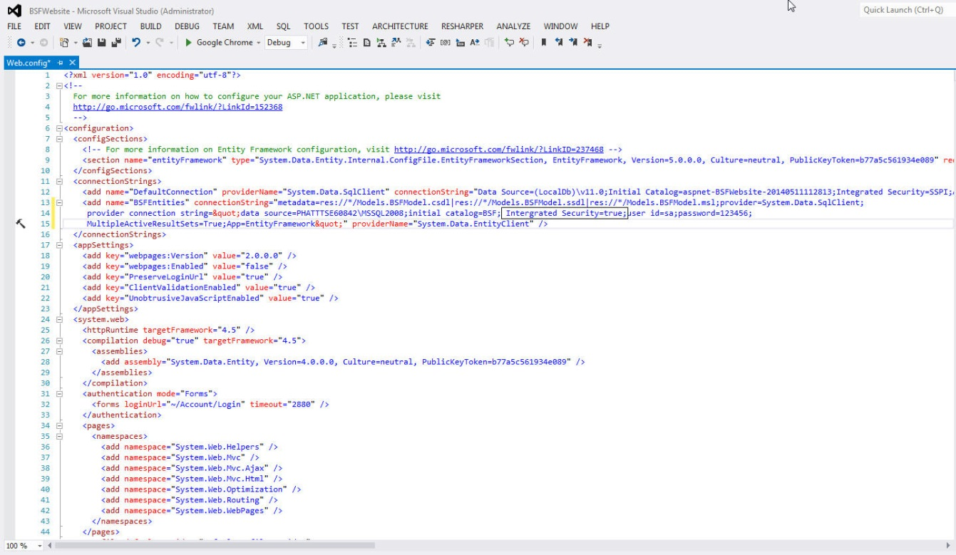

Figure 165: Deploy web application on server - 1

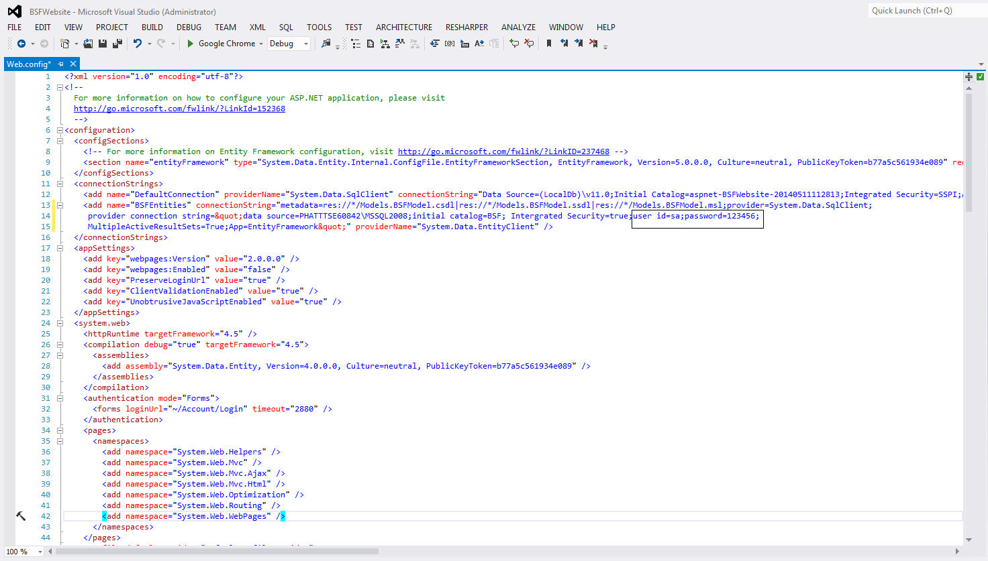

Figure 166: Deploy web application on server – 2

* Right click as Sites. Choose “Add Web Site”.

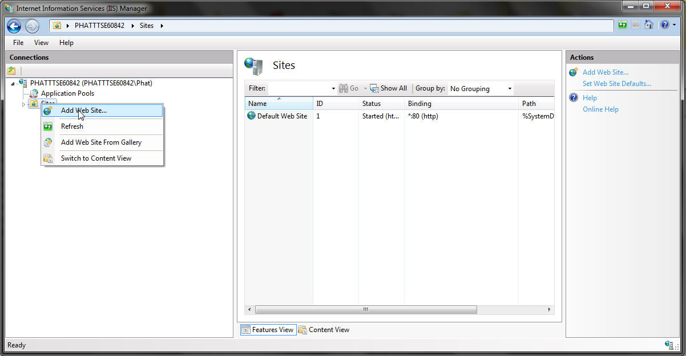

Figure 167: Deploy web application on server – 3

* Enter site name. Choose Application Pool as ASP.NET 4.0
* Select the path as the folder in step 1. Enter port other than 80.

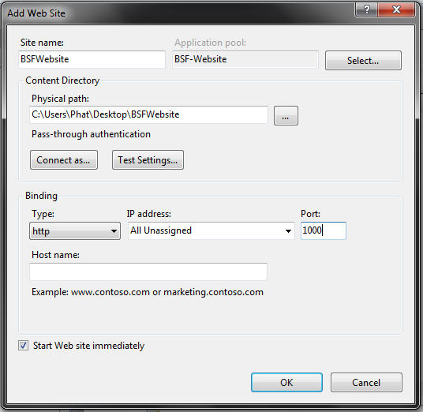

Figure 168: Deploy web application on server – 4

* Press ok to finish the process

Figure 169: Deploy web application on server – 5

## User Guide

### Login

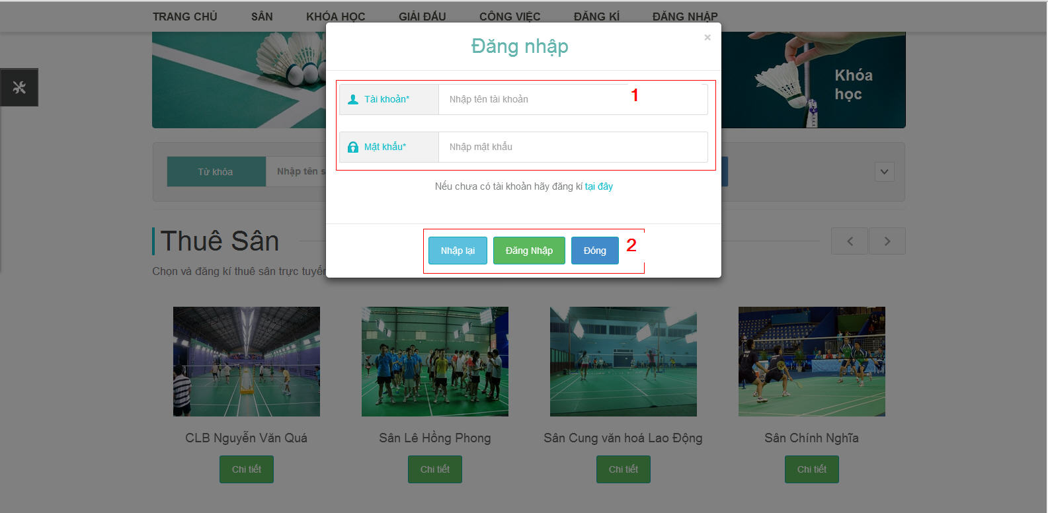

Figure 170: Login Image

|  |  |
| --- | --- |
| **Step** | **Description** |
| 1 | Fill Username and Password  (Sample admin account:  Username: admin. Password: admin) |
| 2 | Click “Đăng Nhập” button to login  Click “Nhập lại” button to reset form.  Click “Đóng” button to close login pop up window. |

Table 6: Login

### Guest –Register Account.

**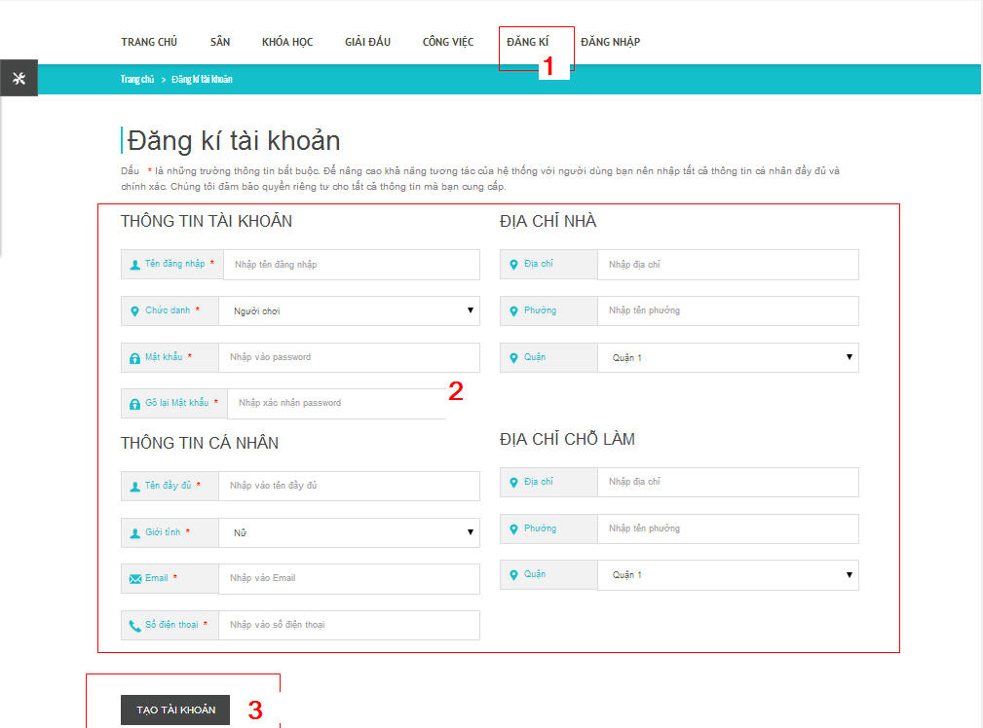**

Figure 171:Register Account

|  |  |
| --- | --- |
| **Step** | **Description** |
| 1 | Click “Đăng kí”tab menu. |
| 2 | Fill required account information. |
| 3 | Click “Tạo tài khoản” button to send registration. |

Table 7: Register Account

### User –Edit Profile.

**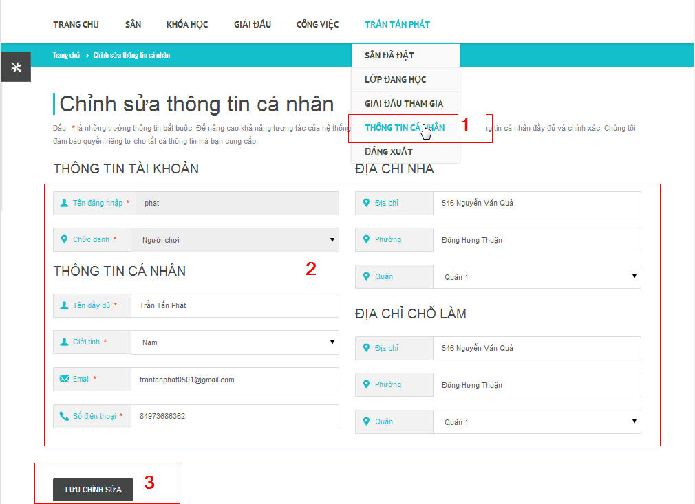**

Figure 172: Edit Profile

|  |  |
| --- | --- |
| **Step** | **Description** |
| 1 | Click “Thông tin cá nhân”tab menu. |
| 2 | Edit account information. |
| 3 | Click “Lưu Chỉnh Sửa” button to save edit registration. |

Table 8: Edit Profile

### User – Advanced Search.

**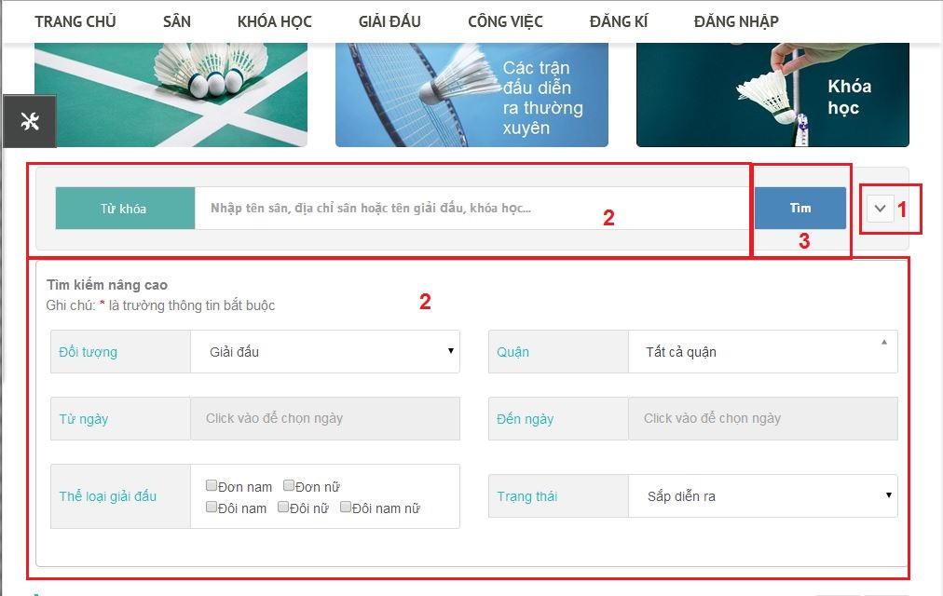**

Figure 173: Advance Search

|  |  |
| --- | --- |
| **Step** | **Description** |
| 1 | Click “Tìm kiếm nâng cao” tab button to view all search parameters. |
| 2 | Fill or choose search parameters. |
| 3 | Click “Tìm” button to search. |

Table 9:Advance Search

### User – View Upcoming Contests.

**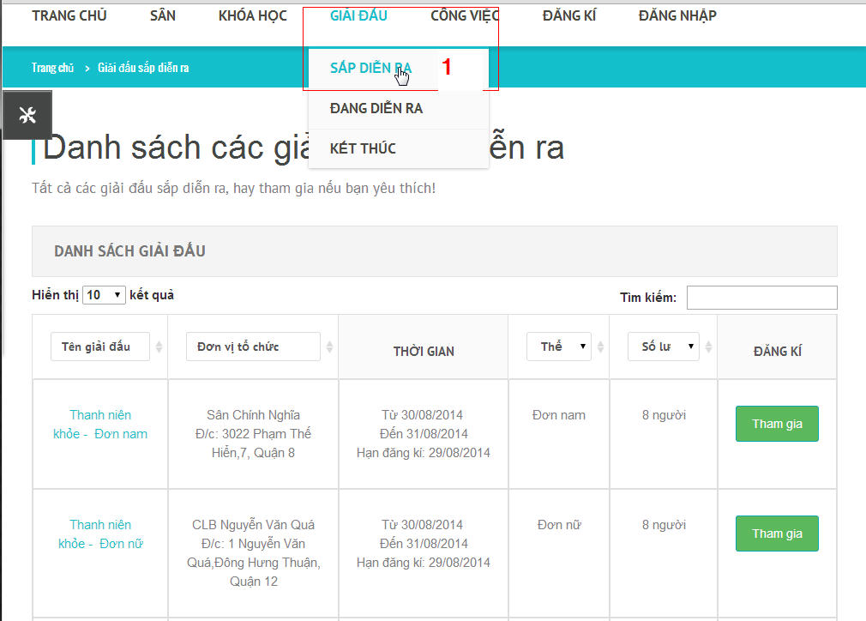**

Figure 174: View Upcoming Contests

|  |  |
| --- | --- |
| **Step** | **Description** |
| 1 | Click “Giải đâu” tab on menu, then click “Sắp diễn ra” submenu tab. |

Table 10: Upcoming Contests

### User –View Happening Contests.

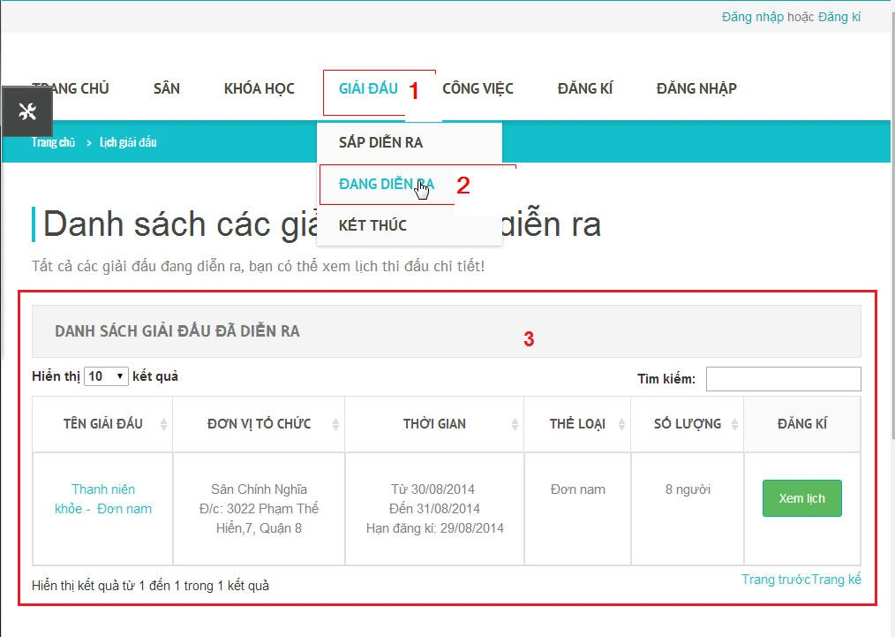

Figure 175: View happening Contests

|  |  |
| --- | --- |
| **Step** | **Description** |
| 1 | Click “Giải đấu” tab on main menu. |
| 2 | System will show sub menu, choose “Đang diễn ra” submenu tab |
| 3 | System will show Happening Contest List table.. |

Table 11: View happening Contests

### User – View Finished Contests.

**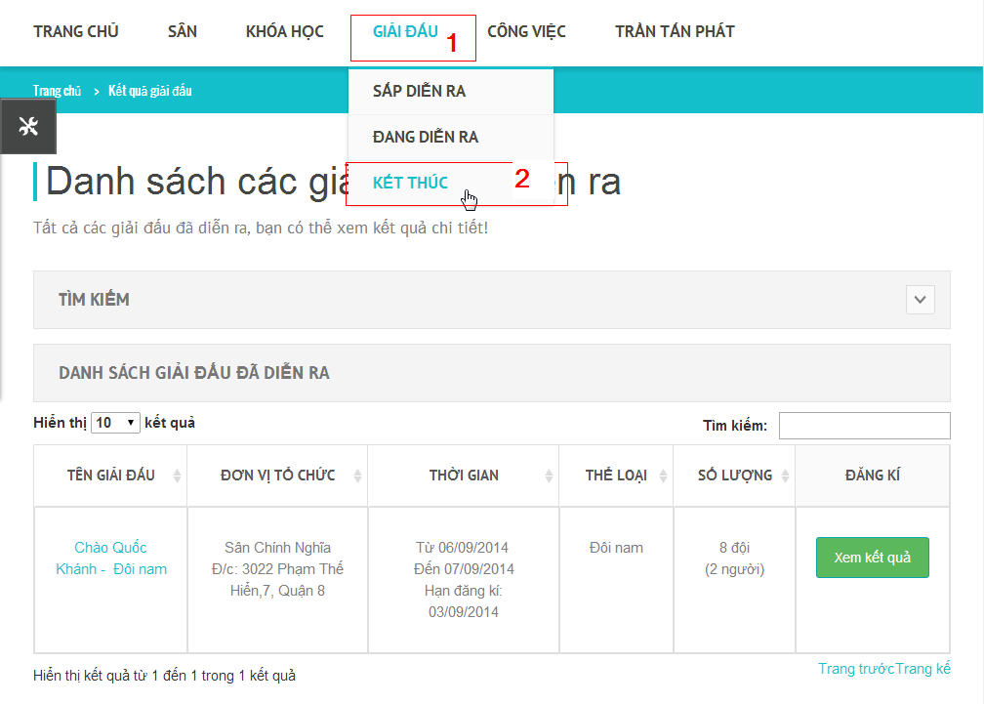**

Figure 176: View Finished Contests

|  |  |
| --- | --- |
| **Step** | **Description** |
| 1 | Click “Giải đấu” tab on main menu. |
| 2 | System will show sub menu, choose “Kết thúc” submenu tab |
| 3 | System will show Finished Contest List table. |

Table 12: View Finished Contests

### Player – View Player’s Joint Contest.

**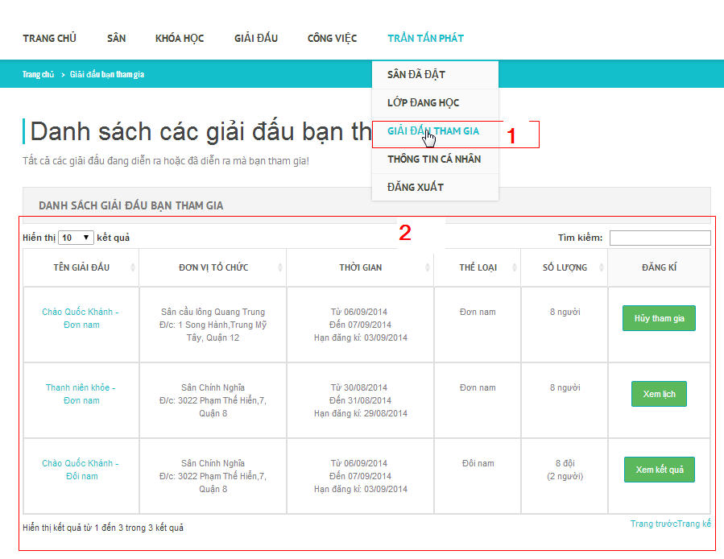**

Figure 177: View Player's Joint Contest

|  |  |
| --- | --- |
| **Step** | **Description** |
| 1 | Click “Giải đấu tham gia” submenu tab on main menu after login to BSF-Website. |
| 2 | System will show list of contests which player have joined. |

Table 13: View Player’s Join Contest

### Player – View ListStadium

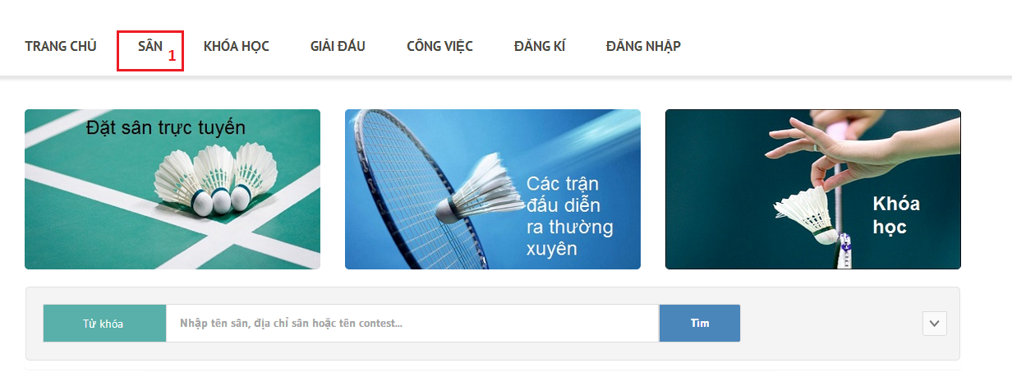

Figure 178:View List Stadium

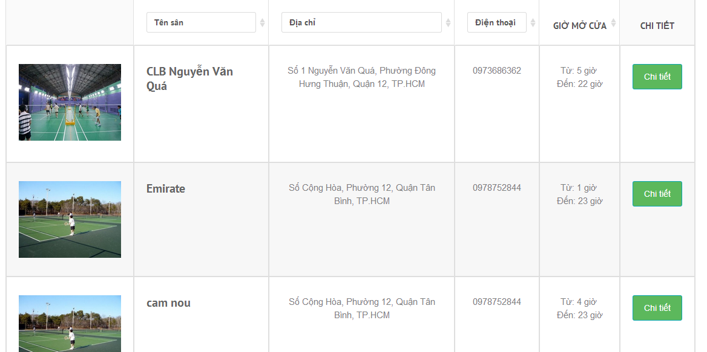

|  |  |
| --- | --- |
| **Step** | **Description** |
| 1 | Click “Sân” link in Home page |

Table 14: List stadium

### Player – View Stadium detail

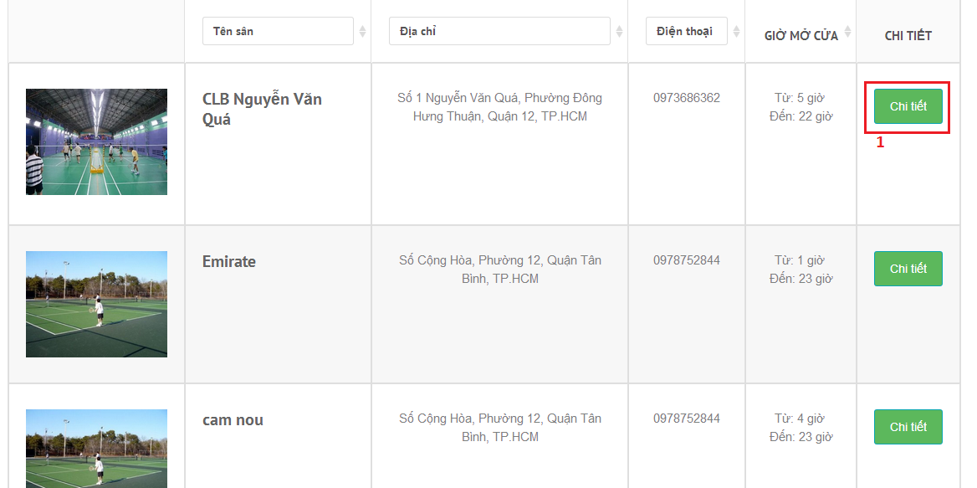

Figure 179:View Stadium Detail

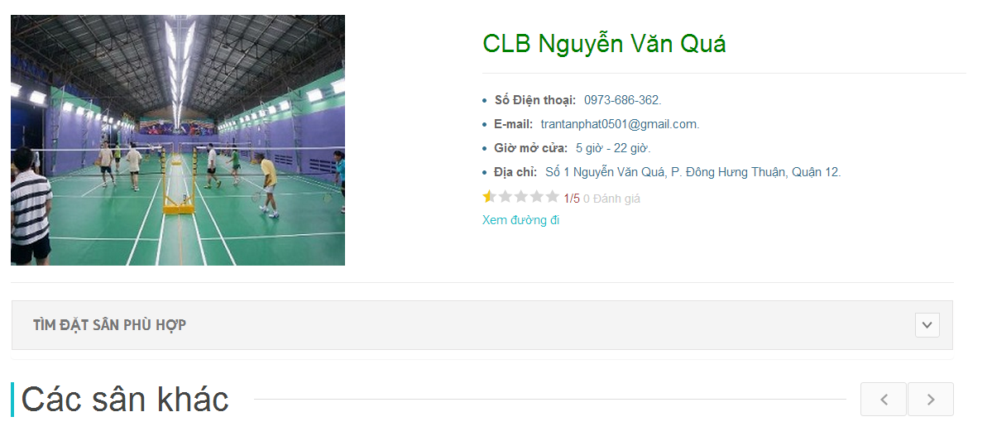

|  |  |
| --- | --- |
| **Step** | **Description** |
| 1 | Click “Chi tiết” button in ListStadium page |

Table 15: Stadium detail

### Player – Find court

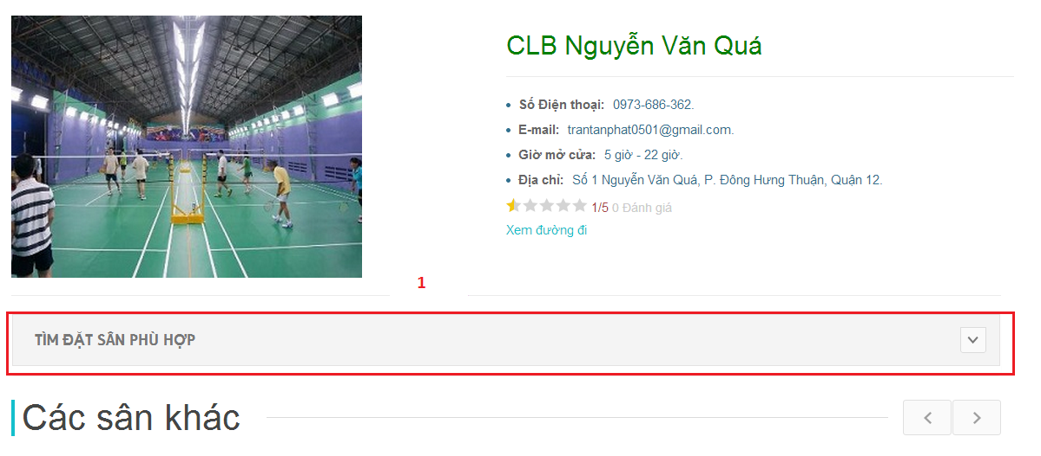

Figure 180: Player-Find court

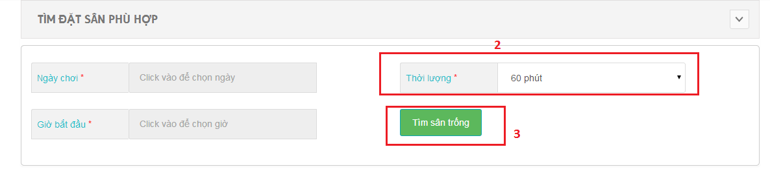  
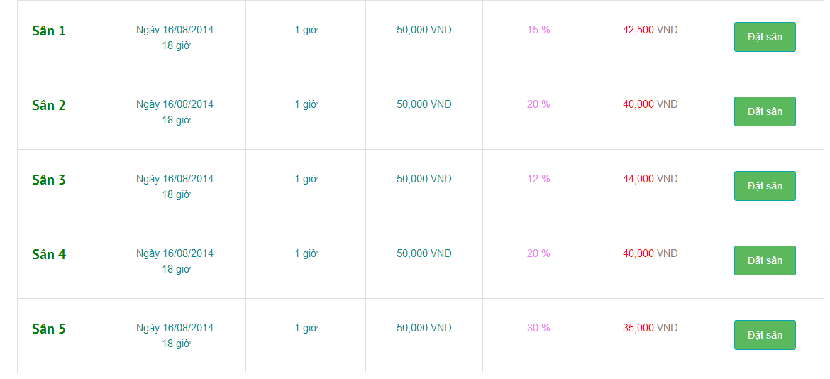

|  |  |
| --- | --- |
| **Step** | **Description** |
| 1 | Use form [Tìm sân trống] |
| 2 | Fill data |
| 3 | Click [Tìm sân trống] button |

Table 16: Find court

### Player – Book court

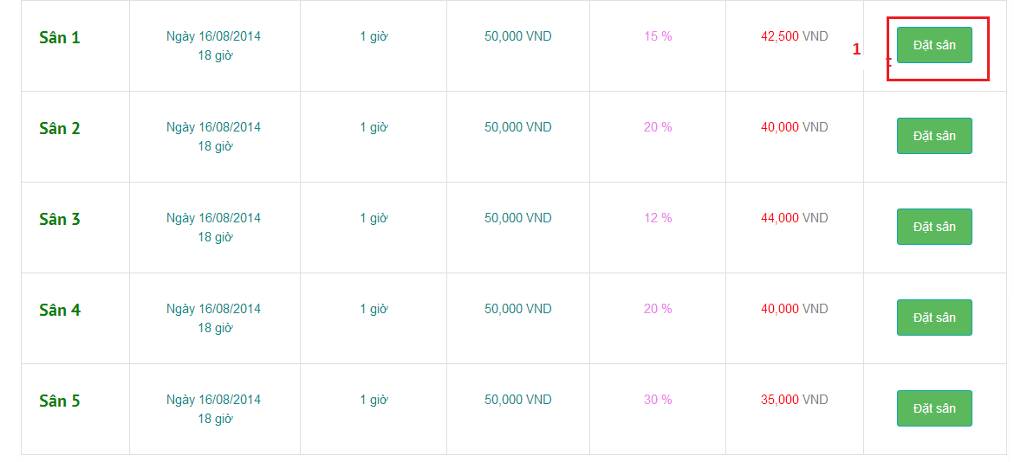

Figure 181:Book Court

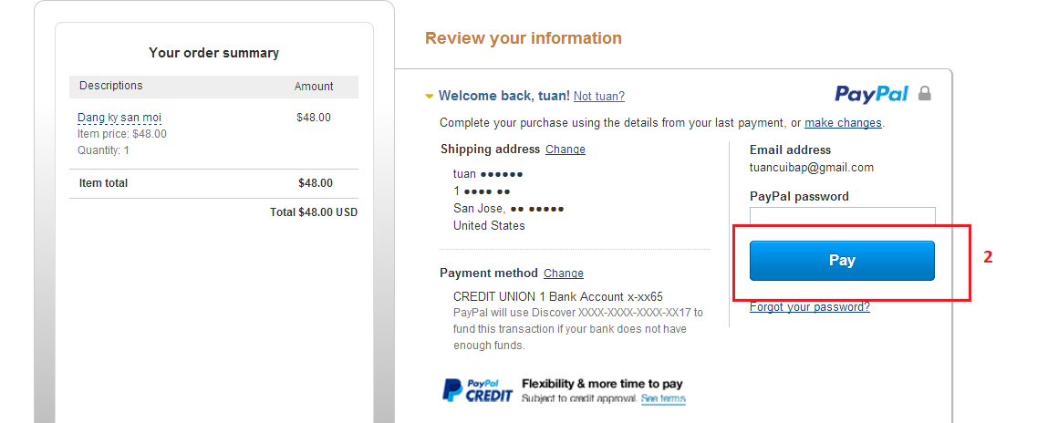

Figure 182: Book Court

|  |  |
| --- | --- |
| **Step** | **Description** |
| 1 | Click [Đặt sân] button |
| 2 | Payment online |

Table 17: Book court

### Player – Book History

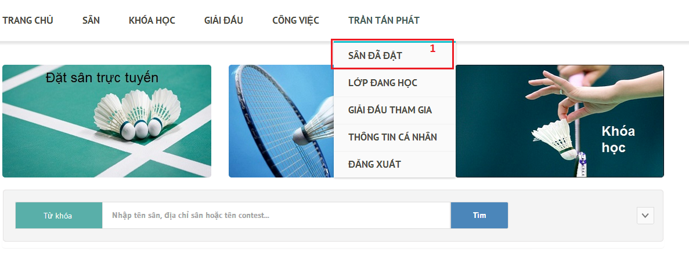

Figure 183: Book History

### User – View Contest Detail.

**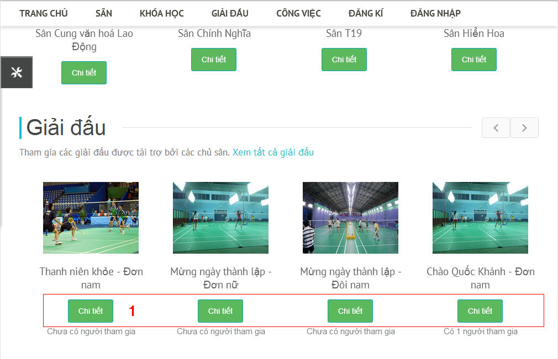**

Figure 184: View Contest Detail

**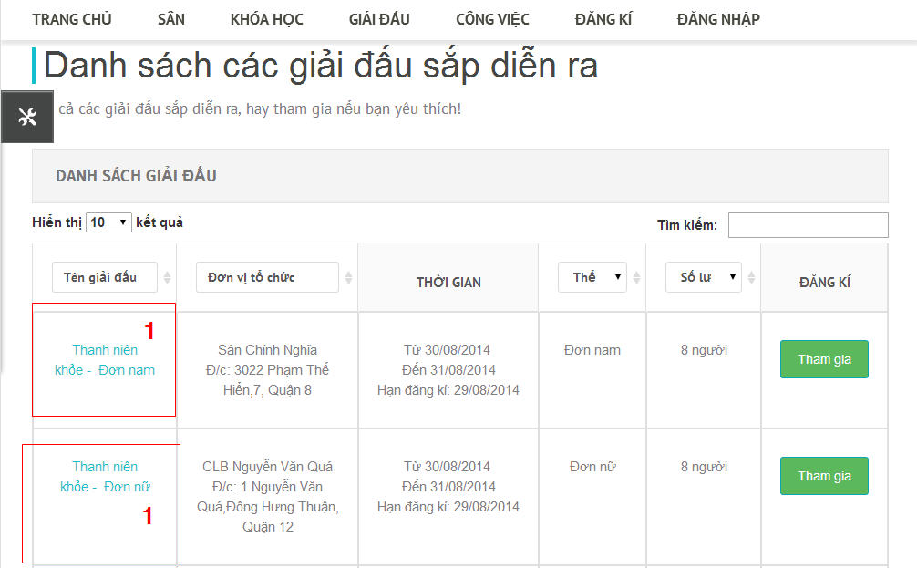**

Figure 185: View ContestDetail 2

**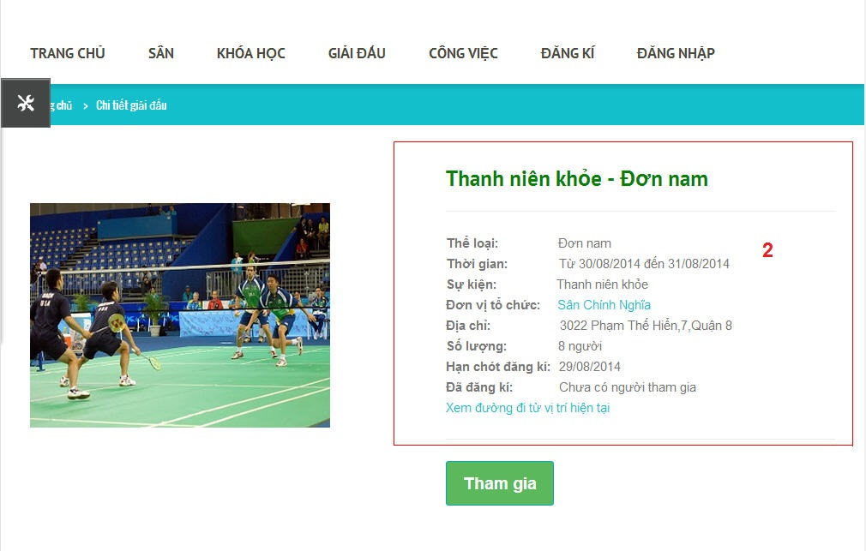**

Figure 186: View ContestDetail 2

|  |  |
| --- | --- |
| **Step** | **Description** |
| 1 | Click “Chi tiết” button on Home Page (Figure ) or Click Contest Name Link in contest list table (Figure) |
| 2 | System redirect to Detail Page. |

Table 18: Contest Detail

### Player –Join Contest.

**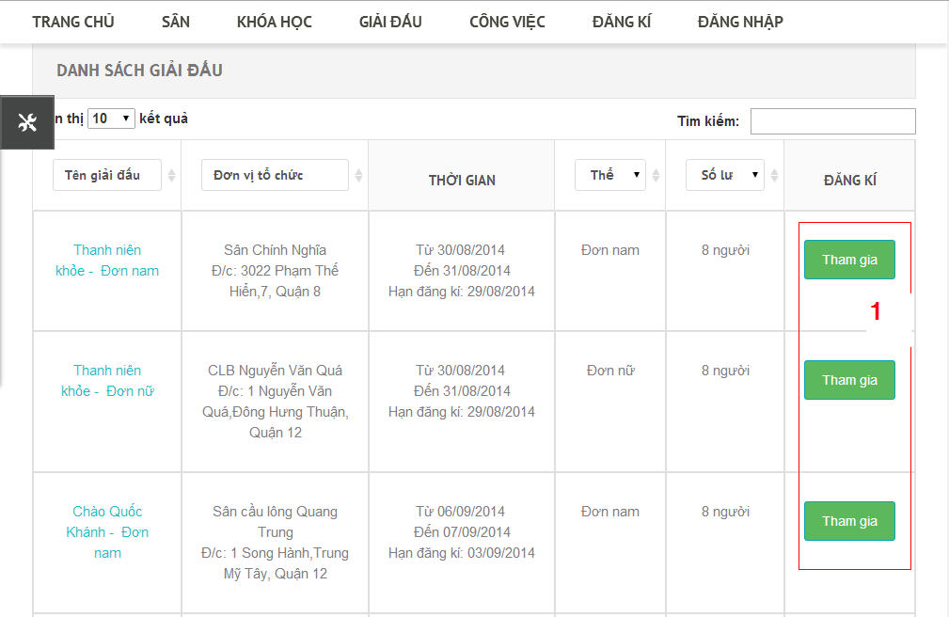**

Figure 187: Join Contest

**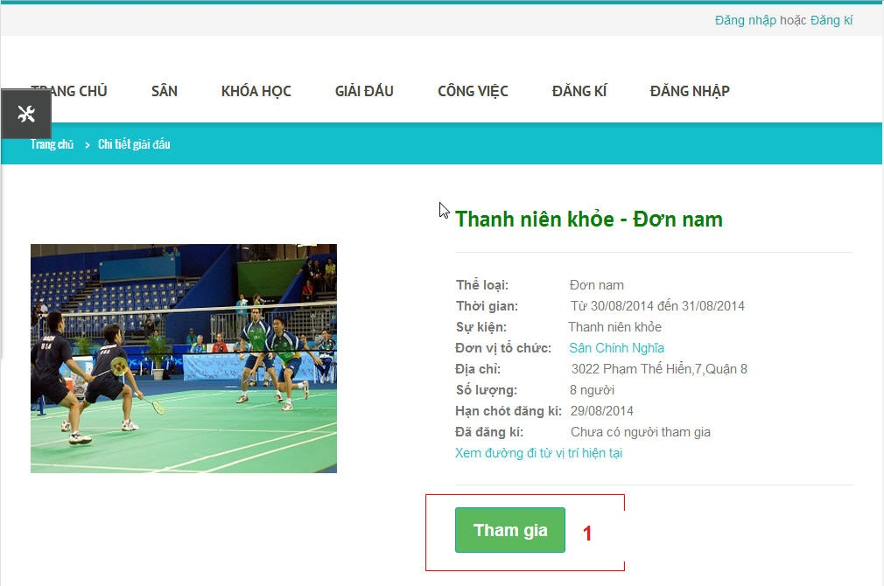**

Figure 188: Join Contest2

**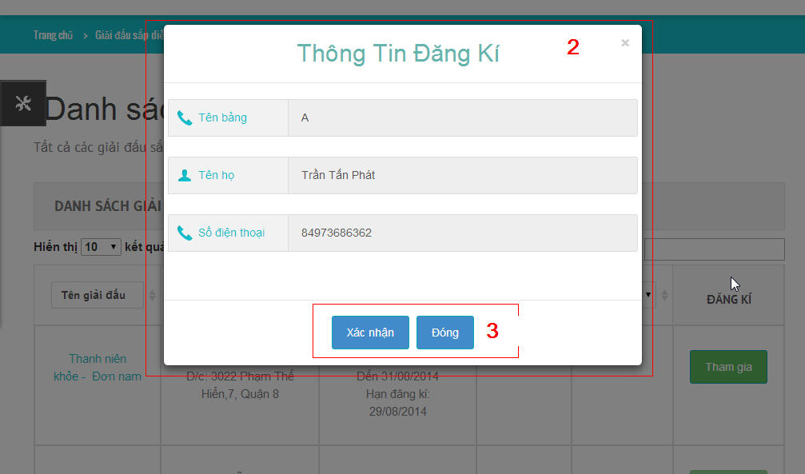**

Figure 189: Join Contest 3

|  |  |
| --- | --- |
| **Step** | **Description** |
| 1 | Click “Tham gia” button on Upcoming Contest List Table (figure) or click “Tham gia” button in Contest Detail Page. |
| 2 | System will show registration information confirm popup. |
| 3 | Click “Xác nhận” button to confirm contest joining.  Click “Đóng” button to close popup window. |

Table 19: Join contest

### Player- Cancel Joining Contest:

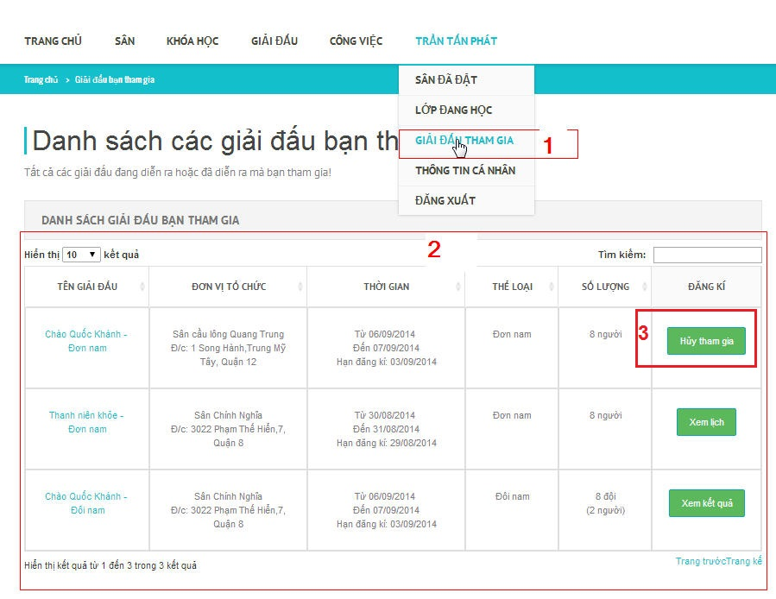

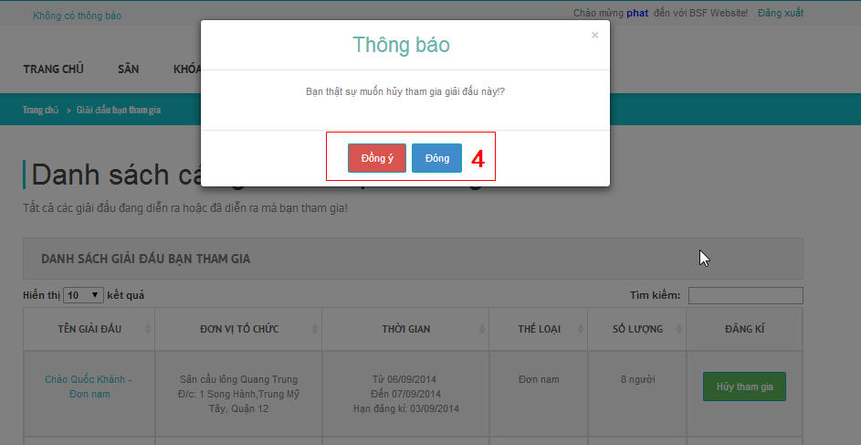

Figure 190:Cancel joining Contest

|  |  |
| --- | --- |
| **Step** | **Description** |
| 1 | Click “Giải đấu tham gia” submenu tab on main menu after login to BSF-Website. |
| 2 | System will show list of contests which player have joined. |
| 3 | Click “Hủy tham gia: button to cancel registration. |
| 4 | Click “Đồng ý” to confirm cacelation.  Click “Đóng” to close poup window. |

Table 20: Cancel contest

### User –View Contest Schedule.

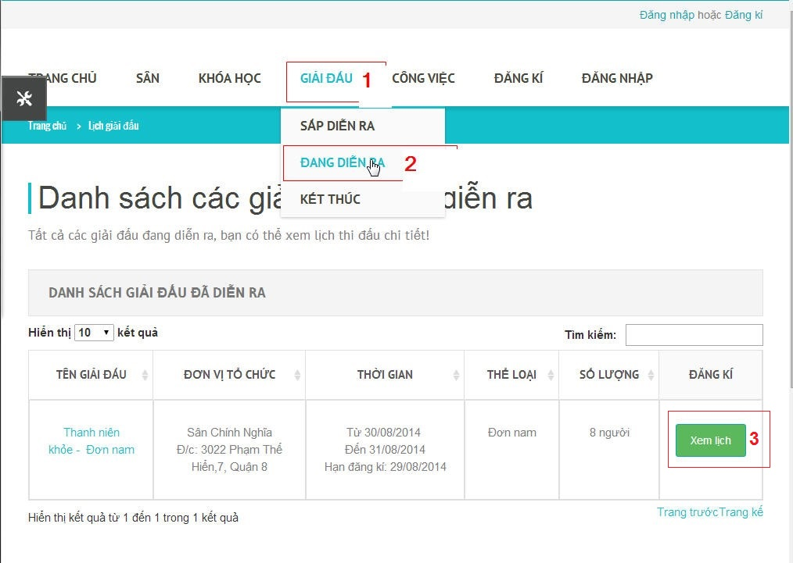

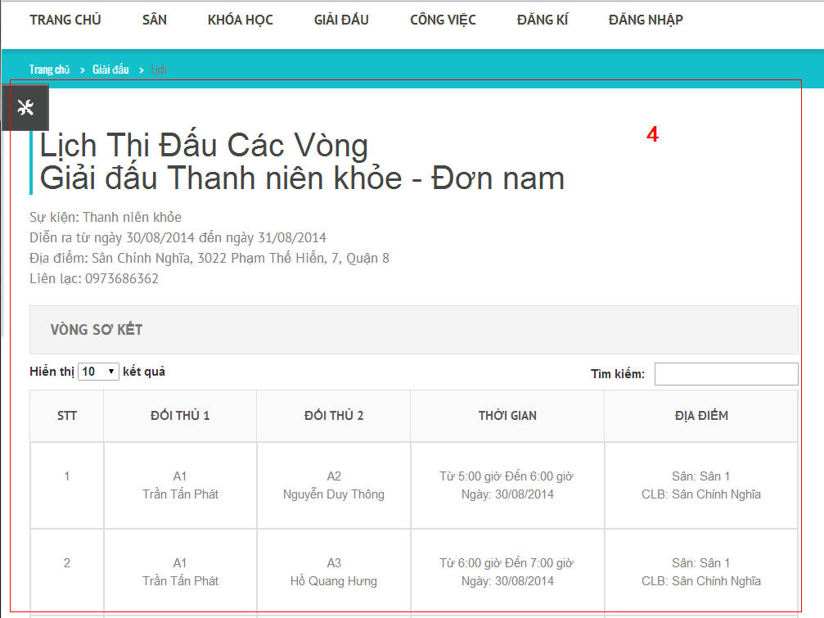

Figure 191:ViewContest Schedule

|  |  |
| --- | --- |
| **Step** | **Description** |
| 1 | Click “Giải đấu” tab on main menu. |
| 2 | System will show sub menu, choose “Đang diễn ra” submenu tab |
| 3 | Click “Xem lịch” button to view contest macth schedule. |
| 4 | System will redirect to contest match schedule page. |

Table 21: Contest Shedule

### User –View Contest Result.

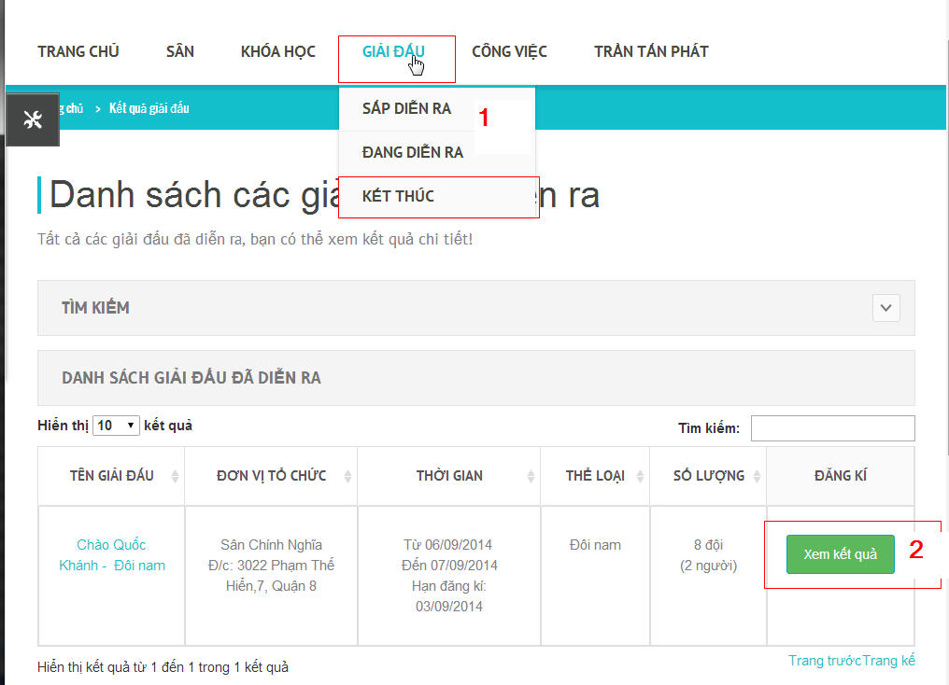

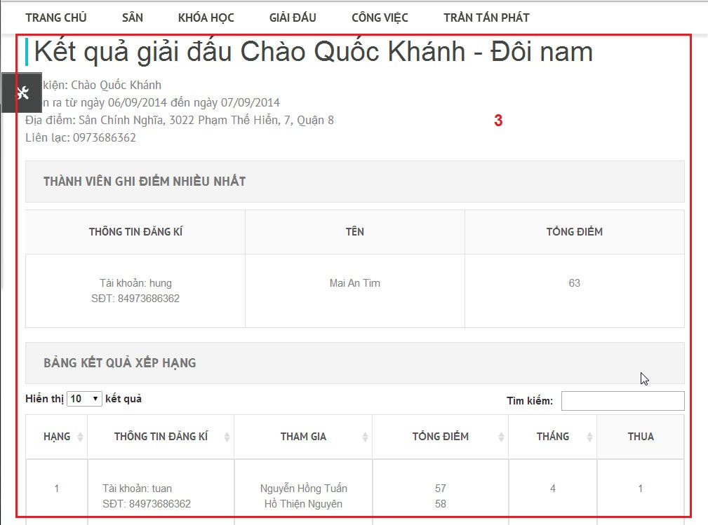

Figure 192: View Contest Result

|  |  |
| --- | --- |
| **Step** | **Description** |
| 1 | Click “Giải đấu”tab menu, then click “Kết thúc” submenu. |
| 2 | Click “Xem kết quả” button to view Contest result. |
| 3 | System will show redirect to contest result page. |

Table 22: Con test Result

### Player- View list Course:

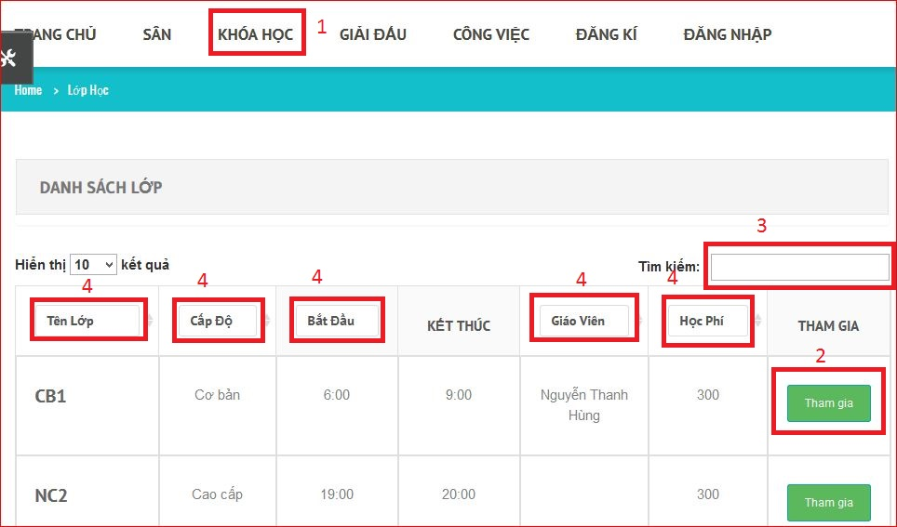

Figure 193: View ListCourse

|  |  |
| --- | --- |
| **Step** | **Description** |
| 1 | Click “Khóa Học” menu tab on main menu after login to BSF-Website to see list courses. |
| 2 | Click “Tham Gia” on row list course to View information of course |
| 3 | Fill “Tìm kiếm” textbox to search course. |
| 4 | Fill textbox to search on column. |

Table 23: list Course

### Player- Join Course:

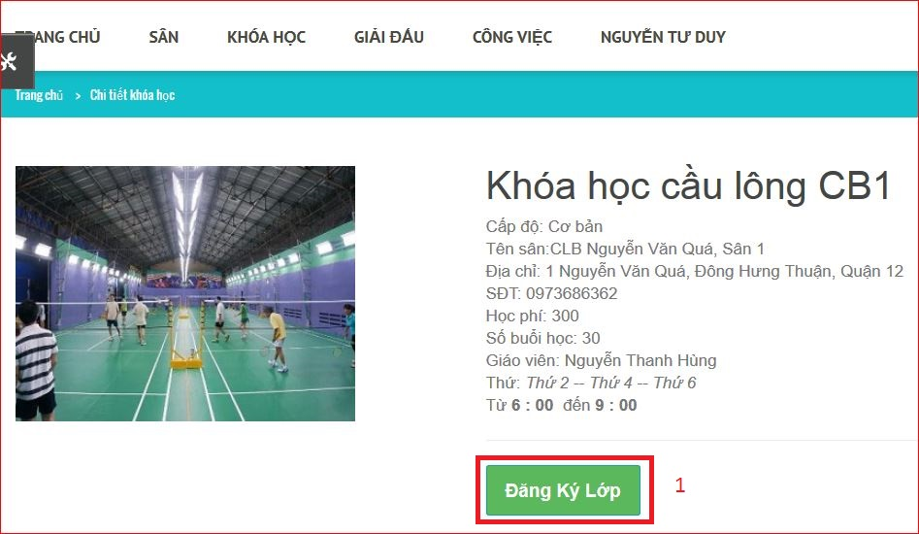

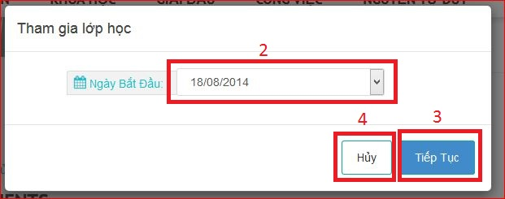

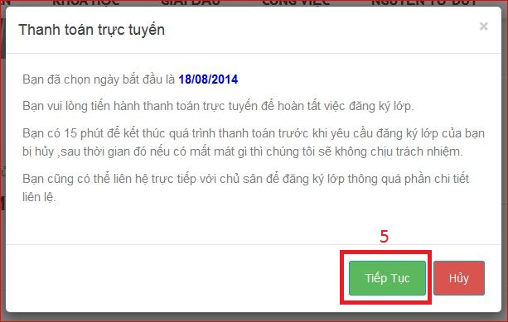

Figure 194: Join Course

|  |  |
| --- | --- |
| **Step** | **Description** |
| 1 | Click “Đăng ký Lớp” to join course |
| 2 | Chose start day |
| 3 | Click “Tiếp Tục” to continuous join course |
| 4 | Click “Hủy” to cancel join course |
| 5 | Click “Tiếp Tục” to continuous payment |

Table 24: Join course

### Player- View list Register Course:

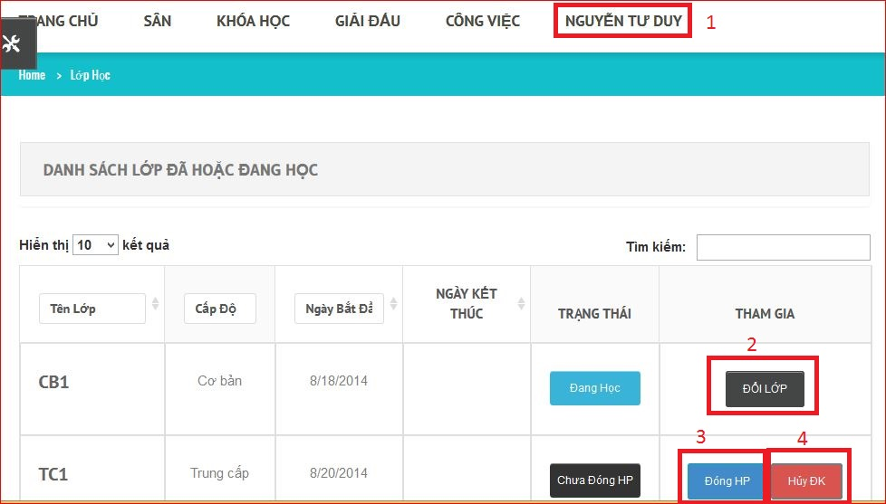

Figure 195:View List Register Course

|  |  |
| --- | --- |
| **Step** | **Description** |
| 1 | Click “Lớp Đã Học” submenu tab on main menu after login to BSF-Website to see list courses. |
| 2 | Click “Chuyển Lớp” on row list course to change course |
| 3 | Click “Đóng HP” on row list course to continuous payment |
| 4 | Click “Hủy” on row list course to cancel request |

Table 25: List register course

### Boss – Manage Stadium

#### Boss-Register stadium

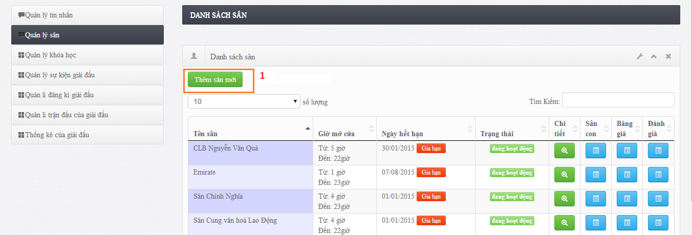

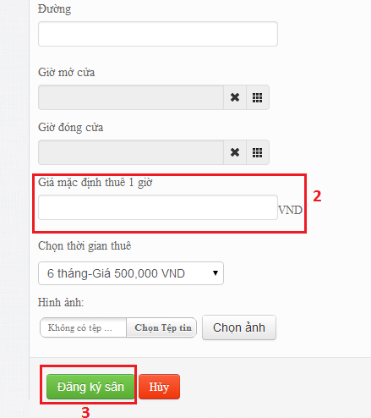

**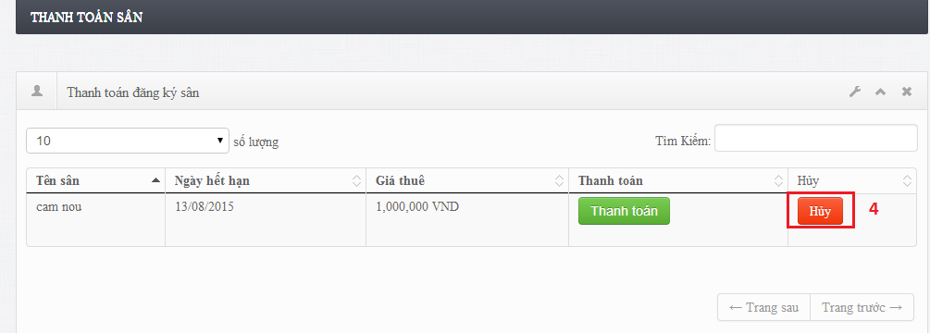**

**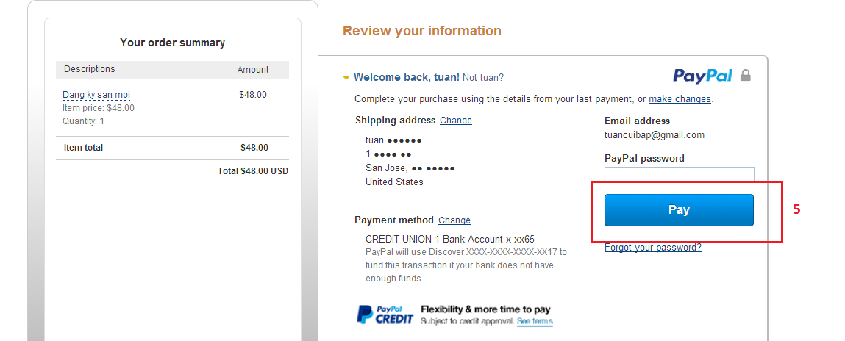**

**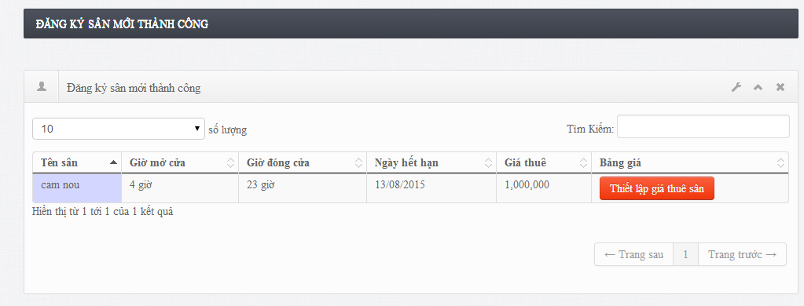**

Figure 196: Manage Stadium

|  |  |
| --- | --- |
| **Step** | **Description** |
| 1 | Click “Thêm sân mới” button |
| 2 | Fill all data |
| 3 | Click [Đăng ký sân] button |
| 4 | Click [Thanh toán] button |
| 5 | Payment onlice |
| 6 | Show success page |

#### Boss-Edit stadium

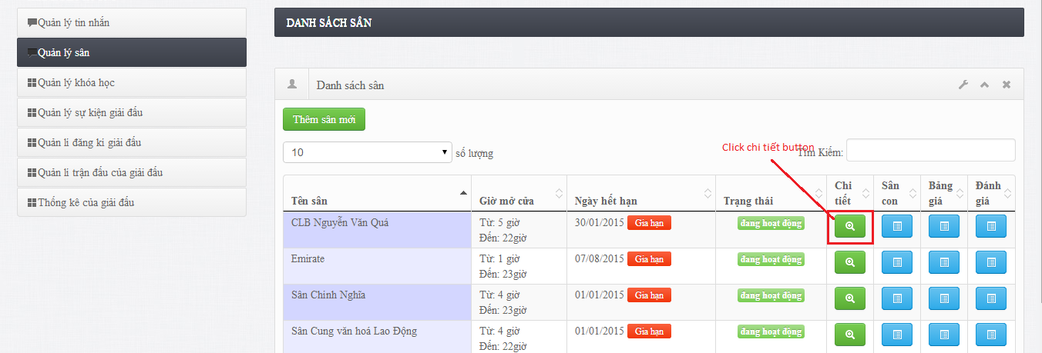

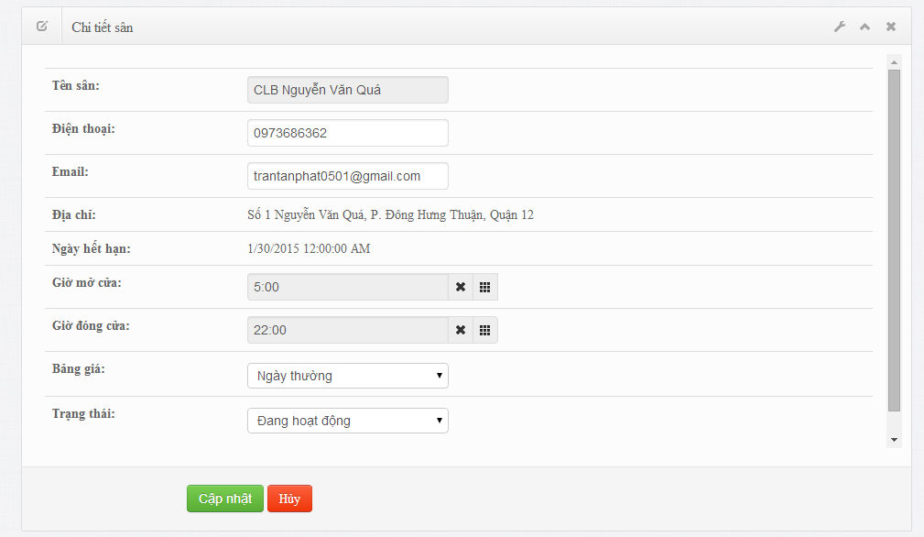

|  |  |
| --- | --- |
| **Step** | **Description** |
| 1 | Click “Chi tiết” button |
| 2 | Fill all data to change |
| 3 | Click [Cập nhật] |

### Boss – Manage Court

#### Boss-Create new court

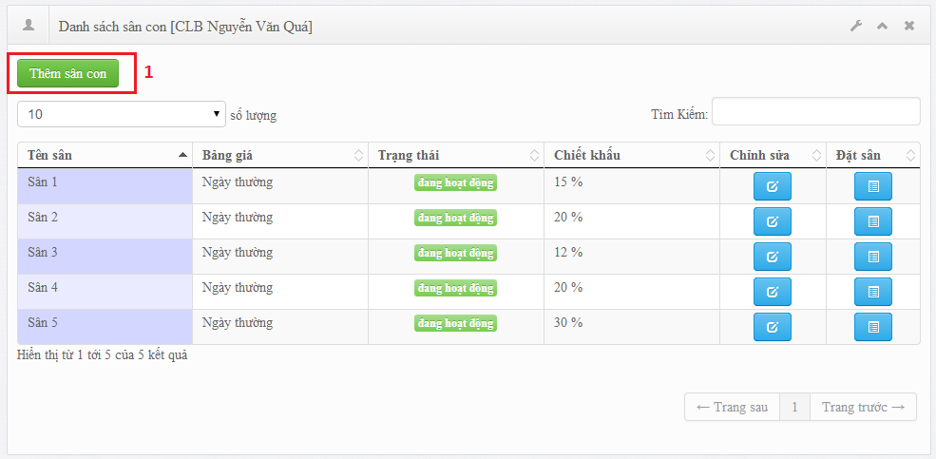

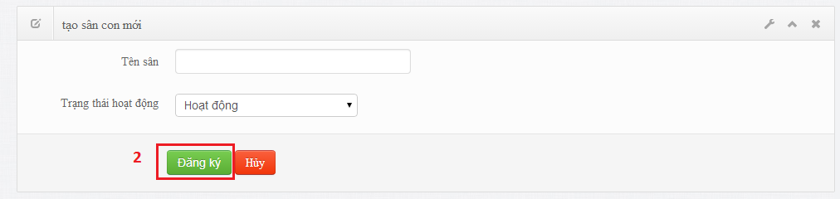

Figure 197: Manage Court

|  |  |
| --- | --- |
| **Step** | **Description** |
| 1 | Click “Thêm sân con” button |
| 2 | Fill all data |
| 3 | Click [Đăng ký] |

Table 26: Create Court

#### Boss-edit court

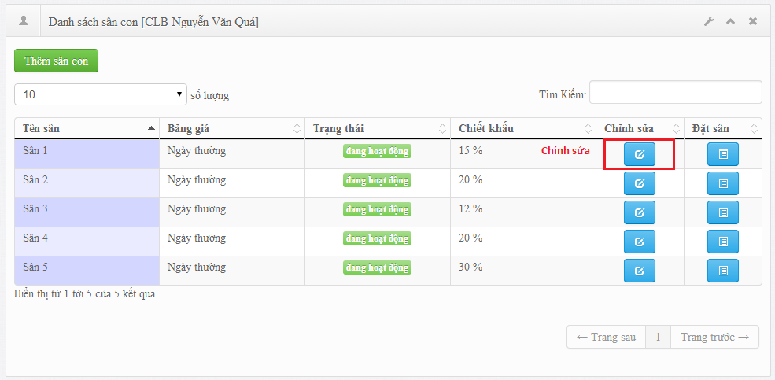

**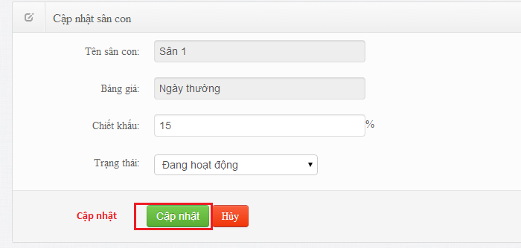**

|  |  |
| --- | --- |
| **Step** | **Description** |
| 1 | Click “Chỉnh sửa” button |
| 2 | Fill data to change |
| 3 | Click [Cập nhật] button |

Table 27: Edit court

### Boss – Manage Reservation

#### Boss-add reservation

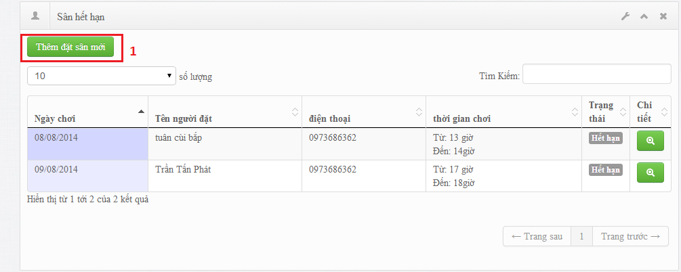

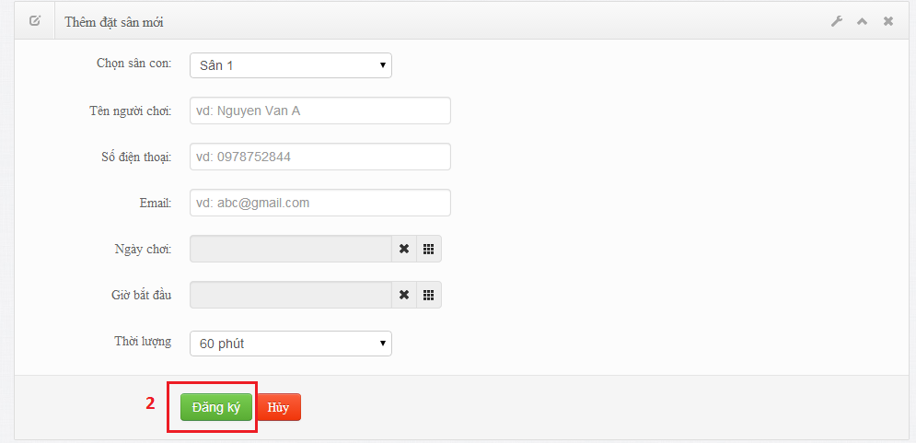

Figure 198:Manage Reservation

|  |  |
| --- | --- |
| **Step** | **Description** |
| 1 | Click “Thêm đặt sân mới” button |
| 2 | Fill data to |
| 3 | Click [Đăng ký] button |

Table 28:Add reservation

#### Boss-reservation detail

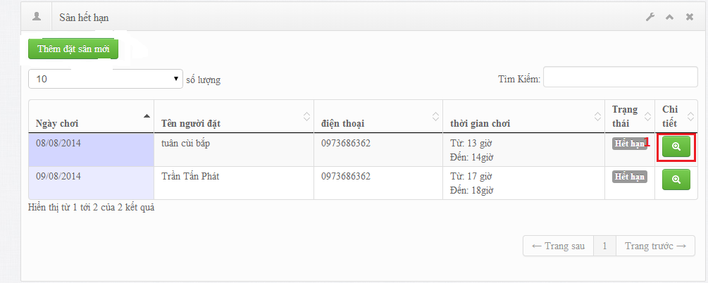

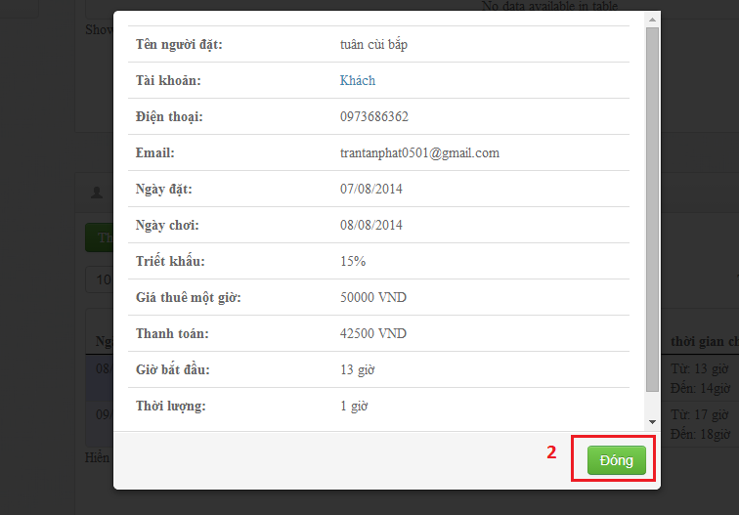

|  |  |
| --- | --- |
| **Step** | **Description** |
| 1 | Click “Chi tiết” button |

Table 29: ReservationDetail

### Boss – Manage Pricelist

#### Boss-create new price

#### Boss-edit price

#### Boss-de-active price

### Boss – Manage Review

#### Boss-Delete review

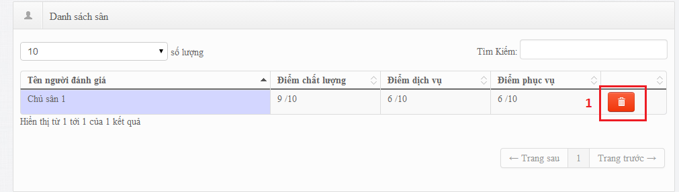

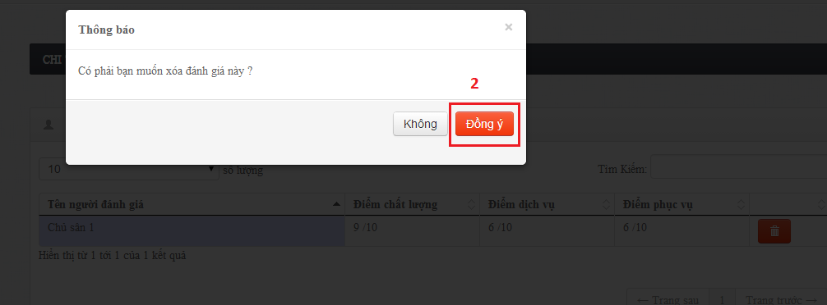

Figure 199: Manage Review

|  |  |
| --- | --- |
| **Step** | **Description** |
| 1 | Click “Xóa” button |
| 2 | Show pop up |
| 3 | Click [Đồng ý] button |

Table 30:DeleteReview

### Boss – Manage Contest Event

#### Boss - View Contest Event List

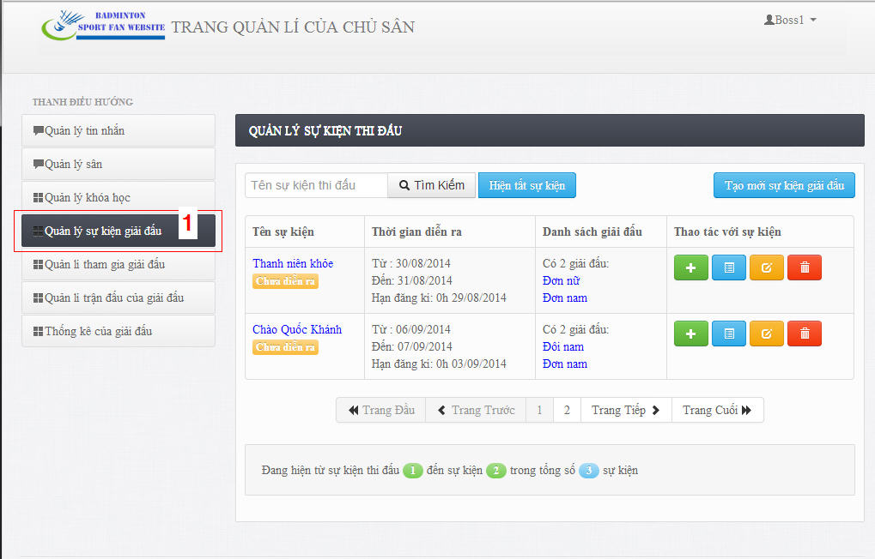

Figure 200: ManageContest Event

|  |  |
| --- | --- |
| **Step** | **Description** |
| 1 | Click “Quản lí sự kiện giải đấu” menu on navigation bar to view list of contest events. |

Table 31: View contest Event

#### Boss - Create Contest Event

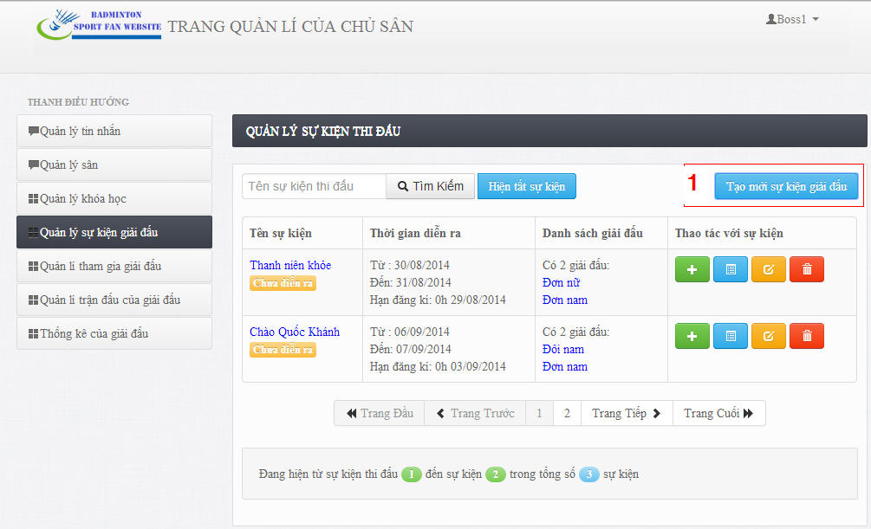

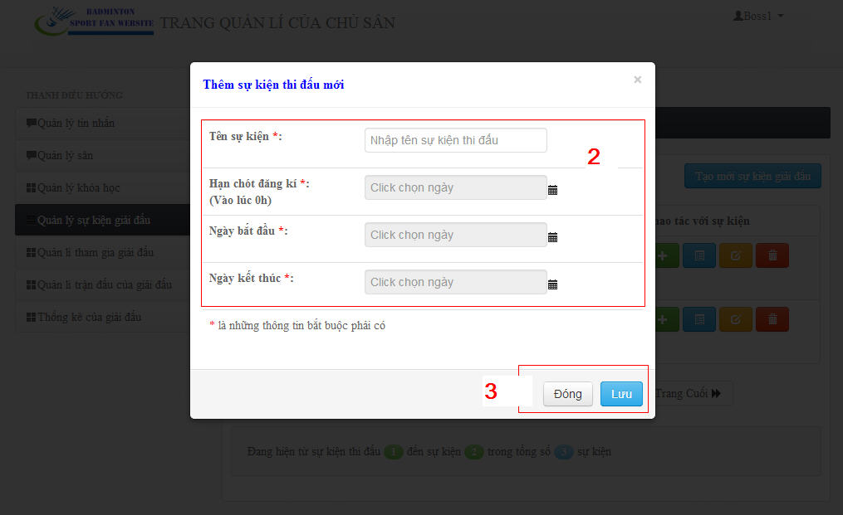

Figure 201: Create Contest Event Image

|  |  |
| --- | --- |
| **Step** | **Description** |
| 1 | Click “Tạo mới sự kiện giải đấu” button to create new contest event. |
| 2 | Fill required information of contest event. |
| 3 | Click “Lưu” button to create new contest event.  Click “Đóng: button to close pop up window. |

Table 32: Create Contest Event

#### Boss - Edit Contest Event

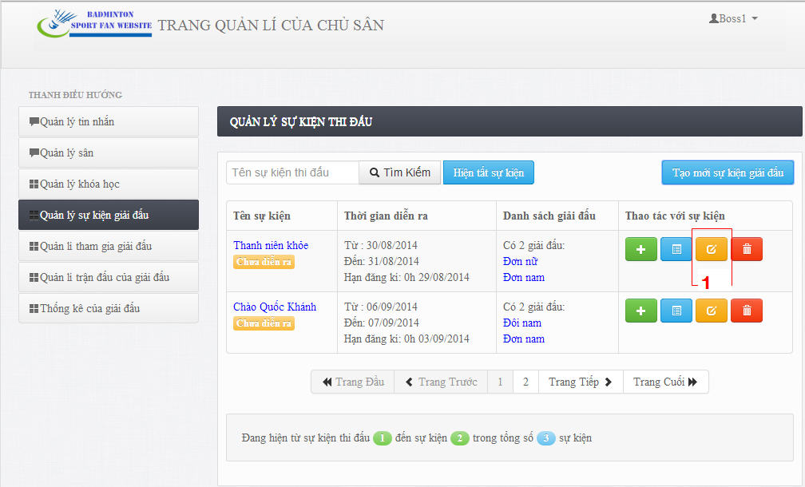

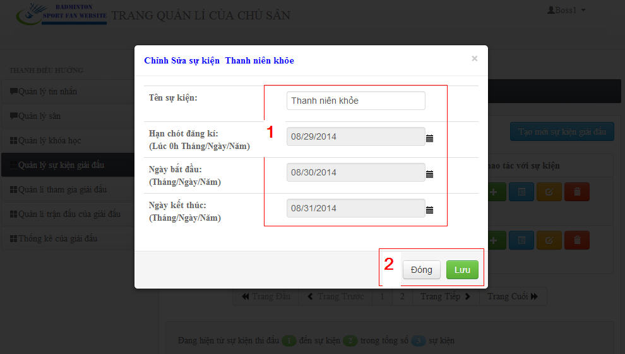

Figure 202: Edit contest event Image

|  |  |
| --- | --- |
| **Step** | **Description** |
| 1 | Click Edit button. |
| 2 | Edit contest event’s information. |
| 3 | Click “Lưu” button to save edited information.  Click “Đóng” button to close popup window. |

Table 33: Edit Contest

#### Boss - Delete Contest Event

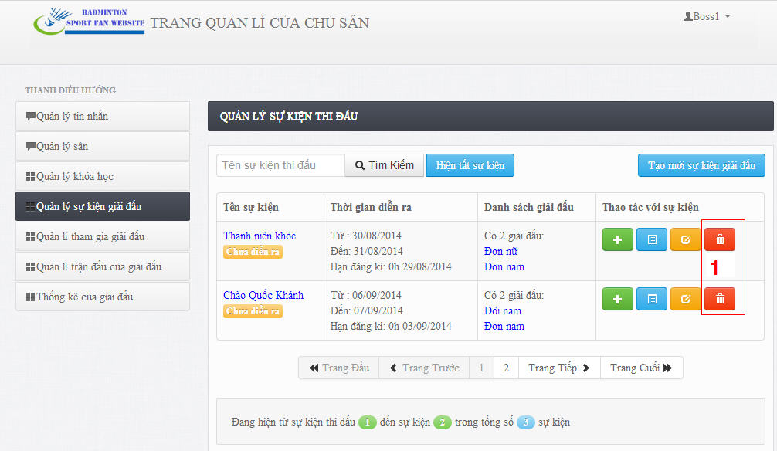

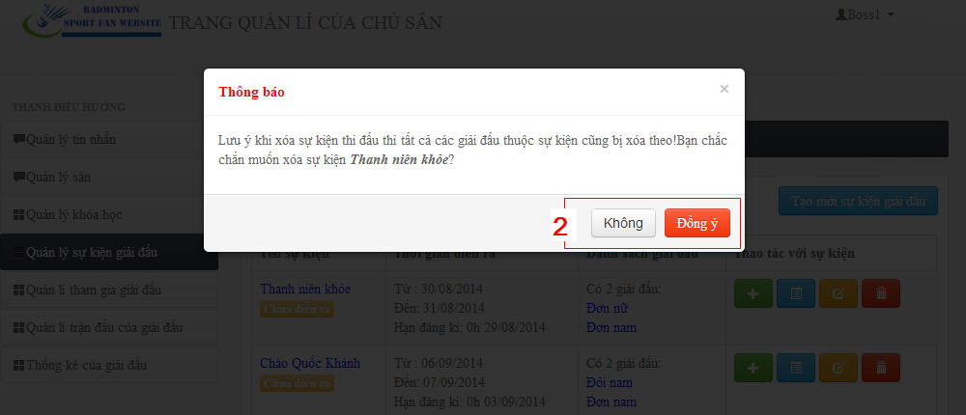

Figure 203: Delete Contest Event Image

|  |  |
| --- | --- |
| **Step** | **Description** |
| 1 | Click delete button. |
| 2 | Click “Đồng ý” button to delete.  Click “Không” button to close pop up window. |

Table 34: Delete Contest Event.

### Boss – Manage Contest

#### Boss - View Contest List

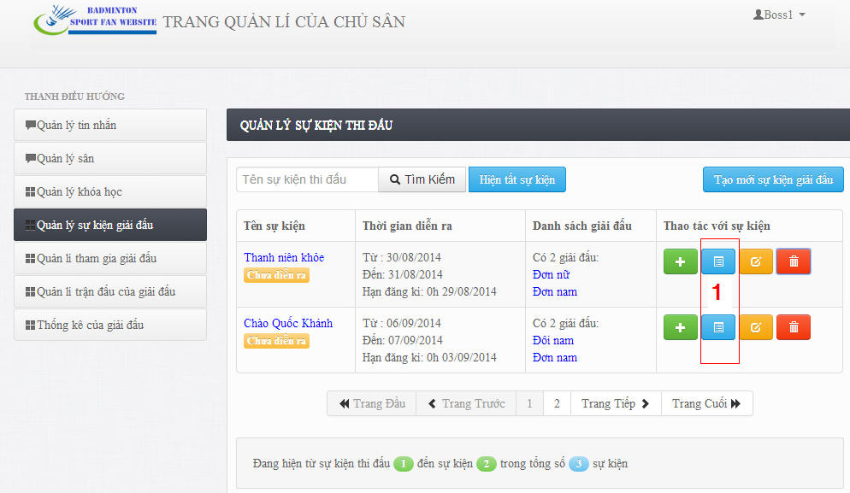

Figure 204:Manage Contest

|  |  |
| --- | --- |
| **Step** | **Description** |
| 1 | Click “Danh sách giải đấu” button to view contest list of contest event. |

Table 35: view contest list

#### Boss - Create Contest

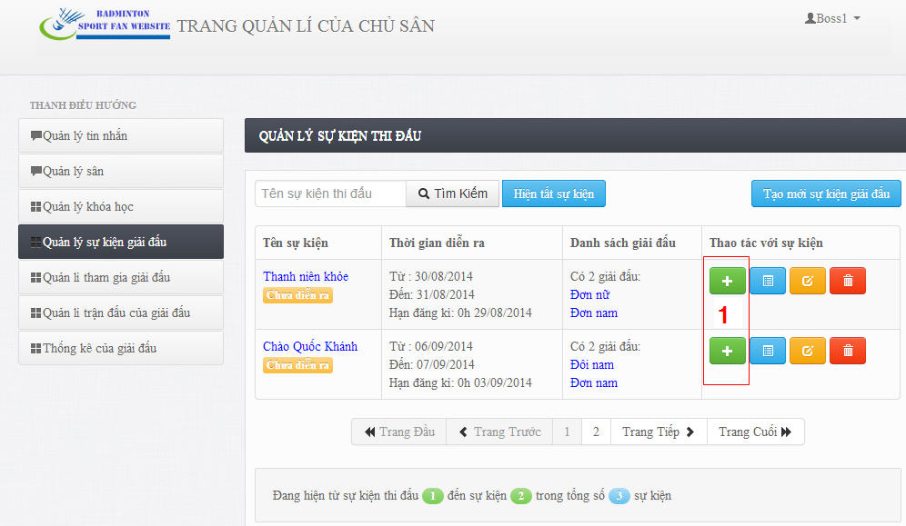

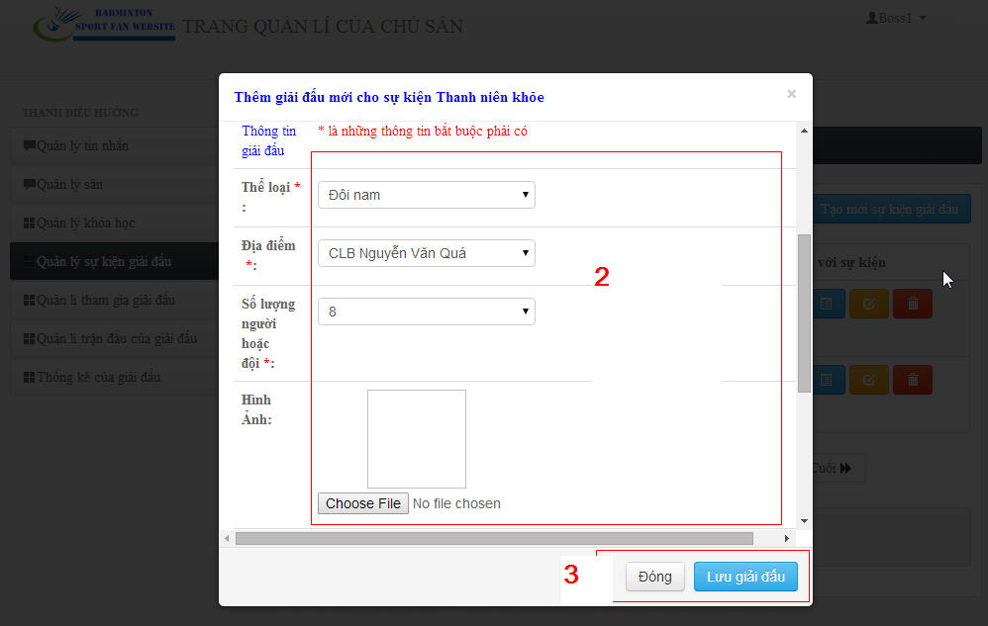

Figure 205: Create Contest Event Image

|  |  |
| --- | --- |
| **Step** | **Description** |
| 1 | Click “Tạo giải đấu” button to create new contest. |
| 2 | Fill required information of contest. |
| 3 | Click “Lưu giải đấu” button to save new contest.  Click “Đóng: button to close pop up window. |

Table 36: Create Contest

#### Boss - Delete Contest

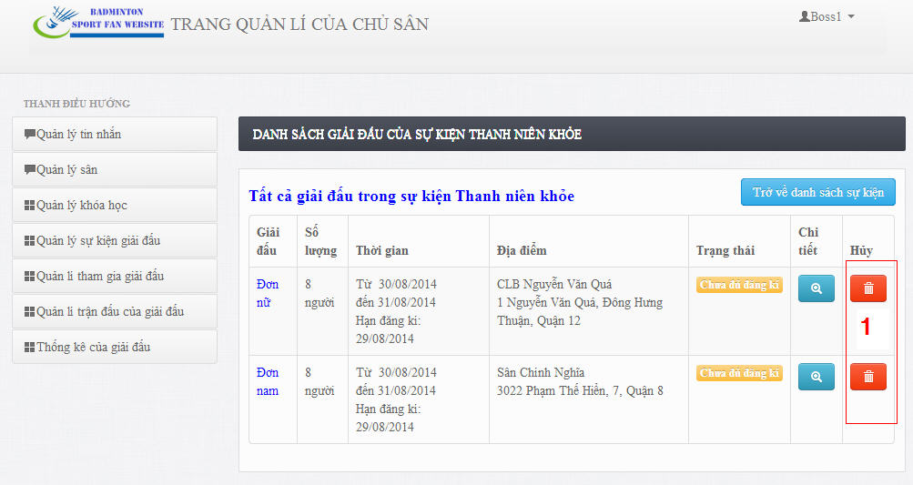

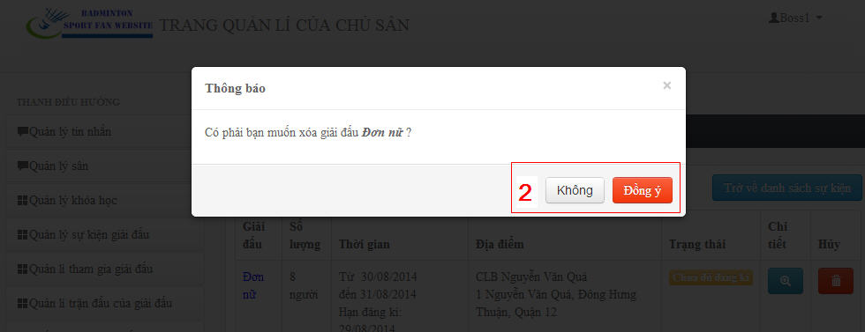

Figure 206: Delete Contest Event Image

|  |  |
| --- | --- |
| **Step** | **Description** |
| 1 | Click delete button. |
| 2 | Click “Đồng ý” button to delete.  Click “Không” button to close pop up window. |

Table 37: Delete Contest.

### Boss – Manage Contest Participation

#### Boss - View Contest Participation List

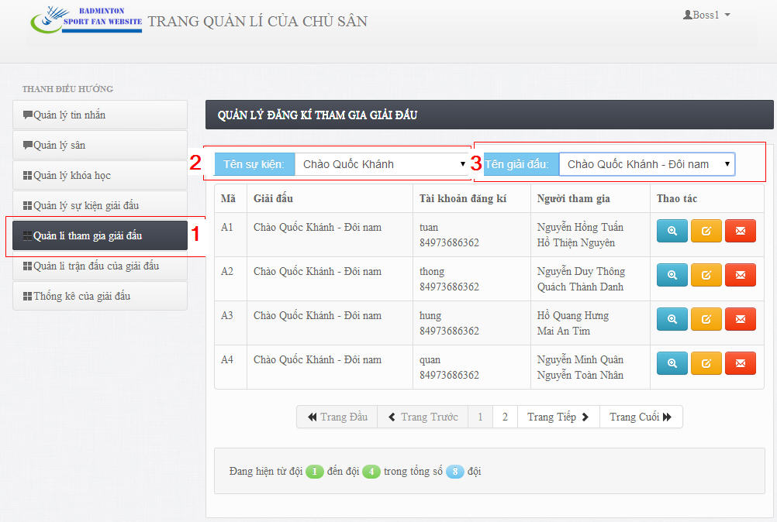

Figure 207: Manage Contest Participation

|  |  |
| --- | --- |
| **Step** | **Description** |
| 1 | Click “Quản lí tham gia giải đấu” menu on navigation bar. |
| 2 | Choose name of contest event in Contest Event Listbox. |
| 3 | Choose name of contest in Contest Listbox. |

Table 38: Contest Participation

#### Boss – Edit Contest Participation

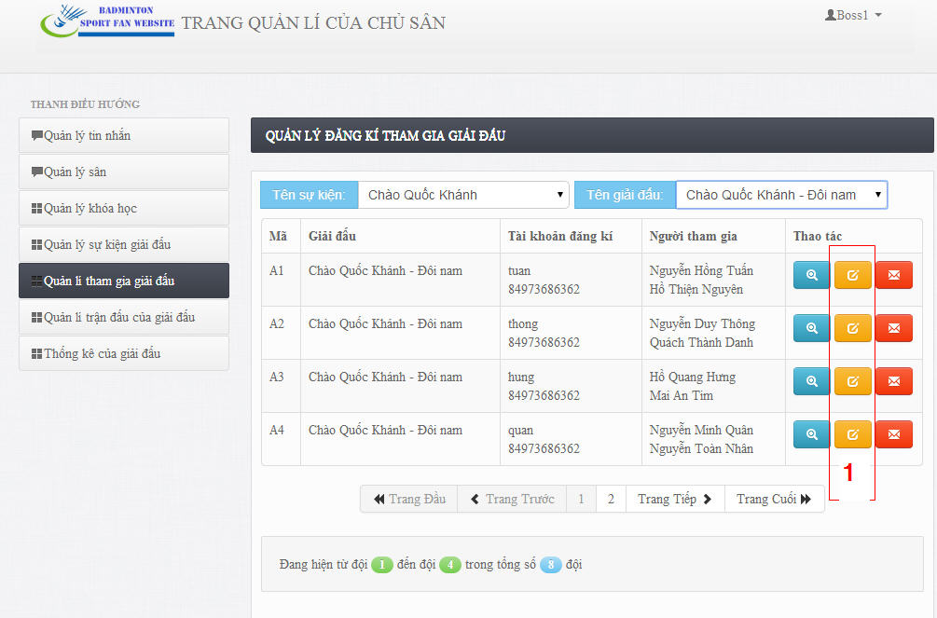

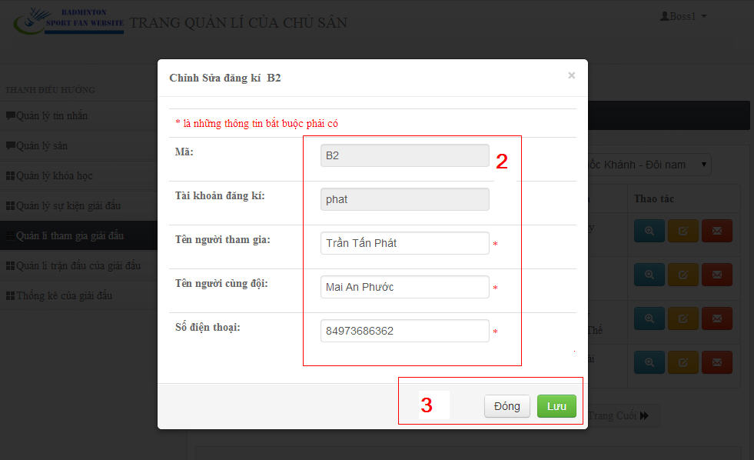

Figure 208: Edit contest event Image

|  |  |
| --- | --- |
| **Step** | **Description** |
| 1 | Click Edit button. |
| 2 | Edit contest registration’s information. |
| 3 | Click “Lưu” button to save edited information.  Click “Đóng” button to close popup window. |

Table 39: Edit contest participation

#### Boss – Report and Reset Viloate Registration

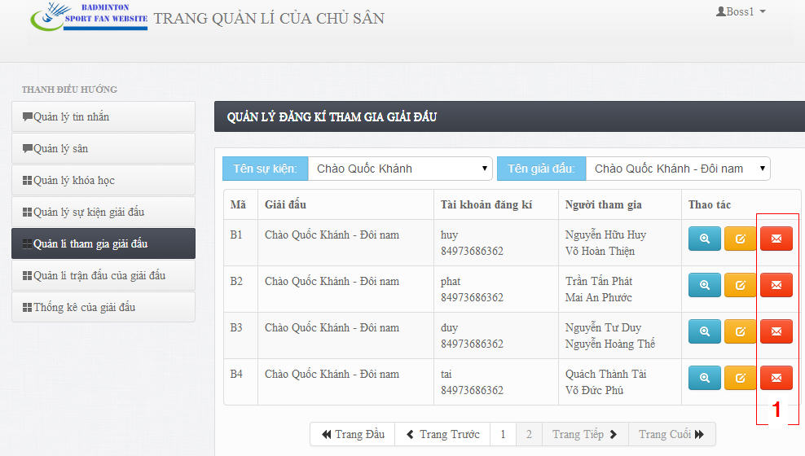

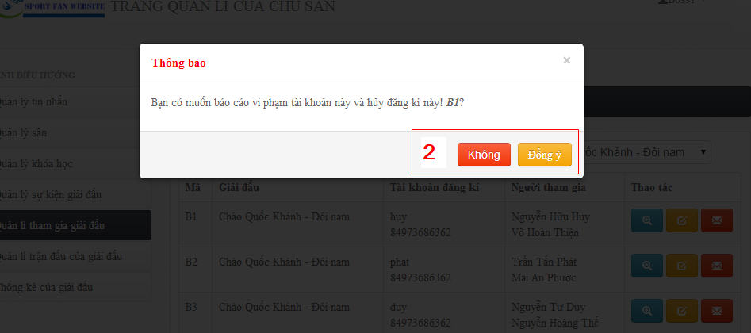

Figure 209: Delete Contest Event Image

|  |  |
| --- | --- |
| **Step** | **Description** |
| 1 | Click “Báo cáo vi phạm và reset đăng kí” button. |
| 2 | Click “Đồng ý” button to report and reset violate registration.  Click “Không” button to close pop up window. |

Table 40: Report and Reset Viloate registration.

### Boss – Manage Matches

#### Boss - View Matches List

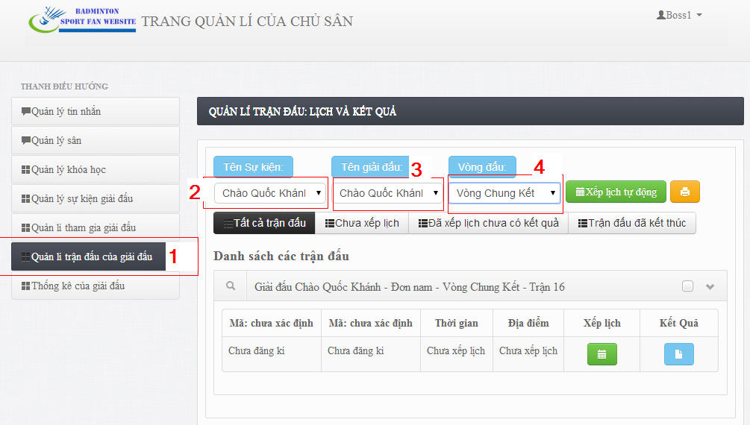

Figure 210: Manage Matches

|  |  |
| --- | --- |
| **Step** | **Description** |
| 1 | Click “Quản lí trận đấu của giải đấu” tab menu on navigation bar to view list of contest events. |
| 2 | Choose contest event name in contest event listbox. |
| 3 | Choose contest name in contest listbox, |
| 4 | Choose round of contest in round listbox. |

Table 41: View matches list

#### Boss – Arrange Match Schedule

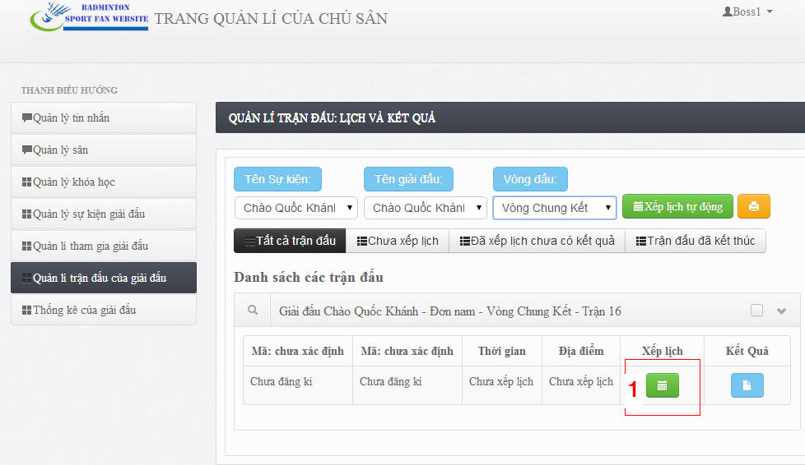

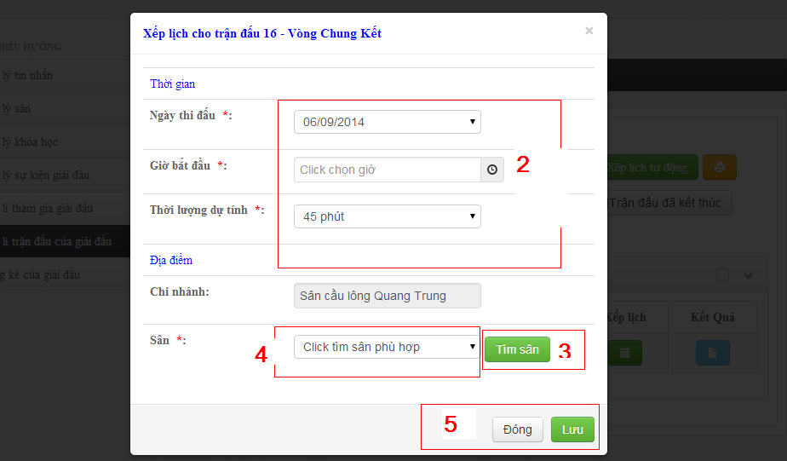

Figure 211: Create Contest Event Image

|  |  |
| --- | --- |
| **Step** | **Description** |
| 1 | Click “Xếp lịch” button to arrange match schedule. |
| 2 | Fill requied information. |
| 3 | Click “Tìm sân” button to find available court for match. |
| 4 | Choose court in available court listbox. |
| 5 | Click “Lưu” button to save schedule.  Click “Đóng” button to close popup window. |

Table 42: Arrange match shedule

#### Boss – Arrange Schedule Automatically

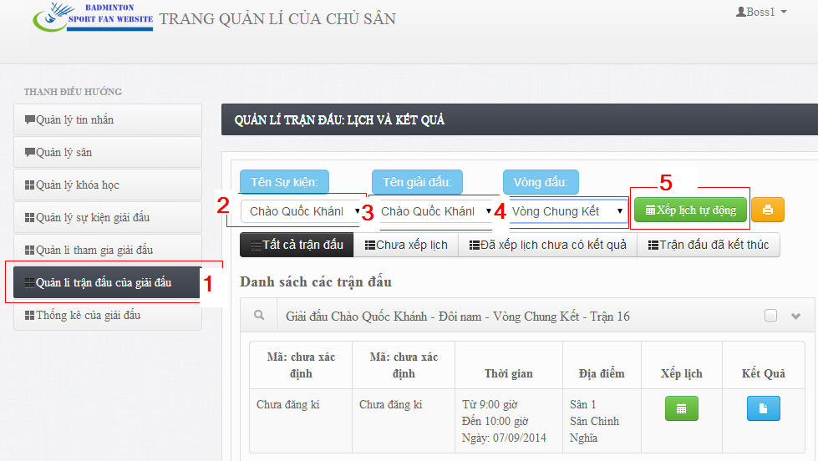

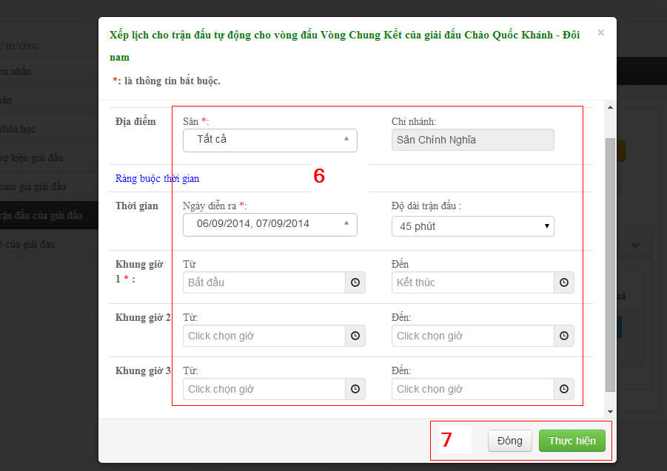

Figure 212: Edit contest event Image

|  |  |
| --- | --- |
| **Step** | **Description** |
| 1 | Click “Quản lí trận đấu của giải đấu” tab menu on navigation bar to view list of contest events. |
| 2 | Choose contest event name in contest event listbox. |
| 3 | Choose contest name in contest listbox, |
| 4 | Choose round of contest in round listbox. |
| 5 | Click “Xếp lịch tự động” button. |
| 6 | Fill required parameters. |
| 7 | Click “Thực hiện” button to arrange match schedule automatically.  Click “Đóng” button to close popup window. |

Table 43: Arrange schedule automatically

#### Boss – Record Match Scores

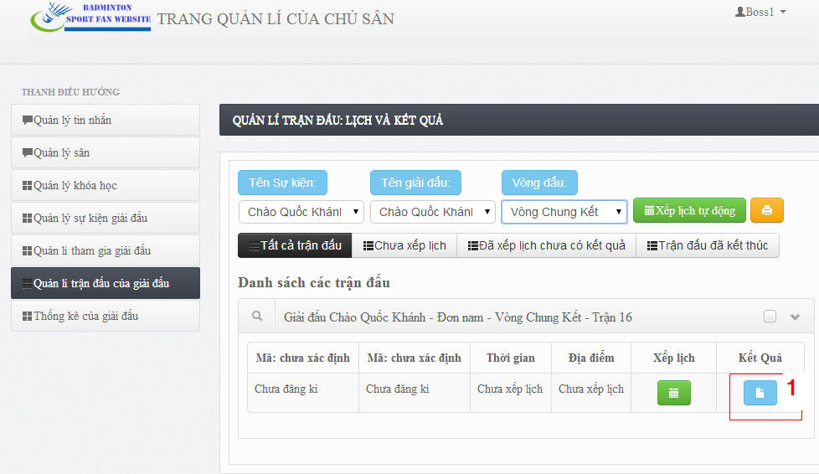

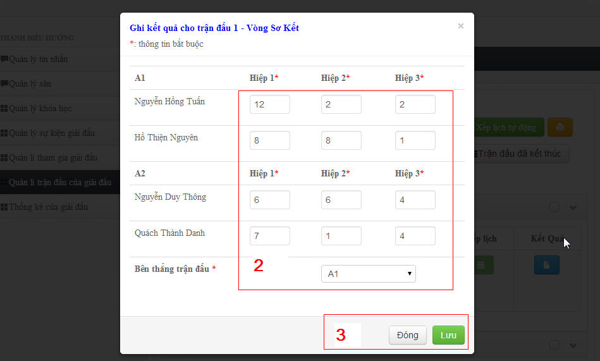

Figure 213: Delete Contest Event Image

|  |  |
| --- | --- |
| **Step** | **Description** |
| 1 | Click “Kết quả” button to record match scores and result. |
|  | Fill required information. |
| 2 | Click “Lưu” button to save information.  Click “Đóng” button to close pop up window. |

Table 44: Record Match Scores.

#### Boss – Export Contest Schedule

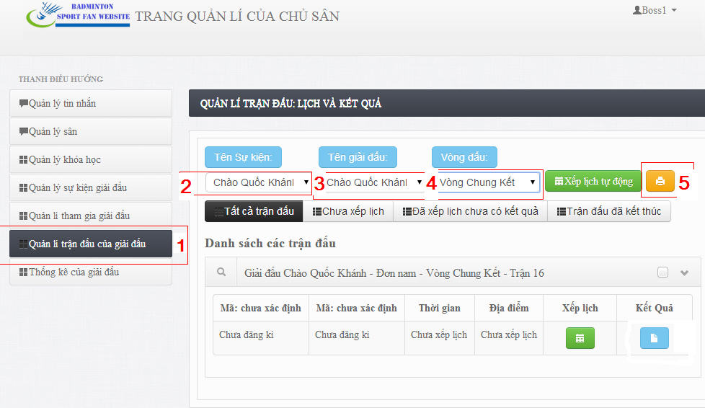

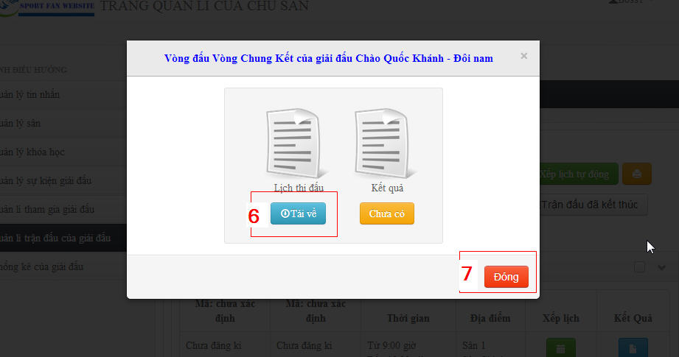

Figure 214: Delete Contest Event Image

|  |  |
| --- | --- |
| **Step** | **Description** |
| 1 | Click “Quản lí trận đấu của giải đấu” tab menu on navigation bar to view list of contest events. |
| 2 | Choose contest event name in contest event listbox. |
| 3 | Choose contest name in contest listbox, |
| 4 | Choose round of contest in round listbox. |
| 5 | Click “Tải lịch và kết quả” button. |
| 6 | Click “Tải về” button to export schedule. |
| 7 | Click “Đóng” button to close popup window. |

Table 45: Export contest schedule

#### Boss – Export Contest Result.



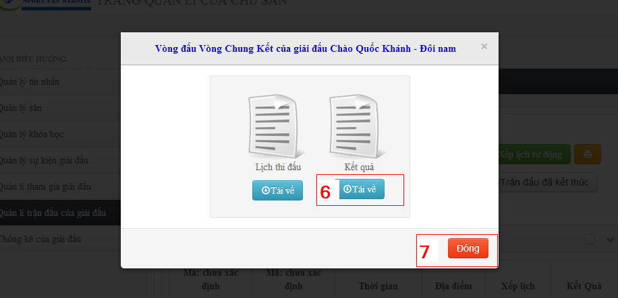

Figure 215: Delete Contest Event Image

|  |  |
| --- | --- |
| **Step** | **Description** |
| 1 | Click “Quản lí trận đấu của giải đấu” tab menu on navigation bar to view list of contest events. |
| 2 | Choose contest event name in contest event listbox. |
| 3 | Choose contest name in contest listbox, |
| 4 | Choose round of contest in round listbox. |
| 5 | Click “Tải lịch và kết quả” button. |
| 6 | Click “Tải về” button to export contest or round result. |
| 7 | Click “Đóng” button to close popup window. |

Table 46: Export contest result.

### Boss – View Contest Statistics.

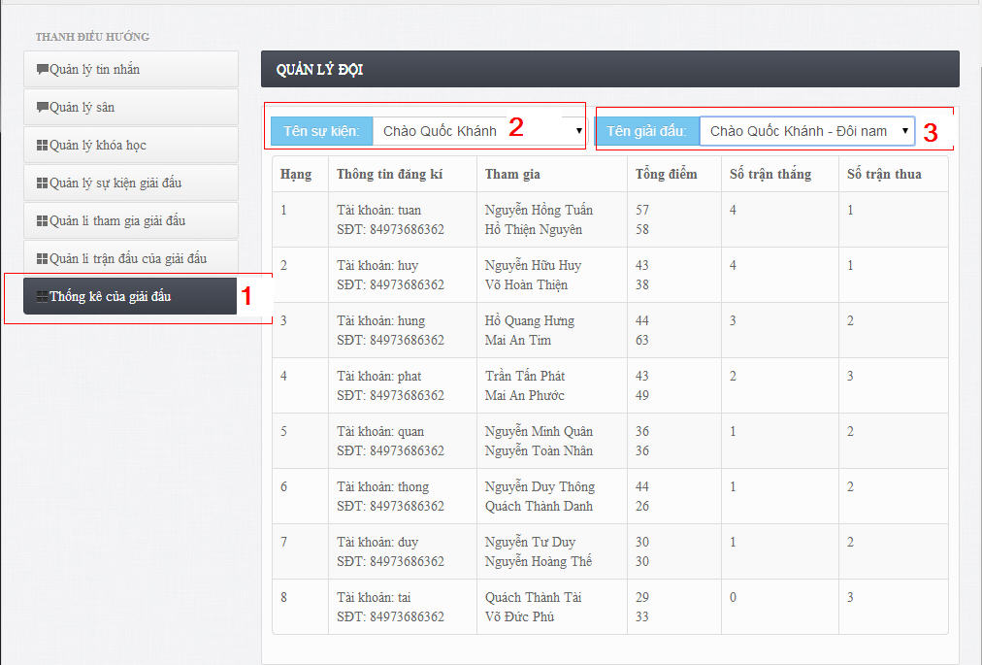

Figure 216: View Contest Statistics

|  |  |
| --- | --- |
| **Step** | **Description** |
| 1 | Click “Thống kê giải đấu” tab menu on navigation bar to view contest statistics. |
| 2 | Choose contest event name in contest event listbox. |
| 3 | Choose contest name in contest listbox, |

Table 47: View contest Statistics

### Boss – Manage Course

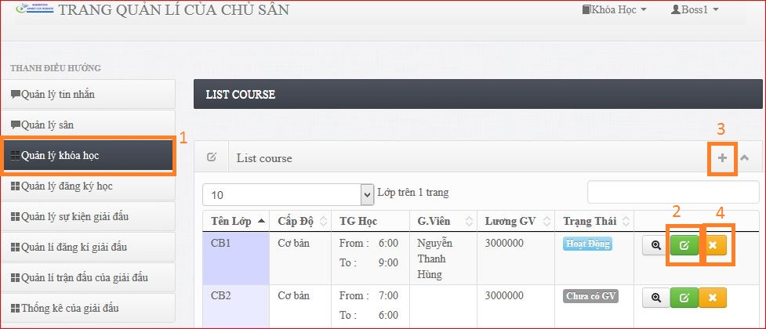

Figure 217: Manage Course

|  |  |
| --- | --- |
| **Step** | **Description** |
| 1 | Click “Quản lí Khóa Học” menu on navigation bar to view list of contest events. |
| 2 | Click [Edit] button row of list course to edit course |
| 3 | Click [+] buton on top right page to create course |
| 4 | Click [x] button on row of list course to delete course |

Table 48:Manage course

### Boss – Manage Register Course

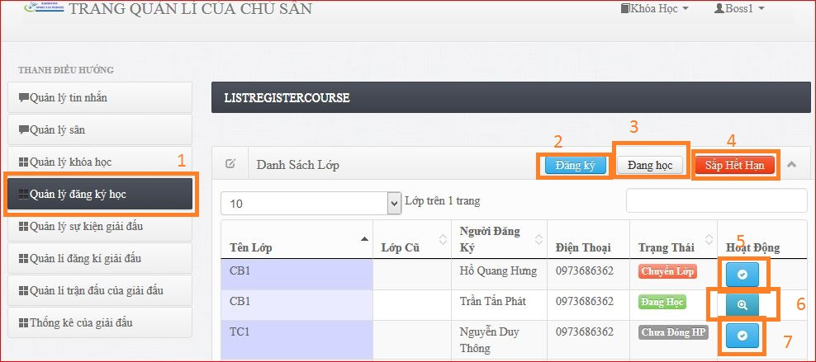

Figure 218: ManageRegister Course

|  |  |
| --- | --- |
| **Step** | **Description** |
| 1 | Click “Quản lí đăng ký học” menu on navigation bar to view list of contest events. |
| 2 | Click [Đăng Ký] on top right page to view all register or change course |
| 3 | Click [Đang Học] buton on top right page to view all player is studing on course |
| 4 | Click [Sắp hết hạn] buton on top right page to view all player is studing on course and will overdual next five days. |
| 5 | Click [confirm] button on row of list course to confirm for request change course |
| 6 | Click [] button on row to view detail course |
| 7 | Click [confirm] button on row of list course to confirm for request join course |

Table 49:Manage register course